Tips

1. Been and Gone: estado/sido (been(=) | ido *implies movement* (gone)
2. **IMPORTANT**: Adjectives → SER | Adverbs → ESTAR
   1. Adverbs: talk about how people are
   2. Adjectives: Talk about someone's character
3. Understanding Haya and Hubo
   1. Tricky Sentence: Perhaps when you come there will be some food. -> Tal vez cuando vengas **haya** algo de comida
      1. “Perhaps” indicates uncertainty + “cuando vengas” is subjunctive due to “Perhaps” + HAYA means “there will be” only because the idea of food is uncertain and its NOT future tense because its not definite that the food is there (Haya/Hay)
   2. Hubo: means “there was” but for preterite sentences (Hubo/Habia)
4. Creo que su esposa lo hace hacer todo. → makes him | do everything
5. **Count me in**: cuenta conmigo | de acuerdo: okay (in agreement)
6. aún: still, even, yet | aún no lo se: I dont know yet | aún asi: even so aúnque: although/even though
7. me da igual: i dont care, it doesnt matter to me, its all the same to me
8. en la secundaria: high school | alguna vez: ever
9. help people understand my system → ayudar a la gente a entender mi sistema
10. so he can realize that → asi que pueda darse cuenta de que
11. He's here! Tell him to come in → ¡Llegó! Dile que pase
12. realize: darse cuenta | you pretend: haces de cuenta
13. Do you have a menu **so that I can** see? → Tienen un menú **para que pueda** ver.
    1. use para que (so that) + “pueda” because it expresses purpose/intention
14. ADVERB vs ADJECTIVE
    1. ADJ: Modifies and describes NOUNS ← GENDER SPECIFIC
       1. La casa **grande** or El coche **rápido**
    2. ADV: Modifies verbs, adj, and adverbs ← NOT GENDER SPECIFIC
       1. He speaks **slowly** (modifies verb hablar) VERB
       2. She is **very** happy (modifies happy) ADJ
       3. She runs **quite** fast (modifies fast) ADV
15. Idiom Phrase: al saber → a el + infinitive == upon/when
    1. Ex: I feel bad knowing that you have → Me siento mal **al saber** que tengas
       1. Exact: I feel bad **upon knowing** that you have
16. I would never hurt you → Yo nunca te haría daño
17. She makes him do everything. I would never ask anyone here for nothing. → Ella le obliga a hacer todo. Nunca le pediría nada a nadie aquí.
18. What comes on this? → ¿Qué lleva esto?
    1. *The verb llevar, which in this context means "to come with" or "to include" (it’s often used to ask what ingredients or toppings a dish has).*
19. With what sides comes this dish? → ¿Con qué acompañamientos viene este plato?
    1. a-com-pan-yah-mien-tos
20. **NOTE**: Llevar (**JUMP TO** **156**)
21. **NOTE**: Getting Hurt (Jump to 179)
22. Estar Gerund vs Conjugated Verb
    1. **Estar Gerund**: the action is happening RIGHT NOW or in progress
    2. **Present Simple**: more neutral, not emphasizing the ongoing nature of verb but just the fact that it happens
    3. Examples
       1. We are changing our house → Estamos cambiando nuestra casa
       2. We are changing it and I’m happy → Lo cambiamos y estoy feliz
23. Entonces vs Asi que
    1. Entonces: then/so; expresses RESULT or CONSEQUENCE based on earlier action
       1. They didn’t exchange the money, so we stayed without dollars. → Ellos no cambiaron el dinero, entonces nos quedamos sin dólares
    2. Así que: so/therefore; cause and effect BUT focuses on that one thing CAUSED another; emphasizes THE REASON behind consequence
24. Remember how to structure quedar (something being left over) #196
25. When talking about things in theory, we can use “se” or reflexive of itself
26. Ponerse: to put on oneself | to become | to start
    1. to put on: Me pongo la chaqueta. → I put on my jacket.
    2. to become: Se puso nervioso. → He/She became nervous
    3. to start: Se pusieron a trabajar. → They started working.
27. To Start (needs prepositional a + infinitive)
    1. Ponerse: emphasizes spontaneity or sudden starting
       1. Me puse a estudiar cuando vi el examen. → I started studying when I saw the exam.
    2. Comenzar: more formal and straight forward
       1. Comenzaron a preparar la ceremonia temprano. → They started preparing for the ceremony early.
28. Mi español ha mejorado mucho desde que empecé este año.
    1. Recorrer un largo camino (to travel a long way) ← He recorrido…
    2. Comparado con el año pasado, es una gran diferencia.
29. **Affection Verbs**: [To whom it happens] + [What happens] + [What causes it]
30. Llevar (Indicate time doing something)
    1. **RULE**: if something starts in the past but continues to present, USE PRESENT tense
    2. **HOW**: Llevar + [amount of time] + [gerund]
31. **Ya** and different meanings:
    1. means “now” or “finally” to express relief or impatience;
    2. ya voy (I’m coming now) // ya basta! (thats enough/stop it already)
32. Cuando: subjunctive vs indicative
    1. indicative: facts/habitual: when i go to the store, i buy fruit
    2. subjunctive: uncertain/not realized yet: i’ll call you when i arrive
33. Cohort Program
    1. Llevo once meses en un programa virtual aprendiendo español.
       1. *means I have started learning spanish and still learning now*
    2. Estoy en un programa virtual de español desde hace once meses
       1. Si no puedes seguir el ritmo, te sacan. ← informal (*incluso*)
    3. AFTER: use estuve + durante un ano

Verbs of Affection/Influence

## Differences and Structure

Understanding Verbs of Affection/Influence

* **RULE**: these verbs focus on the *effect* something has *on the person*, NOT the action it takes
  + The **subject** of sentence **IS NOT** the person **experiencing the action** but instead the thing causing the effect
  + The person (*indirect object*) is receiving the effect of the subject
* **RULE**: these verbs ALWAYS have
  + **INDIRECT OBJECT PRONOUNS**: me, te, le, nos, les ← **WHO IS AFFECTED**
  + **WHAT CAUSES THE EFFECT**: the actual subject which comes **AFTER** the verb
* LANGUAGE Difference
  + 1) dolar: pain is framed as something the body part does to someone
  + 2) bastar: the enoughness of 3 hours for her ← 3 hours are enough for her

Tips to Understanding these Verbs

* Step 1: Think about them as backwards sentences
* Step 2: What is causing the effect (subject)
* Step 3: Who is affect (IdO)
* **STRUCTURE**: [To whom it happens] + [What happens] + [What causes it]

Verbs that use structure

* Gustar, Encantar, Doler, Faltar, Bastar, Importar, Quedar, Interesar, Molestar, Parecer
* Examples

1. Their opinion matters to me ← Me importa su opinión
2. I’m missing two dollars ← Me faltan dos dolares.

Understanding the Structure: Ido Pronoun + Verb + Subject

* [Indirect Object Pronoun] [Verb] [Subject]
* who is affected conjugated to agree w/ subject thing causing effect

1) Le dolerá ← it la pierna

2) Le bastan tres horas

Week 47: Lessons 246-250

Tips

Participles/Gerunds

* Leyendo: reading | Leído: read
* Escribiendo: writing | Escrito*: wrote
* Aprendiendo: learning | Aprendido: learned
* Desayunando: having breakfast | Desayunado: had breakfast
* Almorzando: having lunch | Almorzado: had lunch
* Cenando: having dinner | Cenado: had dinner
* Viajando: traveling | Viajado: traveled

Words

* limpio: clean
* sucio(a): dirty
* seco(a): dry
* mojado(a): wet
* tibio(a): warm/lukewarm (describes something neutral) | tee-bee-oh
* fresco: cool/fresh
* ancho(a): wide
* estrecho(a): narrow
* antiguo(a): old (item)
* corto(a): short (length)
* marrón: brown
* el violeta: purple (doesn’t change on gender)
* rosa: pink (doesn’t change on gender)
* barato(a): cheap
* despacio: slowly (adverb)
* hogar: home/hearth
* departamento: flat/department (synonym for apartment in some countries)
* el alquiler: rent (as in what you pay) | al-kee-lair
* comedor: dining room
* el refrigerador/la nevera: the refrigerator
* bañera: bathtub
* ducha: shower
* inodoro: toilet
* lavamanos: sink
* muebles: furniture
* el armario: cabinet/cupboard/wardrobe (describe w/ noun)
* escritorio: desk

Idioms

* la boca seca: dry mouth

## Ep 249: Hogar

Examples

1. I think I left it at my flat. → Creo que lo dejé en mi departamento.
2. The rent there is too expensive for me. → El alquiler allí es demasiado caro para mí.
3. It doesn’t make any sense that there’s a fridge in the dining room. → No tiene sentido que haya una nevera en el comedor.
4. The bathtub is beside the sink. → La bañera está al lado del lavamanos.
5. Where did you put the furniture? → ¿Dónde pusiste los muebles?
6. Why are your clothes in the dish cabinet? → ¿Por qué está tu ropa en el armario de los platos?

## Ep 248: Limpio, sucio, mojado, seco

Understanding New Words

* when describing how “hot” food is we use caliente (adj) but for temperatures we use “calor”
* colors change on the noun it is describing EXCEPT rosa y violeta
* lento can be used as an adjective or adverb but COMMON as adjective

Understanding SER only Adjectives

* we learned words like grande, pequeño, alto, bajo
* new words are: corto, estrecho, ancho, y antiguo.

Examples

1. We need a little fresh air here. → Necesitamos un poco de aire fresco aquí.
2. Do you want a fast song or a slow song? → ¿Quieres una canción rápida o una canción lenta?
3. The food is very dry. → La comida está muy seca.
4. At the beginning the floor was wet, but now it’s clean. → Al principio el piso estaba mojado, pero ahora está limpio.
5. You shouldn’t travel in December, the roads are wet. → No deberías viajar en diciembre, las carreteras están mojadas.
6. By that time our dinner was cold. → Para ese momento nuestra cena estaba fría.
7. The air is really cool for it to be August; it almost feels like winter. → El aire está muy fresco para ser agosto, casi se siente como invierno.
8. I didn’t know the sky could be so yellow! → ¡No sabía que el cielo podía ser tan amarillo!
9. Read slowly, it’s better in order to understand. → Lee despacio, es mejor para entender.

## Ep 247: Desayunar, Almorzar, Cenar, Viajar

### Verb: Desayunar

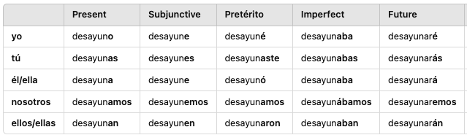

### Verb: Almorzar

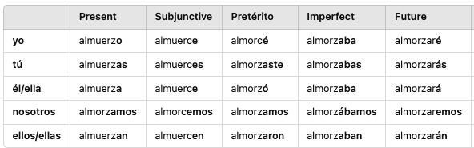

### Verb: Cenar

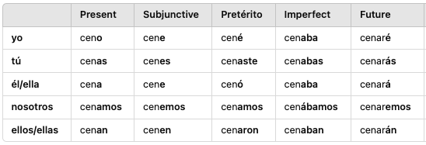

### Verb: Viajar

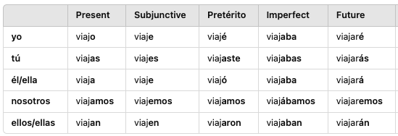

Understanding Food Actions

* in English we can talk about “having breakfast/lunch/dinner” but in Spanish, these are separate verbs
* **RULE**: to say “go out for a meal” must use Salir + a + infinitive → Quiero salir a cenar. ← I want to go out to dinner.
* **NOTE**: resist the urge to use Haber for different tenses like “he had/habia”

Understanding Food Verbs

* **Desayunar**: means “to have breakfast”
* **Almorzar**: means “to have lunch”
* **Cenar**: means “to have dinner” or “to dine”
* **RULE**: can use with direct object like “having X for breakfast” so we can “breakfast it” without por & drop tener
  + Ex: You always have meat for lunch. → Siempre almuerzas carne

Understanding Viajar

* means “to travel” and sounds like the noun trip “viaje”

Examples

1. We had breakfast very early today, but he had breakfast afterwards. → Nosotros desayunamos muy temprano hoy, pero él desayunó después.
2. They had lunch without me, so I had lunch alone. → Almorzaron sin mí, así que almorcé solo.
3. You had dinner with your friends, so he had dinner alone. → Tú cenaste con tus amigos, así que él cenó solo.
4. We travel there when it’s cold, but we’d like to travel to another place. → Viajamos ahí cuando hace frío, pero nos gustaría viajar a otro lugar.

## Ep 246: Leer, Escribir, Aprender

### Verb: Leer

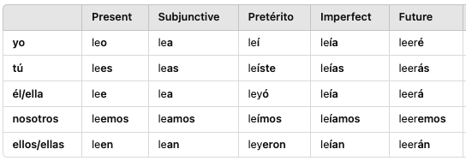

### Verb: Escribir

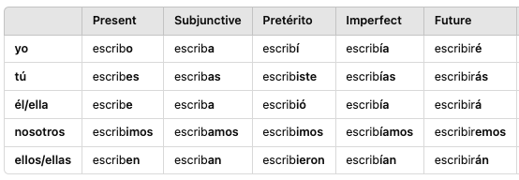

### Verb: Aprender

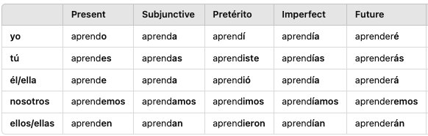

Understanding Escribir

* means “to write/to write down” and can be used with both direct and indirect objects

Understanding Aprender

* means “to learn” and
* RULE: uses “a + infinitive” when learning to do some action ← Aprendió a decir esa palabra. *he learned how to say…*

Week 46: Lessons 241-245

Tips

Words

* existido: existed | Existiendo: existing
* Extrañado: missed | Extrañando: missing
* Soñado: dreamed | Soñando: dreaming
* Olvidado: forgot | Olvidando: forgetting
* Despertado: woken | Despertando: awaking
* principio: beginning (at the beginning ← al)
* rato: while/a little while
* sorbete: drinking straw
* estación: season
* la primavera: spring | el otoño: fall | el invierno: winter | el verano: summer
* **DAYS**: lunes, martes, miércoles, jueves, viernes, sábado, domingo
* **MONTHS**: enero, febrero, marzo, abril, mayo, junio, julio, agosto, septiembre, octubre, noviembre, y diciembre

Idioms

* a través de: across/through/via (indicating movement) + used with SER

## Ep 244: Los días de la semana

Understanding Days of Week

* **RULE**: must put the article in front of the word → ¡Nos vemos el sábado!
* **RULE**: to say “It’s Friday!” no article → ¡Por fin es viernes! *Finally its Friday*

Understanding Months

* **RULE**: to say a specific date, dont say “on” → Su cumpleaños es el 23 de marzo.
* **RULE**: combine days of week + month, drop “el” before number
  + Yes, it’s on Friday, October 18. → Sí, es el viernes dieciocho de octubre.

Examples

1. Her birthday is October 22 and mine is November 27. → Su cumpleaños es el 22 de octubre y el mío es el 27 de noviembre.
2. She feels bad for having told you that last February. → Se siente mal por haberte dicho eso el febrero pasado.

## Ep 243: Haberlo, Haberte, Haberme

Understanding Haber w/ Contractions + Participles

* **Scenario Participles**: to convey the idea of having done something in the past, we can pair haber + contraction + participle which breaks the rule of being at beginning of phrase or end w/ infinitive
  + Example: Thank you for having done it. → Gracias por haberlo hecho.
* **Scenario Deber**: very common with “should” because Deber is already past and Haber further puts it into past; expresses regret of something that should of happened
  + Example: You shouldn’t have eaten it. → No debiste haberlo comido.

Understanding Quedar / Quedarse - to suit

* **NOTE**: has many meanings “to stay” reflexively; “to remain/is left over” w/o reflexive pronoun; “to suit” w/ indirect object
* see Ep:196 for details

Understanding Idiom - a través de

* means “across/through” when indicating direction or movement
* often used with the verb “SER” even though we are talking about location
  + The exit is via the back door. → La salida es a través de la puerta trasera.

Examples - Quedar

1. There were only two boxes left. → Sólo quedaban dos cajas. *to remain*
2. Do you think that this suits him well? → ¿Crees que esto le queda bien?

## Ep 242: Olvidar, Despertar, Alegrar

### Verb: Olvidar

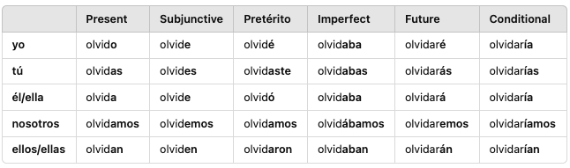

### Verb: Despertar

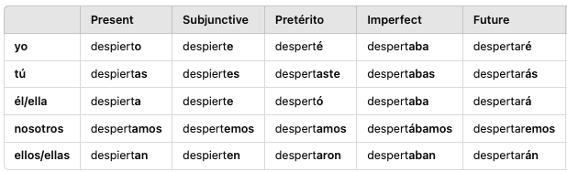

### Verb: Alegrar

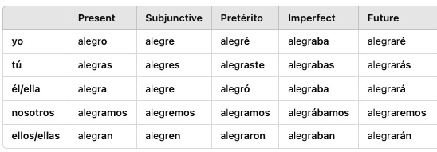

Understanding Olvidar

* means “to forget” and used when its a object or piece of information **NOT** forgetting about something

Understanding Olvidarse

* general meaning “to forget about something” and uses preposition “de”
* also for actions/verbs, pair olvidarse + de + verb
* **Example**: I forgot to open the door. → Me olvidé de abrir la puerta.

Understanding Despertar y Despertarse

* means “to wake up” and commonly used reflexively
* **NOTE**: w/ nuance and much like “sentar” where use direct object to seat someone else but reflexively to seat yourself/sitting down
* **NOTE**: subjunctives get a stem change to focus on
* **RULE**: wake someone else up: direct object | waking up in general: reflexive pronoun

Understanding Alegrar

* means “to cheer up” or “to make glad” and uses DIRECT OBJECT
* **NOTE**: commonly used reflexively to say “I’m really glad”
* **EXAMPLE**: The party cheered her up. → La fiesta la alegró. (pret)

Understanding Alegrarse

* means “to rejoice” or “it makes me happy” *me alegro*
* **NOTE**: using “se alegra” ensures that the subject (he) is experiencing the feeling
* **RULES**: can use de/por and also de que BUT must follow rules below
  + **ACTION**: “de + infinitive”
  + **NEW CLAUSE**: “de que + subjunctive” if introducing a new clause of what you’re happy about

Examples

1. He’s really glad that they’ve come! → ¡Se alegra de que hayan venido! *subjunctive*
   1. It makes him happy that they come → Le alegra que vengan
2. She’s really happy for you! → ¡Ella se alegra por ti! *por*
3. I’m really glad to see you! → ¡Me alegro de verte! *infinitive*
4. She was really glad to know that all that was false. → Se alegró de saber que todo eso era falso.
5. I always wake up at the same time. → Siempre me despierto a la misma hora.
6. He’s very tired; I don’t want anyone to wake him up. → Está muy cansado, no quiero que nadie lo despierte.
7. We’ll do it when she wakes up, but she didn’t wake up yet. → Lo haremos cuando se despierte, pero todavía no se despertó.

## Ep 241: Existir, Extrañar, Soñar

### Verb: Existir

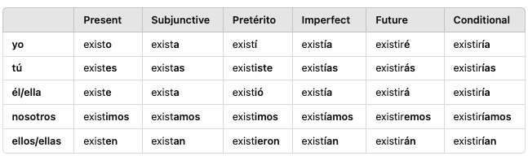

### Verb: Extrañar

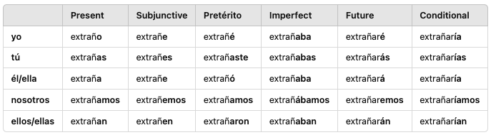

### Verb: Soñar

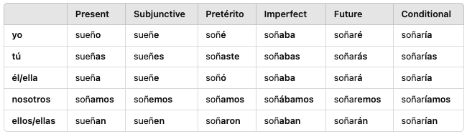

Understanding Existir

* means “to exist”
* **NOTE**: in English we talk about existence using “there is/was” *I didnt know there was a place like that* and Haber can be used **BUT** in Spanish, existir is very common
* **RULE**: in general, the subject of what is existing appears at the end of the sentence
  + **Ex**: I didn’t know that such a thing existed! → ¡No sabía que existía tal cosa!

Understanding Extrañar

* means “to miss” and tends to take DIRECT OBJECTS

Understanding Soñar

* means “to dream” as in hopes and dreams or the literal dreaming
* **RULE**: dreaming “about something” uses **con** as the preposition
  + Ex: I dreamed about a little white dog. → Soñé con un perrito blanco.
* **NOTE**: to say “I had a dream about you” we can use tuve BUT common is “I dreamt about you ← Soñé contigo”

Examples

1. I don’t think those friends really exist, he’s always busy. → No creo que de verdad existan esos amigos, siempre está ocupado.
2. Before, there used to exist a school here. → Antes existía un colegio aquí.
3. Did you miss your parents that day? Do you still miss them? → ¿Extrañaste a tus padres ese día? ¿Aún los extrañas?
4. Last night I dreamed that I lived in Colombia. → Anoche soñé que vivía en Colombia.
5. This is the wrong house, I didn’t dream about it. → Esta es la casa equivocada, no soñé con ella.

Week 45: Lessons 236-240

Tips

* to cure: curar
* arruinar: to ruin
* to steal: robar // ¿Le robaste esto? *did you still this for him*
* ahorrar: to save
* Mess: desastre | Messy: desastroso (des-sahs-trey)
* oración: sentence (or-ras-see-ohn) | un artículo: article
* una medicina: a medicine
* mad: enojada
* the price: el precio (preh-see-oh) // ¿cual es el precio de?
* the beach umbrella: la sombrilla (som-brie-yah)
* Qué le pidió Daniela al genio ←What did Daniela ask the genie?
* controlar las cosas que como ← controlling the things I eat
* Es importante ahorrar para el futuro y tener un *fondo* de emergencia. *fund*
* Ya volvieron **vs** volvieron ← They’re back // they’ve returned (volver preterite)
* Puedes traerme eso?

Words

* traído: brought | Trayendo: bringing
* Vendido: sold | vendiendo: selling
* abierto: opened | Abriendo: opening
* Comprado: bought | Comprando: buying
* abierto: open
* cerrado: closed
* despierto(a): awake (adj)
* cansado(a): tired
* sueño: sleepy
* aburrido: bored/boring
* equivocado: wrong
* amable: kind/nice/friendly
* necesario: necessary
* dulce: sweet
* rico: yummy/tasty(food) | rich (money)
* horrible: horrible
* peligroso: dangerous | peligro (danger)
* falso: false/fake | opposite of verdadero
* mercado: market
* colegio: primary or high school (coh-leh-he-oh)
* estación: station
* la prisión: prison
* la cárcel: jail
* en línea: online

Idioms

* you are wrong: estás equivocado | tener razón (opposite)

## Ep 239: Restaurante, Tienda, Biblioteca

Examples

1. The things they sell in the supermarket are fake. → Las cosas que venden en el supermercado son falsas.
2. Nobody likes that club anymore. → Ya no le gusta a nadie ese club.
3. I’ll go to the library after church. → Iré a la biblioteca después de la iglesia.
4. I’ve known him since I was in college. → Lo conozco desde que estaba en la universidad.
5. She spent four years in prison. → Pasó cuatro años en la prisión.

## Ep 238: Peligroso, dulce, aburrido

Understanding Adjectives

* aburrido:
  + being bored: estar + aburrido ← Estoy aburrido
  + something boring: ser + aburrido ← Este juego es muy aburrido.

Examples

1. (Formal) Open the door please, I’m tired(f). → Abra la puerta por favor, estoy cansada.
2. He’s still awake, but really tired. → Aún está despierto, pero muy cansado.
3. It was in the wrong box, but I put it in the right one. → Estaba en la caja equivocada, pero lo puse en la correcta.
4. You’re wrong, the school is still open. → Estás equivocado, la escuela aún está abierta.
5. Did you bring something to play? I’m bored. → ¿Trajiste algo para jugar? Estoy aburrido.
6. You’re very nice for saying that! → ¡Eres muy amable por decir eso!
7. I brought this game because I heard you’re smart. → Traje este juego porque escuché que eres inteligente.
8. What he did was very sweet. → Lo que hizo fue muy dulce.
9. They say it’s a very dangerous city. → Dicen que es una ciudad muy peligrosa.
10. I thought that it was genuine, but it was fake. → Creía que era verdadero, pero era falso. *imperfect*

## Ep 237: Comprar, Vender, Abrir

### Verb: Comprar

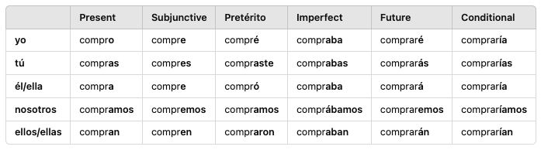

### Verb: Vender

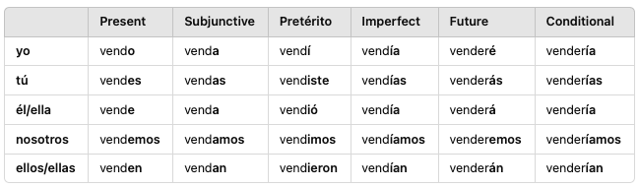

### Verb: Abrir

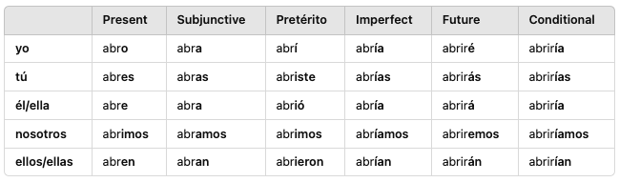

Understanding Comprar

* means “to buy” but its very common to say WHO you’re buying something for even if its yourself so it tends to use the Indirect Object
* Ex: Quiero comprarme un traje nuevo.
  + in English we dont tend to say “for myself” but spanish its normal

Understanding Vender

* means “to sell” and takes both indirect and direct objects or both together
* Ex: She was going to sell me a car. → Me iba a vender un auto.

Understanding Abrir

* means “to open”
* **RULE**: when there is a clear subject performing the action of opening, **DONT** use reflexively
* **RULE**: when subject is NOT performing action but rather **the action happens on the object itself** use “**abrirse**” reflexively
  + What time do the doors open? → ¿A qué hora se abren las puertas?
    - *At what time opens the doors*

Examples - Comprar

1. I want him to buy what I had bought. → Quiero que él compre lo que yo había comprado.
2. She brought what I could not buy. → Ella trajo lo que yo no pude comprar.
3. She buys that because she doesn’t think I’ll buy it. → Ella compra eso porque no cree que yo lo compre.

Examples - Vender

1. My granny sold those things because everyone is selling them. → Mi abuelita vendió esas cosas porque todos las están vendiendo.
2. (Formal) Sell that! It’s still early. → ¡Venda eso! Todavía es temprano.
3. Sell it! He always sells that without a problem. → ¡Véndelo! Él siempre vende eso sin problema.

Examples - Abrir

1. We haven’t opened it yet. → No lo hemos abierto aún.
2. They want me to open the door because I didn’t open it before.
3. Quieren que yo abra la puerta porque no la abrí antes.
4. I have brought the same thing they brought, but they still haven't opened it. → He traído lo mismo que ellos trajeron, pero todavía no lo han abierto.
5. (plural) Open the door! We need someone to open it with that key. → ¡Abran la puerta! Necesitamos que alguien la abra con esa llave.

## Ep 236: Traer vs Llevar vs Tomar

### Verb: Traer

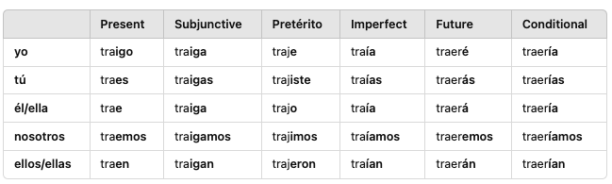

Understanding Traer

* means “to bring” with an emphasis on “**arriving with the object, especially is place is *here* where speaker is**” vs llevar which means to “bring from point a to point b”
* **NOTE**: if you are bringing person/pet don’t forget “a” #1
* **NOTE**: a sentence that uses tomar, llevar and traer which can mean bring/take
  + Take this, take it with you, and bring it to the concert. → Toma esto, llévalo contigo y tráelo al concierto.
* pronounce: triago (tree-ah-go), traes (try-ace), traemos(try-aye-mos), traen (try-en)
* **DIFFERENCES**:
  + **Traer**: emphasis on arriving with the thing especially if place bringing to is *aqui*
  + **Llevar**: emphasis on distant adverbs like *ahi/alli* and act of bringing from one place to another
* Ex: They were going to bring the box here. → Iban a traer la caja aquí.

Examples

1. Tomorrow I’m going to bring my cat to school. → Mañana voy a traer **a** mi gato a la escuela.
2. He wants me to bring a game. → Quiere que yo traiga un juego.
3. He always brings that super early. → Siempre trae eso tempranísimo.
4. We always bring gifts when we come. → Siempre traemos regalos cuando venimos.
5. He takes those things to his work. → Lleva esas cosas a su trabajo.
6. Don’t take this to that building. → No lleves esto a ese edificio.
7. They hadn’t brought anything for dinner. → No habían traído nada para la cena.

Week 44: Lessons 231-235

Tips

Words

* deseando: wishing
* deseado: wished
* jurado: sworn
* prometido: promised
* corriendo: running
* obviamente: obviously
* definitivamente: definitely/permanently (starts sentence)
* últimamente: lately
* enseguida: immediately/right away (related to seguir) *immediately following*
* aún: still/yet ie. synonym for todavía
* aun: even/still (specific scenarios) ← no accent mark
* ojalá: hopefully (triggers subjunctive) *esperar/desear (hope/wish)*
* muchísimo: whole lot (demasiado alternative)
* objeto: object ie synonym for “thing”
* el reloj: the clock / wrist watch
* plato: plate/dish
* vaso: cup (literal is glass)
* la cuchara: spoon
* el cuchillo: knife
* el tenedor: fork
* la cena: dinner
* desayuno: breakfast
* almuerzo: lunch
* la cerradura: the lock
* llave: key
* prisa: haste (used w/ Dar mainly)

Other Words

* cozy: acogedor
* the stress: el estrés
* the neighbor: el vecino

Idioms

* frente a la computadora: at the computer ← *frente a* literal is opposite of but common w/ computer

## Ep 234: Llave, computadora

Understanding New Words

* computadora: normally uses the idiom *frente a la*  when talking about sitting at the computer
  + Ha pasado seis horas frente a la computadora. *Spent 6 hours at…*

Understanding Prisa

* means “haste” to talk about being in a hurry
* **RULE**: used with tener or dar | Dar for when someone needs to hurry up
  + Darte prisa - imperatives
  + Tener prisa - statements or information

Examples

1. Is this your watch? It isn’t working. → ¿Es este tu reloj? No está funcionando.
2. Do you promise you’ll give me those objects? Even the computer? → ¿Prometes que me vas a dar esos objetos? ¿Hasta la computadora?
3. I swear I’ll give you the plates and glasses right away. → Juro que te daré los platos y vasos enseguida.
4. Why do you have a knife and a spoon and not a fork? → ¿Por qué tienes un cuchillo y una cuchara y no un tenedor?
5. He promised us he would make breakfast, not lunch. → Nos prometió que haría el desayuno, no el almuerzo.

Examples Prisa

1. Hurry up, come to the car! → ¡Date prisa, ven al coche!
2. It’s OK, I’m not in a hurry. → Está bien, no tengo prisa.
3. They didn’t hurry at all. → No se dieron prisa para nada.
4. Hurry, there are three locks and two keys. → Date prisa, hay tres cerraduras y dos llaves.

## Ep 233: Adverbs ending in “mente”

Understanding Customizing Nouns, Adverbs and Adjectives

* Adverbs: we can english words that end in “ly” like *completely* by adding “**mente**”

Understanding “aun” (no accent)

* **REMEMBER**: aún w/ accent means “still/yet” ie todavía synonym
* Proposition: aun can be applied to preposition like “without” to say “even without” but can be translated as “hasta sin” but common as first way
  + technically, anytime we use “hasta” as adverb to mean even, we COULD use “aun”
* RULE: use “aun” with propositions

Understanding ojalá

* means “hopefully” and triggers SUBJUNCTIVE
* used VERY COMMON in place of verb Esperar
  + I hope they aren't sad → ojalá no estén tristes ← espero que no estén tristes
* used also in place of the verb Desear
  + I wish this weren’t so difficult → Ojalá esto no fuera tan difícil.

Understanding Diminutives or Baby Talk

* we can take nouns and make them cute by adding “ito/ita” at the end
* **RULE**: if noun ends with A/O → ita/ito BUT if ends with E → cito/cita
  + café: cafecito

Understanding Superlatives

* we can make words stronger by adding “isimo(a)”
* most common is muchísimo

Examples w/ “mente”

1. Obviously there is absolutely no reason to do this. → Obviamente no hay absolutamente ninguna razón para hacer esto.
2. I completely agree, she obviously likes my friend. → Estoy completamente de acuerdo, obviamente le gusta mi amigo.
3. This is definitely much better. → Definitivamente esto es mucho mejor.
4. Can I permanently change my address? → ¿Puedo cambiar definitivamente mi dirección?
5. Lately I sleep until 10 each morning. → Últimamente duermo hasta las 10 cada mañana.
6. This is definitely impossible, have you talked to them lately? → Esto es definitivamente imposible, ¿has hablado con ellos últimamente?

Examples w/ aun + preposition && enseguida

1. Can you come to the office right away? → ¿Puedes venir a la oficina enseguida?
2. They saw it in many places, even on the road. → Lo vieron en muchos lugares, aun en la carretera.
3. That area is not safe, even for them. They have to come back right away. → Esa zona no es segura, aun para ellos. Tienen que volver enseguida.

Examples w/ Olajá

1. I wish I were a little taller. → Ojalá yo fuera un poco más alto.
2. I wish he could do that, but I know he can’t. → Ojalá él pudiera hacer eso, pero sé que no puede.
3. Hopefully he’s here soon; I promised him we were going to see each other. → Ojalá él esté aquí pronto; le prometí que íbamos a vernos.

Examples Diminutives

1. That little boy(dim) is his little friend(dim), do you know him? → Ese niñito es su amiguito, ¿lo conoces?
2. It’s a cute little thingy and there’s a lot of space here for that. → Es una cosita muy bonita y hay mucho espacio aquí para eso.
3. Run! You have to say goodbye to your little sister(dim) before you leave the little house(dim). → ¡Corre! Tienes que decirle adiós a tu hermanita antes de que te vayas de la casita.

Examples Superlatives

1. I found a whole lot of things in the living room. → Encontré muchísimas cosas en la sala.
2. There are a whole lot of kids near the window; did you see them? → Hay muchísimos chicos cerca de la ventana, ¿los viste?
3. There were a whole lot of people in that place because it was super good. → Había muchísima gente en ese lugar porque era buenísimo.

## Ep 232: Prometer vs Jurar

### Verb: Prometer

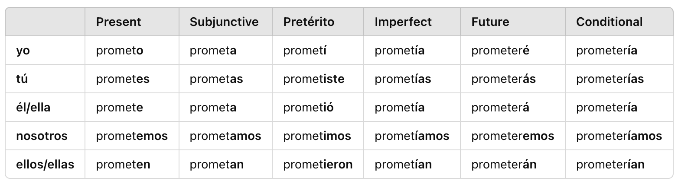

### Verb: Correr

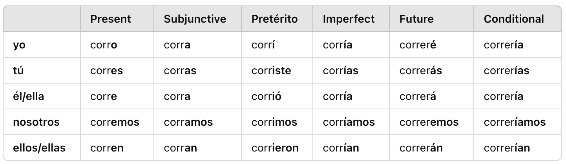

Understanding Prometer

* means “to promise” and typically used for *the future* vs Jurar is all tenses and takes both indirect and direct objects like Jurar

Understanding Correr

* means “to run” and conjugated like deber

Examples - Prometer

1. You promised me that you were going to do it. → Me prometiste que lo ibas a hacer.
2. Promise me that you’re going to go! → ¡Prométeme que vas a ir!
3. She wishes that I be there because I promised it to her. → Ella desea que yo esté ahí porque se lo prometí.
4. It’s wonderful, but you promised me the same that he had promised me. → Es maravilloso, pero me prometiste lo mismo que él me había prometido.

Examples - Correr

1. Don’t run here! You know we only run outside. → ¡No corras aquí! Sabes que solo corremos afuera.
2. I swear you’ll have problems if I see you running here again. → Juro que tendrás problemas si te veo corriendo aquí otra vez.
3. You’re running because he’s running, but they want me to run. → Tú corres porque él corre, pero ellos quieren que yo corra.

## Ep 231: Jurar, Desear

### Verb: Desear

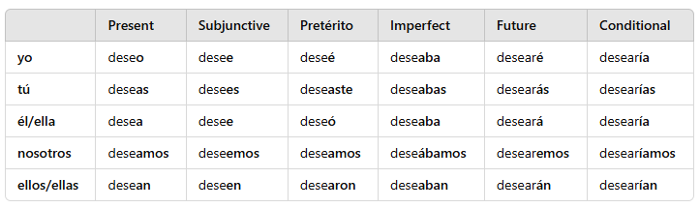

### Verb: Jurar

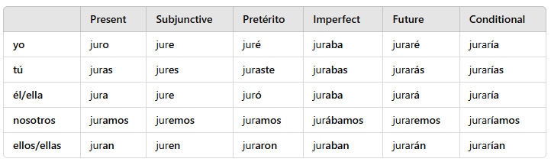

Understanding Desear

* means “to wish” and takes both direct and indirect objects (decir/dar);
  + indirect: recipient; wish something for someone
  + direct: subject; what you wish them
* Indirect Ex: I wish you(formal) a very good day. → Le deseo un día muy bueno.
* Direct Ex: I wish to speak with your boss. → Deseo hablar con tu jefe.

Understanding Jurar

* means “to swear” or “to vow” and takes both direct and indirect objects
* **RULE**: uses “que” phrase when describing what it is that someone is swearing

Examples: Desear

1. He wishes for a bigger house. → Él desea una casa más grande.
2. What do you wish for for your birthday? → ¿Qué deseas para tu cumpleaños?
3. I’ve been wishing for this for years. → He estado deseando esto por años.

Examples - Jurar

1. He swore to them that he was there that day. → Les juró que estuvo allí ese día.
2. I haven’t sworn anything to you. → No te he jurado nada.
3. He swore to her that the window was fine. → Le juró que la ventana estaba bien.
4. I swear the vacation is going to be wonderful. → Juro que las vacaciones van a ser maravillosas.

Week 43: Lessons 226-230

Tips

* one million four hundred and eight: un millión cuantrocientos y ocho
* it’ll be better: será mejor
* this business is working: este negocio está funcionando
* not for long: no por mucho tiempo
* give it to him: Dáselo
* get it before i win: …antes de **que** yo gane ← que phrase because we have a subject but if “winning” no que

Words

* conseguido: gotten (past participle)
* pagado: paid
* ganado: won/earned
* divertido: fun (adj)
* maravilloso: wonderful/marvelous (adj) stress the “yoso”
* raro: weird/rare (adj)
* dirección: direction (the way something is moving)
* dirección: address (specific location of site)
* destino: destination
* destino final: final destination
* espacio: space (synonym for lugar)
* sitio: site (synonym for lugar, parte, lado) or website
* zona: area
* puente: bridge
* acera: sidewalk
* carretera: road
* entrada: entrance
* suelo: ground/floor
* piso: floor/story
* sala: room (where people congregate in like living room) vs cuarto/habitación
* ventana: window
* infierno: hell

Extra Words

* the apartment: el apartamento
* the social networks: las redes sociales
* the price: el precio
* the flag: la bandera
* the television: la televisión
* the savings los ahorros
* the kitchen: la cocina
* the stress: el estrés
* the excitement: la emoción
* the wood: la madera
* the bars: los bares
* sixth: sexto
* sudden: repentina

Idioms

* nos encontramos: we ran into each other
* hace tanto calor: its so hot

## Ep 229: Dirección vs Destino

Examples - Locations

1. What direction did he go? // In that direction. → ¿En qué dirección fue? // En esa dirección.
2. The party is at Juan's house, what's the address? → La fiesta es en casa de Juan, ¿cuál es la dirección?
3. I missed the flight. My final destination is San Antonio. → Perdí el vuelo. Mi destino final es San Antonio.
4. She went to another state, so now she has a new address. → Se fue a otro estado, así que ahora tiene una dirección nueva.
5. We couldn’t find it in any place. → No lo pudimos encontrar en ningún sitio.

Examples - Built Places

1. Yesterday we ran into each other on the bridge. → Ayer nos encontramos en el puente.
2. We can’t walk by foot, this street barely has a sidewalk. → No podemos andar a pie, esta calle apenas tiene acera.
3. You have to be on the sidewalk, not on the road. → Tienes que estar en la acera, no en la carretera.

Examples - Part of Buildings

1. The entrance is far from the exit. → La entrada está lejos de la salida.
2. Why is your food on the floor? → ¿Por qué está tu comida en el suelo?
3. His office is on the third story. → Su oficina está en el tercer piso.
4. He gets an office on that floor. → Consigue una oficina en ese piso.
5. I don’t see the entrance or exit doors. → No veo las puertas de entrada ni de salida.
6. The meeting was in the biggest room of the building. → La reunión fue en la sala más grande del edificio.
7. The dog went out through the window. → El perro salió por la ventana.
8. The living room is as hot as hell. → En la sala hace tanto calor como en el infierno.

## Ep 228: Maravilloso, excelente, divertido

Understanding Contractions

* when adding two contractions together, we can pair the objects or separate them
* **RULE**: if both Indirect and Direct object both start with an L “les lo/le la”, indirect changes to “se”
* Ex: They do it before telling **me it**. → Lo hacen antes de decír**melo**.
* Ex: They forgot it after telling us it. → Lo olvidaron después de decírnoslo.
* Ex: I have to give it to them. → Tengo que dárselo.

Examples - Adjectives

1. Let’s do something fun. → Hagamos algo divertido.
2. It was a very weird dog. → Era un perro muy raro.
3. The event was stupid and the music terrible. → El evento fue estúpido y la música terrible.
4. You’d have earned more money if your job weren’t stupid. → Habrías ganado más dinero si tu trabajo no fuera estúpido.
5. Give me it please. → Dámelo por favor.

## Ep 227: Funcionar vs Trabajar

### Verb: Funcionar

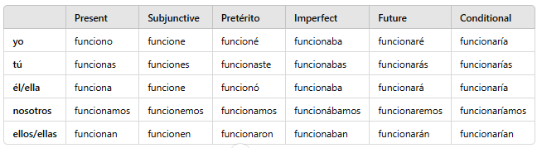

### Verb: Ganar

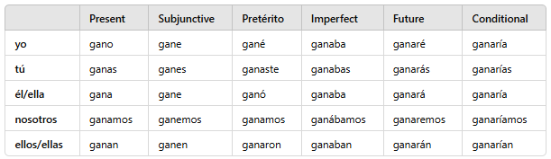

### Verb: Pagar

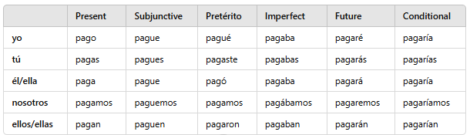

Understanding Funcionar

* means “to function” but modern english is “to work” as in proper function not labor

Understanding Ganar

* means “to win” or “to earn” like a competition or earning money

Understanding Pagar

* means “to pay”
* **RULE**: if you refer to who you’re paying or what you’re paying for; if using both, use Indirect Object + por #1
* **RULE**: but if you paying for something but not mentioning WHO you’re paying it to, DONT USE por

Examples - Funcionar

1. This isn’t working, we need another plan. → Esto no está funcionando, necesitamos otro plan.
2. This has to work, it was seven million dollars. → Esto tiene que funcionar, fueron siete millones de dólares.
3. The plan didn’t work, so my coworker helped me. → El plan no funcionó, así que mi compañero de trabajo me ayudó.

Examples - Ganar

1. I know he likes doing it, but I don’t think he’ll earn anything. → Sé que le gusta hacerlo, pero no creo que gane nada.
2. The captain is making millions of pesos. → El capitán está ganando millones de pesos.
3. He wants me to win the game, but you already won. → Él quiere que yo gane el juego, pero tú ya ganaste.

Examples - Pajar

1. I’ll pay him for his work. → Le pagaré por su trabajo.
2. He left without paying for the car. → Se fue sin pagar el carro.
3. Use your money and pay for the food! → ¡Usa tu dinero y paga la comida!
4. He will pay, because I don’t want to pay. → Él pagará, porque yo no quiero pagar.
5. He has already paid sixty-five million dollars. → Ya ha pagado sesenta y cinco millones de dólares.

## Ep 226: How to say “get” in Español

### Verb: Conseguir

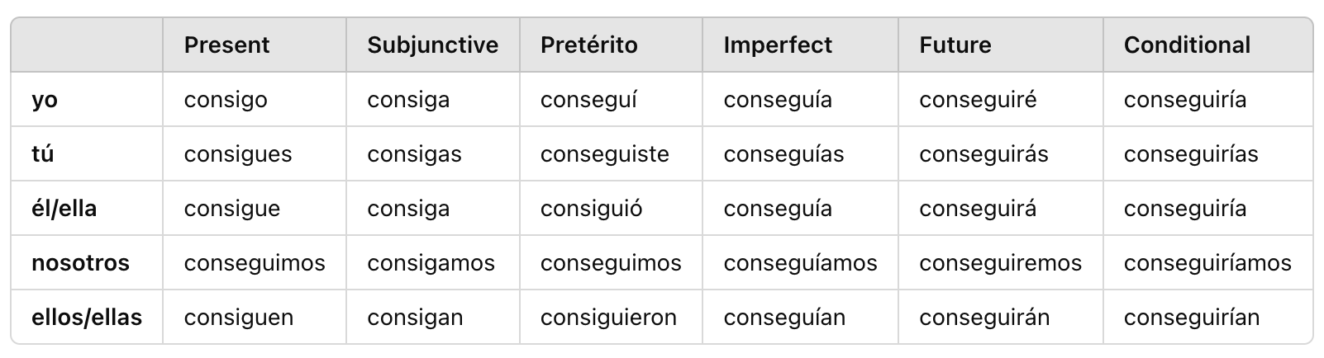

### Verb: Usar

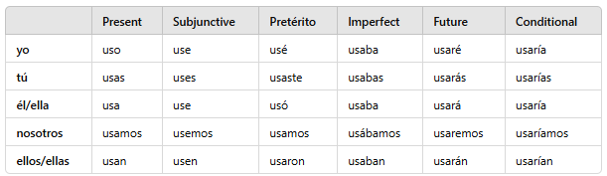

Understanding Ways to say “Get”

* consiguir: means “**to acquire**” or “**to get**” which is normal English; this is an active verb #1
* note, there are nuances like “I get to *do it* every day” which uses **poder** to say *I am able to do it*
* Imperatives: Get ← Consigue |

Understanding Usar

* means “to use”
* **RULE**: when you use something as something else, drop the article ← lo uso como carro *i use it like a car*
* **RULE**: also como can be dropped and replaced with “de” #3

Examples - Conseguir

1. She gets a new car every three years. → Consigue un auto nuevo cada tres años. *actively acquiring car NOT receiving it*
2. He got money working with his friends. → Consiguió dinero trabajando con sus amigos.
3. I don’t think she’ll get the car, but she has to get it. → No creo que consiga el auto, pero tiene que conseguirlo.

Examples - Usar

1. I’ll use this as an example. → Usaré esto como ejemplo.
2. She doesn’t use it much. → No lo usa mucho.
3. She used it before I used it. → Ella lo usó antes de que yo lo usara.

Week 42: Lessons 221 - 225

Tips

* past tense vacation uses fueron because its plural
* you dont “miss your flight” you lose your flight #5 vacation
* my **own** food: mi **propia** comida

Words

* orgulloso(a): proud (adj) (or-guu-yoh-soh)
* dos mil: two thousand
* cuarenta y tres mil: 43 thousand
* millón: million
* mil millones: billions
* abogado(a): lawyer
* detective(a): detective
* capitán(a): captain
* sargento: sargeant
* soldado: soldier
* compañeros(as) de trabajo: coworker
* dueño(a): owner
* propia: own (something that is yours)

Idioms

* igual que: the same way
* hacer una fila: standing in line ← ¿Estas haciendo fila?
* miles y miles: thousands and thousands
* Nos encontramos en: we ran into each other *at the store*
* de **mi** mismo(a): of myself
* de si mismo(a): of him/herself
* de si mism**os**: of themselves

## Ep 224: Las Vacaciones

Understanding Professions

* do not use “article” with professions ← Mi hermano es abogado en esa compañía
* ROLE IN COMPANY: when describing a role like someones position, we can use “papel” or “puesto de”

Examples - Professions

1. My mother is a captain in the army. → Mi madre es capitana del ejército.
2. The captain of the ship got sad. → El capitán del barco se puso triste.
3. Here come the sergeant and his soldiers. → Aquí vienen el sargento y sus soldados.
4. His sergeant(f) is going to need a good lawyer. → Su sargenta va a necesitar un buen abogado.
5. The detective(f) says that one piece of evidence suffices. → La detective dice que una prueba basta.
6. How long has this soldier been in his role? → ¿Cuánto tiempo lleva este soldado en su papel?
7. How long has he been in his position as a detective? → ¿Cuánto tiempo lleva en su puesto de detective?

Examples - Associates

1. His classmate(f) is the owner of two cars. → Su compañera de clase es dueña de dos autos.
2. I don’t know my coworkers. → No conozco a mis compañeros de trabajo.
3. Her cousin isn’t honest with her. → Su primo no es honesto con ella.

Examples - Vacations

1. Are you here for business or on vacation? → ¿Estás aquí por negocios o de vacaciones?
2. We ran into each other at the airport. → Nos encontramos en el aeropuerto.
3. Our vacation was thousands of dollars. → Nuestras vacaciones fueron miles de dólares.
4. It hasn’t been my turn to go on vacation. → No me ha tocado ir de vacaciones.
5. The traffic was so bad we almost missed our flight. → El tráfico era tan malo que casi perdimos nuestro vuelo.
6. Don’t touch that car! → ¡No toques ese carro!
7. Let’s not take a taxi or a bus, there’s a lot of traffic. → No tomemos ni un taxi ni un autobús, hay mucho tráfico.

## Ep 223: Hablando de millones

Understanding Million - millón

* tends to be used with a “de” after it BUT NOT when there is a number after
* Ex: It was a million years later. → Fue un millón de años después.
* Ex: They have five million one hundred thousand dollars. → Tienen cinco millones cien mil dólares. *no “de” here because of number*

Understanding New Gerunds

* Current gerunds have been used like ESTAR to indicate continuous actions or verbs like TERMINAR y SEGUIR that are often followed by gerunds
  + They were walking by foot. → Estaban andando a pie.
  + They keep passing. → Siguen pasando
  + He wanted to be a nurse, but he ended up being a doctor. → Quería ser enfermero, pero terminó siendo médico.
* **Gerunds:** can also **act almost like an adverb** as well ie used as additional information in a sentence much like an afterthought | normally used **with a comma**
  + Simple: Ella lo hizo
  + Simple + Adverb: Ella lo hizo ayer | Ella lo hizo rápido
  + Simple + Preposition: Ella lo hizo en la noche
  + Simple + Gerund: Ella lo hizo pasando por mi casa
  + Ex: Being honest, I don’t want them to be here. → Siendo honesto, no quiero que estén aquí.

Examples - Thousands

1. One thousand six hundred and sixty-six. → Mil seiscientos sesenta y seis.
2. They have nine hundred and three thousand. → Tienen novecientos tres mil.
3. There are one thousand four hundred and sixteen cats. → Hay mil cuatrocientos dieciséis gatos.
4. There will be twenty-three thousand five hundred. → Habrá veintitrés mil quinientos.

Examples - Millions

1. Seven million dollars. → Siete millones de dólares.
2. One million five hundred thousand. → Un millón quinientos mil.
3. There are sixty million kinds. → Hay sesenta millones de tipos.

Examples - Billions

1. Two billion forty-five million. → Dos mil cuarenta y cinco millones.
2. One billion five hundred million. → Mil quinientos millones.

Examples - Gerunds

1. She was there, talking to your friends. → Estaba ahí, hablando con tus amigos.
2. Being honest(f), I don’t love them. → Siendo honesta, no me encantan.
3. They were under the rain, looking at the trees. → Estaban bajo la lluvia, mirando los árboles.
4. He was at home, waiting for the storm to leave. → Estaba en casa, esperando que se fuera la tormenta.

## Ep 222: Gustar vs Encantar vs Amar

### Verb: Encantar

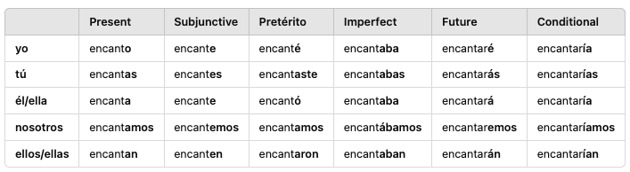

### Verb: Bastar

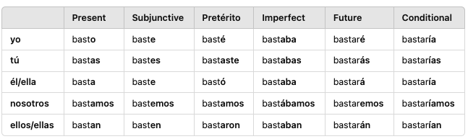

Understanding Encantar *dont confuse w/* ***Encontrar*** *ie to meet/find/encounter*

* means “to enchant” or “very very pleasing” and uses **indirect** objects like gustar/importar;
* **NOTE**: can act as a stronger synonym to gustar; can also mean “to love” but for an inanimate object not a person
* **NOTE**: so be careful about using verb because its like gustar where its NOT reflexive; so *she loves them ← to she they are loved ← le encantan*

Understanding Bastar

* means “to be enough” or “to suffice” | not used frequent except for the form “basta” which means *stop or enough*
* **FORMAT RULE**: format sentence with Indirect + Bastar + subject (like Faltar)
  + ONLY when using indirect objects
* **RULE**: bastar + para is used to say “to do the trick” #1
* idiomatically used to say something like “this would do the trick” or being satisfactory or fulfilling a purpose correctly
  + Ex: This food will do the trick for her. → Esta comida le bastará.

Examples - Encantar

1. I love dogs, but my brother doesn’t like them. → Me encantan los perros, pero a mi hermano no le gustan.
2. She has loved those movies since she was a kid. → Le han encantado esas películas desde que era niña.
3. She wants me to play those songs because she loves them. → Quiere que toque esas canciones porque le encantan.
4. She would love not only those phones, but also those things. → Le encantarían no solo esos teléfonos, sino también esas cosas.
5. Can you play something for us? I think she is going to love it. → ¿Puedes tocar algo para nosotros? Creo que a ella le va a encantar.

Examples - Bastar

1. Would this be enough to shut them up? → ¿Esto bastaría para callarlos? *idiomatically*
2. Three hours are enough for her. → Le bastan tres horas.
3. That food will suffice for the party. → Esa comida bastará para la fiesta.
4. That food was enough for them when they were next to that building. → Les bastaba esa comida cuando estaban junto a ese edificio.
5. One piece of advice would do the trick for you in order to reach your dream. → Un consejo te bastaría para llegar a tu sueño.

## Ep 221: Sonar, Doler, Tocar

### Verb: Sonar

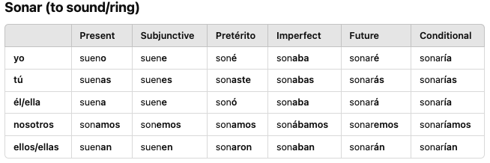

### Verb: Doler

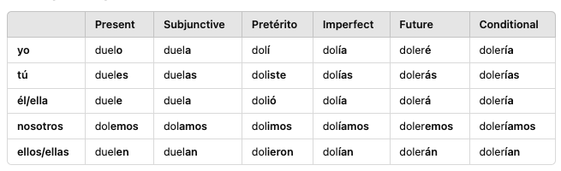

### Verb: Tocar

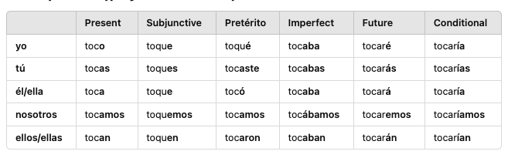

Understanding Sonar

* means “to sound” and to sound good we use “bien” | can be used idiomatically like “*do those plans* ***sound*** *good?*” but **parecer is more commonly used** there
* also means “ring/beep” like when a telephone rings
* **RULE**: do not confuse with soñar which is “to dream”

Understanding Tocar

* means “to touch” or “to play” for instruments | also used idiomatically “to take turns” doing something #1
* **Idiomatic**: “to take turns” **NOT REFLEXIVE** but uses indirect object + **toca** *normally* or conjugate it; meaning “touches yourself to do xyz” #1

Understanding Doler

* means “to hurt” and uses **indirect** object without a direct object much like gustar/importar
* **RULE**: start sentence with verb then the object that is hurting (like Faltar)
* **NOTE**: although we can use “hacerle daño” to mention hurting someone BUT this verb focuses more on **when someone is feeling pain**

Examples - Sonar

1. His telephone rang in the middle of the meeting. → Su teléfono sonó en medio de la reunión.
2. Why does your phone keep ringing? → ¿Por qué tu teléfono sigue sonando?
3. Your phone rang an hour ago. → Tu teléfono sonó hace una hora.
4. We have to be strong in the face of trouble, does it sound good? → Tenemos que ser fuertes ante los problemas, ¿suena bien?

Examples - Tocar

1. It’s your brother’s turn to do this homework. → Le toca a tu hermano hacer esta tarea.
2. Play something for us! → ¡Toca algo para nosotros!
3. Their mom doesn’t want them to touch that. → Su mamá no quiere que toquen eso.
4. It hasn’t been my turn in a while. → No me ha tocado en un tiempo.
5. It’s your turn to go to the building opposite this one. → Te toca ir al edificio en frente a este.
6. Okay, my turn now → Vale, ahora me toca a mí.

Examples - Doler

1. Today my head is hurting me. → Hoy me duele la cabeza.
2. What she said yesterday hurts us a lot. → Lo que dijo ayer nos duele mucho *Figurative*
3. His leg will hurt him if he goes to the sea. → Le dolerá la pierna si va al mar.
4. Apparently, it didn’t hurt her when they were at the lake. → Al parecer, no le dolió cuando estaban en el lago.

Week 41: Lessons 216 - 220

Tips

1. We’re very sorry he doesn’t live here anymore ← Lamentamos que el ya no viva aqui (live is subjunctive)
2. …so that he tries the food ← para que el pruebe (para que will trigger subjunctive for tries)
3. Dont you realize that I’ve already started ← No te das cuenta de que yo ya empecé (I’ve != I have && started == preterite)
4. Why dont you try coming with us ← coming == infinitive form
5. Because he loves nature ← porque le encanta la naturaleza
6. Tenemos que hacerlo antes de que empiece a salir el sol ← the sun starts to come out (starts==subj && *starts to leave the sub* )
7. I think I’m starting to hate it ← Creo que yo empiezo a odiarlo (starting==present)
8. **He’s very sorry that you’ve had to do ← Lamenta que hayas tenido que hacer**
9. We’ll do it when he starts giving us all ← Lo haremos cuando él empiece **a** darnos
10. I like going to the beach **more** ← Me gusta **más** ir a la playa (put in beginning)
11. I’m very sorry that we haven’t been able to see ← …no hayamos podido ver *could*
12. General
    1. Don't forget the “a” after Start + infinitive ← Start doing it (Empiece a hacerlo)
    2. Sorry + have to ← uses *haber* verb subjunctive form a lot *Lamenta que hayas*
    3. because she saves them ← porque ella los salva (them she saves)
    4. There is going **to be** ← Va a **haber**
    5. Nobody is going to save you → Nadie te va a salvar
    6. we start fighting because of that ← a pelear por eso

Words

* probado: tried, tasted, tested
* probando: trying, tasting, testing
* preuba: trail/test (prew-eh-bah)
* naturaleza: nature (natura-lez-kha) **add article**
* planta: plant
* árbol: tree
* la rama: the branch
* bosque: the woods
* río: river
* lago: lake
* sol: sun
* luna: moon
* el mar: the sea
* isla: island
* los dias con sol: sunny days
* frente a: facing or opposite (ADV)
* junto a: next to (ADV)
* al lado de: beside (ADV)
* sino: but rather

Idioms

* hora tras hora: hour after hour
* andar tras: going after/following (love)
* **ante: in the face of**
* un solo(a): just one
* un solo lugar: just one place
* una sola noche: just one evening
* al parecer: apparently (to the seem)
* el tiempo: weather
* lluvia: rain
* la nieve: the snow
* tormenta: storm

## Ep 219: La Naturaleza

Examples

1. I like to spend time in nature. → Me gusta pasar tiempo en la naturaleza.
2. There aren’t many plants around my house. → No hay muchas plantas alrededor de mi casa.
3. The trees here are different from ours. → Los árboles aquí son diferentes de los nuestros.
4. She started to like nature a long time ago. → Le empezó a gustar la naturaleza hace mucho tiempo.
   1. *Remember: gustar “to be pleasing to” and needs “Le” for* ***to her*** *and “gustar” for*
5. She tries all the plants that she sees to see if she can eat them. → Prueba todas las plantas que ve para ver si las puede comer.
6. I want him to save the girl I love, she is in the sea. → Quiero que él salve a la chica que amo, está en el mar.

## Ep 218: Sino vs Pero

Understanding final prepositions and conjugations

* tras: means “after” or “behind” | *note: we have words for after/behind specifically adverbs paired with prepositions (después + de) or (detrás de)* 
  + used less often but used for idiomatic phrases
  + Idiom Ex: He’s going after a girl who doesn’t love him. → Anda tras una chica que no lo ama.
    - meaning: something like *following* or *hot on the heels*
  + Idiom Ex: She keeps doing it, hour after hour, without success. → Lo sigue haciendo, hora tras hora, sin éxito.
* ante: means “before” or “in front of” or “in the face of” | this means more like in front of vs before in that sense
  + Ex: We sat down before the king → Nos sentamos ante el rey
  + Ex: We need to do something in the face of all these problems. → Necesitamos hacer algo ante todos estos problemas.

Understanding Adverbs (need preposition)

* **Notes**: always paired with prepositions to make a prepositional phrase
* junto: means “next to” | already learned juntos
  + Ex: It’s in my room next to my bed. → Está en mi habitación junto a mi cama.
* al lado de: means “beside”
* frente a: means “facing” or “opposite”
  + Ex: She lives in the building opposite my house. → Vive en el edificio frente a mi casa.

Understanding Salvo

* means “except” when used as a preposition | dont confuse w/ save (salvar)
  + Ex: All of my friends came except Juan. → Todos mis amigos vinieron salvo Juan.
* a salvo: means “safe” (noun) | literal: to safeness
  + Ex: It’s OK, now she’s safe. → Está bien, ahora está a salvo.
  + Ex: I know that my daughters are safe. → Sé que mis hijas están a salvo.
* means “safe” as an adjective (**gender**) | happens when NOT used with estar before it
  + Ex: My dog is at home, safe and happy. → Mi perro está en casa, salvo y feliz.
  + NOTE: although seguro means safe, it is used for a place that is secure, not someone's condition
  + NOTE: normally this form is used when there is a phrase used before it

Understanding Final Conjunctions

* mas: means “but” | not used often except in formal or literary context
* sino: means “but rather” |
  + RULE: although “pero” can be used, it connects two entire clauses or phrases that can be entire sentences by themselves;
  + Ex: He isn’t a friend but rather an enemy. → No es un amigo sino un enemigo.
  + Ex: We didn’t go to my hometown but to the city. → No fuimos a mi pueblo sino a la ciudad.

Examples: tras y ante

1. She knows what to do in the face of doubt. → Sabe qué hacer ante la duda.
2. The color before you is really pretty. → El color ante ti es muy bonito.
3. In the face of trouble, you have to be strong. → Ante los problemas, tienes que ser fuerte.
4. She is going after her dreams. → Anda tras sus sueños.

Example: junto a, al lado de, and frente a.

1. She sat next to her friend. → Se sentó junto a su amigo.
2. (Formal) Start working with the one that is opposite you. → Empiece a trabajar con el que está frente a usted.
3. The hospital is beside the school. → El hospital está al lado de la escuela.
4. You can save the dog that is beside that building. → Puedes salvar al perro que está al lado de ese edificio.
5. She tries the food next to that table. → Prueba la comida junto a esa mesa.

Examples: Salvo

1. My dog is safe. → Mi perro está a salvo.
2. I want everything except the last one. → Quiero todo salvo el último.
3. She got home, safe and calm. → Llegó a casa, salva y tranquila.
4. Everyone was here, except Juan. → Todos estaban aquí, salvo Juan.
5. You’ll be safe here. → Estarás a salvo aquí.

Examples: Idioms

1. Apparently she didn’t know where she was going. → Al parecer ella no sabía adónde iba.
2. Can we have both parties in just one evening? → ¿Podemos tener las dos fiestas en una sola noche?
3. Apparently, she wanted just one example. → Al parecer, quería un solo ejemplo.
4. He wants me to start with just one task. → Quiere que empiece con una sola tarea.

## Ep 217: Salvar, Odiar, Lamentar

### Verb: Salvar

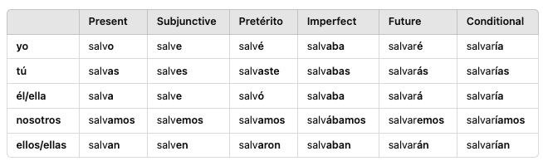

### Verb: Odiar

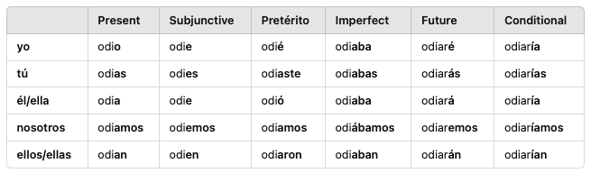

### Verb: Lamentar

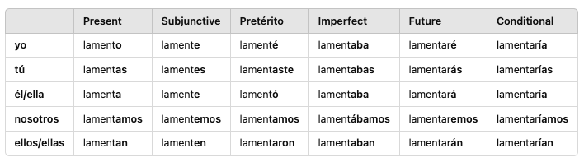

Understanding Salvar

* means “to save” | ie. like “to rescue” not save money (ahorrar)
* Imperatives: salve (formal), salva, salven, salvemos
* **RULES**: when talking about saving someones life, use person as indirect object + la vida #1
* **RULES**: reflexively used to “being saved” #4

Understanding Odiar

* means “to hate” | most common form is “odio” ← I hate

Understanding Lamentar

* means “to lament” or “to be very sorry”
* used mainly to express sorrow, condolences or regret; mainly ONLY **lamento** is used

Examples - Salvar

1. They saved her life. → Le salvaron la vida.
2. His policy saved the majority of the people. → Su política salvó a la mayoría de las personas.
3. I’m a doctor (f) and I save lives, I’ve saved a lot of people. → Soy doctora y salvo vidas, he salvado a mucha gente.
4. We were saved from the danger. → Nos salvamos del peligro.
5. He wasn't saved from his mom because he didn’t do the homework. → No se salvó de su mamá porque no hizo la tarea.

Examples - Odiar

1. I hate that they always do that. → Odio que siempre hagan eso.
2. She used to live there, but she hated it. → Ella vivía allí, pero lo odiaba.
3. Let’s start doing this before he hates us. → Empecemos a hacer esto antes de que él nos odie.
4. I’m sure he’d hate having that doubt. → Estoy seguro de que él odiaría tener esa duda.
5. Try that food. I used to hate it too before, but not anymore. → Prueba esa comida. Yo también la odiaba antes, pero ya no.

Examples - Lamentar

1. He's so sorry you have been sick(f). → Lamenta mucho que hayas estado enferma.
2. I’m so sorry we can’t go today. However, we’ll come back soon. → Lamento que no podamos ir hoy. Sin embargo, volveremos pronto.

## Ep 216: Empezar y Probar

### Verb: Empezar

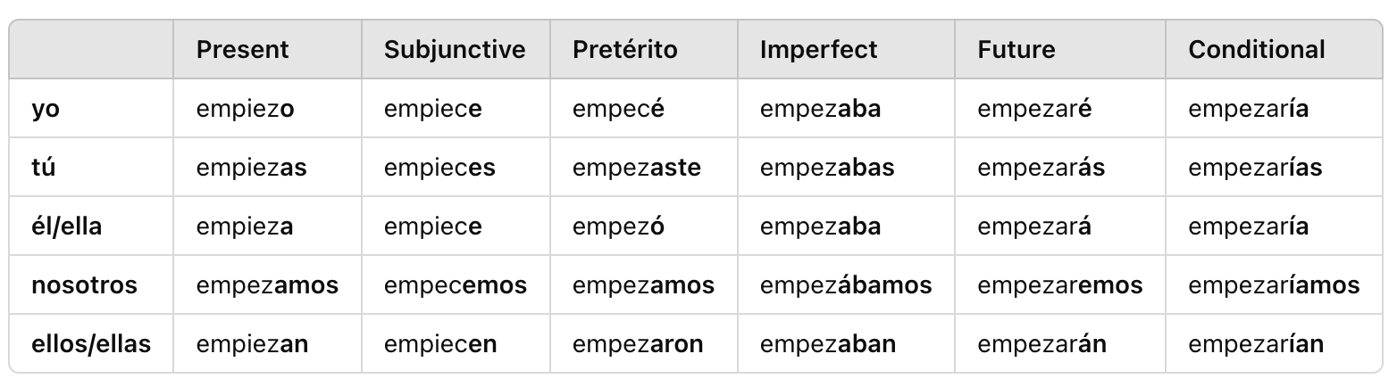

### Verb: Probar

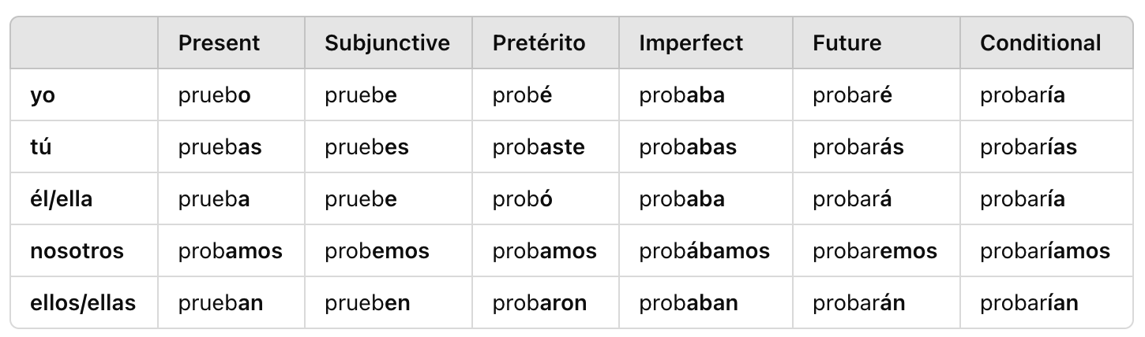

Understanding Empezar

* means “to start” or “to begin”; verb has irregular spellings
* **LANGUAGE RULE**: in spanish the letter Z only occurs before A, O, U but turns to C when its before I or E
* **RULE**: to talk about starting to do something, use “Empezar + a + infinitive”

Understanding Probar

* multiple meanings:
  + “to try” but nuanced for ***giving something a try***
  + “to test” or “to sample”
  + “to taste”

Examples - Empezar

1. She starts to work at five. → Ella empieza a trabajar a las cinco.
2. Don’t start until I tell you the color! → ¡No empieces hasta que te diga el color!
3. Tell us your name before starting. → Dinos tu nombre antes de empezar.

Examples - Probar

1. I want to try this food; I had never tried it before. → Quiero probar esta comida, nunca la había probado antes.
2. She is trying that food for the first time. → Está probando esa comida por primera vez.
3. She hasn’t tried this, so she wants to know what it is before trying it. → No ha probado esto, entonces quiere saber qué es antes de probarlo.
4. You’re trying to be here on time, why don’t you try with the train? → Tratas de estar aquí a tiempo, ¿por qué no pruebas con el tren?

Week 40: Lessons 211 - 215

Tips

* aqui tienes, lo tengo para ti: here you go, i got it for you

Words

* Cállate: Shut Up!
* Cállense: Shut Up! (plural)
* pelea: fight (noun)
* 161: Ciento sesenta y uno
* 100+: Cien, doscientos, trescientos, cuatrocientos, quinientos, seiscientos, setecientos, novecientos
* estado: state/condition (noun)
* puesto: position (more for something more established like a job title)
* posición: position (more for opinions/temporary locations)
* tamaño: size (noun)
* mayoría: majority (sometimes the word “most” is used)
* pareja: couple (two people)
* par: couple (a couple of x)
* la base: the base or basis (foundational aspect) | bah-say
* sonido: sound (positive feeling)
* ruido: noise (negative feeling) (noun)
* ruidoso(a): noisy (adjective)
* el tema: the theme/topic
* duda: doubt
* las ganas: desires/willingness (normally plural)
* red: net/network
* política: politics/policy (dont make it plural)
* sin embargo: however or nevertheless
* aleatorio(a): random (al-eah-tor-io)

Idioms

* por ciento: percent
* en base a: based on

## Ep 214: Color, tamaño, posición

Understanding New Nouns

* when asking about the state/condition, use “**Cual**” #1
* duda is commonly used, especially when someone is giving instructions and want to confirm you understand; almost like saying “do you have any questions” #13

Understanding Ganas

* normally always plural
* the general idea of “feeling like” something or “eagerness to do” is translated as *tener ganas*
* **STRUCTURE**: Tener + ganas + de + infinitive ← Tengo ganas de correr (running)

Examples

1. What was the state of the room when you left? → ¿Cuál era el estado de la habitación cuando te fuiste?
2. We don't know the position of the enemy. → No sabemos la posición del enemigo.
3. I don’t know what it’s called, but I know its size and color. → No sé cómo se llama, pero sé su tamaño y color.
4. The majority of our friends don’t agree. → La mayoría de nuestros amigos no están de acuerdo.
5. A couple of boxes → Un par de cajas
6. I didn’t realize that they were a couple. → No me di cuenta de que eran pareja.
7. There’s a problem with the base of the house. → Hay un problema con la base de la casa.
8. Based on what he said, I think we should stay. → En base a lo que dijo, creo que deberíamos quedarnos.
9. That sound that you hear is their conversation. → Ese sonido que escuchas es su conversación.
10. I think you're making too much noise. → Creo que estás haciendo demasiado ruido.
11. Sometimes I can’t sleep, for example when there’s a lot of noise. → A veces no puedo dormir, por ejemplo cuando hay mucho ruido.
12. I was sure yesterday, but now I have doubts. → Ayer estaba segura, pero ahora tengo dudas.
13. Is everything clear, or do you have any doubt? → ¿Está todo claro o tienes alguna duda?
14. Stop talking about politics. → Deja de hablar de política.
15. This is our policy; however, we don’t have to do it if everyone doesn’t agree. → Esta es nuestra política, sin embargo, no tenemos que hacerlo si todos no están de acuerdo.

Examples: Ganas

1. ​​He wanted to eat there, but I didn’t feel like it. → Él quería comer allí, pero yo no tenía ganas.
2. Do you feel like going to the party with me? → ¿Tienes ganas de ir a la fiesta conmigo?

## Ep 213: Cien vs ciento vs cientos

Understanding 100+

* when using alone just use *cien* but when combining number use *ciento + number*
  + Ex: There were 150 people → Había ciento cincuenta personas
* Two hundred (doscientos) | Three hundred (trescientos)
* Rule for 500: quinientos *kind of like quince ie 15*
* Gender Changes: after 200, numbers MUST agree with noun, doscientos → doscientas

Examples

1. I have seven hundred dollars and you have six hundred and seventy-seven. → Tengo setecientos dólares y tú tienes seiscientos setenta y siete.
2. My brain can’t come up with anything except the number two hundred and twenty-five. → A mi cerebro no se le ocurre nada excepto el número doscientos veinticinco.
3. There are hundreds of places like this one. → Hay cientos de lugares como este.

Examples: Idioms

1. This food is fifty percent water. → Esta comida es cincuenta por ciento agua.
2. The new house is three hundred percent bigger. → La nueva casa es un trescientos por ciento más grande.

## Ep 212: Temer, Pelear

### Verb: Pelear

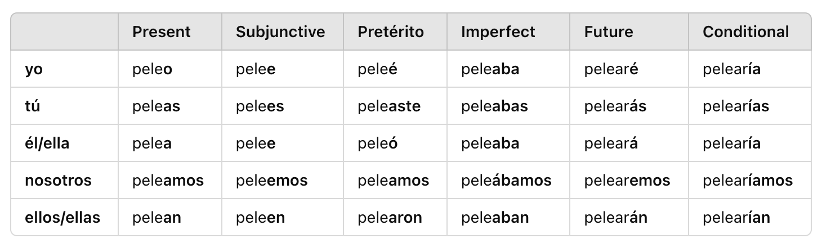

### Verb: Temer

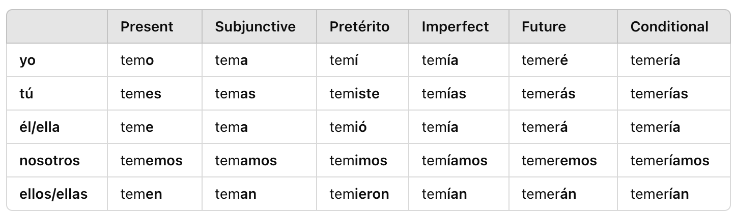

Understanding Pelear

* means “to fight”
* **RULE**: you dont fight “about” something, you fight for “por” something

Understanding Temer

* means “to fear”
* **REMEMBER**: two ways to talk about fear (1) Temer (2) Tener + miedo
* **RULE**: “to be afraid of” something ← tener miedo | “to fear” something in a more formal way ← Temer

Understand Temer (Regret - Unsure of Something)

* can be used as well to express that you’re afraid something might not be true
* **RULE**: this is only when you’re not sure which is why this MIGHT be the case
  + Uses Temer + subjunctive

Understanding Temer (Reflexive)

* means: used to express regret over what is being communicated to another person
* Format: *I’m afraid that* xyz… | DOES NOT TRIGGER SUBJUNCTIVE

Examples Temer

1. Do you fear death? → ¿Temes la muerte?
2. Are you afraid of the future → Tienes miedo del futuro?
3. He fears losing his hair. → Teme perder el pelo.
4. Her brain tells her she must fear you. → Su cerebro le dice que te debe temer.
5. I feared that before, but he doesn’t want me to fear. → Temía eso antes, pero él no quiere que tema.

Examples Temer (Reflexive)

1. We’re afraid that we can’t do that → Nos tememos que no podemos hacer eso.
2. I’m afraid that I cant help you → Me temo que no puedo ayudarte.
3. They are afraid that this medicine won’t be good for your nose. → Se temen que esta medicina no será buena para tu nariz.

Examples Temer (Reflexive + True Unsurity) - Subjunctive

1. I fear that she will fight. → Temo que ella pelee.
2. He fears that he’ll have a heart attack. → Teme que tenga un ataque al corazón.

## Ep 211: Faltar y Callar

### Verb: Faltar

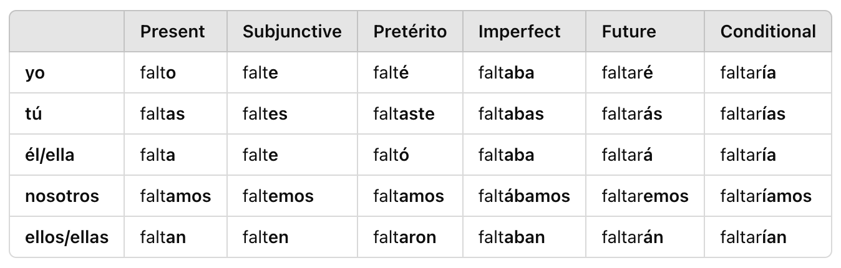

### Verb: Callar

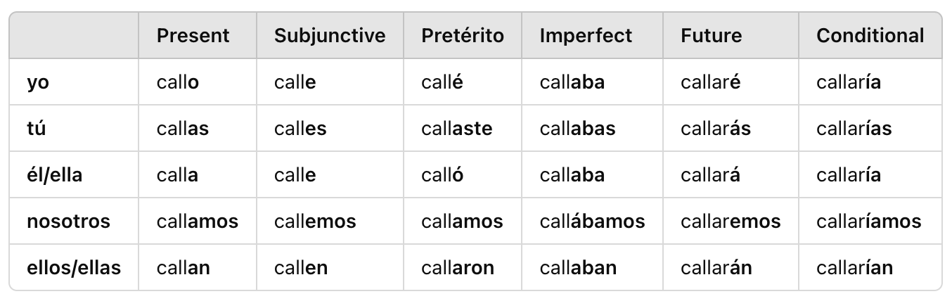

Understanding Faltar

* means “to lack” or “to be missing”
  + missing: a presence is needed
  + lack: object is missing something it needs
* **RULE**: past tense uses the imperfect form more often
* **FORMAT RULE**: Missing are three people → Three people are missing (DROP ARE)
  + Faltan tres personas
* **RULE**: when using “**to lack**” or when object needs more of something, it requires an INDIRECT OBJECT
  + The food lacks salt → A la comida le falta sal
    - **Literal**: *to the food to it lacks salt*
* **IDIOM**: remember *hacerle falta* means “in need of” something so we can use this #2

Understanding Callarse

* means “to shut up” and mainly used in its imperative form
* Imperativo: Callate! | Non-Imperative: se calle

Examples of Faltar

1. The dog is missing some hair → Al perro le falta algo de pelo
2. The food is in need of salt → A la comida le hace falta sal
3. My friends are missing those books → A mis amigos les faltan esos libros
4. A doctor is lacking and that’s why they are sick. → Falta un médico y por eso ellos están enfermos.
5. My brother was missing some things when he returned to his house. → A mi hermano le faltaban algunas cosas cuando volvió a su casa.
6. We’re missing one person. I hope next time we’re not in need of anyone. → Nos falta una persona. Espero que la próxima vez no nos haga falta nadie.

Examples of Callarse

1. Can you shut up? I don’t want to hear anything else about your hair. → ¿Puedes callarte? No quiero oír más nada sobre tu cabello.
2. I want him to shut up and you also to shut up. → Quiero que él se calle y que tú también te calles.
3. Everyone has shut up because he said he didn’t like medicine. → Todos se han callado porque él dijo que no le gustaba la medicina.

Week 39: Lessons 206 - 210

Note Tips

* She has long hair ← Tiene **el** pelo large *must use the hair*
* But he is fine now ← pero ya esta bien *ya also means now*
* I love medicine ← amo la medicina *use article*
* ejército ← air-hair-see-toh
* sentir**se** mejor: make himself feel better

Tips

* Me estuve molestando: i was getting annoyed
* se quejó demasiado: he complained too much (kay-ho)
* quejándose: complaining (key-han-doh-say)
* "Se" is an impersonal pronoun, which makes statements more general and not directed at a specific person.

Words

* durmiendo: sleeping
* amando: loving
* dormido: slept
* amado: loved
* la salud: health
* enfermo: sick (adjective)
* la enfermedad: sickness, illness, disease (noun)
* enfermero(a): nurse
* médico(a): doctor
* la medicina: medicine
* cerebro: brain
* alma: soul
* el brazo: the arm
* la pierna: the leg
* la frente: forehead | Note: el frente means the front (DONT CONFUSE)
* la nariz: the nose
* el oído: the ear (referring to what people use to hear) #5
* la oreja: the ear (the visible part of external ear) #6 (oh-reh-hah)
* una voz: a voice
* pelo: hair (universal)
* cabello: hair (in context of how the hair is styled)
* ataque al corazón: heart attack
* la piedra: the rock

Idioms

* desde el alma: from his soul

## Ep 209: El cuerpo y la salud

Understanding Current Body Parts (Known)

* cuerpo, cabeza, mente, cara, ojo, boca, corazón, mano, and pie.
* body head mind face eye mouth heart hand foot

Understanding New Body Parts

* alma: means *soul* and feminine but can be paired with article “el” ← Do you believe in the soul? → ¿Crees en el alma?
* alma: also can be used idiomaically with “desde” when saying *from your soul*
* voz: to say someone has “a loud voice” use the *muy fuerte*
* ataque al corazón: means “heart attack” but
  + **Past/Gerund Tense**: if someone had one the phrase is “it gave him a heart attack” #10

Examples

1. She didn’t come because she was sick. → Ella no vino porque estaba enferma. (adj)
2. The sick women wanted to talk about their sickness. → Las mujeres enfermas querían hablar de su enfermedad. (noun)
3. He doesn’t come up with anything for having good health. → No se le ocurre nada para tener buena salud.
4. My dad takes his medicine in the evenings. → Mi papá toma su medicina por las noches.

Examples Body Parts

1. I don’t know what happened to my brain today. → No sé qué le pasó a mi cerebro hoy.
2. We can’t do this to him, I feel it in my soul. → No podemos hacerle esto, lo siento en mi alma.
3. I have pain in my leg. → Tengo dolor en la pierna.
4. You have something on your arm. → Tienes algo en el brazo.
5. You didn’t hear the music? It didn’t reach your ears? → ¿No escuchaste la música? ¿No llegó a tus oídos?
6. My ears look too big in this photo. → Mis orejas se ven muy grandes en esta foto.
7. You have a lovely voice. → Tienes una voz bonita.
8. You have to change the style of your hair. → Tienes que cambiar el estilo de tu cabello.
9. I think it was a heart attack. → Creo que fue un ataque al corazón.
10. My parents are going to have a heart attack when they see this. → A mis padres les va a dar un ataque al corazón cuando vean esto.
11. He’s at the hospital because he had a heart attack. → Está en el hospital porque le dio un ataque al corazón. he it gave

## Ep 208: Ser y Estar, Advanced

Remembering Estar/Ser

* Ser: describes something or who someone is *What something is*
  + **Rule**: “to be” verb before noun + what that verb links to is noun == ALWAYS SER | Ex: My dog is my best friend → Mi perro es mi mejor amigo.
  + **Note**: If sentence starts with “My dog is…”
    - sad == Estar
    - walking home == Estar
    - at the house == Estar (the house is a noun but preposition “at” in middle
* Estar: describes where they are or how they are *How something is*
  + **RULE**: cannot use estar when describing a noun, normally w/ adjectives;
    - Except: estar + bueno (like food) OR someone’s subjective experience with something/someone

Helpful Tips

* SER is often used with “feliz”
* SER can be used w/ locations of events #5-7

Nuanced Situations or Ser/Estar

1. She is a happy dog: “a happy dog” is a noun so use SER *Ella es una perra feliz*
2. The dog is (SER) happy: we are describing that kind/type of dog it is in this case vs describing as a happy dog (ESTAR)
3. I want to go back to that city; I was very happy there. → Quiero regresar a esa ciudad; fui muy feliz allí.
   1. used fui instead of estuve because she was a happier person in that city; as if their whole identify was different
4. Their food is(Estar) so good! → ¡Su comida está muy buena!
   1. very common way to say this phrase due to subjective experience
5. The party is at Juan’s house. → La fiesta es en casa de Juan.
   1. location: the event has an identity where the location is tied to it;
6. The party was at my house. → La fiesta fue en mi casa. (SER location)
7. I don’t know where the event is going to be. → No sé dónde va a ser el evento.
8. That thing is done every day. → Esa cosa se hace todos los días.
   1. uses passive voice; in theory, we are talking about doing something BUT not saying anything about who’s doing it; make it reflexive *that thing does itself everyday*
   2. That was done by María. → Eso fue hecho por María.
      1. used a preterite form of fue(SER) + hecho (past-participle) to create a passive voice

Understanding Fue + Participles

* this is to create a passive voice; does not describe what someone or something is
* **RULE**: how to interpret passive as reflexive vs ser+participle? → ser+participle is more formal vs reflexive | es encontrado sounds more formal than se encuentra.

Examples: Fue + Participles

1. The dog was found on the street. → El perro fue encontrado en la calle.
2. Those things were done by María. → Esas cosas fueron hechas por María.
3. The food is made by that man every day. → La comida es hecha por ese hombre todos los días.
4. Those things will be found soon. → Esas cosas serán encontradas pronto.
5. The homework was finished last night. → La tarea fue terminada anoche.
6. The food was made by those people. → La comida fue hecha por esas personas.
7. The things will be found by them. → Las cosas serán encontradas por ellos.
8. The project will be finished by next week. → El proyecto será terminado para la próxima semana.
9. The party would be thrown if it weren’t for you. → La fiesta sería hecha si no fuera por ti.

Examples w/ Context Nuanced

1. In the next one, the person I’m talking to isn’t objectively an old person at 19, but the way they’re behaving is like an old person, so we use Estar.
   1. You might be only 19 years old, but you’re(Estar) old. → Puedes tener solo 19 años, pero estás viejo.
2. In the next one, we’re in a place that isn’t usually pretty, but today it’s pretty due to how it’s been arranged for a specific occasion.
   1. I like what you did to this place, it’s(Estar) pretty. → Me gusta lo que le hiciste a este lugar, está bonito.
3. In the next one, I don’t think of you as a tall person, but compared to when I saw you last time, you seem tall.
   1. I hadn’t seen you in years, you’re(Estar) tall! → No te había visto en años, ¡estás alto!

## Ep 207: Casar y Amar

### Verb: Amar y Casar

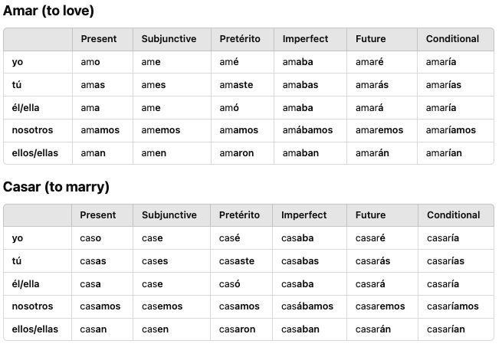

Understanding Love

* using querer is a lighter way to love someone vs amar which is more for close family members or lovers

Understanding Casar

* when someone is “officiating” a wedding or when parents marry off their kids in when you use this form
* Ex: This is where Pedro married Juan and Sofía. → Aquí Pedro casó a Juan y Sofía.

Understanding Casarse

* normally used in reflexive or pronomincal version “Casarse”
* **RULE**: use “con” + person getting married to; NOTE: two people marrying each other, dont use “con”, use se/nos #2
  + I’m marrying Santiago this month → Me caso con santiago este mes
  + We got married in that country. → Nos casamos en ese país. #2

Examples Casarse

1. He doesn’t want me to get married before finishing my degree program. → Él no quiere que me case antes de terminar mi carrera.
2. She got married in the same place that I got married. → Se casó en el mismo lugar que yo me casé.
3. He isn’t going to get married. → No se va a casar.
4. You got married in the year eighty-one. → Te casaste en el año ochenta y uno.

Examples Casar (Non-Reflexive)

1. They've married off all their children. → Han casado a todos sus hijos.

## 

## Ep 206: Ocurrir y Dormir

### Verb: Ocurrir

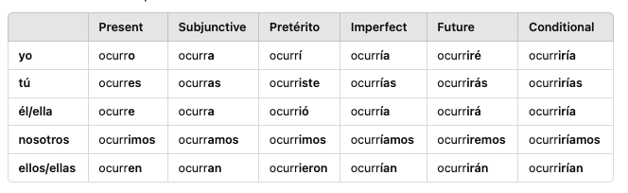

### Verb: Dormir

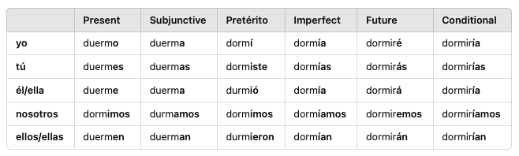

Understanding Different Ways to Say Occur/Happen

* synonyms for “to occur” as in *to happen* are **pasar, suceder** (lesson 177)
  + Estas cosas pasan a veces. | Estas cosas suceden a veces. | Estas cosas ocurren a veces.
* **Suceder** **RULE**: sentences w/ suceder, the subject goes AFTER the verb
  + Ex: Very strange things occurred yesterday. → Ayer sucedieron cosas muy extrañas.

Understanding Ocurrir

* **RULE**: used reflexively w/ “se” to mean “to come up with” or “something occurred to yourself/someone”
* **STRUCTURE RULE**: se + me/te/le/nos (to whom) + ocurrir conjugated on item occurred + item
* this specific verb can mean occur in the sense of “realizing” something happened (reflexive) even though the idiom *darse cuenta* can be used
* Ex: Something strange occurred to me. → Se me ocurrió algo extraño.
  + literal: se ocurrió → it occurred itself
* Ex: He came up with something new. → Se le ocurrió algo nuevo.
  + start with reflexive object, then indirect object “le” *to him*, then verb “ocurrió”
* Ex: The truth occurred to us. → Se nos ocurrió la verdad.

Understanding Ocurrir Reflexive (GPT)

* **Example 1: "Something strange occurred to me."**
  + Spanish: *Se me ocurrió algo extraño.*
* Structure:
  + Se – Reflexive pronoun to make it impersonal, suggesting the idea "came to" someone.
  + me – Indirect object pronoun, meaning "to me."
  + ocurrió – Past tense of "ocurrir" (it occurred).
  + algo extraño – The subject of the sentence, meaning "something strange."

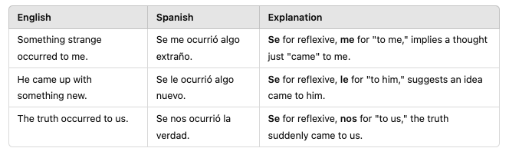

Understanding Dormir

* remember the preterite form has some stem changes similar to morir
* **RULE**: can be used reflexively to put emphasis on the action of falling asleep; Used with imperatives like *No te duermas*!

Examples Ocurrir

1. Sometimes these things occur to me a little late. → A veces se me ocurren estas cosas un poco tarde.
2. We’ll do it (f) when he comes up with that. → La haremos cuando se le ocurra eso.
3. Did you come up with something? → ¿Se te ocurre algo?
4. When he comes up with something, we can go. → Cuando se le ocurra algo, podemos ir.
5. We’re coming up with a great idea. → Se nos está ocurriendo una gran idea.
6. She’ll come up with something, don’t worry. → Se le ocurrirá algo, no te preocupes.
7. He came up with a new name with different letters. → Se le ocurrió un nombre nuevo con letras diferentes.

Examples Dormir

1. He didn’t sleep well for ninety-one nights. → No durmió bien por noventa y una noches.
2. They slept 9 hours, but you only slept 5. → Ellos durmieron 9 horas, pero tú solo dormiste 5.
3. I didn’t sleep, but on the other hand, he is still sleeping. → Yo no dormí, pero por otro lado, él todavía está durmiendo.
4. I fell asleep at the party. → Me dormí en la fiesta.
5. He always falls asleep. → Siempre se duerme.
6. I fall asleep with a book. → Me duermo con un libro.
7. He’s falling asleep, talk to him. → Se está durmiendo, habla con él.
8. They have fallen asleep listening to those lyrics. → Se han dormido escuchando esa letra.

Week 38: Lessons 201 - 205

Tips

* un consejo vs unos consejos: since you cant *give advices* this means “some advice” when plural; just like business
* 204: <https://www.learncraftspanish.com/podcast/proyecto-accidente-sorpresa>
* es importante que + subjunctive (sean) amables ← remember this triggers subjunctive
* two hours away: a dos horas
* contará: focus on o sound “own”
* Tuve que estar aquí todo el día para que su amigo (contar) contara la misma historia otra vez. (past subjunctive form)
* to be born: nacer | I was born → yo nací
* sigo confiando en ti

Words

* andando: walking, going around
* andado: walked, traveled,
* regresando:
* regresado:
* ochenta: eighty
* noventa: ninety
* cien: one hundred
* pie: foot (pee-yay)
* éxito: success/successful (**tener** + related to thing having success) (ehhx-see-toh)
* error: mistake (dont use hacer, use cometer)
* pelea: fight (pay-lea-yah)
* ataque: attack (ah-tak-kay)
* misión: mission/task/role ← large reoccurring tasks
* tarea: task/homework ← one time assignment
* carrera: career/degree/degree program
* carrera: race
* negocio: business/negotiation
* negocios: business (the act of taking care of business) #11
* reunión: meeting (F) (ray-uen-ohn)
* boda: wedding
* sorpresa: surprise
* letra: lyrics/letter (even though lyrics is plural, this is singular)
* callado: quiet/reserved (adj) (cah-yah-do)
* jubilado: retired (who-be-lado)
* **andar:** to get along, to walk, to travel by

Idioms

* de pie: standing
* esta por demas: it's needless (its by the rest)
* por otro lado: on the other hand (by the other side)
* para mi sorpresa: to my surprise
* la mayor parte de: most of the
* la mayor parte del tiempo: most of the time

## Ep 204: Proyecto, Accidente, Sorpresa

Understanding Carrera

* **career**: we use the term “es en” and normally SER isn’t followed by the preposition “en” BUT this indicates an identity of something in the something else
  + Ex: My career **is in** the government. → Mi carrera **es en** el gobierno.
* **race:** also means race (competition for speed)

Understanding Negocios

* means business but when plural, it is the act of taking care of business
* **idiomatic**: *a piece of business* (un negocio) can be used
  + Ex: I want to talk about a piece of business with them. → Quiero hablar de un negocio con ellos.
* also dont forget about asunto: What I do is not your business. → Lo que hago no es asunto tuyo.

Examples

1. He tried to do it, but he wasn’t successful. → Trató de hacerlo, pero no tuvo éxito.
2. They have been successful with most of their projects. → Ellos han tenido éxito con la mayor parte de sus proyectos.
3. I haven’t been there since the accident. → No he estado allí desde el accidente.
4. My friend and I had a fight. → Mi amigo y yo tuvimos una pelea.
5. The army didn’t know it until the attack. → El ejército no lo supo hasta el ataque.
6. In this position, my task is to help the president(f). → En este puesto, mi misión es ayudar a la presidenta.
7. Have you finished your homework? → ¿Has terminado tu tarea?
8. I’m following a different degree program. → Estoy siguiendo una carrera diferente.
9. My career is in the government. → Mi carrera es en el gobierno.
10. I can’t, I have a race that day. → No puedo, tengo una carrera ese día.
11. Come here, let’s talk about business. → Ven aquí, hablemos de negocios.
12. I want to talk about business with them → Quiero hablar de negocios con ellos
13. I have a meeting with my friends from school. → Tengo una reunión con mis amigos de la escuela.
14. I know this song, but I don’t remember the lyrics. → Conozco esta canción, pero no recuerdo la letra.
15. This word has eight letters. → Esta palabra tiene ocho letras.

## Ep 203: Count to 99

Understanding Cualquiera

* **Pronoun Form**: I don’t care, I would like whichever of those boxes. → No me importa, me gustaría cualquiera de esas cajas. | I don’t care, I would like whichever of those cars. → No me importa, me gustaría cualquiera de esos autos.
  + represents both masculine/feminine verbs; auto is masculine noun
* **Adjective Form** (after noun): I would like just any box. → Me gustaría una caja cualquiera.
  + uses indefinite article (una) + noun + cualquiera: this puts more emphasis on the fact that we dont want anything special, just a box
  + **NOTE**: Me gustaría cualquier caja. ← can be used BEFORE NOUN but less emphasis on not caring what box you get
* **RULE**: cualquiera is often used as insults to describe someone of bad character

Examples: Numbers

1. We already listened to that like eight-three times. → Ya escuchamos eso como ochenta y tres veces.
2. The ninety-one people like riding the train. → A las noventa y una personas les gusta andar en tren.
3. Don’t ever come back! She’s ninety-nine and doesn’t want to see you anymore. → ¡No regreses nunca! Ella tiene noventa y nueve y ya no quiere verte.

Examples: Cualquiera/Cualquier

1. I’d want just any table. → Quisiera una mesa cualquiera. (past subjunctive)
2. I want you to return tomorrow, not just any day. → Quiero que regreses mañana, no un día cualquiera.
3. I’d like to meet someone like that, not just any person. → Me gustaría conocer a alguien así, no a una persona cualquiera.

Examples: Idioms

1. Needless to say after that he lost his job. → Está por demás decir que después de eso perdió su trabajo.
2. On the other hand, if we go to that place, we’re going to miss the party. → Por otro lado, si vamos a ese lugar, vamos a perdernos la fiesta.
3. It’s needless to say it, but we all know she won’t come back. → Está por demás decirlo, pero todos sabemos que ella no regresará.

## Ep 202: Andar y Regresar

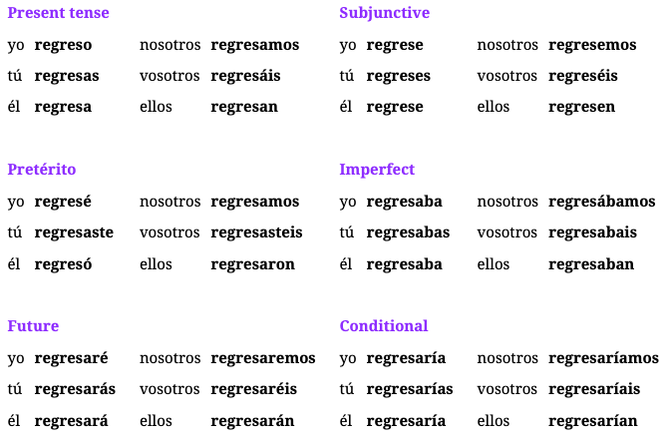

Understanding Andar Different Conjugations

* Preterite forms are conjugated like Estar

Understanding Regresar

* means “to return” but common english is “go back/comeback”
* when mentioning to return something to someone and the recipient used an INDIRECT OBJECT #7
* **RULE**: although volver means the same thing,
  + **volver** is used for repeated actions (again): We never did it again. → Nunca lo volvimos a hacer.  *{****ACTUAL****: we never returned to do it}*
    - Regresar CANNOT do this
  + **regresar** is used to return something to someone or a place; ie give back: I’m going to return the gift. → Voy a regresar el regalo.
    - Volver CANNOT do this

Examples Andar: Different Forms

1. We walked for three hours. → Anduvimos por tres horas.
2. You didn’t walk around there. → No anduviste por ahí.
3. He didn’t get along well at the party. → No anduvo bien en la fiesta.
4. They weren’t getting along well during that time. → No andaban bien durante ese tiempo.
5. I was walking by her house this morning. → Yo andaba por su casa esta mañana.

Examples Regresar

1. She always comes back home at 7. → Siempre regresa a casa a las 7.
2. She went back in order to give you the bag. → Regresó para darte la bolsa.
3. The army hasn’t come back yet. → El ejército aún no ha regresado.
4. If I come back, I don’t want them to come back. → Si regreso, no quiero que ellos regresen.
5. Come back here before your mom comes back from work. → Regresa aquí antes de que tu mamá regrese del trabajo.
6. She wants me to go back, but I don’t have to go back. → Ella quiere que yo regrese, pero no tengo que regresar.
7. I’ll return the gift to my mother. → Le regresaré el regalo a mi madre.
8. We gave the book back to them. → Les regresamos el libro.
9. You gave her back the rest of the things. → Le regresaste las demás cosas.

## Ep 201: Andar Pt.1

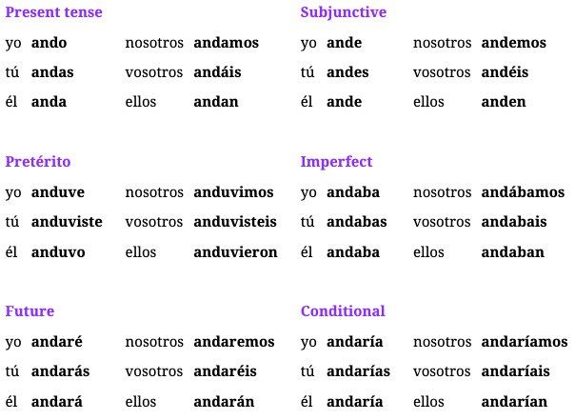

Understanding Andar

* idiomatic verb with many meanings
  + to walk/travel: needs mode of transportation
  + to go along: almost like estar ← Como andas? *How are you doing?*
* **RULE**: IR alternative; use andar when you want to specify which mode of travel you are using; often followed by *en + travel_mode* 
  + Siempre ando en tren al trabajo → *I always go by train to work*
* **RULE**: andar without “en” means you are walking by foot; you can specify with but say “a foot” *a pie* #2

Understanding Andar as Estar → “to get along”

* **RULE**: when using as “estar”, its more idiomatic, its like the act of going/geting along, like a journey or going along in life; *How are you getting along*; Its used the same way as estar #4
* In #4, its not that she is next to him at a particular moment, but rather, they are doing things together or even dating;
  + *Maria is with Juan → Maria anda con Juan*

Understanding Andar Figurative Meaning

* **RULE**: can also mean “going around/moving around” or a repeated action
* Examples
  + He is going around looking for a job → Anda buscando trabajo
  + She is going around telling lies → Anda diciendo mentiras
  + I keep thinking about you → Ando pensando en ti

Examples

1. Most of my family goes by car, but I ride the train. → La mayor parte de mi familia anda en coche, pero yo ando en tren.
2. I walk by foot when I can. → Ando a pie cuando puedo.
3. She was sitting but now she’s standing. → Estaba sentada pero ahora está de pie.
4. María is with Juan. → María anda con Juan.
5. She has gotten along fine with her new lifestyle. → Ha andado bien con su nuevo estilo de vida.
6. Are you going along with your friends? → ¿Andas con tus amigos?
7. They get along fine, but I’m not getting along fine. → Ellos andan bien, pero yo no ando bien.
8. How is she getting along? Does she like her new sword? → ¿Cómo anda? ¿Le gusta su nueva espada?

Week 37: Lessons 196 - 200

Tips

Words

* los/las dos: both
* el resto(a): the rest (left over/excluded)
* los/las demás: the rest of (when you say the rest or the other)
* cualquier: any
* cualquiera: any/whichever (as a pronoun ie any of those people) not gender based
* cámara: camera/chamber
* gobierno: government
* ejército: army
* regalo: gift
* carta: letter/card
* bolsa: bag
* estilo: style
* espalda: sword
* carne: meat/flesh
* los compañeros: the coworkers
* las meseras: the waitresses
* quédense: Stay! (plural)

Idioms

* me cambié de ropa: i changed my clothes
* cambié de idea: I changed my mind
* estar en ello: to be in it (talking about inside jokes or secrets)
* hacerle compañía: keeping someone company
* lo demás es historia: the rest is history

## Ep 199: Carta vs Tarjeta

Understanding New Word

* tarjeta: normally means plastic cards but can mean greeting card too #5

Understanding double verbs

* We can take the sentence *We need to go help him* and it can be translated or changed
  + Changed: We need to go in order to help him. → Necesitamos ir **para** ayudarlo.
    - How: add *para* to join the sentences
  + Translated: We need to go help him. → Necesitamos ir **a** ayudarlo.
    - How: add the preposition a to sentence
* what you do is conjugate the first verb, then add “a” then use the infinitive
* this happens with “Ir” and “Venir” a lot

Examples

1. My uncle was in the army during the fifties. → Mi tío estuvo en el ejército durante los años cincuenta.
2. I keep her company while she works. → Le hago compañía mientras trabaja.
3. My company works **for** the government. → Mi compañía trabaja **para** el gobierno.
4. I changed my mind, I would like a little bit of company. → Cambié de idea, me gustaría un poco de compañía.
5. He gave me a very nice card with my present. → Me dio una tarjeta muy bonita con mi regalo.
6. Does the army still have swords? → ¿El ejército todavía tiene espadas?
7. I’ll be at the dinner, but I don’t eat meat. → Estaré en la cena, pero no como carne.
8. She is always changing style. → Siempre está cambiando de estilo.
9. There is nothing left in the bag, only paper. → No queda nada en la bolsa, solo papel.

Examples: Double Verbs

1. They go do those things sometimes. → Van a hacer esas cosas a veces.
2. I’m going out to eat with my friends. → Voy a salir a comer con mis amigos.
3. She went to exchange money, but she left without it. → Fue a cambiar dinero, pero salió sin él.
4. Some of my friends are coming to play; the others are going to watch a movie. → Algunos de mis amigos vienen a jugar, los demás van a ver una película.

## Ep 198: Ello vs Eso

Understanding todo/todos y cada vs todos

* todos: means everyone ← todos están aquí (everyone is here)
* todo: everything ← todo está aquí (everything is here)
* todo/todas: all + article noun ← todos las cosas o todo la luz
* **NOTE**: sometimes *toda* can be used (rarely) for the word *every/each*
  + Every tables needs a chair → toda mesa necesita una silla

Understanding los dos

* means “both” but other word is ambos ← change based on gender
* Ex: Both guys were at the party. → Los dos chicos estaban en la fiesta.
* Ex: Which seat is mine? I’ll take both. → ¿Cuál silla es la mía? Tomaré ambas.

Understanding “the rest of”

* use “demas” is normally used; if *the rest* or *the others* is interchangeable
* use “el resto” for something left over or excluded from first thing talked about
* **NOTE**: although *the others* or *otros* is a replacement, do NOT USE when you’re talking about remaining amount of something **#5**

Understanding cualquier/cualquiera

* **cualquier**: means “any” as an indefinite adjective when right before a noun
  + Cualquier persona podría hacerlo → Any person could do it
* cualquiera: means “any/whichever” because “any” isn’t directly attached to a noun so used as a pronoun; does not change on gender
  + **Cualquiera** de esas personas podría hacerlo. → Any of those people could do it
* **RULE**: cualquiera is NOT used in negative situation, use “ninguno”
  + No tengo ninguno de esos libros. → I don’t have any of those books.

Understanding “It”

* if “it” is a preposition pronoun, match the gender to what is being described
* It’s my box; put my things in it. → Es mi caja; pon mis cosas en ella
  + how do we put things in “it”? so we need a prepositional pronoun like mi/ti/el/ellos/nosotros
  + because caja is (f) we need ella to match the gender
* **Option II**: using “ello” but rarely used
* It's not what I meant to do, but I’m happy with it. → No es lo que quise hacer, pero estoy feliz con ello.
  + when there is no noun selected, there is no gender for hello
  + we can use eso, esto, or **ello** which is new
* When he wants something, he would do anything for it. → Cuando quiere algo, haría cualquier cosa por ello.

Examples: It

1. It’s your car; you can leave your things in it. → Es tu coche; puedes dejar tus cosas en él.
2. They are the two biggest cities, but I haven’t lived in them. → Son las dos ciudades más grandes, pero no he vivido en ellas.
3. It’s something new, but I’m going for it. → Es algo nuevo, pero voy por ello.
4. She tried to do it while she had the strength for it. → Trató de hacerlo mientras tenía fuerza para ello.

Examples

1. The law says that both(m) can be here. → La ley dice que ambos pueden estar aquí.
2. She doesn’t want me to stay with both women. → No quiere que me quede con ambas mujeres.
3. I only know this house, not the rest. → Solo conozco esta casa, no las demás.
4. I have a bit of water here, but she has the rest. → Tengo un poco de agua aquí, pero ella tiene el resto.
5. These are different from the other ones we saw yesterday. → Estos son diferentes de los otros que vimos ayer.
6. You don’t have to change your mind like the rest. → No tienes que cambiar de idea como los demás.
7. I would like to have any of those books. → Me gustaría tener cualquiera de esos libros.
8. Any of them has enough strength for this. → Cualquiera de ellos tiene suficiente fuerza para esto.
9. I guess it’s a secret; we’re not in on it. → Supongo que es un secreto; no estamos en ello.
10. I’m working on it. → Estoy trabajando en ello.

## Ep 197: Cambiar

### Verb: Cambiar

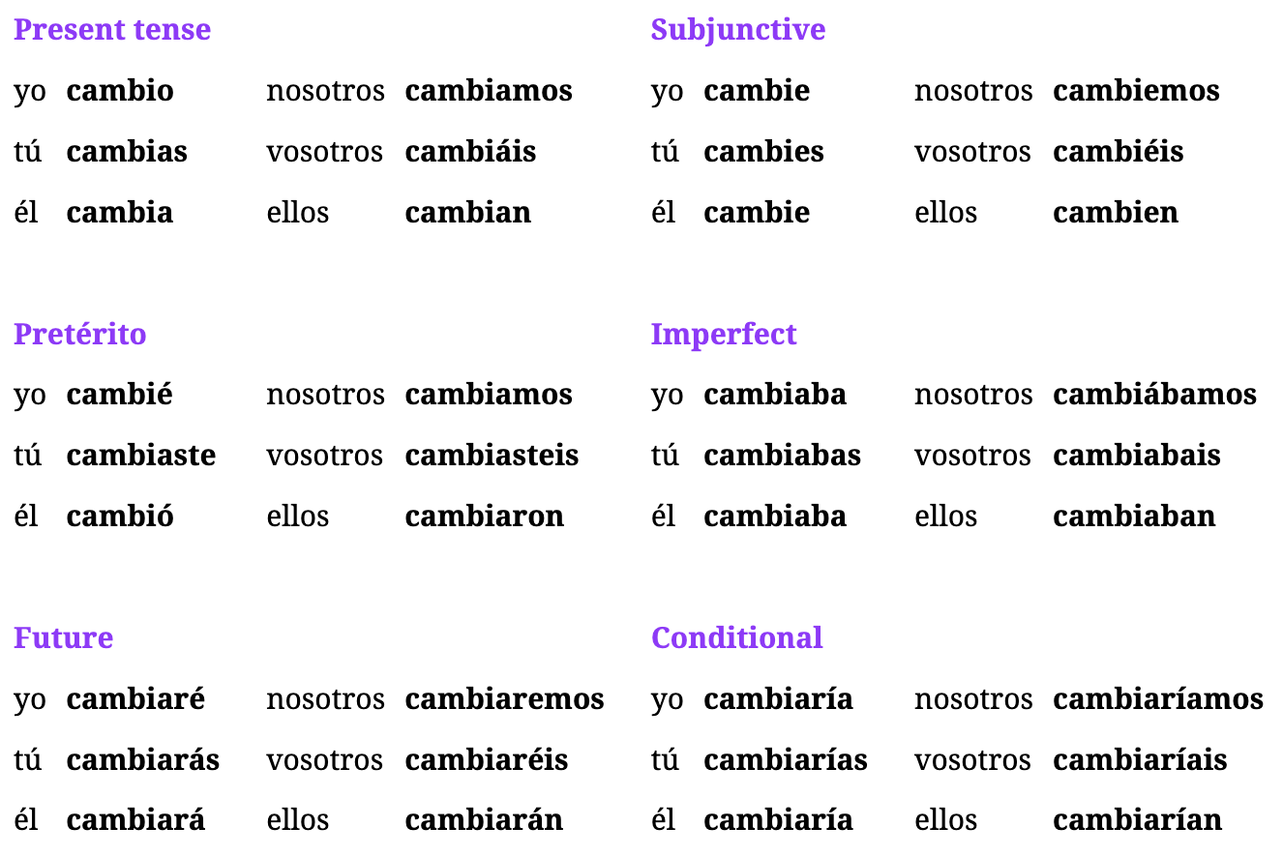

Understanding Cambiar

* means “to change” | can also mean “trade out” #4
* **RULE**: “cambiar + de” is used when the act of changing is on oneself (clothes) and the subject goes after de #1 #2
* **RULE**: “cambiar + por” is used when talking about trading or exchanging for something else #3
* **Imperatives:**
  + tu: cambia | tu negative: no cambies (subj)

Examples: Idiomatic Phrases

1. Something seems different. Did you change your clothes? → Algo parece diferente. ¿Te cambiaste de ropa?
2. I was going to go, but I changed my mind. → Iba a ir, pero cambié de idea.
3. I exchanged this thing for another one. → Cambié esta cosa por otra.
4. Can you trade this box out for another one? → ¿Puedes cambiar esta caja por otra?
5. He wants me to exchange this for seventy dollars. → Quiere que cambie esto por setenta dólares.
6. He changed his mind because he realized he was in danger. → Cambió de idea porque se dio cuenta de que estaba en peligro.

## Ep: 196: Quedar vs Quedarse

### Verb: Quedar

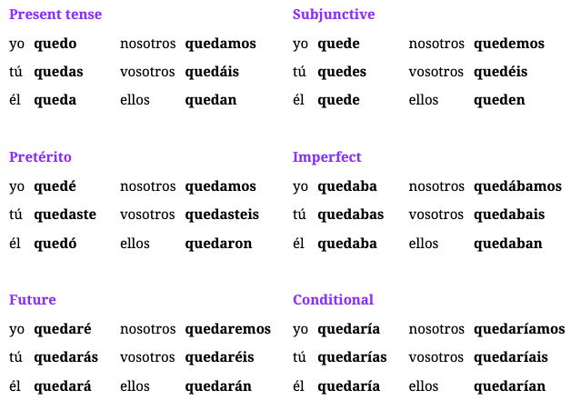

Structuring Quedar

* **FORMAT:** Quedar + what remains (subject) + place/time/condition (where/when it remains)
* **RULE**: whatever that remains/subject goes AFTER the verb quedar
  + There is only one dollar left. → Solo **queda** un dólar.
* Ex: There wasn’t anything left there ← There remained nothing there
  + No quedaba nada ahí.
* Ex: There are no tickets left for the concert → No quedan entradas para el concierto
  + 1. There are no left
  + 2. tickets
  + 3. for the concert
* Ex: There are only five minutes left to finish the class → Quedan solo cinco minutos para terminar la clase
* Ex: After the party, only two people were left in the house → Después de la fiesta, solo quedaban dos personas en la casa

Understanding Quedar Meanings

1. To Remain: (default)
   1. can be interchanged with the idea of *something being left over*
   2. Ex: Only three pesos remain. → Solo quedan tres pesos.
   3. Ex: There is no gold left in the box. → No queda oro en la caja. *not remains going in the box*
2. To Suit
   1. basically the idea of something being appropriate or fitting someone well
   2. takes an **indirect object**
   3. Ex: That outfit suits her very well. → Ese traje le queda muy bien.
   4. Ex: It was a small house, but it suited me fine. → Era una casa pequeña, pero me quedaba bien.
3. To be/Estar
   1. can also be used as a synonym for how someone is doing or where someone is
   2. a synonym for ESTAR
   3. Ex: Where is(Quedar) that city? → ¿Dónde queda esa ciudad?
   4. Ex: After that she was very happy. → Después de eso quedó muy feliz.
4. **RULE**: Imperatives are commonly used and **require contractions**
   1. Stay at home, I’ll be back soon. → Quédate en casa, volveré pronto.

Understanding Quedarse

* means “to stay”

Examples: Quedar (remains)

1. There were 80 people at the party, and 70 still remain. → Había 80 personas en la fiesta y aún quedan 70.
2. After we ate, none of the food was left over. → Después de que comimos, no quedó nada de la comida.
3. There is only one dollar left. → Solo queda un dólar.
4. Nothing remained from the party. → No quedó nada de la fiesta.
5. I don’t think there is anything left. → No creo que quede nada.
6. There might be one program left. → Puede quedar un programa.

Examples: Quedar (Suit/Estar)

1. This will suit you well in a month. → Esto te quedará bien en un mes.

Examples: Quedarse

1. I’ll stay at home all morning. → Me quedaré en casa toda la mañana.
2. She hadn’t stayed in this hotel before. → No se había quedado en este hotel antes.
3. She has to stay here. → Tiene que quedarse aquí.
4. You don’t have to stay there, there are sixty-one men. → No tienes que quedarte ahí, hay sesenta y un hombres.

Week 36: Lessons 191 -195

Tips

* Getting Hurt: The strong sun hurt her eyes → El sol fuerte le hizo daño a sus ojos

Words

* contando: counting
* contado: counted
* sesenta: sixty
* setenta: seventy
* fuerza: force/strength
* silencio: silence
* calma: calm
* modo: mode/way
* peligro: danger/hazard
* libertad: freedom
* el sistema: the system
* el programa: the program
* el servicio: the service
* la ley: the law
* leyes: laws
* derecho: the right (legal)
* vale: worth/valid**

Idioms

* contar conmigo: count on me NOTE: you count **WITH** not ON
* vale la pena: worth it
* los años sesenta: in the sixties
* tengo derecho a: I have the right to
* no te rías de mí: don’t laugh at me

## Ep 194: Fuerza, ley, programa

Understanding Words

* modo: often used to say way but a synonym for *forma y manera*
* the legal right: use the word *derecho* ie straight

Understanding “May” + “Wish” Subjunctives

* if a sentence starts with “May” + “expressing a wish” we can translate the normal way which is *quiero que + expression* but instead of starting with a verb, we can start with *Que + noun + subjunctiveVerb*
* Ex: May God be with you(plural). → Que Dios esté con ustedes.

Examples

1. He wants me to count tonumber seventy. → Quiere que yo cuente hasta el número setenta. ← *hasta can mean (up to/until)*
2. Doing that took a lot of strength. → Hacer eso tomó mucha fuerza.
3. Don’t put that there, it might be a hazard. → No pongas eso ahí, puede ser un peligro.
4. The people would do anything for their liberty. → El pueblo haría cualquier cosa por su libertad.
5. Do you realize this service is worth 80 dollars? → ¿Te das cuenta de que este servicio vale 80 dólares?
6. You don’t have the right to do this. → No tienes derecho a hacer esto.
7. If you tell them your problem, they will help you with the law. → Si les cuentas tu problema, te ayudarán con la ley.
8. Even if she counts on me, I don’t have any rights. → Aunque cuente conmigo, no tengo ningún derecho.
9. May it go well for you! → ¡Que te vaya bien!
10. May you(plural) have a good time! → ¡Que lo pasen bien!
11. May you have a nice day! → ¡Que tengas un buen día!
12. May you have a good time at the party! → ¡Que lo pases bien en la fiesta!

## Ep 193: The 60’s and 70’s

Understanding Words

* to say “in the 60’s” we can add “los años + number” BUT sometimes its omitted #3

Examples

1. How many? I don’t know, like seventy or seventy-one. → ¿Cuántos? No lo sé, como setenta o setenta y uno.
2. This clothing is from the seventies? → ¿Esta ropa es de los años setenta?
3. This house is from the twenties? → ¿Esta casa es de los veinte?
4. Dejamos la basura afuera hace como diecisiete horas. → We left the trash outside like seventeen hours ago.
5. Cuando era niña, en los años setenta, mi familia tenía una perra. → When I was a kid(f), in the seventies, my family had a dog(f).
6. Tenemos que llevar las dieciséis cajas a la casa número sesenta y siete. → We have to take the sixteen boxes to house number sixty-seven.
7. Quiero que ella nos cuente qué va a hacer cuando tenga setenta y seis. → I want her to tell us what she’s going to do when she’s seventy-six.

## Ep 192: Valer

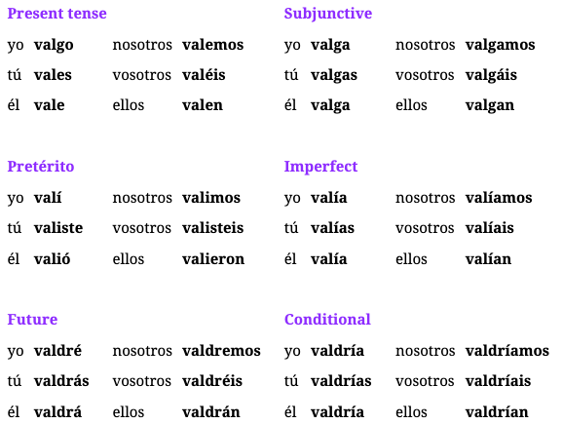

Understanding Valer

* meaning: “to be valuable” or “to be worth” something
* in certain parts of Spain, Vale == Sure/Okay | **LATAM**: Claro/Dale
* **NOTE**: this verb doesn’t take indirect objects, instead uses para #2
* **NOTE**: can also mean “something not valid” when talking about a ticket/ID

Examples

1. What he said isn’t worth anything. → Lo que dijo no vale nada.
2. We’re worth a lot to them. → Valemos mucho **para** ellos.
3. This work is worth it. → Este trabajo vale la pena.
4. I used to go there every week, it was worth it. → Iba allí todas las semanas, valía la pena.
5. I wasn’t able to enter; they told me it isn’t valid anymore. → No pude entrar; me dijeron que ya no vale.
6. We can’t leave until she gets here. // Sure. → No nos podemos ir hasta que ella llegue. // Vale.
7. I don’t want to be here long. // Sure, we’ll leave soon. → No quiero estar aquí mucho tiempo. // Vale, nos iremos pronto.

## Ep 191: Contar

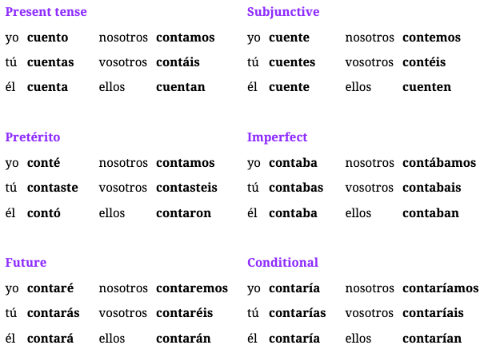

Understanding Contar

* meanings: “to count”, “to tell”, “to recount”
* **RULE**: use contar for long stories or a series or events; Decir for a small piece of information

Examples: Count

1. I didn’t count the people at the party. → No conté a las personas en la fiesta.
2. No, those two houses don’t count. → No, esas dos casas no cuentan.
3. She was counting that when he arrived. → Estaba contando eso cuando él llegó.
4. They’re counting their things the same way we count them. → Cuentan sus cosas igual que nosotros las contamos.
5. Do you count to ten? → ¿Cuentas hasta diez?

Examples: To Tell/Recount

1. Tell me everything about that year! → ¡Cuéntame todo sobre ese año!
2. Tell me everything you did this weekend. → Cuéntame todo lo que hiciste este fin de semana.
3. You don’t have to tell me the story, tell him the story. → No tienes que contarme la historia, cuéntale la historia a él.
4. Are you sure(m) you can count on your friend(m)? → ¿Estás seguro de que puedes contar con tu amigo?

Week 35: Lessons 186-190

Tips

* hurricane: huracán
* boring: aburrido(a)
* tratar de | ayudar a
* to grow up: crecer

Words

* preguntando: asking
* preguntado: asked
* pidiendo: asking, requesting, ordering
* pedido: asked, requested, ordered
* la próxima semana: next week
* el día siguiente: the following day
* próximo: next (used before noun)
* siguiente: following (used after noun)
* propio: own (keep normal structure)
* trasera: back/rear
* oficial: official
* verdadero: true/genuine
* cierto: true (when specifying if fact is true) / originally means certain
* asiento: seat (uses tomar) (masculine)
* la silla: chair
* el banco: bench
* peso: weight (someone's weight)
* efectivo: cash
* vuelto: change (amount of money returned to you)
* la sal: salt
* el oro: gold
* basura: trash
* la caja: box
* un traje: outfit (single item you wear)
* de veras/de verdad: really
* a gusto: comfortable/at ease

Idioms

* rather → más bien
* the greater part/most→ la mayor parte

Extra Words

* the cage: la jaula
* the station: la estación
* the driver: el conductor
* the bag: la bolsa
* the tickets: los tiquetes
* mad: enojada
* chaotic: caótica
* destroyed: destruida
* to buy: comprar
* to pay: pagar

## Ep 189: Silla, asiento, banco

Understanding Nouns

* **RULE**: asiento: does not use an article if you *take a seat* #1
* **NOTE**: do not confuse *vuelto* for the verb volver which is to return or vuelt**a**
* Cambio vs Vuelto
  + vuelto: emphasizes something being returned to you
  + cambio: emphasizes the way things generally change (exchanging money)

Examples

1. I asked him if I could take a seat. → Le pregunté si podía tomar asiento.
2. Does he sit in the red chair or in the green one? → ¿Se sienta en la silla roja o en la verde?
3. Are you really comfortable on that bench? → ¿De veras estás a gusto en ese banco?
4. That’s my seat, so please let me sit down. → Ese es mi asiento, así que por favor déjame sentarme.
5. She wants to ask me if she can sit on that bench. → Me quiere preguntar si puede sentarse en ese banco.
6. Why are you carrying so much money in cash? → ¿Por qué llevas tanto dinero en efectivo?
7. I don’t need the change, thank you. → No necesito el vuelto, gracias.
8. There was a change of plans. → Hubo un cambio de planes.
9. There’s gold in the trash! → ¡Hay oro en la basura!
10. She’s going to ask you if you want salt on your food. → Va a preguntarte si quieres sal en tu comida.
11. I asked for a different outfit. → Pedí un traje diferente.

## Ep 188: Próximo vs Siguiente

Understanding Adjectives

* instead of saying “the next day” use “the following day” via *siguiente*
* siguiente is often used without a noun, “lo siguiente → the following” (#2)
* oficial is used to specify about the official version of something
* propio is used to specify *someones own thing*
* diferente + a/de is used when comparing things, just depends on region #10
* verdadero: used to specify that its real compared to fake, like true and genuine; *real* is used for existence
* cierto: can also mean true when someone is talking about fact; alternative original meaning means “certain”
  + Es cierto que no llegarán a tiempo. *It’s certain they wont arrive on time*
  + Lo que dijo no era cierto  *What he said wasn’t true*

Understanding Perdir + Past Subjunctive

* **pedir** is often used to ask someone to do something
* **RULE**: when using in the request form, this triggers que + subjunctive
  + Present: He asks me to do it here ← Me pide que lo haga aquí.
  + **Past**: He asked me to do it here ← Me pidió que lo hiciera aquí
  + Past: He asked me to eat that ← Me pidió que **comiera** eso.

Understanding Rules for Past Subjunctives

* ER/IR → “era” after (fuera, estuviera, hiciera)
* AR → “ara” after (hablara, encontrará)
  + Ex: We asked them to find it. → Les pedimos que lo encontraran.

Examples

1. We did it again the following day. → Lo hicimos otra vez el día siguiente.
2. Listen carefully to the following. → Escucha bien lo siguiente.
3. I’m going to ask you for a favor next week. → Voy a pedirte un favor la próxima semana.
4. I won’t go next week, rather the following one. → No iré la próxima semana, más bien la siguiente.
5. I don’t want to hurt my own brother! → ¡No quiero hacerle daño a mi propio hermano!
6. The official story says that nobody saw it. → La historia oficial dice que nadie lo vio.
7. In the future she hopes to have her own house. → En el futuro espera tener su propia casa.
8. You can have your own game, but please go to the back door. → Puedes tener tu propio juego, pero por favor ve a la puerta trasera.
9. He doesn’t have his own phone and he was asking me about mine. → No tiene su propio teléfono y me estaba preguntando sobre el mío.
10. This house is very different to mine. → Esta casa es muy diferente a la mía.
11. He doesn’t want me to ask him anything personal. → No quiere que le pregunte nada personal.
12. That’s not his real name. → Ese no es su verdadero nombre.
13. If he asks her, she will tell him something that isn’t true. → Si le pregunta, ella le dirá algo que no es cierto.

Idiom Examples

1. My dog ate **most** of my food. → Mi perro comió **la mayor parte** de mi comida.

## EP 187: Preguntar vs Pedir

### Verb: Pedir

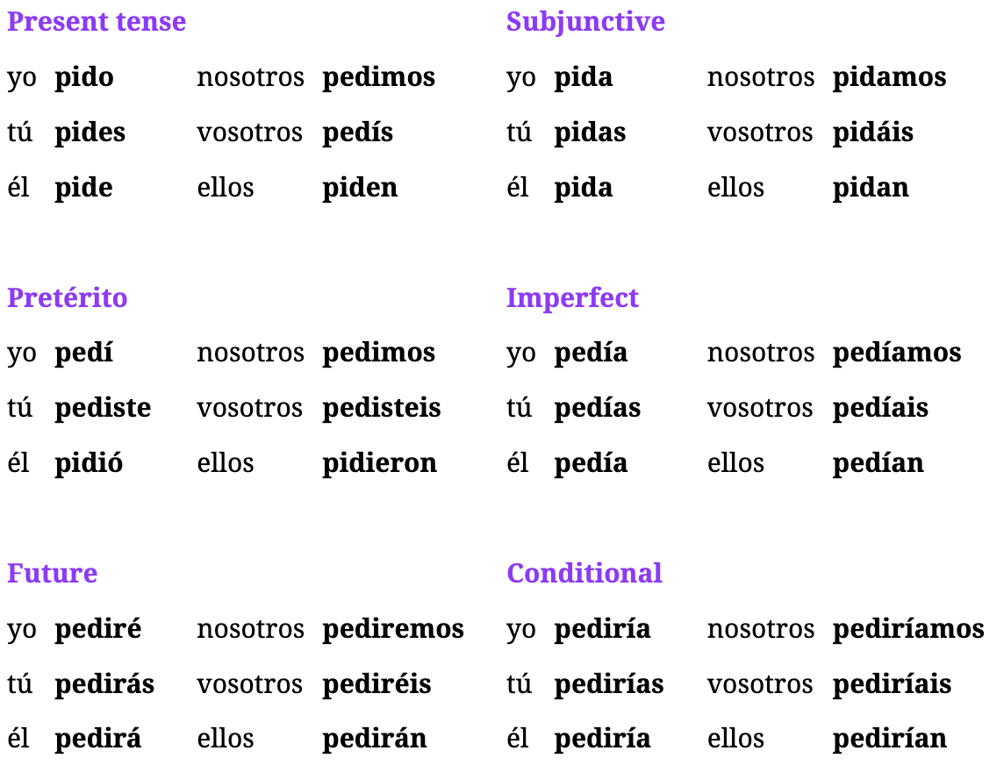

Understanding Pedir

* means “to ask someone to do something”, “to request” or “to order”
* common forms are *infinitive + contraction* like pedirle, pedirme, pedirte
* **RULE**: the request is a “que” phrase + subjunctive after
* Ex: I am going to ask him to do it. ← Le voy a pedir que lo haga.

Pedir Advanced Uses

* Example: They asked me for it today. → Me lo pidieron hoy.
  + Indirect: Me
  + Direct: It
  + Rule: Pedir expects the person you expect something of is Indirect Object and what you are requesting is Direct Object
* Example 2: I asked my dad for them today. → Se los pedí a mi papá hoy.
  + Indirect: My dad
  + Direct: Them
  + Rule: we need to use redundant object for “my dad” so Le == Se
* Ex: They ask you for fifty pesos, but I asked you for them before. → Ellos te piden cincuenta pesos, pero yo te los pedí antes.

Examples

1. I want to ask them to leave. → Les quiero pedir que se vayan.
2. I’m requesting to watch the news. → Pido ver las noticias.
3. You don’t have to order what she orders. → No tienes que pedir lo que ella pide.
4. We ask that you come with us, rather. → Te pedimos que vengas con nosotros más bien.
5. She is ordering something she hasn’t ordered before. → Está pidiendo algo que no ha pedido antes.
6. I’ll leave after asking her to come with me. → Me iré después de pedirle que venga conmigo.
7. When I order my food, we can leave. → Cuando pida mi comida, nos podemos ir.
8. I have ordered forty-three, not forty-four. → He pedido cuarenta y tres, no cuarenta y cuatro.
9. She is going to call me after asking me for my number. → Me va a llamar después de pedirme mi número.
10. She has to call you before asking you for something. → Tiene que llamarte antes de pedirte algo.

## Ep 186: Preguntar

### Verb: Preguntar

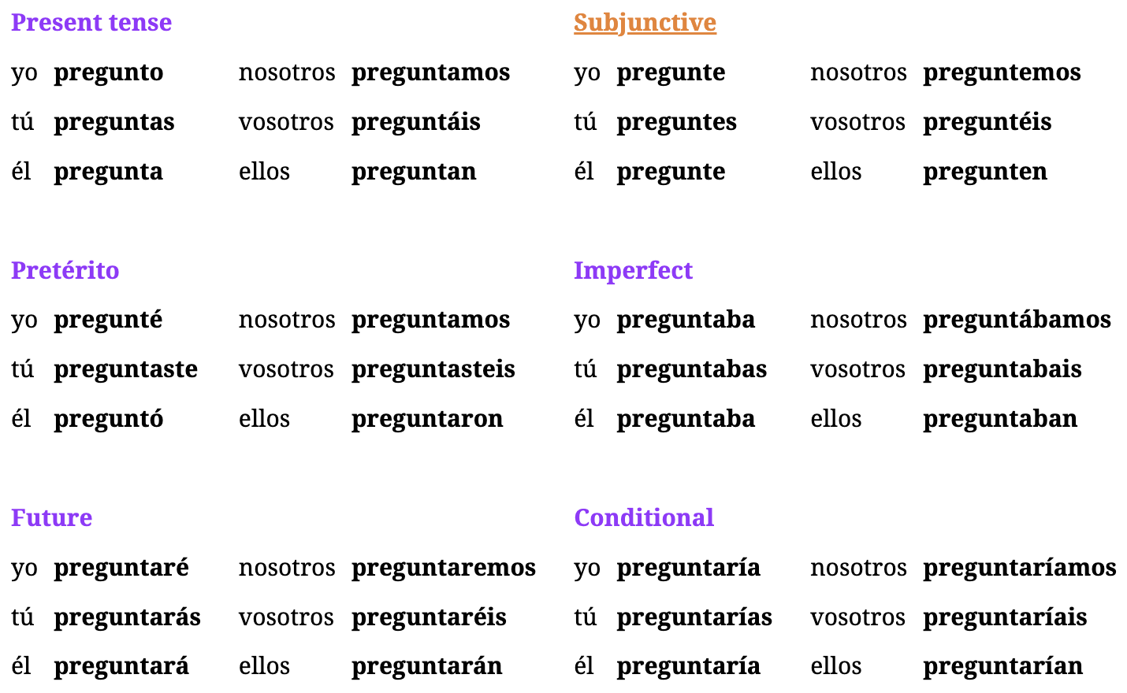

Understanding Preguntar

* means “to ask” and takes both direct and indirect objects
* **RULE**: only for asking for information NOT asking someone to do something for us
* indirect object is the recipient of what is being asked
* sometimes the direct object is an entire phrase
  + They asked me *where she was* ← Me preguntaron *donde estaba*.
* **RULE**: cannot use “preguntar” (Verb) and pregunta (question) in the same sentence, must use **HACER**
  + Fixed: I want to ask them a question. ← Les quiero hacer una pregunta

Understanding Preguntarse (to wonder)

* means “to ask oneself” or “to wonder”

Examples: Hacer vs Preguntar

1. They need to ask me three more things. → Necesitan preguntarme tres cosas más.
2. He didn’t mean to ask me that question. → No me quiso hacer esa pregunta.

Examples Preguntar

1. They asked me what happened. → Me preguntaron qué pasó.
2. I wanted to ask you a question, but I had a call. → Quería hacerte una pregunta, pero tenía una llamada.
3. They asked us that fifty-eight times. → Nos preguntaron eso cincuenta y ocho veces.
4. I asked him first, and later we all asked him. → Yo le pregunté primero y luego todos nosotros le preguntamos.
5. I’m going to ask them if she’s here. → Les voy a preguntar si ella está aquí.
6. I always asked the same thing to my parents. → Siempre les preguntaba lo mismo a mis padres.
7. I didn’t ask because I didn’t know what the question was. → No pregunté porque no sabía cuál era la pregunta.
8. She wants me to ask you when your birthday is. → Ella quiere que yo te pregunte cuándo es tu cumpleaños.

Examples Preguntarse

1. He wonders how he could do it. → Él se pregunta cómo podría hacerlo.
2. I asked myself that everyday when I was young. → Me preguntaba eso todos los días cuando era joven.
3. She was wondering why there were so many people in that place. → Se preguntaba por qué había tanta gente en ese lugar.
4. I wonder what I can do for her. Don’t you wonder the same thing? → Me pregunto qué puedo hacer por ella. ¿No te preguntas lo mismo?

Week 34: Lessons 181-185

Group/Class Tips

* Recuerdas los verbos de hace dos semanas ← from ago two weeks
* se dieron cuenta que ←They realized that
* me di cuenta de que ← I realized that
* cuando era niño mi abuela y yo dábamos vueltas por mi ciudad y comíamos muchos dulces
* Ellos acaban de poner todos los libros en una fila ← they just put all the books in a row
* Una cosa que me preocupa ← that worries me
* That is going to happen after we eat. Once that happens, nobody will have a headache. → Eso va a suceder después de que comamos. Una vez eso suceda, nadie tendrá dolor de cabeza.
  + Use después de que here because *if you want to describe something that happens after an entire fact, “después de que”* see Ep: 83
* **película** ← phey-leek-u-lah | **podremos** ← por-ddrrraaay-mos (open sound more)
* **acabas** ← AH-KAH-bas (emphasis on beginning) | **otro** ← ohhh-throw
* I am sure she knows what the book is about. → Estoy seguro que ella sabe de lo que se trata el libro. *(needs “knows of what”)*

Words

* jugando: playing
* jugado: played
* cuarenta: 40
* cincuenta: 50
* la noticia: the news (singular piece of information “heard the news yesterday about…”
* las noticias: the news (multiple pieces, watching the news)
* consejo: advice
* llamada: call
* la respuesta: response/answer
* la señal: sign/signal
* decisión: decision ← use tomar (day-say-see-ohn)
* porqué: why (when used as a noun NOT conjunction)
* prueba: test/demo
* pruebas: proof (plural)
* el futuro(a) y el pasado(a): future and past
* una cita: appointment/date
* navidad: christmas
* cumpleaños: birthday (completion of years)
* disculpe: excuse me (formal/subj) | disculpa: excuse me (informal)
* incluso: including

Extra Words

* the shirt: la camisa
* the pants: el pantalón
* the statue: la estatua
* the distractions: las distracciones
* to throw away: tirar
* annoying: molesto(a)
* noise: un ruido *Es demasiado ruidoso aquí*
* social media: redes sociales
* websites: sitios web

Idioms

* además de: as well as
* de hoy en dia: of today
* más bien: rather
* o sea: i mean / that is

## Ep 184: Noticia, decision, respuesta

Understanding New Words

* respuesta**:** can be used to *respond to a call or a question*
* señal: expressing when “there is a sign that something is the case” → señal de que
* decisión: instead of making a decision, you “take” a decision ← tomar una decisión

Understanding El Porqué

* this can sometimes be translated to “the reason” but instead of using “la razón” because razon refers to *careful thought or being right about something*
* using el porqué implies there is a sort of “why” question that hasn’t been answered
* Ex: I still don’t understand the reason for that wait. → Todavía no entiendo el porqué de esa espera.

Examples

1. He's watching the news. → Está viendo las noticias.
2. I have a piece of advice for you. → Tengo un consejo para ti.
3. I’m not online, I don’t have a signal. → No estoy en línea, no tengo señal.
4. I couldn’t make the call because I didn’t have a signal. → No pude hacer la llamada porque no tenía señal.
5. If you apologize, she’ll give you the answer. → Si te disculpas, te dará la respuesta.
6. We made the decision against our parents’ advice. → Tomamos la decisión en contra del consejo de nuestros padres.
7. Excuse me, help me with this demo. → Disculpa, ayúdame con esta prueba.
8. I’ll do a test and tell you my decision afterwards. → Haré una prueba y te diré mi decisión después.
9. She said all those strange things without proof. → Dijo todas esas cosas extrañas sin pruebas.
10. He wants me to forgive him because he doesn’t play that on dates. → Quiere que yo lo disculpe porque no juega a eso en citas.

## Ep 183: Cuarenta y Cincuenta

Examples

1. The kids of today don’t understand it. → Los niños de hoy en día no lo entienden.
2. It was a little boy, or rather a teenager. → Era un niño, o más bien un muchacho.
3. If she helps me, instead of fifteen we’ll have forty-three. → Si me ayuda, en vez de quince tendremos cuarenta y tres.
4. Forgive the girl; she’s new and I never play this with her. → Disculpa a la chica, es nueva y nunca juego a esto con ella.
5. Do you play with us, or rather, with me? → ¿Juegas con nosotros, o más bien conmigo?
6. The four things you did haven’t meant anything. → Las cuatro cosas que hiciste no han significado nada.

## Ep 182: Jugar

Verb: Jugar

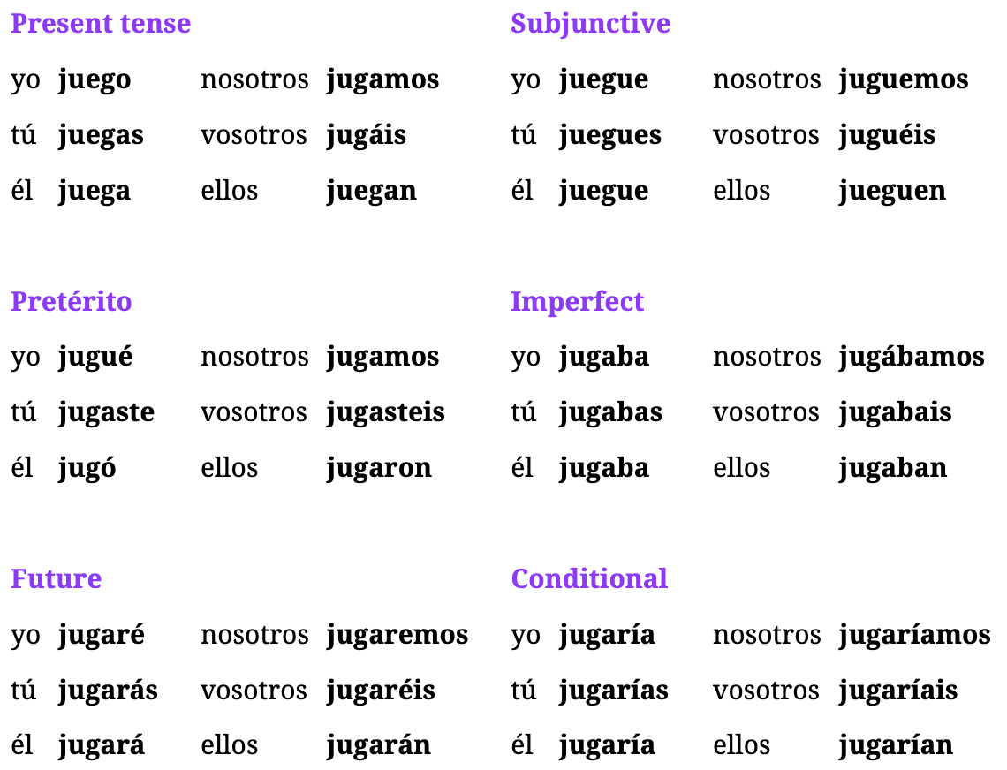

Understanding Jugar (irregular)

* means “to play”
* NOT: playing instrument, playing a role in a movie or pressing play on device
* **RULE**: when naming what game is played, use “a”
  + Ex: She wants to play this → Ella quiere jugar a esto.
* IMPERATIVES: juega! (3rd person form)

Examples: Jugar

1. She probably plays with her friends as well as with my friends. → Probablemente juega con sus amigos además de con mis amigos.
2. I don’t want her to play on top of the car. → No quiero que juegue encima del auto.
3. Please, play with us! So that we play as well. → Por favor, ¡juega con nosotros! Para que juguemos también.
4. That has meant that she didn’t play. → Eso ha significado que ella no jugó.
5. You never play with me, so I played alone. → Nunca juegas conmigo, entonces jugué solo.
6. Do you think it will hurt them if they play? → ¿Crees que les hará daño si juegan? *(to make hurt, hacer)*

## Ep: 181: Disculpar, Ayudar, Significar

### Verb: Significar

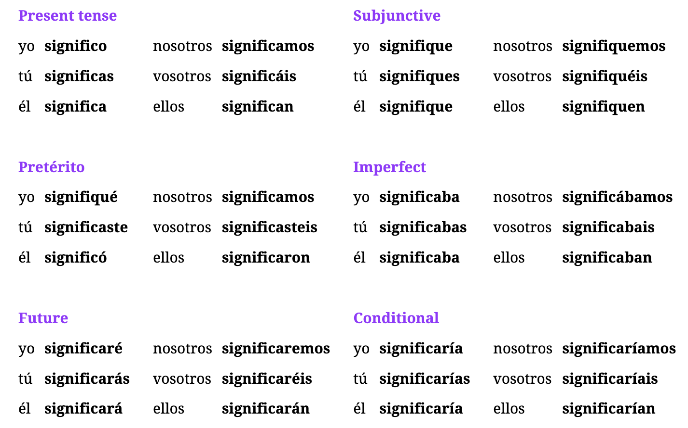

### Verb: Disculpar

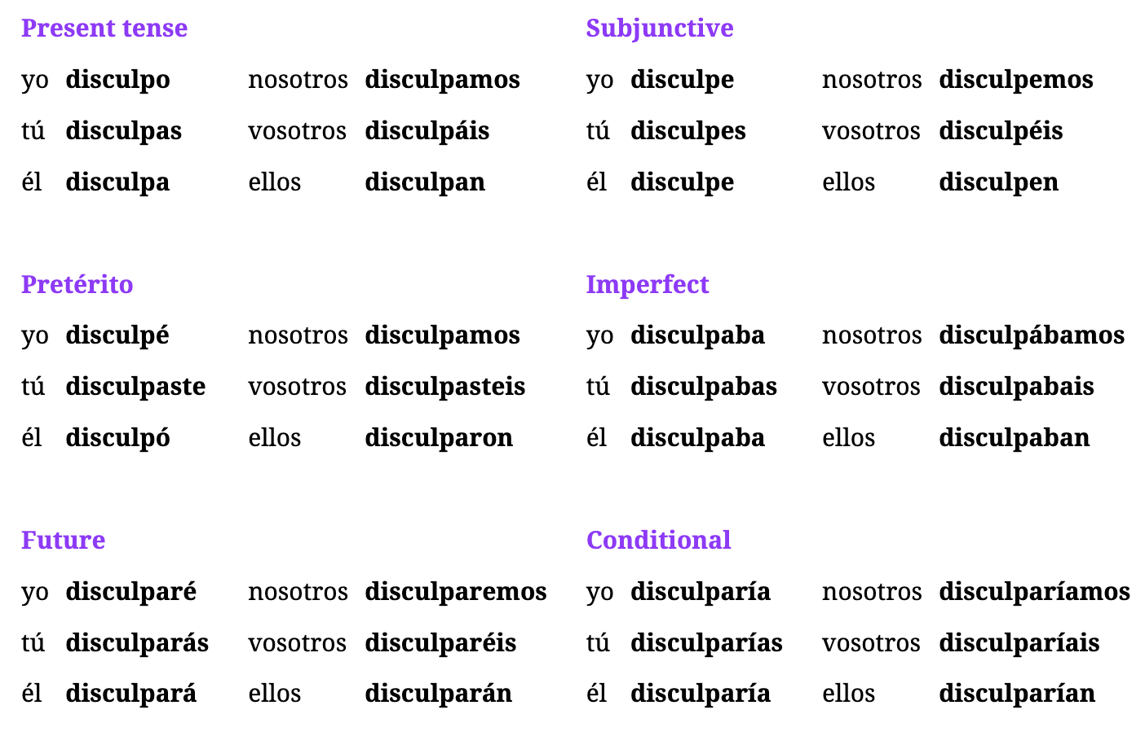

### Verb: Ayudar

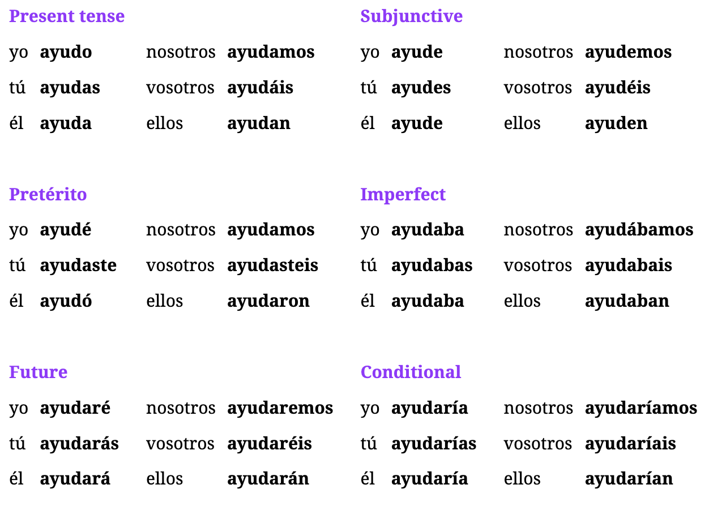

Understanding Significar

* “to mean” as in referring that something has a particular meaning + uses **para**
* but doesn’t mean “meaning to say” something like *what we mean to say is*
* COMMON FORMS: significa, 3rd person

Understanding Ayudar

* “to help” + used with a direct object
* **RULE**: use preposition “a” and infinitive of what you are helping them do
  + Ex: She helps him do that → Ella lo ayuda a hacer eso.

Understanding Disculpar

* means “to forgive” or “to excuse” and the **direct object** is the **person who did something wrong or their behavior**
* Common: use imperative + contraction like *Disculpame*
* Example of excusing behavior:
  + I’m never going to excuse that type of thing. → Nunca voy a disculpar ese tipo de cosas.
* **RULE**: if you want to mention the person AND behavior
  + Ex: Can you forgive **HER** for arriving late? ← ¿**La** puedes disculpar por llegar tarde?
    - Person → Direct Object
    - Behavior → goes after POR
* **COMMON**: another way to say sorry to stranger → Disculpe (usted imperative)
  + Ex: Disculpe, señorita, ¿sabe dónde está el hospital?

Understanding Disculparse

* indicates asking for forgiveness or apologizing
* **RULE**: you apologize **WITH** someone not to someone → use “con”
* Ex: I have to apologize, that was wrong. → Tengo que disculparme, eso estuvo mal.
* Ex: You need to apologize to her. → Te tienes que disculpar con ella.

Examples: Significar

1. What you did had meant something to me. → Lo que hiciste había significado algo para mí.
2. Those things mean a lot to me. → Esas cosas significan mucho para mí.
3. That can’t mean what you’re thinking. → Eso no puede significar lo que estás pensando.

Examples: Ayudar

1. She wants me to help her because she is cold. → Ella quiere que yo la ayude porque tiene frío.
2. Help me! I always try to help you. → ¡Ayúdame! Yo siempre trato de ayudarte.
3. It seems like he’s very hot, can you help him? → Parece que tiene mucho calor, ¿puedes ayudarlo?
4. He wants me to help them because they are hungry. → Quiere que los ayude porque tienen hambre.
5. She helps him every day with what’s behind the house. → Lo ayuda todos los días con lo que está detrás de la casa.
6. You don't want to help me, but you have time to help your friend. → No quieres ayudarme, pero tienes tiempo de ayudar a tu amigo.

Examples: Disculpar

1. He always forgives her for that, including when it’s her fault. → Siempre la disculpa por eso, incluso cuando es su culpa.
2. Forgive me! You know I didn’t mean to hurt you. → ¡Discúlpame! Sabes que no quise hacerte daño.
3. He wants me to forgive him for what he did. → Quiere que lo disculpe por lo que hizo.
4. Why don’t you forgive us? Forgive us, please! → ¿Por qué no nos disculpas? Discúlpanos, por favor.
5. I want him to forgive her while they are inside the place. → Quiero que la disculpe mientras están adentro del lugar.
6. (formal) Excuse me, are you with those people? → Discúlpeme, ¿usted está con esas personas?
7. (plural) Excuse me, do you see what’s on top of the house? → Discúlpenme, ¿ven lo que está encima de la casa?
8. Why does he want us to forgive him? Besides, he never said “I’m sorry”. → ¿Por qué quiere que lo disculpemos? Además, nunca dijo “lo siento”.

Examples: Disculparse

1. I don’t want to apologize to her, I know I’m right. → No quiero disculparme con ella, sé que tengo razón.
2. Why are you apologizing? If you haven’t done anything. → ¿Por qué te disculpas? Si no has hecho nada.
3. He always apologizes, but he’ll probably do it again. → Siempre se disculpa, pero probablemente lo volverá a hacer.

Week 33: Lessons 176-180

Class Tips

Words (Verbs)

* perdido: lost (participle)
* perdiendo: losing/missing (common with perderse)
* sucedido: occurred (particple)
* sucediendo: occurring (gerund)

Words

* realmente: really
* exactamente: exactly
* probablemente: probably (prob-ab-leh-men-tey)
* simplemente: simply
* incluso: including / even including
* hasta: even (adverb) ← kind of like “including”
* anoche: last night
* esta noche: tonight
* dentro, atrás, arriba, y afuera: inside, back (motion), up, outside
* detrás: behind/in the back
* atrás: behind/back (motion like stepping backward)
* adentro: inside (motion inside somewhere)
* dentro: inside (the state of being inside somewhere)
* alrededor: around/surrounding (al-red-e-dor) ← followed by de
* encima: on top/upon
* además: besides/moreover

Words (Feelings)

* hambre: hungry/hunger (Feminine)
* placer: pleasure
* honor: honor
* odio: hatred
* dolor: pain/ache (ache when paired with a body part)
* daño: damage/harm + hacer (indicates getting hurt)
* pena: pity, sorrow, shame

Idioms

* on top of that: encima de
* in honor of: en honor a

Random

* I need my job to slow down → Necesito que mi trabajo baje el ritmo

## Ep 179: Hambre, frío and other feelings

Understanding Feelings

* **hungry, hot, cold, honor, pleasure** + **HAVE** this feeling not BE this feeling
* to say very → use mucho(a)

Understanding Hatred

* uses an indirect object + tener; like the word cariño [le tengo mucho carino a mi hijo] ie *affection* for someone
* Ex: I have a lot of hatred for those animals. → Les tengo mucho odio a esos animales.
  + Literal: *to them I have much hatred to those animals*

Understanding “Getting Hurt”

* the word ***daño + hacer*** is used to talk about hurting/damaging something or someone
* when talking about someone, use indirect object #11
* **IDIOMATIC**: The dog harmed us. → El perro nos hizo daño.

Espanol Maestro “Getting Hurt”

* Structure: Subject + Indirect Object + Hacer dano (subject/person/thing causing harm)
* Juans comments hurt me → El comentario de Juan me hizo daño. *(preterite for Juan)*
* Does it hurt you when I squeeze your arm? → ¿Te hago daño cuando te aprieto el brazo?
* Hurting yourself Reflexive Example:
  + Don’t hurt yourself with the bicycle → No te hagas daño con la bicicleta
    - **NOTE**: this ONLY uses subjunctive form because its expressing a wish or desire or uncertainty
  + I hurt myself when I run fast → Me hago daño cuando corro rápido.
    - **NOTE**: not using subjunctive because this describes something that happened

Examples

1. Is it **because of** their hunger? → ¿Es **por** su hambre? (NOTICE POR NOT Porque)
2. She’s very cold and I’m very hungry. → Ella tiene mucho frío y yo tengo mucha hambre.
3. Do you think you’ll be hot or cold there? → ¿Crees que tendrás calor o frío ahí?
4. I have had the pleasure of meeting your grandfather. → He tenido el placer de conocer a tu abuelo.
5. We did it in honor of our parents. → Lo hicimos en honor a nuestros padres.
6. He lost, but he said it was a pleasure. → Perdió, pero dijo que fue un placer.
7. They lost, but it **still** was an honor and a pleasure for them. → Perdieron, pero **igual** fue un honor y un placer para ellos.
8. I have a strong pain/ache in my left hand. → Tengo un dolor fuerte en mi mano izquierda.
9. My hatred is stronger than my pain. → Mi odio es más fuerte que mi dolor.
10. This might occur and give you pain. → Esto puede suceder y darte dolor.
11. I don’t want to harm anyone. → No quiero hacerle daño a nadie.
12. We went to his house to look at the damage. → Fuimos a su casa para ver el daño.
13. What a shame that you can’t go! → ¡Qué pena que no puedas ir!
14. It’s a shame that he has hurt her. → Es una pena que le haya hecho daño.

## Ep 178: Encima vs Además

Understanding Adding “ly” to Adverbs

* in english we can turn the word real → really by adding “ly”
* spanish we add “mente” after word (sometimes)
* ex: realmente, exactamente, probablemente, simplemente
* **RULE**: after probablemente, triggers SUBJUNCTIVE 75% of the time

Understanding Location Adverbs

* previous: dentro, atrás, arriba, and afuera
* in english “behind it” is used because behind is a preposition, but detrás is an adverb so it is used by itself; MOST COMMON USE: detrás de
* **RULE**: both atrás y detrás both mean “behind” BUT technically atras is meant for backwards motion or stepping back vs detras for “behind”
* **RULE**: both adentro y dentro both mean inside; adentro is for motion inside vs dentro is the state of being inside somewhere

Examples

1. This view is simply the best. → Esta vista es simplemente la mejor.
2. It probably won’t occur again. → Probablemente no vuelva a suceder. (subjunctive)
3. Everyone was there, including/even my grandparents. → Todos estaban allí, incluso/hasta mis abuelos.
4. I like all dogs, including my girlfriend’s very mean dog. → Me gustan todos los perros, incluso el perro muy malo de mi novia.
5. I saw her at the party last night. → La vi en la fiesta anoche.

Examples: location

1. The house has another very small house behind it. → La casa tiene otra casa muy pequeña detrás.
2. Search behind the door. → Busca detrás de la puerta.
3. Go inside! → ¡Ve adentro!
4. There are many animals around the house. → Hay muchos animales alrededor de la casa.
5. You lost your phone somewhere around the house. → Perdiste tu teléfono en algún lugar alrededor de la casa.
6. If you go inside the house, you’ll find it behind the door. → Si vas adentro de la casa, lo encontrarás detrás de la puerta.

Examples: Filler Adverbs

1. They didn’t work and on top of that they said something mean. → No trabajaron y encima dijeron algo malo.
2. I don’t know what occurred. Besides, I wasn’t there. → No sé qué sucedió. Además, yo no estaba ahí.
3. He didn’t come and on top of that he didn’t call. → No vino y encima no llamó.
4. I don’t know who was there besides him. → No sé quién estaba ahí además de él.

## Ep 177: Comer y Suceder

### Verb: Comer

**Present:** como, comes, come, comemos, comen

**Subjunctive:** coma, comas, coma, comamos, coman

**Pretérito:** comí, comiste, comió, comimos, comieron

**Imperfect:** comía, comías, comía, comíamos, comían

**Future:** comeré, comerás, comerá, comeremos, comerán

**Conditional:** comería, comerías, comería, comeríamos, comerían

### Verb: Suceder

**Present:** sucedo, sucedes, sucede, sucedemos, suceden

**Subjunctive:** suceda, sucedas, suceda, sucedamos, sucedan

**Pretérito:** sucedí, sucediste, sucedió, sucedimos, sucedieron

**Imperfect:** sucedía, sucedías, sucedía, sucedíamos, sucedían

**Future:** sucederé, sucederás, sucederá, sucederemos, sucederán

**Conditional:** sucedería, sucederías, sucedería, sucederíamos, sucederían

Understanding Suceder (sue-sair-dare)

* means “to occur” or “to happen”
* NOTE: pasar also means “to happen” or “to come to pass”
* NOTE: most common forms are present tense “sucede” for *it happens* and “suceden” for *they happen* and common preterite forms “sucedió” and “sucedieron”
* **RULE**: sentences w/ suceder, the subject goes AFTER the verb
  + Ex: Very strange things occurred yesterday. → Ayer sucedieron cosas muy extrañas.

Understanding Comer

* means “to eat”

Examples of Suceder

1. I don’t think that’s going to happen. → No creo que eso vaya a suceder.
2. What is occurring here? → ¿Qué está sucediendo aquí?
3. Something occurs that had never before occurred. → Sucede algo que nunca antes había sucedido. **SEE RULE** on shifting of algo
4. Is occurring what you said was going to occur. → Está sucediendo lo que dijiste que iba a suceder.
   1. **SEE RULE**: phrase is AFTER esta sucediendo
5. I don’t lose it because I know what has occurred. → No lo pierdo porque sé lo que ha sucedido.
6. You lost that opportunity, but I don’t think it will occur again. → Perdiste esa oportunidad, pero no creo que suceda otra vez.

Examples of Comer

1. We have thirty-six hours to talk about this situation. → Tenemos treinta y seis horas para hablar de esta situación.
2. The thirty-one men at the party are eating. → Los treinta y un hombres en la fiesta están comiendo.
3. Eat! We need you to eat so that she also eats. → ¡Come! Necesitamos que comas para que ella también coma.
4. He ate a lot because he hadn’t eaten in thirty-nine hours. → Comió mucho porque no había comido en treinta y nueve horas.

## Ep 176: Perder/Perderse

### Verb: Perder

**Present:** pierdo, pierdes, pierde, perdemos, pierden

**Subjunctive:** pierda, pierdas, pierda, perdamos, pierdan

**Pretérito:** perdí, perdiste, perdió, perdimos, perdieron

**Imperfect:** perdía, perdías, perdía, perdíamos, perdían

**Future:** perderé, perderás, perderá, perderemos, perderán

**Conditional:** perdería, perderías, perdería, perderíamos, perderían

Understanding Perder

* means “to lose”; likes to take direct objects; also irregular with stem change like sentir
* also refers to “missing an opportunity” see #2
* **RULE**: gerund form isn’t common with Direct Objects, instead with reflexive perderse
* IMPERATIVES
  + informal: pierde
  + formal: pierda
  + tu: no pierdas

Understanding Perderse

* **MEANING**: changes meaning from “to lose” to “**to get lost**” or “**to be lost**”
  + idea is saying “I lost myself”
* **MEANING**: also means “to miss out on something”

Examples

1. I don’t like this game, I know I’m going to lose. → No me gusta este juego, sé que voy a perder.
2. I don’t want to lose this opportunity. → No quiero perder esta oportunidad. (miss)
3. Do I have your attention? I know you and you always lose everything. → ¿Tengo tu atención? Te conozco y siempre pierdes todo.
4. I don’t know how it’s possible, but I lost thirty-one books. → No sé cómo es posible, pero perdí treinta y un libros.
5. Lose that! They can’t find us with those things. → ¡Pierde eso! No nos pueden encontrar con esas cosas.
6. I’m thirty-four and they don’t want me to lose that opportunity. → Tengo treinta y cuatro años y no quieren que pierda esa oportunidad. (**SUBJ**)
7. We’re going to do all that so that you don’t lose it (f). → Vamos a hacer todo eso para que no la pierdas. (**SUBJ**)

Examples: Perderse

1. I meant to arrive earlier, but I got lost. → Quise llegar antes, pero me perdí.
2. They were talking very fast about that issue and I got lost. → Hablaban muy rápido de ese asunto y me perdí.
3. We're getting lost; we have to see where we are. → Nos estamos perdiendo, tenemos que ver dónde estamos.
4. He gets lost every time he goes to that city. → Él se pierde cada vez que va a esa ciudad.
5. She got lost after you got lost. → Ella se perdió después de que tú te perdiste.
6. They had gotten lost near the green house. → Se habían perdido cerca de la casa verde.

Examples: Perderse (to miss out on)

1. I don’t want to miss out on this opportunity. → No me quiero perder esta oportunidad.
2. They have already missed out on this. → Ya se han perdido esto.
3. We can’t miss out on that opportunity. → No nos podemos perder esa oportunidad.

Week 32: Lessons 171-175

Tips/Class

* pronounce “podremos” as por-ddraaay-mos
* A group of people kept reading the story about that idiot. → Un grupo de personas siguio **leyendo** la historia que se trata de ese idiota.
  + the word “ese” should match gender for who it is talking about
  + siguió + gerund
  + focus on “about that”
* the season starts today → la temporada comienza hoy
* **Verb**: comenzar: to start
* **Verb**: renunciar: to quit

Words

* **encontrado**: found (past participle)
* **recordado**: remembered (past participle)
* **entrado**: entered (past participle)
* **encontrando**: finding (gerund)
* **recordando**: remembering (gerund)
* **entrando**: entering (gerund)
* la información: the information
* el mensaje: the message (men-sah-hey)
* el asunto: the issue (matter/topic/business)
* la atención: attention
* la situación: situation
* el permiso: permission
* la vista: the view (vision sight)

Idioms

* its not your business: no es asunto tuyo
* point of view: punto de vista
* from that point of view: bajo/desde ese punto de vista

Extra Words

* the details: los detalles
* we sent: mandamos

## Ep 174: Información

Understanding Words

* asunto: which means “issue” can have other meanings like “matter” or “topic”; can also mean “**business**” when talking about if someone is involved in something or not and uses *possessive nouns* for idiomatic phrase
  + Ex: It’s not your business. → No es asunto tuyo. (notice tuyo vs tu)

Examples

1. She told me that message was none of my business. → Ella me dijo que ese mensaje no era asunto mío.
2. I had thirty-six messages but still didn’t have enough information. → Tenía treinta y seis mensajes, pero aún no tenía suficiente información.
3. Regarding this matter, she has killed twenty-eight animals. → En cuanto a este asunto, ha matado veintiocho animales.
4. He went out without his mom’s permission. → Salió sin el permiso de su mamá.
5. You don’t need my permission to enter the house. → No necesitas mi permiso para entrar en la casa.
6. Do you have sight of the house? → ¿Tienes vista de la casa?
7. Her vision must be perfect. → Su vista debe ser perfecta.
8. His point of view seemed strange to me. → Su punto de vista me pareció extraño.
9. From my point of view, thirty-one things are better. → Bajo mi punto de vista, treinta y una cosas son mejores.
10. This is a gorgeous view, with a lot of green things. → Esta es una vista hermosa, con muchas cosas verdes.

## Ep 173: Spanish Colors/Numbers

Colors (change on gender or number being described)

* rojo(a): red
* verde: green
* azul: blue

## Ep 172: Entrar y Matar

### Verb: Entrar

**Present:** entro, entras, entra, entramos, entran

**Subjunctive:** entre, entres, entre, entremos, entren

**Pretérito:** entré, entraste, entró, entramos, entraron

**Imperfect:** entraba, entrabas, entraba, entrábamos, entraban

**Future:** entraré, entrarás, entrará, entraremos, entrarán

**Conditional:** entraría, entrarías, entraría, entraríamos, entrarían

Verb: Matar

**Present:** mato, matas, mata, matamos, matan

**Subjunctive:** mate, mates, mate, matemos, maten

**Pretérito:** maté, mataste, mató, matamos, mataron

**Imperfect:** mataba, matabas, mataba, matábamos, mataban

**Future:** mataré, matarás, matará, mataremos, matarán

**Conditional:** mataría, matarías, mataría, mataríamos, matarían

Understanding Entrar

* means “to enter” or “to go in” or “to come in”
* **RULE**: if saying “where you’re GOING INTO” add preposition **en** after
  + Ex: You should go in the house. → Deberías entrar en la casa.
* **Imperatives**
  + Come In! → Entra!

Understanding Matar

* means “to kill”
* **RULE**: when naming person as Direct Object, extra **a** before person

Examples: Entrar

1. We let them come in. → Los dejamos entrar.
2. I arrived, but I wasn’t able to go in. → Llegué, pero no pude entrar.
3. My uncle never enters her house. → Mi tío nunca entra en su casa.
4. She already went in, so tell them to go in as well. → Ella ya entró, así que diles a ellos que entren también.
5. Do you remember that I never enter through that door? → ¿Recuerdas que nunca entro por esa puerta?
6. I didn’t enter and she hasn’t entered either. → No entré y ella no ha entrado tampoco.
7. You have to go in the house because they found something there. → Tienes que entrar en la casa porque encontraron algo allí.
8. When we go in the house, my husband always leaves his phone on the table. → Cuando entramos en la casa, mi marido siempre deja su teléfono en la mesa.

Examples: Matar

1. She’s going to kill me when she realizes. → Ella me va a matar cuando se dé cuenta.
2. Calm down(m), nobody is going to kill your grandmother. → Tranquilo, nadie va a matar a tu abuela.
3. They killed a black dog without meaning to. → Mataron un perro negro sin querer.
4. I didn’t kill it, she killed it! I don’t like to kill. → Yo no lo maté, ¡ella lo mató! No me gusta matar.
5. I didn’t kill anyone, so if she finds something it’ll be strange. → No maté a nadie, así que si encuentra algo será extraño.

## Ep 171: Encontrar y Recordar

### Verb: Encontrar

**Present:** encuentro, encuentras, encuentra, encontramos, encuentran

**Subjunctive:** encuentre, encuentres, encuentre, encontremos, encuentren

**Pretérito:** encontré, encontraste, encontró, encontramos, encontraron

**Imperfect:** encontraba, encontrabas, encontraba, encontrábamos, encontraban

**Future:** encontraré, encontrarás, encontrará, encontraremos, encontrarán

**Conditional:** encontraría, encontrarías, encontraría, encontraríamos, encontrarían

### Verb: Recordar

**Present:** recuerdo, recuerdas, recuerda, recordamos, recuerdan

**Subjunctive:** recuerde, recuerdes, recuerde, recordemos, recuerden

**Pretérito:** recordé, recordaste, recordó, recordamos, recordaron

**Imperfect:** recordaba, recordabas, recordaba, recordábamos, recordaban

**Future:** recordaré, recordarás, recordará, recordaremos, recordarán

**Conditional:** recordaría, recordarías, recordaría, recordaríamos, recordarían

Understanding Encontrar/Encontrarse

* means “to encounter” or “to find” ← relates to finally finding or encountering something
* the difference between *buscar* is that it implies that YOU HAVEN’T found something
* **RULE**: reflexively means “to come across someone/something” or “to find oneself” in a particular situation + followed by “**con**”
  + **Ex**: You’re going to come across a very large building. → Te vas a encontrar **con** un edificio muy grande.
    - Literal: you’re going to find yourself with a very large building

Examples Encontrar

1. If you look for the animal, you’re going to find it. → Si buscas al animal, lo vas a encontrar.
2. Today I ran into an old friend(f). → Hoy me encontré con una vieja amiga. (reflexive)
3. We come across them every time we go there. → Nos encontramos con ellos cada vez que vamos ahí.
4. We have come across Juana’s friend(f). → Nos hemos encontrado con la amiga de Juana.
5. He wants me to find it because he’s not free now. → Quiere que yo lo encuentre porque él no está libre ahora.
6. I come across them every time I pass by that black house. → Me encuentro con ellos cada vez que paso por esa casa negra.

Understanding Recordar

* means “to remember” or “to remind”
* **RULE**: when used as “to remember” it tends use with DIRECT OBJECTS
  + **Ex**: They aren’t going to remember it. → No van a recordarlo.
* **RULE**: when used as “to remind” it leverages INDIRECT OBJECTS
  + **Ex**: It might remind her of her dog. → Le puede recordar a su perro.
    - Start w/ “le” because person being reminded is IDO
    - **Literal**: to her it might remind to her dog

Examples: Recordar

1. It’s going to remind me of my father. → Me va a recordar a mi padre.
2. I remember he’s an idiot, but he’s not a murderer. → Recuerdo que él es un idiota, pero no es un asesino.
3. I don’t think you (plural) will remember it, it was a long time ago. → No creo que lo recuerden, fue hace mucho tiempo.
4. We’ll talk to them when you remember what they told you. → Hablaremos con ellos cuando recuerdes lo que te dijeron.
5. He wants me to remind you of it; he knows you aren’t going to remember it. → Quiere que te lo recuerde, sabe que no vas a recordarlo.

Week 31: Lessons 166-170

Tips

Words

* seguido: kept/continued (participle)
* sigiendo: following (gerund)
* libre(s): free/freedom + ser | free time (estar)
* gratis: free (cost) + ser
* tonto: silly, foolish, dumb
* increíble: incredible/amazing (in-crey-eee-bley)
* especial: special (es-pes-see-ahl)
* duro: hard/tough
* asesino: murderer (ass-ses-seen-oh)
* idiota: idiot (eeh-dee-oh-tah)
* enemigo(a): enemy
* humano: human
* animal: animal (ahn-nee-mahl)
* abuelo(a): grandfather/mother
* abuelos: grandparents
* marido: husband
* tio(a): uncle/aunt
* la boda: the wedding
* relación: relationship (rray-lah-see-on)

## Ep 169: Abuelo, tio, novia

Examples

1. I’m an idiot for not going out beforehand. → Soy un idiota por no salir antes.
2. An idiot told me we were enemies. → Un idiota me dijo que éramos enemigos.
3. (Formal, f) Keep working or you’ll become my enemy. → Siga trabajando o se hará mi enemiga.
4. Your grandfather should meet my grandmother. → Tu abuelo debería conocer a mi abuela.

## Ep 168: Blanco y Negro

Understanding New Adjectives

* gratis tends to be used with ser ← La comida aquí es gratis
* libre when used with estar refers to free time ← No estoy libre hasta tres en punto
* libre when used with ser refers to freedom to make choices / personal liberty
  + At last he was free to do what he wanted. → Por fin era **libre de** hacer lo que quisiera.
  + **RULE**: uses de after libre

Examples

1. Of course, he’s free to do those things. → Por supuesto, es libre de hacer esas cosas.
2. I don’t want them to continue unless it’s free (of charge). → No quiero que sigan a menos que sea gratis.
3. If you’re free now, we can go and drink free coffee. → Si estás libre ahora, podemos ir y tomar café gratis.
4. How dumb that the food gets here four hours late. → Qué **tonto** que la comida llegue cuatro horas tarde. (*template of Que emotion phrase + subjunctive*)
5. We threw a special party for his daughter. → Hicimos una fiesta **especial** para su hija.
6. Those problems were tough, but this one is tougher. → Esos problemas eran **duros**, pero este es más duro.
7. We always finish our job, even if it’s hard. → Siempre terminamos nuestro trabajo, aunque sea duro.

## Ep 166: Terminar

### Verb: Terminar

**Present:** termino, terminas, termina, terminamos, terminan

**Subjunctive:** termine, termines, termine, terminemos, terminen

**Pretérito:** terminé, terminaste, terminó, terminamos, terminaron

**Imperfect:** terminaba, terminabas, terminaba, terminábamos, terminaban

**Future:** terminaré, terminarás, terminará, terminaremos, terminarán

**Conditional:** terminaría, terminarías, terminaría, terminaríamos, terminarían

Understanding Terminar

* means “to finish” or “to end up”
* **RULE**: use “de + infinitive” when you are finishing doing something
* verb also acts like “dejar” in terms of stopping doing something
* **RULE**: to indicate something finishes or ends, like a movie, it will not take a direct object nor a “de”
  + Ex: We’ll leave after the film ends. → Nos iremos después de que termine la película. (*SUBJUNCTIVE* *due to action being dependent on the film ending*)
* **RULE**: when used as “to end up” terminar is followed by GERUND; kind of like estar/seguir which uses gerunds after

Examples

1. The music ended after we left. → La música terminó después de que nos fuimos. (*no direct object nor de*)
2. She wanted to be a doctor, but she ended up being a teacher. → Quería ser doctora, pero terminó siendo maestra. (*verb + gerund*)

## Ep 166: Seguir

### Verb: Seguir

**Present:** sigo, sigues, sigue, seguimos, siguen

**Subjunctive:** siga, sigas, siga, sigamos, sigan

**Pretérito:** seguí, seguiste, siguió, seguimos, siguieron

**Imperfect:** seguía, seguías, seguía, seguíamos, seguían

**Future:** seguiré, seguirás, seguirá, seguiremos, seguirán

**Conditional:** seguiría, seguirías, seguiría, seguiríamos, seguirían

Understanding Seguir

* means “to follow” or “to continue”
* also a verb that takes a gerund just like estar → quieres seguir ***haciendo*** eso?
* **RULE**: seguir is used anything that “keep” could mean “continue”
* **RULE**: seguir can also be used to replace the word “still” ← We’re **still** 22 years old

Understanding Seguir Imperatives

* Common Term: Follow me. → Sígueme.
* Basic: Keep doing that! → ¡Sigue haciendo eso!
* Negative Imperative: Don’t keep doing that. → No sigas haciendo eso.
* Formal: (formal) Keep searching. → Siga buscando.

Examples

1. The dog likes following him. → Al perro le gusta seguirlo.
2. You have to keep talking. → Tienes que seguir hablando.
3. I want to continue working in that position. → Quiero seguir trabajando en ese puesto.
4. If you keep doing this, it will be a problem. → Si sigues haciendo esto, será un problema.
5. I don’t follow you. → No te sigo.
6. You continue doing the same thing. → Sigues haciendo lo mismo.
7. We keep being twenty-two years old. → Seguimos teniendo veintidós años. (**still**)
8. If you continue straight, you’ll see it around the corner. → Si sigues derecho, lo verás a la vuelta de la esquina.
9. (Formal) You follow what he says, but I don’t follow him. → Usted sigue lo que él dice, pero yo no lo sigo.

Examples - Preterite/Subjunctive/Future

1. He followed her for twenty-nine days. → La siguió por veintinueve días.
2. I kept working until seven. → Seguí trabajando hasta las siete.
3. You didn’t follow the steps I told you. → No seguiste los pasos que te dije.
4. I stopped talking so that you (formal) continue watching the movie. → Dejé de hablar para que usted siga viendo la película.
5. Maybe I’ll continue until I’m twenty-five. → Quizás yo siga hasta que tenga veinticinco.
6. She won’t follow you, but I’ll follow you. → Ella no te seguirá, pero yo te seguiré.
7. We’ll continue talking until tomorrow. → Seguiremos hablando hasta mañana.

Examples - Preterite/Gerund

1. They are following us. → Nos están siguiendo.
2. We have continued working on this. → Hemos seguido trabajando en esto.
3. She has continued in a queue for hours. → Ha seguido en una fila por horas.

Week 30: Lessons 161-165

Tips

Words

* el frente: the front
* la esquina: the corner
* el centro: the center
* la edad: the age
* el puesto: the position (dont confuse with participle of poner)
* la línea: the line (marking)
* la fila: line (queue)
* norte, sur, este, oeste: north, south, east, west + EL article always

Idioms

* a la vuelta de la esquina: around the corner
* en línea: online
* hacia el sur: to go southward (adverb)

New Words

* programmer: programador
* a fight: una pelea
* to take it seriously: tomárselo en serio

## Ep 164: Norte, sur, este, oeste

Understanding Nouns: Parts of things

* around the corner is translated as “to the turn of the corner”
* to say “what is someones age” you say “Cual es su edad?”
* the word “position” or el puesto has the same spelling as the past participle of poner
  + Ex: They have **put** me here for today. → Me han **puesto** aquí por hoy.
  + Ex: They have given me this **position**. → Me han dado este **puesto**.

Understanding Directions

* these cardinal directions are all masculine nouns and always tend to use the ARTICLE in front of them
* RULE: if you want to use directions as an adverb to say something like “We went south” you must change to phrase “Fuimos hacia el sur” to say towards instead OR if can be “al sur” for “to the south”

Examples: Parts of Things

1. It’s at a corner. → Está en una esquina.
2. She has just arrived at the front of the house. → Ella acaba de llegar al frente de la casa.
3. It’s in the front, but not in the center. → Está en el frente, pero no en el centro.
4. The center of the city is around the corner. → El centro de la ciudad está a la vuelta de la esquina.
5. When she gets here, I’ll give her the position. → Cuando llegue aquí, le daré el puesto.
6. If you look at the front, it’s in the corner. → Si miras el frente, está en la esquina.
7. Look at his age! He’s twenty-seven, you can’t give him the position! → ¡Mira su edad! Tiene veintisiete, ¡no le puedes dar el puesto!
8. What’s her age? Twenty-three? She can’t be the center of this. → ¿Cuál es su edad? ¿Veintitrés? No puede ser el centro de esto.

Examples

1. The group was behind the line. → El grupo estaba atrás de la línea.
2. He treated her badly online. → La trató mal en línea.
3. The group were in a line to talk to them. → El grupo estaba en una fila para hablar con ellos.

Examples: Cardinal Directions

1. That’s not the east, it’s the north. → Ese no es el este, es el norte.
2. Go to the north; I’ll go to the west. → Ve al norte, yo iré al oeste.
3. He was trying to go south. → Estaba tratando de ir hacia el sur.
4. There are more than twenty-nine towns in the west. → Hay más de veintinueve pueblos en el oeste.

## Ep 163: Veintiuno

Understanding Veintiuno

* this number changes based on the gender; ex: veintiuna casas
* never make this word plural
* **RULE**: when uno occurs right before masculine noun, drop the “O”; ex: veintiún chicos

## Ep 162: Acabar

### Verb: Acabar

Present: acabo, acabas, acaba, acabamos, acaban

Subjunctive: acabe, acabes, acabe, acabemos, acaben

Pretérito: acabé, acabaste, acabó, acabamos, acabaron

Imperfect: acababa, acababas, acababa, acabábamos, acababan

Future: acabaré, acabarás, acabará, acabaremos, acabarán

Conditional: acabaría, acabarías, acabaría, acabaríamos, acabarían

Understanding Acabar (just did something)

* **meaning**: to finish or to wrap-up BUT is used idiomatically for “**just doing something or something just happened**”
* **NOTE**: dont confuse with the word “just” for ONLY when translating; or “justo” when talking about something nearby in either space or time
* **RULE**: when something just happened, use acabar BEFORE the verb
  + Ex: They just left. → Acaban de irse.
  + Ex: My friend(f) just arrived. → Mi amiga acaba de llegar.
    - Literal: My friend finishes of arriving
  + Ex: We just did this → Acabamos de hacer esto

Understanding Acabarse

* when using reflexively, it means “something has run out”
* in second example, when putting the action on people it needs INDIRECT OBJECT
* Ex: The water ran out. → Se acabó el agua.
* Ex: Yesterday they ran out of food. → Ayer se les acabó la comida.
  + Literal: yesterday itself for them finished the food
* Ex: I ran out of water. → Se me acabó el agua.

Examples: Forms of Just

1. He did it just beforehand. → Lo hizo justo antes. (nearby in space/time)
2. There are just fifteen or sixteen. → Solo hay quince o dieciséis.

Examples of Acabar

1. I’ve just seen the bedroom in her country house, it’s gorgeous. → Acabo de ver la habitación en su casa de campo, es hermosa.
2. We just talked to her and she just left. → Acabamos de hablar con ella y ella acaba de irse.

Examples of Acabarse

1. The peace runs out when they arrive, they are not calm people. → Se acaba la paz cuando ellos llegan, no son personas tranquilas.
2. You run out of things very fast here. → Se te acaban las cosas muy rápido aquí.
3. We’ll go to that place when all the food runs out. → Iremos a ese lugar cuando se acabe toda la comida.
4. We ran out of ideas; we have to think of something else → Se nos acabaron las ideas, tenemos que pensar en algo más.

## Ep 161: Tratar

### Verb: Tratar

Present: trato, tratas, trata, tratamos, tratan

Subjunctive: trate, trates, trate, tratemos, traten

Pretérito: traté, trataste, trató, tratamos, trataron

Imperfect: trataba, tratabas, trataba, tratábamos, trataban

Future: trataré, tratarás, tratará, trataremos, tratarán

Conditional: trataría, tratarías, trataría, trataríamos, tratarían

Understanding Tratar (To Treat/To Try)

* **RULE**: when meaning “to try” use “de + infinitive” verb
* **RULE**:
  + to treat: always takes a DIRECT OBJECT ← Lo tratan bien. (they treat him well)
  + to try: conjugate tratar + de + infinitive ← Tratamos de hacer esas cosas.
* Imperatives: trata, no trates,

Understanding Tratarse (to be about)

* **RULE**: when using pronominal version, this means “to be about”
* **RULE**: when using Tratarse + de means that a book/movie/media form is about something
* Ex: This book is about the war. → Este libro se trata de la guerra.
  + Literal: this book treats itself of the war

Examples Tratar

1. I was trying to talk to her, but she just wanted to look at the sky. → Trataba de hablar con ella, pero ella solo quería mirar el cielo.
2. Why are you trying to talk to him? He doesn’t treat you well. → ¿Por qué tratas de hablar con él? Él no te trata bien.
3. You know her and you know what she has tried to do. → La conoces y sabes lo que ha tratado de hacer.
4. He tried to take my things and bring them to the countryside. → Trató de tomar mis cosas y llevarlas al campo.
5. I treated him well that day and now he wants me to treat him well too. → Lo traté bien ese día y ahora quiere que lo trate bien también.

Examples: Tratarse

1. That story has not been about that. → Esa historia no se ha tratado de eso.
2. I think the new book is going to be about the war. → Creo que el libro nuevo va a tratarse de la guerra.
3. Are you going to bring the book that is about family? → ¿Vas a llevar el libro que se trata de la familia?

Week 29: Lessons 156-160

Tips/Group

Words

* tomando: drinking, taking
* tomado:
* llevado:
* llevando:
* conocido: met (past participle)
* extraño: strange
* gracioso: funny
* lindo/bonito/a: pretty/cute
* hermoso/a: gorgeous (the looks of a person)
* bello/a: beautiful
* pobre: poor/pity
* edificio: building
* oficina: office
* la habitación: bedroom
* el cuarto: room (non-sleeping)
* el campo: countryside/country
* el cielo: sky/heaven (needs article) (see-ehh-lo)

Other Words

* el centro: downtown
* el dueño: the owner
* la sala: the living room

Idioms

* Yo llevaré eso: I’ll take that on

## Ep 159: Edificio, oficina, bano

Understanding New Words

* **RULE**: when referring to any place in spanish, you need the article
  + Ex: I went to heaven → Fui **al** cielo

Examples

1. I want to go to heaven. → Quiero ir al cielo.
2. Drink coffee with your family when you’re in the country. → Toma café con tu familia cuando estés en el campo.
3. Meet him before he is on a plane in the sky. → Conócelo antes de que esté en un avión en el cielo.
4. We spent the weekend in the countryside. → Pasamos el fin de semana en el campo.
5. I always bring this from my bedroom to my office. → Siempre llevo esto de mi habitación a mi oficina.
6. Do you know the funny guy who lives in that building? → ¿Conoces al chico gracioso que vive en ese edificio?

## Ep 158: Lindo, bonito, hermoso

Understanding New Adjectives

* ¡Qué lindo! is a common term used
* Saying “¡Qué casa *tan* bonita!” requires *tan* to be used ← What a pretty house!
* Hermoso is used to describe the looks of someone
* tranquilo can be used to say “calm down” or “dont worry” but can also use “no *te preocupes”*
  + **RULE**: use tranquilo when you’re in a hurry

Understanding Pobre (poor/pity)

* to indicate lack of money → noun + pobre
  + Example: I am poor today → Soy pobre hoy
* to indicate pity → pobre + noun
  + Example: Poor dog → Pobre perro

Examples

1. (Plural) Calm down! This way it’s perfect. → ¡Tranquilos! Así es perfecto.
2. The average this week is twenty, so that’s perfect. → La media esta semana es de veinte, entonces eso es perfecto.
3. I don’t care if she is poor, she is perfect. → No me importa si es pobre, es perfecta.
4. I didn’t know this place, it’s gorgeous. → No conocía este lugar, es hermoso.
5. We’ll see each other in the gorgeous place at two thirty. → Nos vemos en el lugar hermoso a las dos y media.
6. We can put the pretty dogs in order. → Podemos poner a los perros bonitos en orden.
7. I think this is cute, but that is beautiful. → Creo que esto es lindo, pero eso es bello.
8. I don’t think it’s pretty, I think it’s gorgeous. → No creo que sea bonito, creo que es hermoso.
9. Have you seen this beautiful thing? → ¿Has visto esta cosa bella?

## Ep 157: Conocer vs Saber

### Verb: Conocer

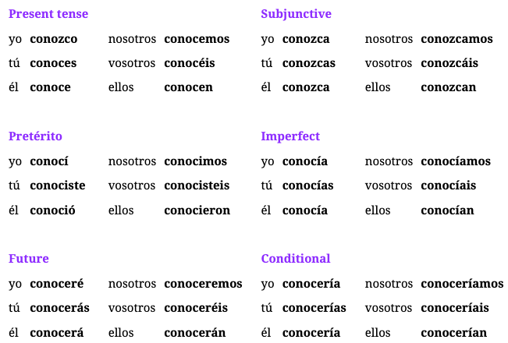

Understanding Conocer

* literal meaning “to be acquainted” and takes direct objects
* can refer to first meeting someone OR ongoing fact of knowing someone
* present YO and subjunctive forms get “Z” in conjugations
* is also used with being familiar with a place “I know that city”

Examples of Conocer

1. I want to be acquainted with him → Lo quiero conocer (him I want to acquaint)
2. She’s from your hometown, you must know her! → Es de tu pueblo, ¡la debes conocer!
3. I haven’t met them yet. → No **los** he **conocido** aún.
4. I’ve never met anyone like this. → Nunca he conocido a nadie así.
5. Everything is in order because I’m going to meet her parents. → Todo está en orden porque voy a conocer a sus padres.
6. They have known it for a long time, and now he has to know it. → Lo han sabido por mucho tiempo, y ahora él lo tiene que saber.

Examples: Conocer Conjugations

1. You wear those clothes now, but not when I met you. → Llevas esa ropa ahora, pero no cuando te conocí.
2. They want me to meet him because you already know him. → Quieren que yo lo conozca porque tú ya lo conoces.
3. I know my friend and he’s going to arrive late. → Conozco a mi amigo y él va a llegar tarde.
4. He already knew that city and now he’s coming back with her. → Él ya conocía esa ciudad y ahora vuelve con ella.
5. Take this, I know you’re not going to do it if I don’t give it to you now. → Toma esto, sé que no lo vas a hacer si no te lo doy ahora.
6. They want me to meet them while they are drinking coffee together. → Quiere que los conozca mientras están tomando café juntos.

## Ep 156: How to say Take

### Verb: Tomar

**Present:** tomo, tomas, toma, tomamos, toman

**Subjunctive:** tome, tomes, tome, tomemos, tomen

**Pretérito:** tomé, tomaste, tomó, tomamos, tomaron

**Imperfect:** tomaba, tomabas, tomaba, tomábamos, tomaban

**Future:** tomaré, tomarás, tomará, tomaremos, tomarán

**Conditional:** tomaría, tomarías, tomaría, tomaríamos, tomarían

### Verb: Llevar

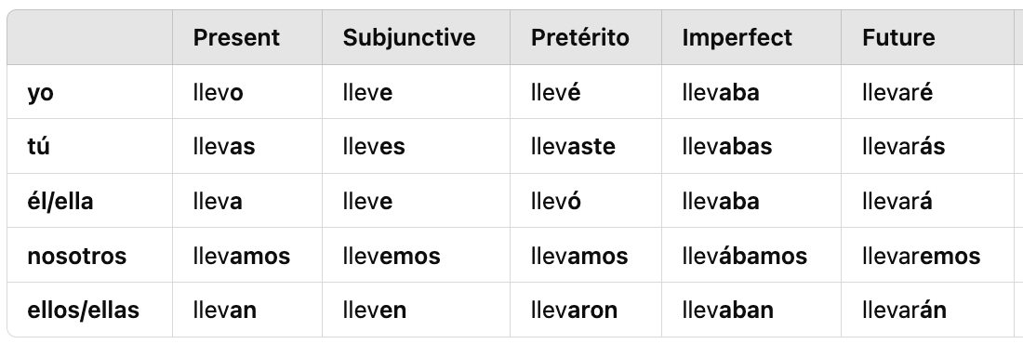

Understanding Tomar (touching, drink)

* refers to the action of **touching something** to take it ← pick something up off a table
* also refers to an additional meaning to drink something

Understanding Llevar (possession, bringing, bearing, wearing)

* **RULE**: refers to the action of **taking possession** of something ← can mean something like bringing something from one place to another
* also refers to actions related to bringing or bearing something or even wearing clothes
* poner + llevar can be used where ponerse describes putting on clothes but llevar refers to the ongoing action of wearing them

Understanding Llevar (GPT)

1. **to carry / to bring** (something/someone)
   1. **RULE**: physically transport something from one place to another
   2. I carry/bring my backpack to school ← Llevo mi mochila a la escuela.
   3. Can you take this to the kitchen? ← Puedes llevar esto a la cocina?
2. **To wear** (clothing)
   1. **RULE**: talk about what someone is wearing
   2. She’s wearing a red dress ← Ella lleva un vestido rojo.
   3. What are you wearing today? ← ¿Qué llevas puesto hoy?
      1. llevar + puesto == to have on / to be wearing
3. **to be in charge of** (manage/lead)
   1. **RULE**: means to be responsible for something
   2. She manages the accounting for the company ← Ella lleva la contabilidad de la empresa
4. **to have been doing something**
   1. **RULE**: used in time scenarios to express how long someone has been doing something
   2. I have been learning spanish for 3 years ← Llevo tres años aprendiendo español.
5. **to come with or include** (ingredients/components)
   1. **RULE**: refers to what something comes with or includes
   2. What does the salad come with? ← Que lleva esta ensalada?
6. **to lead or be ahead** (competition/comparison)
   1. **RULE**: express when someone is ahead in a competition or situation
   2. In the race, he is 3 meters ahead of me ← En la carrera, el me lleva tres metros.

Examples of How to Distinguish Llevar and Tomar

1. Are you going to take what is on the table → ¿Vas a tomar lo que está en la mesa?
2. Do you want to drink a coffee with me tomorrow afternoon → ¿Quieres tomar un café conmigo mañana por la tarde?
3. We’re going to take the twenty things that are there → Vamos a tomar las veinte cosas que están ahí.
4. Can you take all these things to the party tonight → ¿Puedes llevar todas estas cosas a la fiesta esta noche?
5. You have to take this to that place or I’m going to go crazy(f) → Tienes que llevar esto a ese lugar o me voy a volver loca.
6. She wants to wear those clothes because the party is very important → Ella quiere llevar esa ropa porque la fiesta es muy importante.

Examples Tomar Only

1. They are going to do it when I take what is mine → Lo van a hacer cuando yo tome lo que es mío.
2. Take this, you can do it because you know the order of the things → Toma esto, tú puedes hacerlo porque sabes el orden de las cosas.
3. He drinks coffee every morning, but I can’t drink anything → Él toma café todas las mañanas, pero yo no puedo tomar nada.
4. He took those things too because he saw I was taking them → Tomó esas cosas también porque vio que yo las estaba tomando.
5. We want him to drink a lot of water during these days → Queremos que tome mucha agua durante estos días.

Examples Llevar Only

1. I won’t take anything tomorrow → Yo no llevaré nada mañana.
2. Take all this to your house, he already took the other things → Lleva todo esto a tu casa, él ya llevó las otras cosas.
3. I’m not taking anything, but the rest of the people are going to take it → Yo no llevo nada, pero el resto de las personas lo va a llevar.
4. You always take those twenty things to school. Do you need them → Siempre llevas esas veinte cosas a la escuela. ¿Las necesitas?
5. It’s clear that he’s taking that far away because those people are about to arrive → Está claro que lleva eso lejos porque esas personas están por llegar.

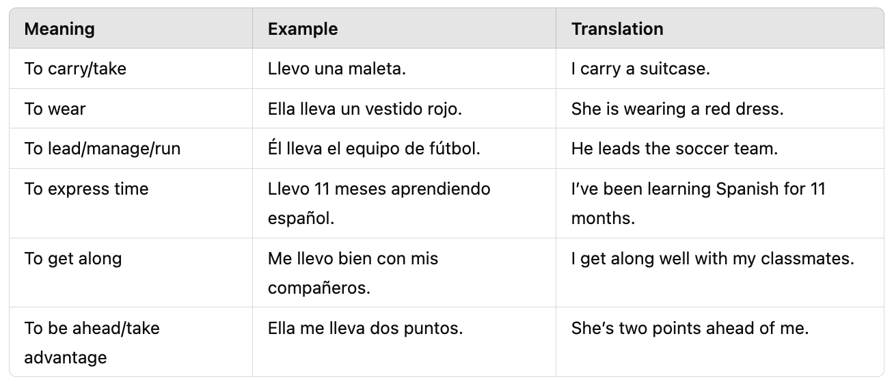

Week 28: Lessons 151-155

Tips/Group

* REMEMBER: pronounce J as an H
* aunque: although, even though
* preocupar meaning practice
* me hace falta ← I’m in need of (lack)
* por: because of

Words

* vuelto: gone back/come back (past participle)
* llegado: arrived (past participle)
* buscando: looking (gerund)
* el resto: the rest (refers to remainder of quantity of something)
* el largo: the length (noun)
* largo/a: long (adj)
* la mitad: the half (**RULE**: need to add article)
* media: average | for time to say “thirty”
* baja: drop/loss/casualty
* bajo: under/short/low
* el orden: order (how things are arranged)
* la orden: the order (a command)

Idioms

* volver a + infinitive: indicates to do something again
* llegamos: We’re here
* que pase: to come in (to pass, to enter)
* estar + por llegar: about to arrive (near future)
* estar + por venir: yet to come (distant future)
* me [volver] loco: I’m going crazy

Extra Words

* programmer: programador
* mathematician: matemático
* pain: dolor
* prepared: preparada
* the tent: la carpa

## Ep 154: Media v Mitad

Examples of New Words

1. What did you do with the rest of the water? → ¿Qué hiciste con el resto del agua?
2. If we get there, we’ll see the length of the place. → Si llegamos ahí, veremos el largo del lugar.
3. She gave me half of her things. → Ella me dio la mitad de sus cosas.
4. I only want half of your food. → Solo quiero la mitad de tu comida.
5. It’s three thirty. → Son las tres y media.
6. There were a lot of losses this year. → Hubo muchas bajas este año.
7. After last week’s drop, we haven’t had any more. → Después de la baja de la semana pasada, no hemos tenido más.
8. There were very few casualties. → Hubo muy pocas bajas.
9. The drop is because of the order of the numbers. → La baja es por el orden de los números.

## Ep 153: Counting to 20

Understanding “Going Crazy” Idiom

* volver normally means “to return” or “do something again”
* **RULE**: use reflexively + adjective loco means → to go crazy

Examples: Go Crazy (volver + loco)

1. Afterwards he went crazy. → Después se volvió loco.
2. The teenage girls go crazy about this. → Las muchachas se vuelven locas por esto.
3. I’m going crazy because of the demons. → Me vuelvo loco por los demonios.
4. We went crazy last year because of work. → Nos volvimos locos el año pasado por el trabajo.

## Ep 152: Llegar, Buscar

### Verb: Llegar

**Present:** llego, llegas, llega, llegamos, llegan

**Subjunctive:** llegue, llegues, llegue, lleguemos, lleguen

**Pretérito:** llegué, llegaste, llegó, llegamos, llegaron

**Imperfect:** llegaba, llegabas, llegaba, llegábamos, llegaban

**Future:** llegaré, llegarás, llegará, llegaremos, llegarán

**Conditional:** llegaría, llegarías, llegaría, llegaríamos, llegarían

### Verb: Buscar

**Present:** busco, buscas, busca, buscamos, buscan

**Subjunctive:** busque, busques, busque, busquemos, busquen

**Pretérito:** busqué, buscaste, buscó, buscamos, buscaron

**Imperfect:** buscaba, buscabas, buscaba, buscábamos, buscaban

**Future:** buscaré, buscarás, buscará, buscaremos, buscarán

**Conditional:** buscaría, buscarías, buscaría, buscaríamos, buscarían

Understanding Llegar: to arrive/to get here/there

* means to arrive or to get here/there
* **NOTE**: got/gets to a place is english terminology
  + He got here at 12 (Llegó a las 12)
* **RULE**: when describing where someone has arrived, use “a after verb”
  + We’ll do it when **she gets to** the party. → Lo haremos cuando **ella llegue a** la fiesta. ← USE **SUBJUNCTIVE**
* **NOTE**: In english we say “Were here” but instead its “We arrived” ← Llegamos! (pret)

Understanding Llegar Idiom Near Future (about to arrive)

* **REMEMBER**: there is a special use for “por” to indicate something is about to happen
  + Ex: The man is about to do that → El hombre está por hacer eso.
  + **RULE**: conjugate estar + por + infinitive
* IDIOM: this can be done with Llegar
  + **RULE NEAR FUTURE**: used when something is in the near future
    - Ex: The best is **about to arrive**. → Lo mejor **está por llegar**.
  + **RULE DISTANT FUTURE**: use venir to say, “yet to come” → **por venir**
    - Ex: I’m afraid of what is yet to come. → Tengo miedo de lo que está por venir.
  + **RULE ALT**: use “a punto de” to mean about to do something
    - Ex: I am about to study → Estoy a punto de estudiar
* Examples
* 1. The man is about to do that ←El hombre está por hacer eso.
* 2. The best is about to arrive ←Lo mejor está por llegar.
* 3. I’m afraid of what is yet to come ← Tengo miedo de lo que está por venir.
* 4. I am about to study ← Estoy a punto de estudiar

Understanding Buscar: to seek / to look for / to search

* **RULE**: you dont need to say the word “for” just use the direct object
* Ex: I’m looking for her. → La estoy buscando.

Examples: Llegar (to arrive)

1. Yes, he has arrived; he got here at 11. → Sí, ha llegado; llegó a las once.
2. He’s here! Tell him to come in. → ¡Llegó! Dile que pase.
3. Get here on time! Don’t be the last one(f)! → ¡Llega a tiempo! ¡No seas la última!
4. The gentleman hasn’t arrived yet, but the lady already arrived. → El caballero no ha llegado aún, pero la dama ya llegó.
5. She always arrives after we leave. → Siempre llega después de que nos vamos.
6. We didn’t arrive on time, but it’ll be fine when she arrives. → No llegamos a tiempo, pero estará bien cuando ella llegue.
7. She wants me to get to her house at 7. → Ella quiere que yo llegue a su casa a las siete.

Examples: Buscar (to search/look for)

1. They have searched through the whole house, it’s not real. → Han buscado por toda la casa, no es real.
2. They always look for trouble. → Siempre buscan problemas.
3. She is looking for her phone. → Está buscando su teléfono.
4. We’re going to look for it. → Vamos a buscarlo.
5. The devil always looks for fear. → El diablo siempre busca el miedo.
6. You don’t have to look for your car, it’s here. → No tienes que buscar tu auto, está aquí.
7. I’m looking for the house that is on the left, but I only see the one on the right. → Busco la casa que está a la izquierda, pero solo veo la de la derecha.
8. Look for the phone like we are looking for it. → Busca el teléfono como nosotros lo buscamos.

## Ep 151: Volver

### Verb: Volver

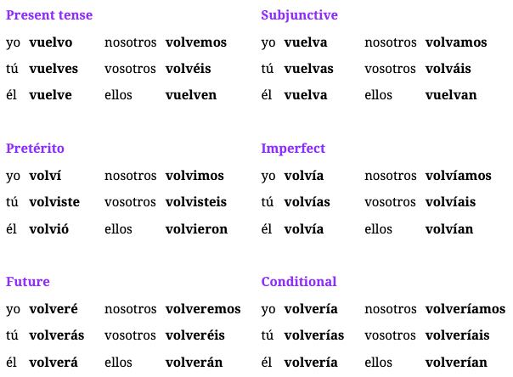

**Past Participle**: **vuelto**: gone back/come back | **Gerund**: volviendo: returning

Understanding Volver: to go back

* **RULE**: volver a + infinitive → to do something again (COMMON WAY TO SAY AGAIN)
  + No quiero volver a hacer eso → I dont want to do that again
  + Ella ha **vuelto** a hacerlo → She has done it **again** (she has again done it)
* **NOTE**: there are now multiple ways to say “again”
  + otra vez, de nuevo, de vuelta, volver a + infinitive
* FUTURE:
* Imperatives:
  + Simple informal: Vuelve | Simple Formal: Vuelva
  + Negative imperative triggers subjunctive
    - Dont do this again! → No vuelvas a hacer esto

Understanding Conjugation Order for Again

* **RULE**: in order to use volver to say “again” DO NOT conjugate the verb that is being repeated
* NOTE: the preterite conjugation, volvió, is the most common forms of verb
* Ex: She called me again → Ella me volvió a llamar
  + Literal: She went back to calling me

Examples: Again using “Volver a + infinitive” & Participle

1. She wants to work again. → Quiere volver a trabajar.
2. He has gone straight home again. → Ha vuelto a ir derecho a casa.
3. She hasn’t come back because she feels sad. → No ha vuelto porque se siente triste.
4. He has gone straight home again. → Ha vuelto a ir derecho a casa.
5. You don’t have to go back if you don’t want to. → No tienes que volver si no quieres.
6. She hasn’t done it again since last week. → No lo ha vuelto a hacer desde la semana pasada.

Examples: Again w/ Preterite Tense

1. My friend(f) went out partying again. → Mi amiga volvió a salir de fiesta.
2. I went back to the left house. → Volví a la casa izquierda.
3. You went straight back home after the party. → Volviste derecho a casa después de la fiesta.
4. I didn’t do it again. → No lo volví a hacer.
5. We went to that place again another day. → Volvimos a ir a ese lugar otro día.
6. They didn’t speak about the general idea again. → No volvieron a hablar de la idea general.
7. You worked until late again. → Volviste a trabajar hasta tarde.

Examples: Again + Present Tense

1. He does it again. → Lo vuelve a hacer.
2. I’m not doing that again. → No vuelvo a hacer eso.
3. You aren’t doing that again. → No vuelves a hacer eso.
4. The teenage boy comes back, but they don’t talk to him again. → El muchacho vuelve, pero ellos no vuelven a hablar con él.

Examples: Again + Subjunctive

1. I hope they don’t do it again. → Espero que no lo vuelvan a hacer.
2. I want you(formal) to come back to our house. → Quiero que usted vuelva a nuestra casa.
3. God doesn’t want you to do that again. → Dios no quiere que vuelvas a hacer eso.
4. He is a gentleman, so I hope he comes back. → Él es un caballero, así que espero que vuelva.

Examples: Again + Future

1. He will do it again if you let him. → Lo volverá a hacer si lo dejas.
2. You will come back home soon. → Volverás a casa pronto.
3. We won’t talk to the teenage girl again. → No volveremos a hablar con la muchacha.
4. I will work again soon. → Volveré a trabajar pronto.

Examples: Imperatives

1. Come back here now! → ¡Vuelve aquí ahora!
2. (Formal) Do that again, please! → ¡Vuelva a hacer eso, por favor!
3. Don’t go to the last place again. → ¡No vuelvas a ir al último lugar!
4. (Plural) Go back home because I don’t feel well. → Vuelvan a casa porque no me siento bien.

PAUSE WEEK: BOGOTA SCHOOL

Tips

* Integrate vs Deliver: notice that there is a “R” in Entregar. So Integrate, focus on “Te” sound vs “Tre” sound
* I vs E sounds: I sound == Eee | E sound == Ehh
* Slowly how to use in adverb vs adjective
  + ADVERB: Puedes hablar mas lento? <- describes the verb to talk
  + ADJ: La tortuga es lenta. <- describes the turtle
* Un importante proceso de aprendizaje ←An important learning process (NOUN)
* time is always feminine; hasta LAS cuatro

Words

* calmarse: calm down
* útil: useful | inutil: useless
* liviano: soft/light | pesado: heavy
* delgado: thin | gordo: fat
* bello/a: very beautiful
* el ritmo: the pace/rhythm (reeht-moh)
* aprendizaje: learning (noun) ah-pren-de-sah-hey
* oración: sentence (or-ah-see-on)
* frases: phrases (frah-sehs)
* cerezas: cherries (ser-dehh-sahs)
* Dueña/o: Owner
* roto/a: broken (past participle) adj for romper
* la silla: the chair
* el asiento: the seat (este es mi asiento)
* el hielo: the ice (yeah-loh)
* sujeto/a: subject
* se lesiona: gets injured
* los entrenamientos: the trainings (in-tren-nah-mientos)
* acostarse: lie down / go to bed
* nuevamente: again (kind of like de nueve)
* exigente rutina: demanding routine (ex-ee-hen-tay roo-tee-nah)
* un rato: a while

Idioms

* Ya voy en camino: I’m on the way
* antes de salir: before leaving
* para poder: so I can ← literal: in order to + be able to
* a menudo: often
* antes de acostarse: before bedtime
* aun asi: even though or even so
* se parece a mi: look like me
* me lo han dicho: they have said it to me
* cada vez: every time
* almorzaste algo?: did you have anything for lunch

### Frases Interesantes

1. Estoy en un programa intensivo [en-ten-see-voh] de aprendizaje [ah-pren-de-zah-hey] de idiomas que dura un año. Si no estudio mucho y no sigo el ritmo, me sacan del programa.
   1. de aprendizaje de idiomas: aprendizaje is the noun of learning
   2. dura: 3rd person of verb Durar (NOT SUBJ)
   3. sigo: 1st person of verb Seguir (I keep up)
   4. el ritmo: the pace
   5. me sacan: reflexive 3rd person Sacar present (they take out/remove)
   6. Translate: *I am in an intensive language learning program that lasts one year. If I don't study hard and keep up with the pace, they'll remove me from the program.*
2. Que bien, y que te trae por Bogotá?
   1. te trae: indirect “te” to person being address + trae 3rd person (brings you)
3. Espero que puedas aprender muchisimo mas (much more)
4. Qué trabajo te gustaría tener en el futuro? ← remember job is trabajo
5. Qué tipo de trabajo te gustaría hacer en el futuro? ← like to do
6. Solo me interesa saber de ti aun así sea antes de dormir
   1. me interesa: interests me or I am interested
   2. saber de ti: to know about you or hear from you
   3. aun asi: even so / even though
   4. antes de dormir: before sleeping or going to bed
   5. Translation: I'm only interested in hearing from you, even if it's just before bed.
7. Espero que la gente de alli **sea** paciente conmigo.
8. Ojalá te vea pronto ← requires subjunctive (oh-hha-lah, focus on ending “a”)
9. Yo salí del trabajo **hace** un rato ← i left work a while ago (remember **ago** is first)

### Idiom: al+ infinitive (upon/when) ← Creates the “verb+ing”

* **RULE**: when preposition “a” + article “el/la” + infinitive verb creates the idea of “upon [doing something]” or “when [doing something]”
* **RULE**: al + infinitive expresses upon [verb]ing or when [verb]ing
* Ex: Upon hearing the new, I was surprised → Al escuchar la noticia, me sorprendí
* Ex: I feel very bad knowing that you have those thoughts → Me siento muy mal al saber que tengas esos pensamientos

### **Días de la Semana**:

* Lunes, Martes, Miércoles, Jueves, Viernes, Sábado, Domingo

New Verbs

1. **Requerir**: to require
2. **Realizar**: to carry out/perform
3. **Entregar**: to deliver/hand over/submit
   1. Yo entrego los paquetes a tiempo. ← I deliver the packages
   2. Ellos entregaron el proyecto ayer ← They submitted
   3. Mañana tú entregarás el informe final ← Will submit the final report
   4. Nosotros hemos entregado todos los documentos necesarios ← We have delivered
4. **Contar**: to count/tell/recount
   1. Ella cuenta historias muy interesantes ← She tells
   2. Nosotros contamos el dinero antes de salir ← We counted X before leaving
   3. Ella se contó un cuento para **calmarse** ← She told herself X to **calm down**
   4. Ellos se han **contado** secretos desde niños ← They have **told** each other
5. **Contarse**: to tell oneself or consider oneself
   1. Ellos se han **contado** entre los mejores jugadores del equipo ← They have **considered** themselves
6. **Jubilarse**: to retire, used reflexively ONLY | who-bee-lar-say
   1. Quiero trabajar duro ahora para poder jubilarme temprano ←I want to work hard now so I can retire early
      1. para: in order to | poder: to be able to
   2. Mis padres se jubilaron el año pasado
   3. Retirado: adj meaning to be retired already
      1. Mi abuelo está retirado y vive en el campo ←is retired
      2. Mi objetivo es estar retirado a los 50 años ← goal is to be retired
7. **Romper**: to break (rrom-pear) + roto (PastPart)
   1. La ventana está rota
   2. Voy a romper el papel (tear)
   3. Él rompió la silla ← He broke the chair
   4. Ella rompió con su novio ← she broke up
   5. Romper el hielo ← break the ice

### Verbos Reflexivos

1. To Wake up: despertase, levantarse
2. To dry: secarse
3. to brush: peinarse
4. to wear: vestirse, ponerse
5. To take off: desvestirse, quitarse
6. To stand: pararse
7. To sleep: dormirse

## New Verbs: Integrar

Examples

1. My job requires me **to integrate** different systems → Mi trabajo requiere que **integre** diferentes sistemas.
   1. requiere que: “To require” present tense 3rd person ← **it requires that**
   2. integre: subjunctive Yo
2. I integrate different systems together in order to make them do different things → Integro diferentes sistemas juntos para hacer que realicen diferentes funciones.
   1. hacer que realicen: realicen verb is “Realizar” which is **to carry out/perform** subjunctive tense
3. I integrated that already → Ya integré eso. (PRETERITE)
4. I will integrate that tomorrow → Integraré eso mañana. (FUTURE)
5. Did you integrate that system yet? → ¿Ya integraste ese sistema? (PRETERITE)

## New Verbs: To Start

Different Verbs

1. Empezar: to start/begin
   1. Usage: starting actions, activities and events
   2. Ex: La película va a empezar pronto ← is going to start
2. Comenzar: to start/begin
   1. Usage: more formal
   2. Ex: Vamos a comenzar la reunión ahora ← the meeting
3. Iniciar: to initiate/start/login
   1. Usage: formal for starting processes and systems or abstract
   2. Ex: Inicia sesión con tu cuenta ←login w/ your account

## Ojalá: Hopefully

Understanding Ojalá: Hopefully

* Not a verb, but a INTERJECTION to express desire like “God willing”
* Pronounce: oh-ha-la
* requires SUBJUNCTIVE after
* Ex: Ojalá llueva mañana ←hope it rains tomorrow

Week 27: Lectures 146-150

Tips/Group Notes

* Understanding a las
  + if event you are not going to or is not happening, dont add "a las"
  + only use "a" to tell time or stating the time
  + if the even you are referring to is happening at a specific time use "a las"
  + It's already six o'clock --> Ya son las sies en punto (use son for 'they are')
* Understand Gustar (Tips)
  + **FORMAT**: who is being pleased + gustar tense + subject
  + She likes the queen → A ella le gusta la reina
    - The queen is pleasing to her -> to her the queen is pleasing
    - *use "a ella" in beginning or end to add emphasis or avoid confusion when there are multiple people involved*
* Might need help → Ellos podrían necesitar ayuda
* I dont know what to think --> No se que pensar (we can drop the "lo que" because of direct object + infinitive)
* We have been waiting for hours --> Hemos estado esperando por hours (when refering to time, ALWAYS use por, not for people)
* We have been waiting for him --> Lo hemos estado esperando (drop the por due to waiting for person)
* As soon as I do this, I'll go there --> Tan pronto como haga esto, ire ahi (tan pronto como triggers subjunctive)

Words

* sentido: felt (participle)
* sintiendo: feeling (gerund)
* retirarme: retire myself
* sentado/a: seated/sitting down (participle/gender)
* sentando: sitting (gerund)
* único: only (before noun)
* último: last (before noun)
* correcto: correct (after noun/without w/ lo)
* izquierda: left
* derech**a**: right
* la mano: hand (FEMININE)
* derech**o**: straight/directly (adverb)
* Damas: Ladies
* Caballeros: Gentlemen
* el muchacho/a: teenager boy/girl
* demonio: demon
* santo/a: saint
* san: saint (before masculine noun -shortened)
* organizarse: to get organized
* correr: to run

Idioms

* soy sólo yo: is it just me (am I just I)
* amor por ella: love for her (love because of her)
* lo correcto: the correct/right thing (without noun)
* el camino de la derecha: the path on the right
* dejar ir: to let go of

## Ep 149: Damas y Caballeros

Examples

1. Could you give this to the mister at the second table? → ¿Podrías darle esto al señor de la segunda mesa?
2. Ladies and gentlemen, please **listen carefully**. → Damas y caballeros, por favor **escuchen bien**.
3. He always felt like a gentleman. → Siempre se sentía como un caballero.
4. The lady **wanted** to know where that place was. → La dama **quería** saber dónde estaba ese lugar.
5. (Formal) Sit down in front of the teenage boy and the teenage girl. → Siéntese adelante del muchacho y de la muchacha.
6. The teenage girl went out partying with her friends. → La muchacha salió de fiesta con sus amigos.
7. He will see the gods when he sits down on the left. → Verá a los dioses cuando se siente a la izquierda.
8. It was because of the demons of her past. → Era por los demonios de su pasado.
9. The people of this city like Saint Juan and Saint Maria. → A la gente de esta ciudad le gustan San Juan y Santa María.
10. You have to let go of your demons. → Tienes que dejar ir tus demonios.

## Ep 148: Right in Spanish

Understanding New Words

* futuro: can be used before or after a noun
  + before noun: something you expect to be yours ← futura esposa
* directions: tend to use “hacia” before the noun
  + ¿Fuiste hacia la derecha? Yo fui hacia la izquierda ← Did you go to the right? I went to the left.
  + **NOTE**: left/right change genders based on noun BUT normally used with feminine nouns

Examples of Correcto

1. I’m talking about the last guy. → Estoy hablando del último chico.
2. Last week we were at the correct place. → La semana pasada estuvimos en el lugar correcto.
3. These aren’t the correct places. → Estos no son los lugares correctos.
4. I want to do the right thing. → Quiero hacer lo correcto.
5. The last car is the correct one. → El último auto es el correcto.
6. He did the right thing, even if he was the last one. → Hizo lo correcto, aunque fuera el último.
7. This isn’t the right house, I wasn’t here last week. → Esta no es la casa correcta, no estuve aquí la semana pasada.

Examples II

1. The general idea is not to have secret places. → La idea general es no tener lugares secretos.
2. That’s the general reason **why** they were here. → Esa es la razón general **por** la que estaban aquí.
3. We’ll do it again at some future moment. → La haremos otra vez en algún momento futuro.
4. I can only do it with my right hand. → Sólo lo puedo hacer con mi mano derecha.
5. It’s over there, on the left side. → Está por allá, del lado izquierdo.
6. Afterwards she went straight to his house. → Después fue derecho a su casa.
7. She went to the left and then **went right home**. → Fue a la izquierda y después **fue derecho a casa**.
8. You have to go **to the right** and I’ll go to the left. → Tienes que ir **hacia la derecha** y yo iré hacia la izquierda.
9. I don’t feel well, so I should go straight home. → No me siento bien, entonces debería ir derecho a casa.
10. They feel like the path on the right is better than the one on the left. → Sienten que el camino de la derecha es mejor que el de la izquierda.

## Ep 147: Sentar/Sentarse

### Verb: Sentar (to seat, place; to suit, fit)

**Present:** siento, sientas, sienta, sentamos, sientan

**Subjunctive:** siente, sientes, siente, sentemos, sienten

**Pretérito:** senté, sentaste, sentó, sentamos, sentaron

**Imperfect:** sentaba, sentabas, sentaba, sentábamos, sentaban

**Future:** sentaré, sentarás, sentará, sentaremos, sentarán

**Conditional:** sentaría, sentarías, sentaría, sentaríamos, sentarían

Understanding Sentar

* TRUE meaning: to seat;
* **RULE**: ONLY for the action of first sitting down NOT the state of siting down for a length of time
* although siento has the same spelling for sentir/sentar (yo) can tell from context
* **RULE**: use **sentar** when one person is seating another person
* **RULE**: use **sentarse** when sitting down or seating yourself

Understanding “is sitting” ie the act of already being seated not initial

* Ex: She is sitting over there ← *se está sentado allí* → NOT CORRECT (herself is sitting down)
  + you would imply this is correct BUT sentarse is not used
  + use “sentado/a” adj to mean
  + CORRECT: Ella está sentada allí.
* Ex: She sits down over there → se sienta allí (The **initial act** of sitting)

Understanding Subjunctives

* again there is conflict with “siente” for sentir verb but check context
* I want them to sit together. → Quiero que se sienten juntos.
  + could also mean I want them to FEEL together

Understanding Imperatives

* Common to say “Sit Down” → siéntate | Formal: siéntese | Group: siéntense

Examples

1. I’m going to sit down here. → Me voy a sentar aquí.
2. There are eleven boys and we have seated them all. → Hay once chicos y los hemos sentado a todos.
3. Why have you sat down? They feel that they need you. → ¿Por qué te has sentado? Ellos sienten que te necesitan.
4. Do you want to sit down? They have already sat down. → ¿Te quieres sentar? Ellos ya se han sentado.
5. I’m sorry, I won’t sit here. → Lo siento, no me siento aquí.
6. The boys are sitting at that table. → Los chicos están sentados en esa mesa. (not initially first sitting down)
7. Did she sit down where I sat down? → ¿Ella se sentó donde yo me senté?
8. (plural) Sit down! It's already time for us to sit down. → ¡Siéntense! Ya es hora de sentarnos. (Imperative)

## Ep 146: Sentir/Sentirse

### Verb: Sentir (to feel, sense, regret)

**Present:** siento, sientes, siente, sentimos, sienten

**Subjunctive:** sienta, sientas, sienta, sintamos, sientan

**Pretérito:** sentí, sentiste, sintió, sentimos, sintieron

**Imperfect:** sentía, sentías, sentía, sentíamos, sentían

**Future:** sentiré, sentirás, sentirá, sentiremos, sentirán

**Conditional:** sentiría, sentirías, sentiría, sentiríamos, sentirían

Understanding Sentir

* means: feeling
* can be used reflexively like “me siento feliz”
* lo siento can mean “I feel sorrow/remorse”
* **RULE**: “I feel like” must change to “I feel that ← Siento que”
* **REFLEXIVE**: used to describe how YOU/SOMEONE is feeling + adjective

Examples

1. Is it just me or are you feeling that? → ¿Soy sólo yo o estás sintiendo eso?
2. I’m sorry, I shouldn’t have done that. → Lo siento, no debí hacer eso./ No debería haber hecho eso
3. I feel like nothing **actually** happened. → Siento que **en verdad** no pasó nada.
4. Do you feel like someone is watching us? → ¿Sientes que alguien nos está mirando?
5. We feel like **they feel sad**. → Sentimos que ellos **se sienten tristes**.
6. I felt sad when **I knew** you didn’t feel anything. → Me sentí triste cuando **supe que** no sentiste nada.
7. When he was fifteen he felt love for her. → Cuando tenía quince años sintió amor por ella.

Week 27: Lectures 141-145

Tips/Group Notes

* Tienes → Tay-enes
* viajaron → Via-HA-rone
* The *third person* seems strong, stronger than what I thought she **was**. → La *tercera persona* parece fuerte, más fuerte de lo que creí/pensé que ella **era**.
* Even if it’s → aunque sea (triggers subjunctive)
* Creías → crey-eeee-as
* I think that + verb ← DOES NOT TRIGGER SUBJUNCTIVE only negative
  + I think that you have to → Creo que tienes que
* el fin de semana pasa**d**o
* Qué te parecen → What do you think
* como me llamo → Whats my name
* viaje vs viejo (trip/old)
* mujer(woman) vs mejor(better) vs mayor(elderly)
* reunión: meeting (rrey-une-yon)
* tanto: so much |
* guerra: (gare-rrah) | ejército: army (ir-HARE-see-toh)
* sumergirme: immerse myself

Random

* un pastel: cake | el horno: the stove | tonta: foolish
* sacar tiempo para: to make time for
* ajetreado/a: busy/hectic (AHH Hey Tray Ah Doh)
* en vez/lugar de... instead of
* caminata.. long walk or hike
* como tarde / mas tarde: at the latest
* estoy deseando: I am looking forward to
* cargar pilas: to recharge one's batteries/ to regain one's energy

Words

* muerto: died (participle)
* muriendo: dying (gerund)
* entendido: understood (participle) (en-ten-dee-doh)
* sueño: dream, sleepy
* maldición: curse (Mal + dee + ce + ion)
* una orden: an order (FEMININE)
* por falta de: lack of
* me hace: makes me
* me haces feliz: you make me happy
* muy exigente: very demanding

Idioms

* I’m dying to do something: muero por + infinitive
* thought I heard → had understood → habia entendido
* my lucky number: mi número de la suerte
* I’m in need of: Me hace falta + word

## Ep 144: Sueno, orden, falta

Understanding New Words

* Sueño can mean multiple things from dream, sleepy, sleepiness
  + very sleep → mucho sueño
* IDIOM: I’m in need of luck → Me hace falta suerte
  + uses the verb hacer
  + literal meaning: for me makes lack luck

Understanding **What do you think** Idioms

* Qué te parecen
  + Literal: what do they seem to you
  + Used: ask opinion on something specific like items, ideals (PLURAL)
  + ¿Qué te parecen las nuevas reglas? (new rules)
* Que piensas
  + Literal: What do you think
  + Used: more general on broader range of topics
  + ¿Qué piensas sobre viajar a España?

Examples

1. We’re not in need of anything here! → ¡No nos hace falta nada aquí!
2. They’re in need of a lot of money. → Les hace falta mucho dinero.
3. When she was in the city she didn’t see me for lack of time. → Cuando estuvo en la ciudad no me vio por falta de tiempo.
4. You must leave now, it was **an order**. → Debes irte ahora, fue una orden.
5. During her **dream** that night she heard a **curse**. → Durante su sueño esa noche, ella escuchó una maldición.
6. You could see that he was **sleepy**. → Podías ver que tenía sueño.
7. It was eleven and I was sleepy. → Eran las once y tenía sueño. (plural + ser)

## Ep 143: Once, doce, trece

Understanding Number Scenarios

* multiplying: use “por” to multiply numbers
* day of the month: use the article “el + number”; I will be here the twelve
* RULE: You have 12 people here ← you need “a” preposition due to people/names
  + Tienes a doce personas aqui

Examples

1. Please don’t die! You have twelve people here with you! → ¡Por favor no mueras! ¡Tienes **a** doce personas aquí contigo!
2. He said he would be here either the thirteenth or the fifteenth of this month. → Dijo que estaría aquí o el trece o el quince de este mes.
3. If you give me three more, I’ll have fourteen, because now I have eleven. → Si me das tres más, tendré catorce, porque ahora tengo once.
4. Cuatro por tres es igual a doce. → Four times three equals twelve.
5. El número trece es mi número de la suerte. → The number thirteen is my lucky number.

## Ep 142: Entender

**Verb: Entender (to understand)**

**Present:** entiendo, entiendes, entiende, entendemos, entienden

**Subjunctive:** entienda, entiendas, entienda, entendamos, entiendan

**Pretérito:** entendí, entendiste, entendió, entendimos, entendieron

**Imperfect:** entendía, entendías, entendía, entendíamos, entendían

**Future:** entenderé, entenderás, entenderá, entenderemos, entenderán

**Conditional:** entendería, entenderías, entendería, entenderíamos, entenderían

Understanding Entender

* IDIOM: the english phrase “I thought you heard something” in spanish is really switched with “understood something”
* HOW TO SAY: entendió → inten-dee-OH

Examples

1. I haven’t understood anything that he has told me. → No he entendido nada de lo que me ha dicho.
2. Tell me that again; I want to understand. → Dime eso otra vez, quiero entender.
3. She had understood something different. → Había entendido algo diferente. (*thought had heard*)
4. If you say “going to be”, he might think he hears “going to do”. → Si dices “va a ser”, puede entender “va a hacer”.
5. He doesn’t understand you, but we do understand you. → Él no te entiende, pero nosotros sí te entendemos.
6. They told me it but I didn’t understand it. → Me lo dijeron pero no lo entendí.
7. We understood that it was in the car, but they understood something different. → Entendimos que estaba en el coche, pero ellos entendieron algo diferente.
8. I told it to you (formal) so that you understand it. → Se lo dije para que usted lo entienda.

## Ep 141: Morir

**Verb: Morir (to die)**

**Present:** muero, mueres, muere, morimos, mueren

**Subjunctive:** muera, mueras, muera, muramos, mueran

**Pretérito:** morí, moriste, murió, morimos, murieron

**Imperfect:** moría, morías, moría, moríamos, morían

**Future:** moriré, morirás, morirá, moriremos, morirán(mor-de-dan)

**Conditional:** moriría, morirías, moriría, moriríamos, morirían

Understanding Morir

* means “to die” and can be a person or a device
* the word “muerto” means both **dead** and the past participle for **died** too
* pretertite forms have an irregularity as it replaces with a “u”
* **REFLEXIVE**: can also be used pronominally: *me estoy muriendo!*

Examples

1. He hasn’t died yet. → No ha muerto aún.
2. I got sad upon hearing that her dog had died. → Me puse triste al oír que su perro había muerto.
3. I’m dying to see what she did. → Muero por ver lo que ella hizo.
4. Maybe she dies at the end. → Quizás muera al final.
5. He hears that she died. → Él oye que ella **murió**. (preterite irregular item)
6. I need to go home; my phone is dying. → Necesito ir a casa; mi teléfono está muriendo.

Week 26: Lectures 136-140

Tips/Group Notes

* HOLD

### Verb: Oír

Present: oigo, oyes, oye, oímos, oyen

Subjunctive: oiga, oigas, oiga, oigamos, oigan

Pretérito: oí, oíste, oyó, oímos, oyeron

Imperfect: oía, oías, oía, oíamos, oían

Future: oiré, oirás, oirá, oiremos, oirán

Conditional: oiría, oirías, oiría, oiríamos, oirían

### Verb: Escuchar

Present: escucho, escuchas, escucha, escuchamos, escuchan

Subjunctive: escuche, escuches, escuche, escuchemos, escuchen

Pretérito: escuché, escuchaste, escuchó, escuchamos, escucharon

Imperfect: escuchaba, escuchabas, escuchaba, escuchábamos, escuchaban

Future: escucharé, escucharás, escuchará, escucharemos, escucharán

Conditional: escucharía, escucharías, escucharía, escucharíamos, escucharían

### Verb: Trabajar

Present: trabajo, trabajas, trabaja, trabajamos, trabajan

Subjunctive: trabaje, trabajes, trabaje, trabajemos, trabajen

Pretérito: trabajé, trabajaste, trabajó, trabajamos, trabajaron

Imperfect: trabajaba, trabajabas, trabajaba, trabajábamos, trabajaban

Future: trabajaré, trabajarás, trabajará, trabajaremos, trabajarán

Conditional: trabajaría, trabajarías, trabajaría, trabajaríamos, trabajarían

Words

* oído: heard (past participle)
* Oye: Listen! & Hey! (imperative/interjection)
* Oiga: Listen (Formal)
* primero: first
* segundo/a: second
* tercero/a: third
* cuarta: fourth
* mayor: greater/bigger/older/elderly (adj)
* pequeño: small (goes before or after noun) (adj)
* largo: long (for time or physical size)
* América del Sur: South America (America of the South)
* fuerte: strong/sturdy (strong flavor or even loud noise)
* aire: air (eye-ray)
* avión: plane
* barco: boat
* el premio: the prize
* un viaje: a trip
* sencillo: simple (adj, gender)

Idioms

* nada de lo que: anything that ← literal: nothing of what
* mas de lo que: more than (when comparing numerical values)

## Ep 138: Fácil, difícil

Understanding Numbers

* **RULE**: numbers can be shortened w/ a MASCULINE NOUN
* numbers for first, second, third etc will change based on gender
* for the number “fourth” this is the same word as BEDROOM

Understanding New Adjectives

* **RULE**: when comparing numerical amounts, use “de”
* **RULE**: when connecting two clauses to compare, use “de lo que”
  + Ex: I worked more than he → Trabaje más que él.
    - use “que” as a comparative word + a simple noun after
  + Ex: I worked more than he knows. → Trabajé **más de lo que** él sabe.
    - the word “than” separates the sentences + has conjugated verb
* **RULE**: when using “posible” with the template of Es posible que… will require a subjunctive; same as Es importante que + estén listos
* for size or comparisons, words like “greater → mayor”

Examples

1. The first house was better than the second. → La primera casa era mejor que la segunda.
2. I liked the second house more than the first. → Me gustó más la segunda casa que la primera. *reversed order*
3. On the second day, we saw what they had done on the first day. → El segundo día, vimos lo que habían hecho **el primer** día. ← *shortened primero*
4. I didn’t listen the first time, but I did it the second (time). → No escuché la primera vez, pero lo hice la segunda. ← *we can remove “vez”*
5. This is the first place I’ve been in a week. → Este es el primer lugar en el que he estado en una semana.
6. You’re going to like the third house. → Te va a gustar la tercera casa.
7. The third day was the best. → **El tercer** día fue el mejor. ← **shorted tercero**
8. (Plural) Listen! This is the fourth time that this has happened this week. → ¡Oigan! Esta es la cuarta vez que esto ha pasado esta semana.

Examples Adjectives for Comparison

1. The fourth house is bigger than the third. → La cuarta casa es mayor que la tercera.
2. It was an elderly person. → Era una persona mayor.
3. My older sister has the control. → Mi hermana mayor tiene el control.
4. These little things really do matter. → Estas pequeñas cosas realmente importan.
5. The path was long and the house was small. → El camino era largo y la casa era pequeña.
6. This is more easy than I expected. → Esto es más fácil de lo que esperaba.
7. There were fewer than 9 people at the party. → Había menos de 9 personas en la fiesta.
8. I worked more than he knows. → Trabajé más de lo que él sabe.
9. I did more than you saw. → Hice más de lo que viste.
10. That was more difficult than I wanted it to be. → Eso fue más difícil de lo que quería que fuera.
11. It’s possible that they will be ready on time. → Es posible que **estén** listos a tiempo.
12. (Formal) Listen! You have to be strong. → ¡Escuche! Tiene que ser fuerte.
13. Aprender vocabulario nuevo es sencillo si practicas todos los días.

Examples Lesson 139

1. The movie doesn’t look like the picture. → La película no se parece a la foto.
2. I heard a train pass. → Oí pasar un tren.
3. We went to the city by train. → Fuimos a la ciudad en tren.
4. She works at that place, but she has to work a lot. → Trabaja en ese lugar, pero tiene que trabajar mucho.
5. I work in a place where I have to listen to people all day. → Trabajo en un lugar donde tengo que escuchar a las personas todo el día.
6. They listen to the trains and the planes go by → Oyen pasar los trenes y los aviones.

## Ep 137: Escuchar vs Oír

**Verb: Escuchar**

Present: escucho, escuchas, escucha, escuchamos, escuchan

Subjunctive: escuche, escuches, escuche, escuchemos, escuchen

Pretérito: escuché, escuchaste, escuchó, escuchamos, escucharon

Imperfect: escuchaba, escuchabas, escuchaba, escuchábamos, escuchaban

Future: escucharé, escucharás, escuchará, escucharemos, escucharán

**Verb: Trabajar**

Present: trabajo, trabajas, trabaja, trabajamos, trabajan

Subjunctive: trabaje, trabajes, trabaje, trabajemos, trabajen

Pretérito: trabajé, trabajaste, trabajó, trabajamos, trabajaron

Imperfect: trabajaba, trabajabas, trabajaba, trabajábamos, trabajaban

Future: trabajaré, trabajarás, trabajará, trabajaremos, trabajarán

Understanding Escuchar (to listen)

* tends to take **direct** objects ← **Lo** vas a escuchar? → Are you going to listen to **him**
* in English we say “to him” but instead we use the direct object of “lo”
* **RULE**: if you cant hear someone well, must use “cant listen them”
  + Ex: I can’t hear you very well. → No te escucho muy bien.

Understand Trabajar

* when talking about your profession, you work of profession
  + **Ex**: I work as a doctor. → Trabajo de doctor.

Understanding Using Escuchar y Oír

* use “Oye” to get someone’s attention to say “Hey”
* Imperatives of Oir like “oye, oiga, oigan” are general “get someones attention”
* Escuchar is for “close attention” to what you are saying

Examples Escuchar

1. You have to listen to us, please. → Nos tienes que escuchar, por favor.
2. Listen to me! I’m telling you the truth. → ¡Escúchame! Te estoy diciendo la verdad.
3. I didn’t listen to any of what you said. → No escuché nada de lo que dijiste.
4. Listen to me! I’m telling you the truth. → ¡Escúchame! Te estoy diciendo la verdad.
5. (Plural) Listen! I want you to do what I’m telling you. → ¡Escuchen! Quiero que hagan lo que les digo.
6. You didn’t listen to anything that I said. → No escuchaste nada de lo que dije.
7. I called him by phone, but I didn’t hear anything. → Lo llamé por teléfono, pero no escuché nada.

Examples Trabajar

1. Work! We have to do this today. → ¡Trabaja! Tenemos que hacer esto hoy.
2. I wasn’t working that day. → No estaba trabajando ese día.
3. I was working there and now she works there. → Yo trabajaba ahí y ahora ella trabaja ahí.
4. I know you don’t want to work, but if you work now you can leave soon. → Sé que no quieres trabajar, pero si trabajas ahora te puedes ir pronto.

## Ep 136: Oír

**Verb: Oír**

**Present**: oigo, oyes, oye, oímos, oyen | **Subjunctive**: oiga, oigas, oiga, oigamos, oigan

**Pretérito**: oí, oíste, oyó, oímos, oyeron | **Imperfect**: oía, oías, oía, oíamos, oían

**Future**: oiré, oirás, oirá, oiremos, oirán | **Conditional**: oiría, oirías, oiría, oiríamos, oirían

Understanding Oír (to hear)

* requires using “y” in present tenses
* **Present**: oigo, oyes, oye, oímos, oyen | **Pretérito**: oí, oíste, oyó, oímos, oyeron

Understanding Imperatives

* **RULE**: when trying to get someones attention in english we say “Listen!” but in spanish they say “Hear” as in “Hear me out” → **¡Oye!**
* these do not use the Subjunctive tense, remember “Hey Siri”

Examples: Preterite

1. We heard what he said. → Oímos lo que él dijo.
2. I already heard what they heard before. → Ya oí lo que ellos oyeron antes.
3. Did you hear? We have to leave soon. → ¿Oíste? Nos tenemos que ir pronto.
4. She heard they were in waiting for those things. → Oyó que estaban a la espera de esas cosas.

Examples: Present

1. He always hears what we say. → Siempre oye lo que decimos.
2. They didn’t hear what I heard. → No oyeron lo que yo oí.
3. You never hear what he hears. → Nunca oyes lo que él oye.
4. Yes, I hear it. → Sí, lo oigo.

Examples: Paresarse ← use preposition “a” for look alike vs comparing

1. My son looks like his father. → Mi hijo se parece a su padre.
2. Those books look like the ones we have at home. → Esos libros se parecen a los que tenemos en casa.

Week 25: Lectures 131-135

Tips/Random/Class

1. Exit through something → MUST use “por”
2. How to pronounce preocupa → Pray-oh-ku-pa
3. Verb Congugations
   1. IR/ER → Present: OE → Preterite: IO
   2. AR → Present: OA → Preterite: EO
4. La ultima vez: the last time
5. Understanding Time
   1. Do X **at** 10pm → **a** las diez
   2. Do x before 10pm → antes de las diez

### Verb: Llamar

**Present**: me llamo, te llamas, se llama, nos llamamos, se llaman

**Subjunctive**: me llame, te llames, se llame, nos llamemos, se llamen

**Pretérito**: me llamé, te llamaste, se llamó, nos llamamos, se llamaron

**Imperfect**: me llamaba, te llamabas, se llamaba, nos llamábamos, se llamaban

**Future**: me llamaré, te llamarás, se llamará, nos llamaremos, se llamarán

**Conditional**: me llamaría, te llamarías, se llamaría, nos llamaríamos, se llamarían

### Verb: Parecer

**Present**: parezco, pareces, parece, parecemos, parecen

**Subjunctive**: parezca, parezcas, parezca, parezcamos, parezcan

**Pretérito**: parecí, pareciste, pareció, parecimos, parecieron

**Imperfect**: parecía, parecías, parecía, parecíamos, parecían

**Future**: pareceré, parecerás, parecerá, pareceremos, parecerán

**Conditional**: parecería, parecerías, parecería, pareceríamos, parecerían

### Verb: Salir

**Present**: salgo, sales, sale, salimos, salen

**Subjunctive**: salga, salgas, salga, salgamos, salgan

**Pretérito**: salí, saliste, salió, salimos, salieron

**Imperfect**: salía, salías, salía, salíamos, salían

**Future**: saldré, saldrás, saldrá, saldremos, saldrán

**Conditional**: saldría, saldrías, saldría, saldríamos, saldrían

Words

* salido: left/departed (past participle)
* saliendo: coming out
* trato: treatment (as in how someone is treated)
* trato: deal (used with hacer to “make a deal”)
* control: control (Kon-trohl)
* tiempo de espera: wait time
* la espera: the wait
* hecho: done w/ hacer (past participle)
* hecho: act (as in an action or incident or event)
* hecho: fact
* de hecho: in fact/indeed
* la peor: the worst
* saludable: healthy (sal-you-dahh-bley)
* alguna vez: ever
* en la secundaria: high school
* listo (adj): clever

Idioms

* llamar a la puerta: knock on the door (conjugate llamar)
* salir de fiesta: to go partying
* bajo control: under control
* me da igual: i dont care, it doesn't matter to me, its all the same to me
* Le pareció que: It seemed to her like/that
* No te preocupes: Don’t worry
* Salí ayer y fue malo: I went out yesterday and it was bad
* Llamala: Call her!

## Ep134: Control, trato, and de hecho

Understanding New Words

* trato: has two meanings “treatment” and “deal”
  + treatment is not related to medical treatment, but for “how someone is treated”
  + deal is often used as meaning “to make a deal”
* espera y tiempo de espera
  + wait time is idiomatic to mean “tiempo de espera”
  + using the noun “the wait” is just “la espera”
  + to refer to someone as “in waiting or waiting for something” its “a la espera”
* hecho
  + initial meaning is used with hacer as past participle “done”
  + also mean “act” as an action, incident, or event
  + often means “fact” or use “de hecho” to mean “in fact or indeed”
  + note: indeed can also be replaced with “si”
    - She did indeed do that → Ella sí hizo eso

Understanding Indeed (de hecho y si)

* if you use “indeed” the way you use “in fact” use de hecho
* if you want to emphasize something IS true vs false, use “si”
* Ex: But he indeed DOES want to live here! → ¡Pero sí quiere vivir aquí!
* Ex: They(f) are, *indeed*, in a good place. → Ellas están, *de hecho*, en un buen lugar.

Examples

1. You seem to have control over this. → Pareces tener control sobre esto.
2. Let’s make a deal, I want us to go out tonight. → Hagamos un trato, quiero que salgamos esta noche.
3. The wait is the worst part, so we’re going out. → La espera es la peor parte, así que estamos saliendo.
4. This is not the best treatment I’ve had. → Este no es el mejor trato que he tenido.
5. I don’t have any control over the deal. → No tengo ningún control sobre el trato.
6. We spent three hours in waiting. → Pasamos tres horas a la espera.
7. You didn’t mind the wait? → ¿No te importó la espera?
8. We were in waiting and later we went out. → Estábamos a la espera y luego salimos.
9. We had a deal, so we are going out partying. → Teníamos un trato, así que vamos a salir de fiesta.
10. The wait is not that bad. → La espera no es tan mala.
11. Was it **actions** or just words? → ¿Fueron **hechos** o solo palabras?
12. **The events** after the party were better than the party. → **Los hechos** después de la fiesta fueron mejor que la fiesta.
13. **It’s a fact** that he doesn’t want her to go out. → **Es un hecho** que él no quiere que ella salga.
14. He is, **indeed**, one of her best friends. → Él es, **de hecho**, uno de sus mejores amigos.
15. In fact, we made a deal yesterday. → De hecho, hicimos un trato ayer.

## Ep133: Add and Subtract

Understanding Common Number Based Terms

* to describe how many of you there are say “We are <number>”
  + There are ten of us. → Somos diez.

Understand Add/Subtract/Equals

* use “más” as a preposition to mean “plus” | “menos” is minus
* RULE: use “son” unless the number is uno
* RULE: use “Cuanto es” to ask a math equation “How much is”
* Three plus seven are ten → Tres más siete son diez.
* Ten minus four is six. → Diez menos cuatro son seis.
* Nine minus eight **is** one. → Nueve menos ocho **es** uno.
* Four plus four **equals** eight. → Cuatro más cuatro **es igual a** ocho.

## Ep132: Salir

Verb: Salir (to exit, or come out)

**Present**: salgo, sales, sale, salimos, salen

**Subjunctive**: salga, salgas, salga, salgamos, salgan

**Pretérito**: salí, saliste, salió, salimos, salieron

**Imperfect**: salía, salías, salía, salíamos, salían

**Future**: saldré, saldrás, saldrá, saldremos, saldrán

**Conditional**: saldría, saldrías, saldría, saldríamos, saldrían

Understanding Salir

* means “to exit” or “coming out” of something or some place
* ideal for when you want to collect money from an ATM
* imperatives use subjunctive BUT informal singular is irregular “Sal”
  + **Let’s go** partying. → **Salgamos** de fiesta.
  + **Go out**, it’s already late. → **Sal**, ya es tarde.
* **RULE**: if you want to say “to go out + shopping/club/leaving house to do something” we use salir vs “IRSE”

Understand Salir vs Irse

* Salir is used more idiomatic to mean: go out, come out or exit
* They left this morning → Se fueron esta mañana
* They left this morning → Salieron esta manana
* We left because there was nobody there. → Nos fuimos porque no había nadie allí.

Examples of Salir

1. But nothing has come out! → Pero no ha salido nada (past participle)
2. The water is *coming out* fast. → El agua está *saliendo* rápido. (gerund)
3. The dollars come out of this part. → Los dólares salen de esta parte.
4. Do we exit **through** this door? → ¿Salimos **por** esta puerta?
5. **We went out** after they(f) went out. → **Salimos** después de que ellas salieron.
6. We went out partying all week. → Salimos de fiesta toda la semana.

Examples Salir (Irregular)

1. I don’t want them to go out yet. → No quiero que salgan aún. (subjunctive)
2. I never go out partying. → Nunca salgo de fiesta. (present)
3. When I go out I always go to that place. → Cuando salgo siempre voy a ese lugar.
4. She doesn’t want me to go out with him. → Ella no quiere que yo salga con él.
5. I’m old, so I don’t think we’ll go out partying tonight. → Soy viejo, así que no creo que salgamos de fiesta esta noche.

Examples Salir Imperatives

1. Don’t go out! It’s not safe! → ¡No salgas! ¡No es seguro!
2. (formal) Go out and I hope you have fun! → ¡Salga y espero que lo pase bien!
3. Go out of here and talk to your professor! → ¡Sal de aquí y habla con tu profesor!
4. Let’s go out partying tonight! → ¡Salgamos de fiesta esta noche!

Examples Salir Conditional/Future

1. If you did that, it wouldn’t come out. → Si hicieras eso, no saldría.
2. I would go out more if I could. → Saldría más si pudiera.
3. It’ll come out when you do that. → Saldrá cuando hagas eso.
4. He will go out with the president. → Saldrá con el presidente.

## Ep131: Llamar and Parecer

Verb: Llamar

**Present**: me llamo, te llamas, se llama, nos llamamos, se llaman

**Subjunctive**: me llame, te llames, se llame, nos llamemos, se llamen

**Pretérito**: me llamé, te llamaste, se llamó, nos llamamos, se llamaron

**Imperfect**: me llamaba, te llamabas, se llamaba, nos llamábamos, se llamaban

**Future**: me llamaré, te llamarás, se llamará, nos llamaremos, se llamarán

**Conditional**: me llamaría, te llamarías, se llamaría, nos llamaríamos, se llamarían

Verb: Parecer

**Present**: parezco, pareces, parece, parecemos, parecen

**Subjunctive**: parezca, parezcas, parezca, parezcamos, parezcan

**Pretérito**: parecí, pareciste, pareció, parecimos, parecieron

**Imperfect**: parecía, parecías, parecía, parecíamos, parecían

**Future**: pareceré, parecerás, parecerá, pareceremos, parecerán

**Conditional**: parecería, parecerías, parecería, pareceríamos, parecerían

Understanding Llamar

* means “to call” and takes a direct object && direct object pronouns
* **RULE**: if someone is calling you because of something, use POR
* direct objects
  + if a person or a group, must include preposition “a”
* direct object pronouns
  + these replace the noun that receives the verb
* the prenominal version is “Llamarse” which is “to call oneself” or “is called”

Understanding Parecer

* means “to seem” and used to describe how something seems to someone
* means “to look like” as well ← Parece que (It seems like…)
* common verb but the form “parece” is the most common
* subjunctive is irregular w/ parezca
* RULE: the word “like” disappears in this verb

Understand Parecerse (to look like)

* this is the pronominal version for Parecer
* means: to be a like or to look like
* **RULE**: requires the preposition “a” to complete the idiom BUT when something seem like each other, don't use
* Ex: She looks like her sister. → Se parece **a** su hermana. (preposition)
* Ex: He and his brother look alike. → Él y su hermano se parecen. (no preposition)

Example Llama w/ Direct Object vs Direct Object Pronoun

1. I’m going to call him tomorrow → Lo voy a llamar mañana
2. He meant to call her yesterday → La quiso llamar ayar
3. She is going to call **the** police officer(f). → Va a llamar a **la** policía.

Examples: Llamar

1. My parents call me every evening. → Mis padres me llaman todas las noches.
2. You didn’t know that I called you? → ¿No sabías que te llamé?
3. They call me every day. → Me llaman todos los días.
4. She called him yesterday. → Lo llamó ayer.
5. If you call me, we’ll talk. → Si me llamas, hablaremos.
6. She hasn’t called the doctor yet. → No ha llamado al doctor aún.
7. I never call him because he never calls me. → Nunca lo llamo porque nunca me llama.
8. Call me tomorrow! → ¡Llámame mañana!
9. I’ll call you if I have to call you. → Te llamaré si te tengo que llamar.
10. The doctor is calling you **because** of something important → El doctor te llama **por** algo importante.

Examples: Knocking on the Door (Idiom)

1. First I’ll knock at the door. → Primero llamaré a la puerta.
2. You didn’t realize that she knocked at the door? → ¿No te diste cuenta de que llamó a la puerta?

Examples: Llamarse

1. My dog is called Pedro. → Mi perro se llama Pedro.
2. She is called María and they are called José and Marcos. → Ella se llama María y ellos se llaman José y Marcos.
3. If your name is Juan, you can’t go. → Si te llamas Juan, no puedes ir.
4. The party was called ‘the best party’. → La fiesta se llamó ‘la mejor fiesta’.
5. I’ve been called that my whole life. → Me he llamado **así** toda mi vida. ← *i have called myself that way*

Examples: Parecer common form

1. His house seems old to me. → Su casa me parece vieja.
2. It seems to me like a good plan. → Me parece un buen plan.
3. It seems like a good idea to him. → Le parece una buena idea.
4. It seems wrong to them. → Les parece mal.
5. It seems to us that she wouldn’t like it. → Nos parece que no le gustaría.
6. It seems to me that she is 10 years old. → Me parece que tiene 10 años.
7. It seems to you that they aren’t here. → Te parece que no están aquí.

Examples: Parecer Forms

1. The houses seem kind of good to me. → Las casas me parecen medio buenas.
2. You don’t seem so old(f) to me. → No me pareces tan vieja.
3. He seemed very mean to us. → Nos parecía muy malo. **(imperfect)**
4. The party seemed very crazy to us, so we left. → La fiesta nos pareció muy loca, así que nos fuimos. **(preterite)**
5. To me it has seemed like enough. → Me ha parecido suficiente. (**participle**)

Examples: Parecer Subjunctive

1. I don’t want it to seem mean to them. → No quiero que les parezca malo.
2. I’ll be there when it seems safe to me. → Estaré allí cuando me parezca seguro.

Week 24: Lectures 126-130

Tips/Random/Class

* There’s a technical term for these verbs that take indirect objects: Gustar, Importar, and Preocupar are all called “affective verbs”, because they describe the *affect* that something has on someone.
* In real life, there are no hard-and-fast rules about how to translate a sentence like this: “I’m worried about the party.” This could use either Preocuparse or Preocupar; it could be me preocupo por la fiesta, or it could be me preocupa la fiesta.

Extra Words

* the station: la estación
* fun: divertido
* calm/chill: tranquilo
* the IDs: las identificaciones
* tired: cansada

Words

* malo: bad/mean (adjective && gender specific) | drop “o” before singular masculine noun
* mal: badly (adverb)
* viejo: old | joven: young ← ser/estar changes (common is estar)
* genial: awesome, brilliant, great ← HEN-YHAL
* maestro: teacher/master of a skill (gender specific)
* profesor: teacher a more general sense
* el / la agente: agent
* jefe: boss (gender specific)
* el rey: king (keeps article)
* la reina: queen (keeps article)

Idioms

* Lo más importante: The most important (thing) ← lo más before descriptor (importante) and drop the “thing”

### Verb: Gustar

**Present:** me gusta(n), te gusta(n), le gusta(n), nos gusta(n), les gusta(n)

**Subjunctive:** me guste(n), te guste(n), le guste(n), nos guste(n), les guste(n)

**Pretérito:** me gustó (gustaron), te gustó (gustaron), le gustó (gustaron), nos gustó (gustaron), les gustó (gustaron)

**Imperfect:** me gustaba(n), te gustaba(n), le gustaba(n), nos gustaba(n), les gustaba(n)

**Future:** me gustará(n), te gustará(n), le gustará(n), nos gustará(n), les gustará(n)

**Conditional:** me gustaría(n), te gustaría(n), le gustaría(n), nos gustaría(n), les gustaría(n)

### Verb: Importar

**Present:** me importa(n), te importa(n), le importa(n), nos importa(n), les importa(n)

**Subjunctive:** me importe(n), te importe(n), le importe(n), nos importe(n), les importe(n)

**Pretérito:** me importó (importaron), te importó (importaron), le importó (importaron), nos importó (importaron), les importó (importaron)

**Imperfect:** me importaba(n), te importaba(n), le importaba(n), nos importaba(n), les importaba(n)

**Future:** me importará(n), te importará(n), le importará(n), nos importará(n), les importará(n)

**Conditional:** me importaría(n), te importaría(n), le importaría(n), nos importaría(n), les importaría(n)

### Verb: Preocupar

**Present:** me preocupo, te preocupas, se preocupa, nos preocupamos, se preocupan

**Subjunctive:** me preocupe, te preocupes, se preocupe, nos preocupemos, se preocupen

**Pretérito:** me preocupé, te preocupaste, se preocupó, nos preocupamos, se preocuparon

**Imperfect:** me preocupaba, te preocupabas, se preocupaba, nos preocupábamos, se preocupaban

**Future:** me preocuparé, te preocuparás, se preocupará, nos preocuparemos, se preocuparán

**Conditional:** me preocuparía, te preocuparías, se preocuparía, nos preocuparíamos, se preocuparían

## Ep129:Maestro vs Profesor

Examples Profesor y Maestro y Titles

1. My son wants to tell something to his teacher(f). → Mi hijo quiere decirle algo a su maestra.
2. Our professor(f) hasn’t told us that yet. → Nuestra profesora no nos ha dicho eso aún.
3. My sister is a master at that. → Mi hermana es una maestra de eso.
4. The professor(f) would like to talk to the young ones. → A la profesora le gustaría hablar con los jóvenes.
5. She said it as if she were the president or something. → Lo dijo como si fuera la presidenta o algo.
6. The queen didn’t like what the king did. → A la reina no le gustó lo que hizo el rey.
7. He is the king, but the president(f) is the boss here. → Él es el rey, pero la presidenta es la jefa aquí.
8. Their boss is old, but they don’t worry about that. → Su jefe es viejo, pero no se preocupan por eso.

Understanding How to Say Age

* dont say “someone is 7 years old” instead they “have 7 years”
* a short hand way to say this is My son is 6 → Mi hijo tiene seis.
* Ex: I used to do that when I was six years old. → Hacía eso cuando tenía seis años.
* Ex: The morning kids are six and the afternoon ones are four. → Los chicos de la mañana tienen seis y los de la tarde tienen cuatro.
* Ex:Her son is four years old and her daughter is six or seven. → Su hijo tiene cuatro años y su hija tiene seis o siete.

## Ep128: Joven y Viejo

Remember

* adjectives talk about someone’s character (someone is mean)
* adverbs talk about how someone is (someone is sick)
* the phrase “It’s xyz that you be” will trigger subjunctive #10

Understanding Distinguishing Young and Old

* means change based on using ser vs estar
* estar: describes how old someone appears or something is
* ser: describes how to distinguish one person from another on who or which they are
* can also use adjective without a noun for these adjectives
* **SER**: Did you see that house? It’s really old. → ¿Viste esa casa? Es muy vieja
* **ESTAR**: I can’t do this anymore, I’m getting old. → Ya no puedo hacer esto, estoy viejo.
* **NO_NOUN**: I’m talking with the young one(f). → Estoy hablando con la joven.

Understanding Gender Specific Adjectives that drop “o”

1. He’s a very bad friend. → Es un amigo muy malo.
2. He’s a bad friend. → Es un mal amigo.
3. Your dog is mean. → Tu perro es malo.
4. I had a bad day. → Tuve un mal día.
5. They didn’t like those things because they were bad. → No les gustaban esas cosas porque eran malas.
6. You are doing it wrong. → Lo estás haciendo mal.
7. He liked that girl, even though she was bad. → Le gustaba esa chica, aunque era mala.

Understanding Talking About People (Adjectives → SER | Adverbs → ESTAR)

1. She’s well, but I’m unwell. → Ella está bien, pero yo estoy mal. (ADVERB)
2. She’s good, but I’m mean(f). → Ella es buena, pero yo soy mala. (ADJ)
3. I can’t do this anymore, I’m getting old. → Ya no puedo hacer esto, estoy viejo.
4. Did you see that house? It’s really old. → ¿Viste esa casa? Es muy vieja.
5. His friends are still young. → Sus amigos aún son jóvenes.
6. There were two houses, but that was the older one. → Había dos casas, pero esa era la más vieja.
7. My friends(f) and I are always together, but we aren’t crazy. → Mis amigas y yo siempre estamos juntas, pero no estamos locas.
8. How awesome that they’re together(f)! → ¡Qué genial que estén juntas!
9. He’s a very brilliant guy. → Es un chico muy genial.
10. It’s important that you be here on time. → Es importante que estés aquí a tiempo.
11. It’s awesome that you are here! → ¡Es genial que estés aquí!
12. The most brilliant thing is that she didn’t even see him. → Lo más genial es que ella **ni siquiera** lo vio.

## Ep127: Preocupar and Preocuparse

Understanding Past Tense - Gustar

* imperfect tense is used more common because liking/caring is an ongoing effort
* gustar uses the preterite on occasion

Examples: Past Tense (Gustar/Importar)

1. I liked that place → Me gustaba ese lugar
2. I cared about my parents → Me importaban mis padres.
3. She used to like you and that’s why you mattered to her → Le gustabas y por eso le importabas.
4. She didn’t like those 5 things → No le gustaban esas cinco cosas.

Examples: Preterite (Gustar)

1. I saw her house and I liked it → Veo su casa y me gustó. (gustó uses the
   1. *I saw her house and it was pleasing to me.*
2. I liked those things that day → Me gustaron esas cosas ese día.
3. I realized that I didn’t like the food at the party. → Me di cuenta de que no me gustó la comida en la fiesta.
4. You liked all the places that time. → Te gustaron todos los lugares esa vez.

Examples: Conditional (Gustar)

1. I would care about them, but we aren’t friends(m). → Me importarían, pero no somos amigos.
2. I realized that I would like to be there with them. → Me di cuenta de que me gustaría estar ahí con ellos.
3. It would matter to him if he were my friend. → Le importaría si él fuera mi amigo.

Examples: Future,Subjunctive, Participle (Gustar)

1. You will like the party, I’m sure. → Te **gustará** la fiesta, estoy seguro.
2. No, we won’t care about that. → No, no nos importará eso.
3. I hope they like the house. → Espero que les **guste** la casa.
4. I don’t think she cares about that. → No creo que le importe eso.
5. Have you liked being here? → ¿Te **ha** gustado estar aquí?
   1. Why ‘ha’ instead of ‘has’ because the literal is:
      1. *to you, has it been pleasing you to be here?* ← “IT” is the subject
6. He has to pretend that he will like it. → Tiene que hacer de cuenta que le gustará.
7. It won’t matter to her because she hasn’t liked it. → No le importará porque no le ha gustado.
8. I don’t think he likes it. → No creo que le guste.
9. I’ll tell you the truth when it matters to you. → Te diré la verdad cuando te importe.
10. I hope she likes it. → Espero que le guste.

Understanding Verb: Preocupar

* means “to worry”
* Ex: His dog worries me. → Me preocupa su perro. ← *to me preoccupies his dog*

Understanding Verb: Preocuparse

* this is a “prenominal” verb which makes it used reflexively to change its meaning
* this changes from describing how something worries someone else
* it now means: to be worried (much like poner and quedar)
* commonly used with imperatives
* Ex: She is worried a lot → Ella se preocupa mucho
* Ex: I worry a lot **about** this. → Me preocupo mucho **por** esto. ← *I worry myself a lot because of this*
  + describing what I am worried about
  + uses “por” to do it by changing this to “because”

Examples: Preocuparse

1. Do you worry about the party? → ¿Te preocupas por la fiesta?
2. I’m worried about my friend(f). → Me preocupo por mi amiga.
3. My parents don’t worry about the money. → Mis padres no se preocupan por el dinero.
4. He worries about what happened yesterday. → Se preocupa por lo que pasó ayer.

Examples: Preocuparse Imperatives

1. Don’t worry, I’ll do it. → No te preocupes, lo haré.
2. Don’t worry(plural) about those things. → No se preocupen por esas cosas.
3. (Formal) Don’t worry, ma’am, that’s not going to happen. → No se preocupe, señora, eso no va a pasar.

Examples: Preocupar vs Preocuparse

1. They say that I worry them. → Dicen que les preocupo.
2. Don’t worry about the house, darling.→ No te preocupes por la casa, cariño. ***subjunctive***
3. That dog worries me. → Me preocupa ese perro.
4. Don’t worry(formal) about us. → No se preocupe por nosotros.
5. They’re worried about their things. → Se preocupan por sus cosas.
6. You haven’t worried about that? → ¿No te has preocupado por eso?
   1. “YOU” is the subject, therefore has needs to be used
7. She’s going to worry about him. → Ella va a preocuparse por él.
8. Don’t worry(plural). → No se preocupen.
9. You don’t have to worry about her. → No tienes que preocuparte por ella.
10. You worry me when you do that. → Me preocupas cuando haces eso.

## Ep126: Gustar

Understanding Gustar

* means “to like” or literal “to be pleasing”
* gustar/importar **tend to be used with INDIRECT OBJECTS** not direct objects
* **RULE**: Person + gusta + subject **ALWAYS** at end
* **STRUCTURE RULE:** who is doing liking + gustar w/ subject tense + subject
* **RULE**: make sure that the person who feels a certain way is the indirect object, and the thing or person they feel something about is the subject
* however, the structure is modified from english to spanish:
  + English: She likes this food
    - Spanish: This food is pleasing to her ← Esta comida le gusta
  + Spanish Correct Structure: Le gusta esta comida
    - English Literal: To her is pleasing this food
    - subject == this food
* Ex: He likes my dog → Le gusta mi perro

Examples of Gustar Structure

1. He likes my dog → Le gusta mi perro
   1. My dog is pleasing to him ← mi perro le gusta (but for gustar, subject at end)
2. She likes those houses → Le gustan las casas
   1. What is the subject: The houses
   2. **The houses** **are** pleasing **to her** ← **Las** casas **le** gust**an**
   3. **WRONG**: Le gusta esas casas ← we are talking about the subject of houses
3. I don't like those dogs → No me gustan esos perros
4. He likes my parents → Le gustan mis padres.
5. They like my car → Les gusta mi auto ← *to them is pleasing my car*
6. He likes to go to that place → Le gusta ir a ese lugar

Understanding Verb: Importar

* it means “to matter” or “to be important” or “to care”
* **RULE**: if person feels a certain way about X thing, the thing is now the subject therefore goes to end
* **STRUCTURE RULE FOR FEELING**: who is feeling + importa w/ sub tense + subject
* Ex: This matters **to her** a lot. → Esto **le** importa mucho.
* Ex: This matters **to them** a lot. → Esto **les** importa mucho.
* Ex Feel: Your things matter to me. → Me importan tus cosas.

Examples of Importar (To be Important/To Care/To matter)

1. Are these words important to you? → ¿Te importan estas palabras?
2. Is the dog important to them? → ¿Les importa el perro?
3. I care about my friends. → Me importan mis amigos.
4. They care about their house. → Les importa su casa.
5. My children matter to them. → Les importan mis hijos.
6. He cares about my mom. → Le importa mi mamá.
7. Our friends are important to us. → Nos importan nuestros amigos.
8. My family isn’t important to you? → ¿No te importa mi familia?
9. We like that place. → Nos gusta ese lugar.

Understanding Liking and Pleasing (*Note: whoever is being liked is subject)*

1. You like me? → ¿Te gusto? ← To you am I pleasing?
2. She likes us → Le gustamos ← To her we are pleasing
3. She likes me. → Le gusto.
4. I like you → Me gustas
5. You matter to me a lot → Me importas mucho

Examples for Present Tense

1. I think I matter to him. → Creo que le importo.
2. I like you(all). → Me gustan ustedes.
3. Do you like it when I do that? → ¿Te gusta cuando hago eso?
4. Do you care about those three people? → ¿Te importan esas tres personas?
5. My parents like us. → A mis padres les gustamos. (*redundant indirect object)*
6. These things matter to my father. → A mi padre le importan estas cosas.
7. **My mom likes my dog. → A mi mamá le gusta mi perro**. *(common template)*

Examples of Redundant Indirect Objects

1. My friends care about the party. → A mis amigos les importa la fiesta.
2. Your family likes what I did. → A tu familia le gusta lo que hice.
3. This thing matters to my brother. → A mi hermano le importa esta cosa.

Week 23: Lectures 121-125

Tips/Random/Class

* Negative statements for creer/pensar will trigger subjunctive
* tan pronto como: as soon as ← this can replace “pronto” with any other word “tan alto como” meaning “as tall as”
* We can replace “I am not ready for the first thing” with dropping cosa to say → para lo primero
* Remember: dejarme and **dejame** mean different things, infinitive for the first and “let me think” for the second
* dont say “me encanto”, use third person like gusta → **me encanta**
* Esperar drops “for” → We waited for a couple of hours.Esperamos un par de horas.

**Extra Words**

* some songs: unas canciones
* a date: una cita
* the restaurant: el restaurante
* the pizzeria: la pizzería
* a movie: una película
* the movie theater: el cine
* concert: concierto
* laughter: risas
* Mexican: mexicano/mexicana
* closed: cerrada

**Words**:

* mirando: looking | mirado: looked
* necesitando: needing | necesitado: needed
* viviendo: living | vivido: lived (past participle)
* sí: themselves, him/herself as prepositional pronoun for reflexive reasons
* si mismas: themselves
* ti/ti mismo: yourself as prepositional pronoun for reflexive reasons
* el plan: the plan
* recuerdo: memory (sense of a distinct memory NOT how well you remember thing)
* sentido: sense
* culpa: blame / fault
* las veras: truths (never singular, always idiomadically used)
* cuenta: account (applies to anything that has a bill)

**Idioms**

* seguro de sí mismo: sure of himself / confident
* seguro de mí mismo: sure of myself
* me da lo mismo: it’s all the same to me (it gives me the same)
* me da igual: it's all the same to me
* en punto: o’clock | a las cuatro en punto
* en primer lugar: in the first place
* puede ser: could be / it might be / it might be true
* de veras: really (surprised) vs de verdad (normal)
* hacer de cuenta que: pretending that (congugate hacer)
* realizing: darse cuenta de que (to give oneself account of that)

### Verb: Necesitar

**Present**: necesito, necesitas, necesita, necesitamos, necesitan

**Subjunctive**: necesite, necesites, necesite, necesitemos, necesiten

**Pretérito**: necesité, necesitaste, necesitó, necesitamos, necesitaron

**Imperfect**: necesitaba, necesitabas, necesitaba, necesitábamos, necesitaban

**Future**: necesitaré, necesitarás, necesitará, necesitaremos, necesitarán

**Conditional**: necesitaría, necesitarías, necesitaría, necesitaríamos, necesitarían

### Verb: Mirar

**Present**: miro, miras, mira, miramos, miran | **Subjunctive**: mire, mires, mire, miremos, miren

**Pretérito**: miré, miraste, miró, miramos, miraron | **Imperfect**: miraba, mirabas, miraba, mirábamos, miraban

**Future**: miraré, mirarás, mirará, miraremos, mirarán | **Conditional**: miraría, mirarías, miraría, miraríamos, mirarían

**Imperative:** Mira (tu) | no mires (tu neg) | mire (Ud)

### Verb: Vivir

**Present**: vivo, vives, vive, vivimos, viven | **Subjunctive**: viva, vivas, viva, vivamos, vivan

**Pretérito**: viví, viviste, vivió, vivimos, vivieron | **Imperfect**: vivía, vivías, vivía, vivíamos, vivían

**Future**: viviré, vivirás, vivirá, viviremos, vivirán | **Conditional**: viviría, vivirías, viviría, viviríamos, vivirían

## Ep124: Saying o’clock

Understanding New Phrases

* en primer lugar → means “In the first place” **RULE**: drop “the”
* sentido → means “sense” but used in many ways
  + 5 senses
  + in that sense, lets do x
  + this/that makes sense → use verb TENER instead of MAKE
  + Ex: Yes, that makes sense. → Sí, eso tiene sentido.
  + **RULE**: You aren’t making any sense → eso no tiene sentido (NEVER MAKE PLURAL)
* culpa → means blame/fault but used with specific structure
  + It’s my sisters fault → its fault of my sister → Es culpa de mi hermana
  + NOTE: to say someone has the fault/blame for something, use tener
    - Ex: My family is to blame → Mi familia tiene la culpa.

Understanding Cuenta Idioms

1. to say “pretend” we have to *make of account* which requires conjugation of **hacer de cuenta que**
   1. He pretends that he’s not my brother → Hace de cuenta que no es mi hermano.
   2. We pretended that we were in a very big city. → Hicimos de cuenta que estábamos en una ciudad muy grande.
2. to say “realizing” we have to say *to give oneself account of that* which congugates **darse cuenta de que**
   1. Afterwards I realized that she had my things. → Después me di cuenta de que ella tenía mis cosas.
   2. She realizes that → Ella se da cuenta de que

Examples: New Idioms

1. There are several problems. In the first place, your family isn’t there. → Hay algunos problemas. En primer lugar, tu familia no está allí.
2. Could be… let me think about this. → Puede ser… déjame pensar en esto.
3. Don’t look at him! Does he know that you live there? → ¡No lo mires! ¿Sabe que vives ahí?
4. Could be, he knows I look at that every day. → Puede ser, sabe que miro eso todos los días.
5. I don’t know if we have to be there at four o’clock. → No sé si tenemos que estar ahí a las cuatro en punto.

Examples: Realize/Pretend Idioms

1. He pretends he has seven cars. → Hace de cuenta que tiene siete autos.
2. I realized that we had already talked about that. → Me di cuenta de que ya habíamos hablado de eso.
3. I pretend I don’t see it. → Hago de cuenta que no lo veo.
4. We realized we didn't want to live in that place. → Nos dimos cuenta de que no queríamos vivir en ese lugar.
5. We pretended we were looking at him. → Hicimos de cuenta que lo estábamos mirando.
6. They realized I didn't want to look at that. → Se dieron cuenta de que no quería mirar eso.

Examples

1. They live far away now, but we still have a good memory. → Viven lejos ahora, pero igual tenemos un buen recuerdo.
2. I found out how to say that word when I was living there. → Supe cómo decir esa palabra cuando estaba viviendo ahí.
3. It’s not a good plan, but I know it had to do with his memories. → No es un buen plan, pero sé que tenía que ver con sus recuerdos.
4. It didn’t make sense, he was living far away from home. → No tenía sentido, vivía muy lejos de casa.
5. It’s our fault, but we need you to do that for us. → Es nuestra culpa, pero necesitamos que hagas eso por nosotros.
6. It makes sense, she does that because it was her fault. → Tiene sentido, hace eso porque fue su culpa.
7. Really? You have five accounts? How did you do it? → ¿De veras? ¿Tienes cinco cuentas? ¿Cómo lo hiciste?

## Ep123: Cuatro, cinco

Understanding Reflexive: Refer to people doing something with each other

* you use these pronouns in any case people are doing something with each other
* you can use these where they normally would take either a direct or indirect object BUT pronoun is always before the verb
  + Ex: They saw each other. → Se vieron.
  + Ex: They talked with each other. → Se hablaron.
* However, what would happen if what their doing with each other needs a prepositional pronoun? Notice that “sí” has accent mark;
* You will use “si” when the world would be el/ella/ellos/ellas like the word “se” is used but specifically after a preposition
  + Ex: They believe in their friends → Creen en sus amigos.
  + Ex: They believe in me → Creen en mi ← *change their friends to pronoun*
  + Ex: They believe in themselves → Creen en sí.
  + Ex: They talked among themselves. → Hablaron entre sí.

Examples: Reflexive Prepositional Pronouns

1. You have to believe in yourself. → Tienes que creer en ti.
2. You have to believe in yourself. → Tienes que creer en ti mismo.
3. They(f) believe in themselves. → Ellas creen en sí mismas.
4. He has to do it by himself. → Tiene que hacerlo por sí mismo.
5. They have to talk among themselves. → Tienen que hablar entre sí.
6. She is looking at herself. → Se está mirando a sí misma.
7. They have to talk among each other by phone. → Tienen que hablar entre sí por teléfono.
8. I used to live there and they used to make those things for themselves. → Yo vivía ahí y ellos hacían esas cosas para sí mismos.

Examples: Sure of Yourself

1. She is very sure of herself. → Ella es muy segura de sí misma.
2. You(f, formal) are very self-sure. → Usted es muy segura de usted misma.
3. I told you he is sure of himself. → Te dije que es seguro de sí mismo.
4. I didn’t know you were so sure of yourself(f). → No sabía que eras tan segura de ti misma.
5. Look! She is sure of herself. → ¡Mira! Ella es segura de sí misma.
6. I don’t think they are sure of themselves. → No creo que sean seguros de sí mismos.
7. In all the time we have lived, we have been sure of ourselves. → En todo el tiempo que hemos vivido, hemos sido seguros de nosotros mismos.
8. You can do anything, it’s all the same to me. → Puedes hacer cualquier cosa, me da igual.

## Ep122: Vivir

Understanding Vivir

* imperfect tense is used more often than preterite since living somewhere is an ongoing process NOT one-time event
* subjunctive is pretty common

Examples: Present, Preterite, Imperfect

1. We’re leaving this year; we’re going to live in Argentina. → Nos vamos este año; vamos a vivir en Argentina.
2. My friend lives in this house. → Mi amigo vive en esta casa.
3. They live in their house and you (formal) live in another place. → Ellos viven en su casa y usted vive en otro lugar.
4. He lived with me and we lived in the same house. → Vivió conmigo y vivimos en la misma casa.
5. They lived in that town and they left. → Vivieron en ese pueblo y se fueron.
6. The tall man and his wife used to live in the same house. → El hombre alto y su esposa vivían en la misma casa.
7. You were living in Uruguay when that happened. → Vivías en Uruguay cuando eso pasó.

Examples: Subjunctive, Gerund

1. She is going to go with you (formal) when you live with him. → Ella va a ir con usted cuando usted viva con él.
2. When he doesn’t live with me, I want you to live here. → Cuando él no viva conmigo, quiero que vivas aquí.
3. I don’t think we live in a house that is so high. → No creo que vivamos en una casa que está tan alta.
4. I have been living with someone short. → He estado viviendo con alguien bajo.

## Ep121: Necesitar and Mirar

**Understanding Necisitar + obligation**

* pronunciation: nes-ah-see-tar | stress “tar”
* **common tense**: imperfect (necesitaba)
* I need to do this now → Necesito hacer esto ahora
  + **RULE**: for obligations, you use “tener que or deber/debería” but sometimes necesitar is used for obligation to someone else + subjunctive

Necesitar Examples: Obligations + Subjunctives

1. I don’t need to have that and they don’t need to be at home. → Yo no necesito tener eso y ellos no necesitan estar en casa.
2. We don’t need to go because he is fast. → No necesitamos ir porque él es rápido.
3. You need to do it. → Necesitas hacerlo.
4. You (formal) shouldn’t be with the coffee in bed. → Usted no debería estar con el café en la cama.
5. I must go with you. → Debo ir contigo.
6. You have to go and I should leave. → Tienes que ir y yo debería irme.
7. I need you to do this now. → Necesito que hagas esto ahora.
8. We need him to leave. → Necesitamos que él se vaya.

Necesitar Examples: Present, Imperfect

1. I need your help now. → Necesito tu ayuda ahora.
2. She needs you for this. → Te necesita para esto.
3. I need to do this now. → Necesito hacer esto ahora.
4. They needed to talk to you quietly. → Necesitaban hablar contigo bajo.
5. You didn’t need it, but she needed it. → Tú no lo necesitabas, pero ella lo necesitaba.
6. You (formal) needed to be the first to do it. → Usted necesitaba ser el primero en hacerlo.

**Understanding Mirar (to watch/to look at)**

* RULE: mirar implies more attention or duration | very similar verb “ver”
  + “see” will translate → Ver
  + “watch” and “look” will translate → Mirar
* RULE: dont say “look at” drop the AT and just replace with direct object EXCEPT named person
  + Ex: We look at those everyday → Miramos eso todos los días.
  + Ex: I watch her brother do those things → Miro a su hermano hacer esas cosas.
* Common: imperatives, contractions, gerund

Examples: Present, Imperatives, Subjunctive, Gerund/Participle

1. I had to watch him → Lo tuve que mirar
2. Look, she’s still there! → ¡Mira, ella todavía está allí! (imperative)
3. They are looking at the same thing we are looking at. → Miran lo mismo que miramos.
4. She is looking at the dog, but I’m not looking at it. → Ella mira al perro, pero yo no lo miro. (pets get “A”)
5. Look at the dog! → ¡Miren al perro! (imperative group)
6. Look what I can do! → ¡Mira lo que puedo hacer! (imperative single)
7. Don’t look at those people like that. → No mires a esas personas así.(neg. imperative)
8. Please, **look at me** when I’m talking. → Por favor, **mírame** cuando estoy hablando.
9. I need her **to look at** this. → Necesito que ella **mire** esto.
10. Look at how they’re looking at each other! → ¡Mira cómo se están mirando!
11. It’s been a long time since he’s looked at me that way. → Ha pasado mucho tiempo desde que me miró de esa manera.
12. He hasn't looked at me like that in a long time. → Hace mucho que no me ha mirado así.

Examples: Mirar + Alternative Ways to Use

1. He has looked at the girl before. → Ha mirado a la chica antes.
2. Look! - Well, you don’t have to look if you don’t want to. → ¡Mira! - Bueno, no tienes que mirar si no quieres.
3. (plural) Look at my phone! → ¡Miren mi teléfono!
4. I’m not looking at the short person. → No estoy mirando a la persona baja.
5. He is looking at it now because he hadn’t looked at it. → Lo está mirando ahora porque no lo había mirado.

Week 22: Lectures 116-120

Tips/Random/Class

* remember to match “a lot” or mucho/mucha with the following noun after ← it has a lot of security (tiene mucha seguridad) because la seguridad
* al and del == masculine nouns; ex: go to the street → ir a la calle
* for the word “happened” things like “the war happened” will be “la guerra paso” NOT pasado
* for things like “more information about it” change to about this/that ← sobre eso
* Ex: My city is the best city ***in the world***, we must *be very lucky* **to have** the best city and the best people in this country →
  + Mi ciudad es la mejor ciudad ***del mundo***, debemos *tener mucha suerte* **para** **tener** la mejor ciudad y la mejor gente en este país.

Words

* guerra → gare-rrah | espero → ess-perro
* creído: believed (past participle)
* pensado: thought (past participle)
* creyendo: believing (gerund)
* pensando: thinking (gerund)
* igual: equal/the same (adjective)
* alto/bajo: high/low (adjective + estar)
* primer: first + before masculine noun ← drop the “o”
* lista: list (noun)
* lista/listo: ready (adjective + estar)
* lista/listo: clever (adjective + ser)
* claro: clear (estar)
* claro: visually clear/transparent (ser)
* justo: just/right before/right behind (adverb)
* justo: fair/just (adjective) + normally w/ subjunctive
* tiempo: weather
* un bien: a good (product like canned good or manufactured good)
* el fuego: fire
* la arma: weapon (sometimes takes el like agua does | the weapon → el arma)
* teléfono: telephone (make sure you stress the ‘lef’)
* la cama: bed
* posible: possible (poh-seee-bley)

Idioms

* ¡Piénsalo bien!: think carefully or think about it thoroughly
* de todas formas: anyway (all of the ways)
* el tiempo lo dirá: time will tell (time will tell it)
* hay quienes: there are those who
* Que hay de: how about a
* mejor voy → I better go | mejor voy de nuevo a la cama (i better go back to bed)
* eso no importa → that doesnt matter

Remember Idioms/Words

* What about: Que hay sobre
* Mas alla: beyond
* mierda en mi cara: sh*t in my face
* Ese chico es muy **callejero**

**Present:** creo, crees, cree, creemos, creen **Subjunctive:** crea, creas, crea, creamos, crean

**Pretérito:** creí, creíste, creyó, creímos, creyeron **Imperfect:** creía, creías, creía, creíamos, creían

**Future:** creeré, creerás, creerá, creeremos, creerán **Cond:** creería, creerías, creería, creeríamos, creerían

**Present:** pienso, piensas, piensa, pensamos, piensan **Subjunctive:** piense, pienses, piense, pensemos, piensen

**Pretérito:** pensé, pensaste, pensó, pensamos, pensaron **Imperfect:** pensaba, pensabas, pensaba, pensábamos, pensaban

**Future:** pensaré, pensarás, pensará, pensaremos, pensarán **Cond:** pensaría, pensarías, pensaría, pensaríamos, pensarían

## Ep119: Perro, cafe, teléfono

Understanding Weather

* you dont say “the weather is good” instead → It makes good weather today
  + Hace buen tiempo hoy

Examples

1. We took a walk because the weather was nice → Dimos una vuelta porque hacía buen tiempo.
2. That place has food and other goods. → Ese lugar tiene comida y otros bienes.
3. Yesterday the weather was good, do you(all) think that today it will be, too? → Ayer hizo buen tiempo, ¿creen que hoy lo haga también?
4. I was thinking about the goods that we don’t have. → Estaba pensando en los bienes que no tenemos.
5. How sad! Today the weather is not good for doing that. → ¡Qué triste! Hoy no hace buen tiempo para hacer eso.
6. The weapon wasn’t ours. → El arma no era nuestra. (taking masculine article)
7. I can’t believe it, what do you mean he has a weapon? → No puedo creerlo, ¿cómo que tiene un arma?
8. Don’t think about letting the dog be on the bed. → No pienses en dejar que el perro esté en la cama.
9. This morning when I was in bed I thought about that. → Esta mañana cuando estaba en la cama pensé en eso.
10. Marcos believes that you thought that bed was his. → Marcos cree que tú creías que esa cama era suya.
11. Anyway, he doesn’t believe in what he previously believed. → De todas formas, él no cree en lo que antes creía.
12. Maybe Ana thinks that that is fair; time will tell. → Quizás Ana crea que eso es justo, el tiempo lo dirá.

## Ep118: Adjectives w/ Ser and Estar

Remember: when words are used as Adjective, it changes based on gender and amount; Adverbs do not change

**RULE**

1. the first person to do something is phrased as “the first person AT doing something” needing (en)

Adjective Examples

1. I didn’t know that the girls were so fast. → No sabía que las chicas eran tan rápidas.
2. All of these houses are the same. → Todas estas casas son iguales.
3. My brother is very fast, he’s always there on time. → Mi hermano es muy rápido, siempre está ahí a tiempo.
4. The girl is the same, she has her mother’s face. → La chica es igual, tiene la cara de su madre.
5. His house is very high. → Su casa está muy alta.
6. I think the table is too low. → Creo que la mesa está demasiado baja.
7. She’s going to believe he’s very short when she sees him. → Ella va a creer que es muy bajo cuando lo vea.
8. The boy is very tall and the table is very low for him. → El chico es muy alto y la mesa está muy baja para él.
9. He was **the first guy** that went there. → Él fue **el primer chico** que fue allí.
10. I was **the first person to** go there last month. → Fui **la primera persona en** ir ahí el mes pasado.
11. Yes, she’s very clever. → Sí, es muy lista.
12. You did it and nobody saw you? How clever! → ¿Lo hiciste y nadie te vio? ¡Qué listo!
13. It’s clear that they won’t be ready on time. → Está claro que no estarán listos a tiempo.
14. Did you see the girl with very light eyes? → ¿Viste a la chica de ojos muy claros?
15. I want the game to be fair. → Quiero que el juego sea justo.
16. It’s **not fair that** they don’t leave me in peace. → No es **justo que** no me dejen en paz.
17. It’s not fair, you don’t think about what you do. → No es justo, no piensas en lo que haces.

## Ep117: Pensar

Understanding Pensar (To Think)

* emphasizes: what you are thinking about && the action of thinking
* **RULE**: pensar does not take a direct object so “think about it” is just pensarlo (think it)
* **RULE**: when talking about what you’re thinking about, add “en” → **you’re thinking on something**

Examples

1. We think about this sometimes. → Pensamos en esto a veces.
2. We think about this problem all the time. → Pensamos en este problema todo el tiempo.
3. There are those who are thinking about that. → Hay quienes están pensando en eso.

Examples - Past

1. We think about what you said, but I think more than them. → Pensamos en lo que dijiste, pero yo pienso más que ellos.
2. I thought about my family. → Pensé en mi familia.
3. You never think… What about your friends? → Nunca piensas… ¿Qué hay de tus amigos?
4. He says he thinks when he is alone, but in reality he doesn’t do it. → Dice que piensa cuando está solo, pero en realidad no lo hace.
5. I was thinking about our game. → Yo pensaba en nuestro juego.
6. You (formal) were thinking the same thing we were thinking. → Usted pensaba lo mismo que nosotros pensábamos.

Examples - Subjunctive

1. As soon as she thinks about that, she will tell us it. → Tan pronto como piense en eso, nos lo dirá.
2. She wants me to think about her idea. → Quiere que yo piense en su idea.
3. They don’t want us to think about the place beyond the city. → No quieren que pensemos en el lugar más allá de la ciudad.
4. She told us the truth so that we think about our problem. → Nos dijo la verdad para que pensemos en nuestro problema.
5. I want you (formal) to think for us. → Quiero que usted piense por nosotros.

Examples - Imperatives/Contractions

1. Think about your family. → Piensa en tu familia.
2. Don’t think about that, it’ll be fine. → No pienses en eso, estará bien.
3. Think before saying it loudly! → ¡Piensa antes de decirlo alto!
4. You have to think about it well. → Tienes que pensarlo bien.
5. First, **think about it** carefully; after thinking about it, you can do it. → Primero, **piénsalo** bien; después de pensarlo, puedes hacerlo.

## Ep116: Creer

Understanding Creer

* means “to believe” or “to think” when it can be replaced with believing
* when you are believing someone in what they say is true, use INDIRECT OBJECTS (le/te/les) #5
* when you DONT BELIEVE something is the case, this creates subjunctive due to uncertainty #8
* past tense: uses the imperfect more often
* preterite tense: a moment speaker believed something

Examples

1. They haven’t believed those things. → No han creído esas cosas.
2. I believe in my friends. → Creo en mis amigos.
3. They believe you when you tell the truth. → Te creen cuando dices la verdad.
4. I believe that they have the list. → Creo que tienen la lista.
5. I don’t believe them. → No les creo.
6. Wait, you really believe her? → Espera, ¿de verdad le crees?
7. I think she’s not present. → Creo que no está.
8. I don’t think that he’s present. → No creo que **esté**. (negative creates subjunctive)

Examples Past Tense/Preterite/Subjunctive

1. I thought that you weren’t here yet. → Creía que no estabas aquí todavía.
2. He used to believe in those things. → Él creía en esas cosas.
3. At that moment I thought she was my mother. → En ese momento creí que era mi madre. (preterite)
4. She thought she was at the other party. → Ella creyó que estaba en la otra fiesta.
5. They thought he left, but he was still there. → Creyeron que se fue, pero aún estaba ahí.
6. She wants us to believe what she says. → Quiere que creamos lo que dice.

Other Examples

1. Believe in yourself(f)! → ¡Cree en ti misma! (Informal Imperative)
2. Don’t believe what they say. → No creas lo que dicen. (negative informal imperative)
3. Believe me, I didn't do it! → ¡Créeme, yo no lo hice! (contraction)

Week 21: Lectures 111-115

Tips/Random/Class

|  |  |
| --- | --- |

Words

* antes: first (used when something happens before another thing)
* primero: first (first of all)
* pronto: soon
* jamás: never; normall paired with nunca jamás for “never ever” (more to emphasize negative meaning)
* medio: kind of (not used as middle)
* bastante: quite/fairly/pretty (not used as ‘quite a bit’)
* peor: worse
* justo: just (but only in specific use cases)
* rápido: fast
* loudly: alto
* quietly: bajo
* acerca de: about (used with talking)
* igual: the same / the same way NOTE: not “lo mismo” because it acts as a noun

Idiom

* para nada: not at all
* igual que: used to say someone does something in the same way as another
* hay quienes: there are those who
* Que hay de: how about a

Remember

* that place: esa parte
* stop talking about: dejar de hablar de
* another place: otra lado
* inside the house: dentro de la casa
* it has X to do with: tiene X que ver con

## Ep114: Spanish Nouns

New Words/Nouns

* seguridad: safety or security
* realidad: reality (rrally-dad); common way to say “really”
* la lista: list
* el juego: game (playing games)
* la guerra: war (ghar-rah)

New Idioms

* tan pronto como: as soon as | alternate in regions: en cuanto
* mas allá de: beyond (distance or distant idea)
* hay quienes: there are those who
* Que hay de: how about a (what is there of) | different from Que tal (what about); this is used for proposing an idea

Examples

1. In reality, we leave those things there. → En realidad, dejamos esas cosas ahí.
2. He was hoping to have safety. → Esperaba tener seguridad.
3. Still, that’s not the reality. → Igual, esa no es la realidad.
4. The reality is that there isn’t security here. → La realidad es que no hay seguridad aquí.
5. In reality, we did quite a bit and we didn’t leave a lot of work. → En realidad, hicimos bastante y no dejamos mucho trabajo.
6. This board game is fast. → Este juego de mesa es rápido.
7. We have a list with the things for the war. -> Tenemos una lista con las cosas para la guerra.
8. Leave the list of games for the party! → ¡Deja la lista de juegos para la fiesta!
9. This board game is kind of difficult. → Este juego de mesa es medio difícil.
10. Don’t leave that here or we’ll have to wait. -> No dejes eso aquí o tendremos que esperar.
11. I’ll do it as soon as they leave → Lo haré tan pronto como se vayan.
12. **There are those who** say it’s not the same. → **Hay quienes** dicen que no es lo mismo.
13. **How about a** board game? → **¿Qué hay de** un juego de mesa?

Idiom Examples

1. You don’t want that game? How about this one? → ¿No quieres ese juego? ¿Qué hay de este?
2. You never leave your things here. → Jamás dejas tus cosas aquí.
3. There are those who leave as soon as they can. → Hay quienes se van tan pronto como pueden.
4. First, we have to do this as soon as we can. → Primero, tenemos que hacer esto tan pronto como podamos.
5. You’re waiting here, but I didn’t leave anything. → Esperas aquí, pero yo no dejé nada.
6. There are those who go beyond that place, but how about you? → Hay quienes van más allá de ese lugar, pero ¿qué hay de ti?

## Ep113: Spanish Adverbs

Understanding Justo

* normally translates to “just” but can also mean “only” or “solo”
* Ex: I just want to be at peace → Solo quiero estar en paz
* BUT saying things like “just before/after” doesn’t mean “only” we mean “right before/after” or “just behind”
* Ex: my friend was just behind the door → My amigo estaba justo atrás de la puerta
* RULE: when using with time, or location this is when you use justo

Examples: first, soon and never

1. We’ll go to your house, but **first** we’ll go to mine. → Iremos a tu casa, pero **antes** iremos a la mía.
2. **First** we’re going to see what we have to do. → **Primero** vamos a ver qué tenemos que hacer.
3. They’re going to do it very **soon**. → Lo van a hacer muy **pronto**.
4. I’ll **never ever** go there again. → **Nunca jamás** iré allí de vuelta.
5. I **never** wait for her more than an hour. → **Jamás** la espero más de una hora.
6. Can you stop doing that? **First** we have to do this. → ¿Puedes dejar de hacer eso? **Primero** tenemos que hacer esto.
7. I’m sure that we’re going to do it **soon**. → Estoy seguro de que lo vamos a hacer **pronto**.
8. **First**, you have to stop talking like that. → **Primero**, tienes que dejar de hablar así.
9. Are you going to be there soon? They are **never** here on time. → ¿Vas a estar ahí pronto? **Jamás** están aquí a tiempo.

Examples: kind of, quite

1. This place is **kind of** safe. → Este lugar es **medio** seguro.
2. This place is **pretty** safe. → Este lugar es **bastante** seguro.
3. This place **isn’t at all** safe. → Este lugar **no es nada** seguro.
4. Your house is **kind of** close, so we can go. → Tu casa está **medio** cerca, así que podemos ir.
5. The place is **pretty** big. → El lugar es **bastante** grande.
6. Your brother **isn’t at all** serious, you should talk with him. → Tu hermano **no es nada** serio, deberías hablar con él.
7. It might be that those places are **kind of** safe. → Puede que esos lugares sean **medio** seguros.
8. That place is **pretty** new and there’s a need to wait a lot of time. → Ese lugar es **bastante** nuevo y hay que esperar mucho tiempo.

Examples: just, worst

1. We did it **worse** than they. → Lo hicimos **peor** que ellos. (ADVERB)
2. It’s the **worst** house around here. → Es la **peor** casa por aquí. (ADJECTIVE)
3. We came here **just** before 2. → Vinimos aquí **justo** antes de las 2.
4. What you want is **just** behind the door. → Lo que quieres está **justo** atrás de la puerta.
5. My friend did something much **worse**. → Mi amigo hizo algo mucho **peor**.
6. I just want to talk with you. → Solo quiero hablar contigo.
7. We leave those things **right on** the table. → Dejamos esas cosas **justo sobre** la mesa.
8. What they did is **worse…** I just want to see you. → Lo que hicieron es **peor…** solo quiero verte.
9. We did it **just before** she was here. → Lo hicimos **justo antes de que** ella estuviera aquí.
10. We do it **just after** they stop talking. → Lo hacemos j**usto después de que** ellos dejan de hablar.

Examples: fast, loud, quietly

1. I only know they speak fast and quietly. → Sólo sé que hablan rápido y bajo.
2. (you all) Wait! He’s going to do it fast. → ¡Esperen! Él lo va a hacer rápido.
3. They should speak louder because they always speak quietly. → Deberían hablar más alto porque siempre hablan bajo.
4. Leave me! I don’t want to be with you if you’re going to talk loudly. → ¡Déjame! No quiero estar contigo si vas a hablar alto.
5. (formal) Wait! You know he didn’t do it at all fast. → ¡Espere! Usted sabe que él no lo hizo nada rápido.

Examples: about, same

1. They are sisters and they talk the same. → Son hermanas y hablan igual.
2. My mother hopes that I talk about that. → Mi madre espera que yo hable acerca de eso.
3. Stop doing everything the same as me! → ¡Deja de hacer todo igual que yo!
4. We want to talk about what’s going on with you. → Queremos hablar acerca de lo que pasa contigo.

## Ep112: Esperar: to hope

Understanding Esperar (infinitive)

* generally used as “to hope” + subjunctive
* also means “to await” or “to expect”
* most common way to put in the past is “imperfect”

Understanding To Wait

* **RULE**: uses a “direct object” instead of using the word “for”
  + Ex: He waits for her at the hospital → Él la espera en el hospital
  + Ex: We are waiting for it → Lo esperamos
  + Ex: You (formal) were waiting for her yesterday. → Usted la esperaba ayer.
  + Ex: She is waiting for you in her country. → Te espera en su país.
* **RULE**: can be used without a direct object to refer to “waiting” + period of time; dont use “por” here because the amount of time replaces it
  + Ex: We waited for a couple of hours. → Esperamos un par de horas.
  + Ex: We’re waiting for him. → Lo estamos esperando.

General Examples

1. Wait! I have one. → ¡Espera! Yo tengo uno.
2. We have to wait for three hours. → Tenemos que esperar tres horas.
3. She hopes that we go to the party. → Espera que vayamos a la fiesta.
4. (formal) Wait here, please. → Espere aquí, por favor.
5. We’re waiting for him. → Lo estamos esperando.
6. The woman was hoping that I was her friend(f). → La mujer esperaba que yo fuera su amiga.
7. They hope that you come to their house tomorrow. → Esperan que vengas a su casa mañana.
8. I was hoping that you would do it. → Esperaba que lo hicieras.
9. I hope they don’t leave. → Espero que no se vayan.
10. (all of you) Wait at home until he is here. → Esperen en casa hasta que él esté aquí.
11. She was waiting for him. → Ella lo esperaba.
12. We wait for your friend. → Esperamos a tu amigo.
13. You hope that she doesn’t do it? → ¿Esperas que no lo haga?

## Ep111: Dejar: to leave, stop, let

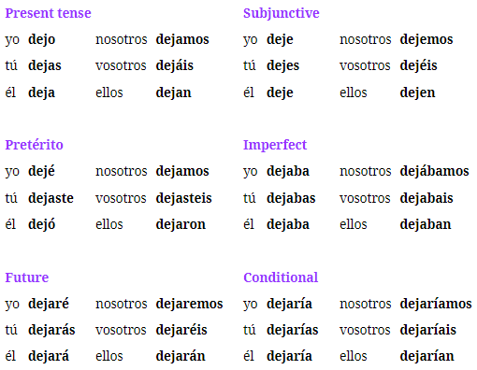

Understanding Dejar (infinitive)

* literally means “to leave” ← to leave something behind
* alternate meaning “to stop” ← to leave off doing something **REQUIRES “de” after**
* a common use is leaving someone in a state like “Leave me alone” using Imperative
* a common use is “letting someone do something” using direct object + infinitive
* I want **to leave** my car here → Quiero **dejar** mi auto aquí
* I want **to stop** doing that → Quiero **dejar de** hacer eso.

Examples

1. He stops passing by here → Deja de pasar por aqui.
2. He stopped passing by here. → Dejó de pasar por aquí.
3. You leave your things at my house. → Dejas tus cosas en mi casa.
4. Leave me alone! → ¡Déjame solo! (leaving someone in a state)
5. Leave me in peace → ¡Déjame en paz! (leaving someone in a state)
6. Let me do this! → ¡Déjame hacer esto!
7. He lets her do this. → La deja hacer esto. (letting someone do something)
8. We have let you go there. → Te hemos dejado ir ahí. (participle)
9. We have not let you do that. → No te hemos dejado hacer eso. (participle)

Pre-Quiz

1. I have left my things at their house. → He dejado mis cosas en su casa.
2. Stop doing that! → ¡Deja de hacer eso!
3. Yesterday, he let her see his house. → Ayer, la dejó ver su casa.
4. Don’t stop doing that. → No dejes de hacer eso.
5. I will let them(f) do something else. → Las dejaré hacer algo más.
6. (formal) Stop doing that! → ¡Deje de hacer eso!
7. I left her alone. → La dejé en paz.
8. She lets them talk about that. → Los deja hablar de eso.
9. She allows her kids to talk about that. → Deja que sus hijos hablen de eso. (There are also some more complex cases where Dejar is used before an entire que phrase that is subjunctive. To make sentences like this easier, I recommend practicing rewording them in your mind in English first.)
10. He allows his friends to do those things. → Deja que sus amigos hagan esas cosas. (Let’s reword this as: “He allows that his friends do those things.”)
11. The mother allows her son to go to those places. → La madre deja que su hijo vaya a esos lugares.
12. He allowed them to be with those people. → Dejó que ellos estuvieran con esas personas.
13. Allow the boys to do whatever they want! → ¡Deja que los chicos hagan lo que quieran!
14. I’ve allowed them to do that. → He dejado que hicieran eso.
15. Don’t allow them to talk about that kind of things! → ¡No dejes que hablen de ese tipo de cosas!

Week 20: Lectures 106-110

Tips/Random/Class

* la cagaste: you screwed up
* Estás en la parte trasera del edificio → You are at the back part of the building (ed-ee-fee-cee-oh)

Words

* allí: there (3rd mutual location)
* allá: there (vague location)
* ahí: there (place the person you’re talking to is)
* acá: here
* aquí: here
* abajo: down/below/downstairs (adverb) | bajo: under (preposition before noun)
* afuera: outside/outdoors or action of moving out
* fuera de: out/outside | to specify what you’re outside of (BEFORE NOUN ONLY)
* atrás: back/backwards + paso (specific for directions not rear)
* paso: step
* adelante: in front
* dentro: inside
* cerca: near
* lejos: far
* arriba: up/upwards/upstairs
* espalda: back (anatomy)

Words II

* la ciudad: city (larger/smaller)
* pueblo: town (like a smaller city or hometown)
* pueblo: people but a sense of group of a common background
* la puerta de atrás: the back door
* el cuarto: room (sleeping room)
* el país: the country
* tierra: earth
* mundo: world

**Idioms**

* de aquí para allá: from here to there (like running around doing errands)
* para acá: over here
* por allí/alla: over there (general area)
* para allí/allá: over there (implies direction ie towards over there)
* ahí abajo: down there
* un paso atrás: a step back
* hacia atrás: act of moving backwards
* atrás de: behind something
* arriba de: on top of / upon (like sobre)
* dejarme en paz: leave me alone
* unos cuantos *noun*: a small number of *masculine noun*
* otra parte: another place
* cualquier lado: anywhere
* cualquier parte: anywhere
* del mundo: in the world (of the not in the)
* todo el mundo: everybody (singular)
* tiene que ver: has to do ← must use the verb tiene + que ver
* tiene algo que ver: has something to do
* no tiene nada que ver: doesn’t have anything to do

Understanding Over There

* para alla/alli: implies direction or movement toward a place; “towards over there” or “to over there” → Let’s go over there (Vamos para alla)
* por alla/alli: implies general reference to an area; “around there” | I’ve seen Jamal around there → He visto a Jamal por alla;

Remember

* dejar: to leave/permit
* usar: uso/usas/usa/usamos/usan
* we can use them **to** have a good time → podemos usarlos **para** pasarlo bien
* My friends must **have**(Deber preterite plus haber) **talked** to everyone there. -> Mis amigos debieron **haber hablado** con todos ahí.
* He estado aprendiendo español así que podría decir cosas incorrectas.
* Necesitaba relajarme
* Espero que te sientas mejor
* Quizás después del verano, en octubre quiero visitar españa.
* Como amaneciste -> How are you this morning | amanecer→to wake up (aman-eh-sees-they)
* dije la palabra **equivocada** | e-kee-voh-kah-dah

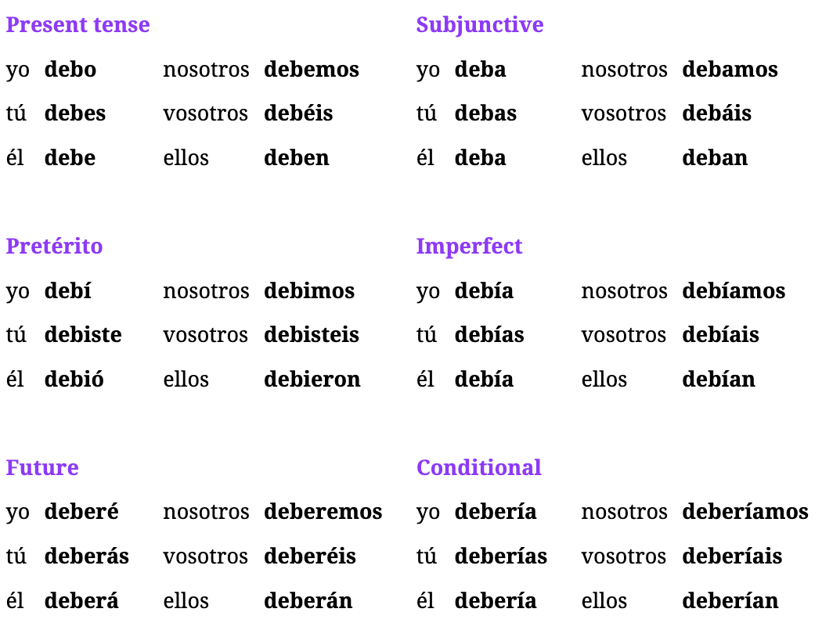

## Additional: Sentir

Understanding Sentir: to feel, sense; to regret

* used as a regular verb when paired with a NOUN
* and as a reflexive verb when paired with ADJECTIVE/ADVERB
* to sense:
  + I sense a strange smell in the kitchen → Siento un olor extraño en la cocina.
* to regret/sorrow:
  + I regret/I’m sorry for being late → Siento haber llegado tarde
  + I am very sorry/deeply regret your loss → Siento mucho tu pérdida

Conjugations

* Present: siento, sientes, siente, sentimos, sienten
* Subjunctive: sienta, sientas, sienta, sintamos, sientan
* Preterite: sentí, sentiste, sintió, sentimos, sintieron
* Imperfect: sentía, sentías, sentía, sentíamos, sentían
* Future: sentiré, sentirás, sentirá, sentiremos, sentiran

Examples Regular (followed by noun)

1. Yo siento frío
2. Ella siente alegría | joy
3. Siento el viento en mi cara. → I feel the wind on my face

Examples Reflexive (followed by adjective/adverb)

1. Yo me siento bien
2. Tu te sientes cansado
3. Me siento enfermo hoy. → I feel sick today.

## Ep109: calle, pueblo, ciudad, mundo

Examples

1. I haven’t been **to** my hometown in a while → No he estado **en** mi pueblo en un tiempo
2. I want to be with my people → Quiero estar con mi pueblo
3. You should have **been**[deber imperfect] in **the biggest city** of that country. → Debías **estar** en **la ciudad más grande** de ese país.
4. I must be inside the city and not underneath. → Debo estar dentro de la ciudad y no abajo.
5. You should be at the hospital and not in a hotel. → Deberías estar en el hospital y no en un hotel.
6. We passed through the back door. → Pasamos por la puerta de atrás.
7. My room’s door is big. → La puerta de mi cuarto es grande.
8. No, it’s not in front, you should go to the back door. → No, no está adelante, deberías ir a la puerta de atrás.
9. He can go anywhere. → Puede ir a cualquier parte.
10. Not over there; anywhere. → No allá, en cualquier parte.
11. It can be anywhere, even outside. → Puede estar en cualquier lado, hasta afuera.
12. He is the biggest on the team. → Él es el más grande del equipo.
13. Everybody wants you to be there! → ¡Todo el mundo quiere que estés ahí!
14. She wants everything on earth to be hers. → Quiere que todo en la tierra sea suyo.

## Ep108: Alli, Alla, arriba, adelante

Understanding different “there” words

* ahí is used when talking about the place the person you’re talking to is; like their own house if you want to meet them at their place
* allí tends to refer to a 3rd location; like a park
* allá is more idiomatic when pointing off to a distance or a vague location

Sentence Examples - There

* The man is around there in some place. -> El hombre está por allá en algún lugar.
* You are there and I am here, but the things are there. -> Tú estás ahí y yo estoy aquí, pero las cosas están allí.
* What you want is not there, it’s over there(precise). -> Lo que quieres no está ahí, está por allí.
* They had to(Deber preterite) go from here to there. -> Debieron ir de aquí para allá.
* (Deber preterite)I had to go there(vague). -> Debí ir allá.
* We have to go over there(vague) because what you want isn’t there(with you). -> Tenemos que ir para allá porque lo que quieres no está ahí.
* Come over here! -> ¡Ven para acá!

Interesting Idiomatic Phrases

* give a turn -> take a walk → Dar una vuelta
* give a step -> take a step → Di un paso atrás
* act of moving backwards → hacia atrás
* using atrás + de is for the “positional behind” something

Sentence Adverb Examples

1. The kid is **under** the table. -> El niño está **bajo** la mesa.
2. The kid is **below**. -> El niño está **abajo**.
3. We(f) were going **down**, toward the house. -> Nosotras estábamos yendo **abajo**, hacia la casa.
4. The family is **downstairs**, but I can talk to them. -> La familia está **abajo**, pero puedo hablar con ellos.
5. You should be **outside**, it will be good for you. -> Deberías estar **afuera**, será bueno para ti.
6. You should see it, it’s **down there**. -> Deberías verlo, está **ahí abajo**.
7. The things are **outside** because there were already many things **downstairs**. -> Las cosas están **afuera** porque ya había muchas cosas **abajo**.
8. The kids must go **downstairs** and ***later*** come over here. -> Los niños deben ir **abajo** y ***después*** venir para acá.
9. I took a step backwards. -> **Di un paso atrás**.
10. We turned back. → **Dimos una vuelta hacia atrás**. (we gave a turn to move backwards)
11. She took a few steps back. → **Dio** **unos pasos hacia atrás**.
12. She did it behind the house. -> Lo hizo **atrás de** la casa.
13. They’re outside the house. → Están **fuera de** la casa.
14. Yes, they’re here, in front of the house. → Sí, ellas están aquí, **adelante de** la casa.
15. My father is inside the house. → Mi padre está **dentro de** la casa.
16. No, it’s too far from my house. → No, está demasiado **lejos** de mi casa.
17. The kid is upstairs. → El niño está **arriba**.

Sentence Idiom Examples

1. He must take a step back. → Debe dar un paso hacia atrás.
2. I can’t see that if I’m behind. → No puedo ver eso si estoy atrás.
3. It shouldn’t be there(where you are), it should be behind that thing. → No debería estar ahí, debería estar atrás de esa cosa.
4. We should tell her to go backwards. → Deberíamos decirle que vaya hacia atrás.
5. I had to(Deber imperfect) put it behind the house. → Debía ponerlo atrás de la casa.
6. His house is behind and that’s why I must go. → Su casa está atrás y por eso debo ir.
7. The little girl is on top of the house. → La niña está **arriba de** la casa.

## Ep106-107: Deber and “should”

Understanding Deber

* commonly used to mean “must” right before another verb -> debo hacer eso
* often used like “poder” which is called a “modal verb”
* translates to “should” when using the conditional form
* obligation also refers to “tener que” but its common to “have to do” something vs MUST do something
* will get confusing with “must”, “should”, and “have to”
  + PRESENT: must: deber | should: debería| have to: tener que
* PRONOUNCIATIONS
  + We must: de-bay-mos
  + debes: deh-bes
  + debo: deh-boh

Understanding deber + de

* only when deber is used for logical/reasoning statement
* the extra de is commonly left off, its like saying “whom” but its okay to leave off
* Ex: They must be at the party. -> Deben **de estar** en la fiesta.

Tener que vs Deber Examples

1. You must obey your mother. -> Debes hacerle caso a tu madre.
2. They have to be at that place at 3 in the afternoon. -> Tienen que estar en ese lugar a las tres de la tarde.

General Examples - Present Tense

1. You must not pass by here. -> No debes pasar por aquí. (negative order)
2. She must be around here! -> ¡Ella debe estar por aquí! (logical/reasoning not obligation)
3. The police say that you must not go there at night. -> La policía dice que no debes ir ahí en la noche.
4. Carlos must have done that. -> Carlos debe haber hecho eso.

Understanding Preterite Deber |  **debí -> debiste -> debió -> debimos -> debieron**

* there is no way to put the word “must” in the past in English; use “had to” in examples
* “We had to…” debimos -> “they had to…” debieron -> “I had to…” debí -> “you had to…” debiste -> “she had to…” debió

Understanding Conditional Deber (SHOULD)

* this is how you say “should” even though it translates as “would must”
* Ex: You all **must go** there. -> Ustedes **deben** ir ahí. (very hard/cold way to say)
* Ex: You all **should go** there. -> Ustedes **deberían** ir ahí.

Examples - Preterite Tense

1. She had to go to the house with her mother. -> Debió ir a la casa con su madre.
2. You had to be here, Julia already left. -> Debiste estar aquí, Julia ya se fue.
3. The class was good, but we had to have that book. -> La clase fue buena, pero debimos tener ese libro.
4. Did they have to do it today? -> ¿Debieron hacerlo hoy?
5. Yes, I had to know this. -> Sí, debí saber esto.

Examples - Imperfect and Future Tense

1. I had to be with my mom that day, but I wasn’t. -> Debía estar con mi mamá ese día, pero no estuve.
2. Did we have to be at home? -> ¿Debíamos estar en casa?
3. You will have to do that in the future. -> Deberás hacer eso en el futuro.
4. I was not happy, that is why you had to be with me. -> No estaba feliz, por eso debías estar conmigo.
5. She will have to have a house. -> Ella deberá tener una casa.

Examples - Conditional

1. Susana should do it this way. -> Susana debería hacerlo así.
2. You should have more tables here. -> Deberías tener más mesas aquí.
3. Should they leave this place? -> ¿Deberían irse de este lugar?

Examples - Present Tense Nuances

1. Sorry, we should leave now. -> Perdón, nos deberíamos ir ahora.
2. My point is they shouldn’t do it. -> Mi punto es que no deberían hacerlo.
3. I have to know what they must do. -> Tengo que saber lo que ellos deben hacer.
4. She must speak Spanish. -> Debe hablar español.
5. They don’t have to do that. -> No tienen que hacer eso.
6. I should go to the party, but I don’t want to. -> Debería ir a la fiesta, pero no quiero.
7. I must do what she told me to do. -> Debo hacer lo que ella me dijo que hiciera.
8. Yikes, we have to leave this place now. -> Ay, nos tenemos que ir de este lugar ahora.
9. Finally! You must have a good time at the party! -> ¡Por fin! ¡Debes pasarlo bien en la fiesta!
10. All right, but you shouldn’t do it. -> Bueno, pero no deberías hacerlo.
11. Enough, you don’t have to do it anymore today, see ya! -> Basta, ya no tienes que hacerlo hoy, ¡nos vemos!

Week 19: Lectures 101-105

Tips

1. suficiente -> su-fisss-iente
2. Creo que el tema en el club el viernes es la noche latina.
3. Quiero pasar tiempo contigo fuera de aquí.(afuera|fuera de)
4. El tren ha pasado | El año pasado (past participle vs adjective)
5. te lo haré saber | remember hacer: to do/to make so “I will do” is hare | lo refers to the information you will let someone know
6. de que ciudad eres | de qué parte de <COUNTRY> eres?
7. Ellos no quieren que nosotros pasemos un mal rato <- a bad time/while is rato
8. Ellos quieren que nosotros pasemos un buen rato
9. Ella no quiso pasarlo <- querer can also mean in the past “didnt want or didn’t mean”

Class Words

* a lot of people everywhere: mucha gente en todas partes
* descuento: discount <- des-quin-toh
* ganar peso: gain weight
* Conocía a la dueña del restaurante: I knew the owner of the restaurant
* Conocí a la dueña: I met the owner:
* intentar: intenté <- I tried

Dialogue Words

* the concert: el concierto
* the restaurant: el restaurante
* the window: la ventana
* hard: dura
* fun: divertido
* intense: intenso
* next: de al lado

Weekly Words

* hablado: talked (past participle)
* hablando: speaking/talking (gerund)
* pasado: passed (past participle) | also can function as an adjective of “last”
* pasando: happening (gerund)
* par: couple of
* punto: point (point in a discussion)
* punto de: point (point in time, dont use “en”)
* puta: b-word
* propina: tip (money)
* medio: middle
* fin y final: end / ending
* el fin: the purpose or end goal
* la vida: life
* muerte: death
* el tema: the theme

Interjections

* bueno: all right (to shift gears)
* okey: okay
* hey: hey
* ay: ouch/yikes (startled or bothered)
* eh: ummm
* claro: I see/aha
* basta: enough / stop
* perdón: pardon
* dale: go ahead (also means give to him)

Weekly Idioms

* del que ellos hablan: of which they speak
* de lo que tu hablaste: what you talked about
* de lo que él habló: about what he talked about
* pasa: !Come In! (imperative of pasar w/ other meaning)
* unos cuantos: a small number of <- gender specific
* cuanto mas/menos: the more/the less
* un par de: a couple of
* nos vemos: see you (used after saying adios)
* al final: in the end
* por fin: finally
* en fin: anyway / in a nutshell all in all
* en cuanto a: regarding
* no pasa nada: no worries
* no pasó nada: nothing happened
* pasarlo bien: having fun (pass it well) <- conjugate this

Cuanto Variations

* cuánto/a: How much (mass nouns)
* Cuántos: How many
* cuanto: as much (no accent mark)
* cuanto + subjunctive: as much as they want
* cuanto/a: as much (adjective)

Remember

* Hay que: there is a need
* haya: there is / there to be
* hubo: there was
* hace: ago
* hacia: toward
* sea lo que sea: whatever it is (be what it be)
* sean lo que sean: whatever they are
* o sea: I mean / that is (or be it)
* yo que sepa: as far as I know (that I know)
* sobre todo: especially / above all
* desde ya: from now on / as of now

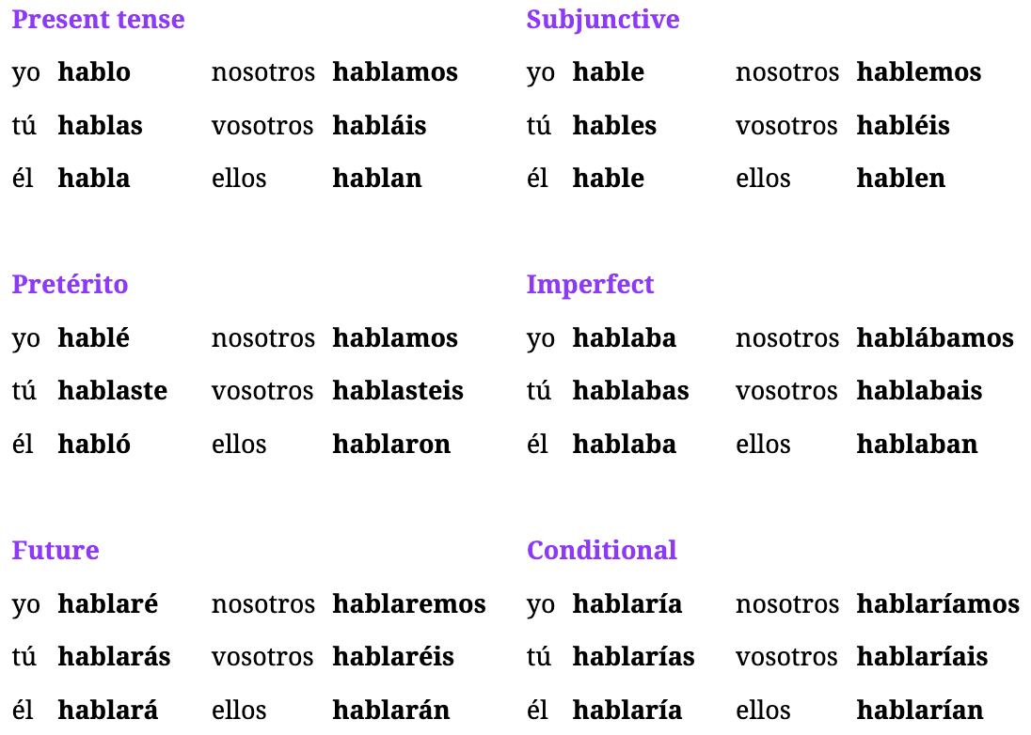

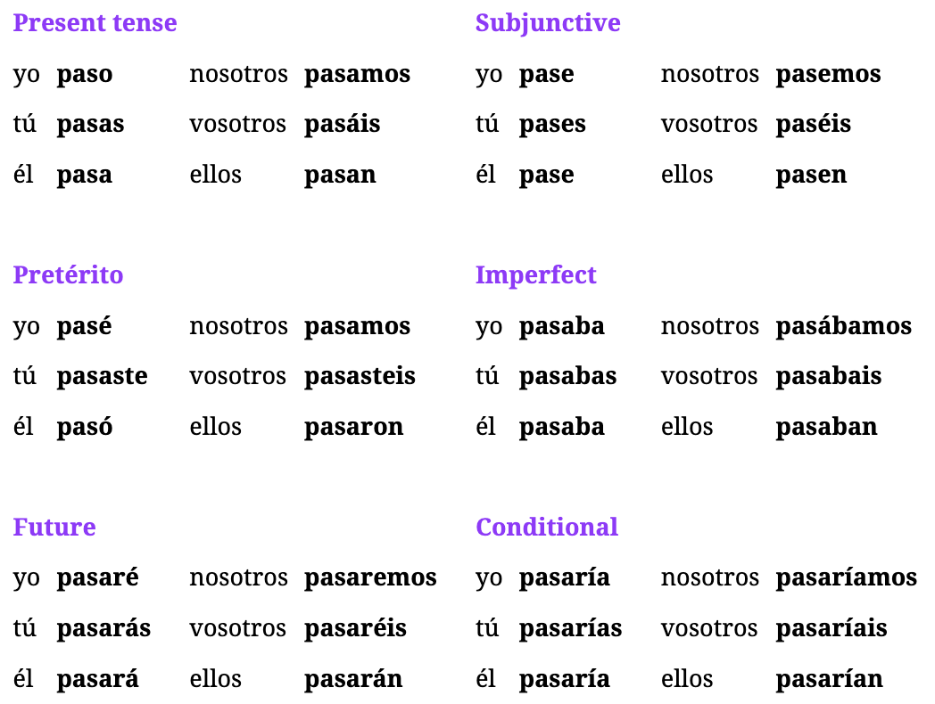

## Ep104: Fin, muerte, and other nouns

Words

* par: couple of
* punto: point (point in a discussion)
* punto de: point (point in time, dont use “en”)
* puta: b-word
* propina: tip (money)
* medio: middle
* fin y final: end / ending
* el fin: the purpose or end goal
* la vida: life
* muerte: death
* no pasa nada: no worries (nothing happens)
* pasarlo bien: having fun (pass it well) <- conjugate this

Understanding Fin and Final

* Case 1: casually talking about the ending of a story -> **final**
* Case 2: purpose of something or end goal
* Idioms
  + al final: in the end
  + por fin: finally
  + en fin: anyway/in a nutshell/all in all

New Idioms and Examples

1. **As for** the party, it hasn’t happened yet. -> **En cuanto a** la fiesta, no ha pasado aún.
2. It’s OK, **no worries**! -> ¡Está bien, **no pasa nada**!
3. Yes, **she’ll have fun** at the party. -> Sí, **lo pasará bien** en la fiesta.
4. **I had fun** at the party that day. -> **Lo pasé bien** en la fiesta ese día.
5. He always **has fun** at your parties! -> ¡Siempre **lo pasa bien** en tus fiestas!
6. Okay, ***no worries***! We have had fun! -> Okey, ***no pasa nada***! ¡Lo hemos pasado bien!

Examples

1. That was **a couple of** days ago -> Eso fue hace **un par de** días. (that was ago a couple of days)
2. Yes, in a couple of minutes! -> ¡Sí, en un par de minutos!
3. You have to have the same number of things. -> Tienes que tener el mismo número de cosas.
4. At this point in my life, I want to have more friends(f). -> En este punto de mi vida, quiero tener más amigas.
5. He has a good point. -> Él tiene un buen punto.
6. The point is that she doesn’t want us to talk. -> El punto es que ella no quiere que hablemos.
7. At this point you spend way too much time here. -> En este punto pasas demasiado tiempo aquí.
8. They were talking in the middle of the place. -> Estaban hablando en el medio del lugar.
9. No, that wasn’t the end. -> No, ese no fue el fin.
10. I want a book with a happy **ending**. -> Quiero un libro con un **final** feliz.
11. What is **the purpose** of life? -> ¿Cuál es **el fin** de la vida?
12. She doesn’t want it ***to be*** the end. -> No quiere que ***sea*** el fin.
13. She saw the house, but **in the end**, she didn’t want it. -> Vio la casa, pero **al final**, no la quería.
14. You **finally** came to my house -> **Por fin**, viniste a mi casa.
15. All right, **anyway**, now we’re friends. -> Bueno, **en fin**, ya somos amigos.
16. **In the end** we’re spending more time here than at home. -> **Al final** estamos pasando más tiempo aquí que en casa.
17. She didn’t know about his death. -> Ella no sabía de su muerte.

## Ep103: Spanish Interjections

Understanding Interjections

* word or phrase that is grammatically independent from the words around it, and mainly expresses feeling rather than meaning
* most common is “bueno” which means “all right” at the beginning of a phrase to shift gears

Examples of Interjections

1. All right, let’s talk about something else. -> Bueno, hablemos de algo más.
2. Hey, I don’t want them to talk. -> Hey, no quiero que hablen.
3. Okay, we’re talking right now, so I’m going to say it. -> Okey, estamos hablando ahora, entonces lo voy a decir.
4. Ah, got it, he’s your friend. -> Ah, claro, es tu amigo.
5. Bye! See you at the party! -> ¡Adiós! ¡Nos vemos en la fiesta!
6. Stop! Don’t do that! -> ¡Basta! ¡No hagas eso!
7. Pardon me! I didn’t see you. -> ¡Perdón! No te vi.
8. Go ahead! Do it! -> ¡Dale! ¡Hazlo!
9. They are spending time here, so I don’t want them to say goodbye. -> Están pasando tiempo aquí, entonces no quiero que digan adiós.

Cuanto Variations

* cuánto/a: How much (mass nouns)
* Cuántos: How many
* cuanto: as much (no accent mark)
* cuanto + subjunctive: as much as they want
* cuanto/a: as much (adjective)
* en cuanto a: regarding / as for (idiom)

Understanding Cuanto

* **RULE**: cuanto + subjunctive is only for future cases NOT PRESENT;
  + *You can do* as much as they want (*future*) <- cuanto quieras
  + *We have* as much as we want (*present*) <- cuanto queremos
  + NOTE: cuanto/a can also be used as an ADJECTIVE BEFORE NOUN #6

Examples w/ Cuanto

1. How much water do you want? -> ¿Cuánta agua quieres?
2. How many children does she have? -> ¿Cuántos hijos tiene?
3. They can have as much as they want. -> Pueden tener cuanto quieran.
4. You can do as much as you want! -> ¡Puedes hacer cuanto quieras! (subj. future)
5. Yes, we have as much as we want. -> Sí, tenemos cuanto queremos. (subj. present)
6. I did as many things as he told me. -> Hice cuantas cosas me dijo. (adjective)
7. We gave as much food as you told us. -> Dimos cuanta comida nos dijiste.
8. Only a small number of people came. -> Solo unas cuantas personas vinieron.
9. The more we talk, the less we do. -> Cuanto más hablemos, menos hacemos.
10. **Regarding** the car, I don’t know if they want it. -> **En cuanto al** auto, no sé si lo quieren.
11. **As for** the party, it hasn’t happened yet. -> **En cuanto** a la fiesta, no ha pasado aún.

## 

## Ep102: Pasar

Understanding Pasar

* meanings: “to pass” or “to happen”
  + I don’t want **to pass** by that place. -> No quiero **pasar** por ese lugar.
  + That’s never going **to happen**! -> ¡Eso no va a **pasar** nunca!
  + That’s never going to happen -> Eso nunca va a pasar.
* gerund: This isn’t **happening** -> Esta no está **pasando**.
* past participle: He hasn’t **passed** by here yet -> Él todavía no ha **pasado** por aquí.

Examples: Present and Tense

1. I pass by your house all the time. -> Yo paso por tu casa todo el tiempo.
2. When he is here that doesn’t happen. -> Cuando él está aquí eso no pasa.
3. These things happen sometimes. -> Estas cosas pasan a veces.

Examples: Preterite and Future Tense

1. I told you that I didn’t pass by her house. -> Te dije que no pasé por su casa.
2. Actually, that didn’t happen. -> En verdad, eso no pasó.
3. That’s what will happen if you don’t leave. -> Eso es lo que pasará si no te vas.

Understanding Imperative (Come In)

* imperative is “pasa” which also means “Come In”
* Ex: Come in and don’t speak! -> ¡Pasa y no hables!

Understanding Spending Time

* when you spend time doing something, its translated as “passing time”
* also conveys the meaning “enjoying or doing something enjoyable” Ex2
* Ex: I spent two hours with Juan -> Pasé dos horas con Juan
* Ex: They want us to have a good time -> Ellos quieren que **lo pasemos** bien.

Practice

1. I will spend the whole day with my friend tomorrow. -> Pasaré todo el día con mi amigo mañana.
2. He spent three hours with her. -> Pasó tres horas con ella.
3. They want me to spend time with him. -> Quieren que yo pase tiempo con él.
4. She will spend the afternoon with her friends(f). -> Pasará la tarde con sus amigas.

## Ep101: Hablar

Understanding Hablar

* **RULE**: “Talking **about** something” -> talk **of** something
  + I want to **talk about** this -> Quiero **hablar de** esto.
* RULE: “Talk to someone” -> talk **with** someone
  + We haven’t talked to him -> No hemos **hablado con** el.
* RULE: when saying “talk about what you talked about” the word “about” leaves and its just “lo que tu hablaste”

Examples: Hablar Hablado and Hablando

1. ***There is a need*** to talk to Juan about that problem -> ***Hay que*** hablar con Juan sobre ese problema.
2. Talking to that dude is not good. -> Hablando con ese tipo no es bueno.
3. We have already talked about the car before. -> Ya hemos hablado del auto antes.
4. Who is the one that has talked to her? -> ¿Quién es el que ha hablado con ella?
5. Are you talking to Maria or Ana? -> ¿Estás hablando con María o con Ana ?

Examples: Present Tense

1. You(formal) always talk about that and we never talk about another thing. -> Usted habla siempre de eso y nunca hablamos de otra cosa.
2. Why don’t you talk about that day ***that they speak about***? -> ¿Por qué no hablas de ese día ***del que ellos hablan***?

Examples: Preterite Tense

1. You didn’t talk to her? -> ¿No hablaste con ella?
2. You talked among yourselves? -> ¿Hablaron entre ustedes?
3. I did not talk to that woman in the past, I never talk to her. -> Yo no hablé con esa mujer en el pasado, nunca hablo con ella.
4. Tomás talks about that all the time, right? -> Tomás habla sobre eso todo el tiempo, ¿verdad?
5. **We talk** every day! **We talked** yesterday. -> ¡Hablamos todos los días! Hablamos ayer.
6. Certain men spoke with those women. -> Ciertos hombres hablaron con esas mujeres.
7. They never ***talk about what you talked about*** yesterday. -> Ellos nunca ***hablan de lo que tú hablaste*** ayer.
8. I talked **about what he talked about**. -> Hablé **de lo que él habló**.

Examples: Imperatives

1. Talk to her! -> Habla con ella!
2. (formal) Talk with her. -> Hable con ella.
3. Don’t talk about any boy, please! -> ¡No hables de ningún chico, por favor!
4. Talk to her, you(both) can’t be without talking. -> Habla con ella, no pueden estar sin hablar.
5. OK, let’s speak with the truth once and for all. -> Bueno, hablemos con la verdad de una vez por todas.

Week 18: Lectures 96-100

Tips

1. When you see “person + comes” use present tense
2. When you see “person + has come” use viendo

**Weekly Words**

* viendo: seeing
* visto: seen
* verte: to see you
* verlo: to see it/to see him
* a ver: lets see (when used to figure something out)
* viendo: come (participle) + hacer
* Ven!: Come! (imperative)
* Venga: Come! to a group of people (formal imperative)
* Vengan!: Come! to a group of people (informal imperative)
* Vengamos!: Lets Come!
* agua: water
* el agua: the water (masculine when saying the)
* algo de equipo: equipment

**Indefinite Adjectives** (put before noun to replace article)

* otra: another
* ninguno: none/any (use when there is no noun after, acts as a **PRONOUN**)
* ninguna: none/no (used to emphasize something doesn’t exists)
* ningún: No (used ONLY before a masculine noun); shortened
* alguno: some/several (synonym of unos/unas which mean some/few); more indefinite way to say some
* alguna: some/several (synonym of unos/unas which mean some/few); more indefinite way to say some
* algún: some (can be shorted w/ masculine noun)
* poco de: a little bit (used as a noun and ONLY MASCULINE and tends to have “de” after)
* pocos/pocas: few (used before a noun its an adjective)
* cierto: certain
* demasiados: large amount of something
* demasiado: ADVERB which describes how much something is/isn’t true
* tantos: so much/so many
* bastante: quite a bit
* bastantes: quite a few (for things that aren’t countable) like parties we threw
* suficiente: sufficient/enough
* tal: such a
* cada: each (does not change based on noun, ALWAYS FEMININE)
* cualquier: any / whichever

**Weekly Idioms**

* algo de: some (when talking about mass items)
* ven aqui: come here
* nos vemos: See ya! or “we see ourselves” (very common parting greeting)
* tal: such
* como tal: as such
* por tal razón: because of such reason
* que tal: Whats up? or How about
* cada vez más: more and more
* tal vez: perhaps
* se ven: is seen (reflexive ver)
* ya esta: now it is <- used better than it was before, now done, or now ready
* ya que: since (when since means because)

## Ep99: Agua, dinero, auto

Understanding Reflexive Ver

* when Ver is used reflexively, it can mean something “is seen” without referencing who is seeing it
* Ex: Our friends **are seen** every week -> Nuestros amigos **se ven** todas las semanas.
* Ex: My sister and I **see each other (ourselves)** every day. -> Mi hermana y yo **nos vemos** todos los días.
* Ex: Until tomorrow! See ya! -> ¡Hasta mañana! ¡Nos vemos!
* Ex: **We tell each other** a lot of things. -> Nosotros **nos decimos** muchas cosas. <- We tell ourselves a lot of things

Understanding Cada (more and more)

* in spanish the term “more and more” doesn’t exists, instead its “each time more” or “more each time” when paired with vez
* Ex: He does those things **more and more**. -> Hace esas cosas **cada vez más**.
* Ex: **There are** **fewer and fewer** people here. -> **Cada vez hay menos** gente aquí.
* Ex: I am more and more fond of her. -> Cada vez le tengo más cariño.

Example Sentences

1. **When they come**, we are going to have the dollars -> **Cuando vengan**, vamos a tener los dólares. <- SUBJUNCTIVE
2. They gave me some money -> Me dieron algo de dinero
3. They came here because of water -> Vinieron aqui por el aqua.
4. They came here because of the good water. -> Vinieron aquí por el agua buena.
5. Come, someone has to see it with me. -> Ven, alguien tiene que verlo conmigo.
6. He comes here for some money and for water. -> Él viene aquí por algo de dinero y por agua.
7. He didn’t manage to do it because there wasn’t enough light. -> No pudo hacerlo porque no había suficiente luz.
8. We want some equipment so that they see it. -> Queremos algo de equipo para que ellos lo vean.
9. Each team is in its place, but there is little light. -> Cada equipo está en su lugar, pero hay poca luz.
10. Why did you put your water on top of the car? -> ¿Por qué pusiste tu agua sobre el auto?
11. We all came for the book that is on the table. -> Todos vinimos por el libro que está en la mesa.
12. I want Juan to come **since** they came from that place. -> Quiero que Juan venga **ya que** ellos vinieron desde ese lugar.
13. It’s too late, certain days that can’t be done. -> Es demasiado tarde, ciertos días eso no se puede hacer.

Idiom Examples

1. There were only 3 people, and as such, it wasn’t a party. -> There were only 3 people, and as such, it wasn’t a party.
2. We didn’t have money, and therefore we went home. -> No teníamos dinero y por tal razón fuimos a casa.
3. She was his friend and therefore she came to the party. -> Ella era su amiga y por tal razón vino a la fiesta.
4. Ana is his friend and as such she has to do something. -> Ana es su amiga y, como tal, tiene que hacer algo.
5. You always come late and therefore there is never enough time. -> Siempre vienes tarde y, por tal razón, nunca hay suficiente tiempo.
6. We have come before; therefore, it’s not a new place. -> Hemos venido antes, por tal razón, no es un lugar nuevo.
7. They have seen each other twice and, as such, they can’t be friends. -> Se han visto dos veces y, como tal, no pueden ser amigos.
8. **How about** that book that I gave you? -> ¿**Qué tal** ese libro que te di?
9. **Perhaps** he’s still in the car. -> **Tal vez** todavía esté en el auto.
10. How about the new car? Any person would want to have it. -> ¿Qué tal el auto nuevo? Cualquier persona lo quisiera tener.
11. Hello, what’s up? Come, he wants me to see this. -> Hola, ¿qué tal? Ven, él quiere que yo vea esto.

Understanding algo de (some + mass item)

* the idiom “algo de” means some when referring to a “mass noun”
* mass nouns are like water, food vs something countable
* Ex: Come here, we have some food for you -> Ven aqui, tenemos algo de comida para ti.

End of Lesson Sentences

1. Let’s see… you see fine and you have the equipment. -> A ver… tú ves bien y tienes el equipo.
2. Perhaps the book is about that. As such, it might be good. -> Tal vez el libro sea sobre eso. Como tal, puede ser bueno.
3. I haven’t seen any cars in this part. -> No he visto ningún auto en esta parte.
4. It has to be this way, and as such, you have to do it. -> Tiene que ser así y, como tal, tienes que hacerlo.
5. Don’t come if there is no light, I want you to see the table. -> No vengas si no hay luz, quiero que veas la mesa.
6. Marcos has two cars and I don’t have any. -> Marcos tiene dos autos y yo no tengo ninguno.
7. Why are we seeing this equipment? It's a lot of dollars. -> ¿Por qué estamos viendo este equipo? Son muchos dólares.
8. Perhaps when you come there will be some food. -> Tal vez cuando vengas haya algo de comida.
9. Did anyone see Tomás? He was going to come this morning. -> ¿Alguien vio a Tomás? Iba a venir esta mañana.
10. My friends want us to come here more for the water. -> Mis amigos quieren que vengamos aquí más por el agua.
11. Are you(m) sure? We did not see such a book in that place. -> ¿Estás seguro? No vimos tal libro en ese lugar.
12. As I have so much time here, I always see that. -> Como tengo tanto tiempo aquí siempre veo eso.
13. How about the food? They look at it in another way. -> ¿Qué tal la comida? Ellos la ven de otra forma.
14. Perhaps she comes since there are quite a few dollars. -> Tal vez ella venga ya que hay bastantes dólares.
15. Tomorrow my friends(f) come and therefore it will be a good day. -> Mañana vienen mis amigas y por tal razón será un buen día.
16. We come for the book that is on the table. -> Venimos por el libro que está en la mesa.
17. I always come here, therefore I have a table. -> Siempre vengo aquí, por tal razón tengo una mesa.
18. There is still some time for us to see that. -> Aún hay algo de tiempo para que veamos eso.
19. Because there is no light they didn’t see the table. -> Porque no había luz no vieron la mesa.
20. Hello, what’s up? Did you see Sonia? -> Hola, ¿qué tal? ¿Viste a Sonia?
21. Did you only come for the water or for something else? -> ¿Solo viniste por el agua o por algo más?
22. Some friends(f) are from Peru and, as such, you can’t tell them that. -> Algunas amigas son de Perú y, como tal, no les puedes decir eso.

## Ep98: Indefinite Adjectives

Examples of Ninguno

1. They saw **another** thing there -> Vieron **otra** cosa ahí.
2. No, I see **no** house here -> No, no veo **ninguna** casa aquí.
3. **No** job is too big for her -> **Ningún** trabajo es demasiado grande para ella.
4. She saw many places, but I saw **none** -> Ella vio muchos lugares, pero yo no vi **ninguno**. <- NO NOUN AFTER
5. I don’t have **any** job for you -> No tengo **ningún** trabajo para ti.
6. **No** man has come to this place -> **Ningún** hombre ha venido a este lugar.
7. I don’t want **any** boy to come here -> No quiero que **ningún** chico venga aquí.
8. **No** girl comes to these kinds of parties -> **Ninguna** chica viene a este tipo de fiestas.
9. He came without **any** -> Vino sin **ninguno**.

Examples of Alguno

1. Yes, we saw **some** houses there. -> Sí, vimos **algunas** casas allí.
2. There were **several** people at the party. -> Había **algunas** personas en la fiesta.
3. **Some** person that I didn’t see did it. -> **Alguna** persona que no vi lo hizo.
4. Yes, she said that to **some** guy. -> Sí, ella le dijo eso a **algún** chico.
5. She saw many places, and I saw **several**. -> Ella vio muchos lugares, y yo vi **algunos**.
6. These are my games(m), but I only like **some**. -> Estos son mis juegos, pero solo me gustan **algunos**.

Examples of Pocos/Pocas (few)

1. There are very **few** reasons for doing that. -> Hay muy **pocas** razones para hacer eso.
2. There are **few** people at the party. -> Hay **poca** gente en la fiesta.
3. They want us to come, but there is **very little** time. -> Quieren que vengamos, pero hay **muy poco** tiempo.
4. There are **very few** reasons for you to come here. -> Hay **muy pocas** razones para que vengas aquí.

Examples of Cierto and Demasiados

1. **A certain** man was at the party and he said he was your friend. -> **Cierto** hombre estaba en la fiesta y dijo que era tu amigo.
2. **A certain** girl doesn’t want me to be there. -> **Cierta** chica no quiere que yo esté ahí.
3. There are **certain** people that came to the party. -> Hay **ciertas** personas que vinieron a la fiesta.
4. There were **a whole lot of** guys and very few girls. -> Había **demasiados** chicos y muy pocas chicas.
5. This is **too much** work for my team. -> Esto es **demasiado** trabajo para mi equipo.
6. I don’t want **too many** people to see this. -> No quiero que **demasiadas** personas vean esto. <- “que” phrase because it is a desire and the dependant clause is describe what the speaker doesn’t want to happen

Examples of Tantos, Bastante, Suficiente

1. There were **so many** problems that I couldn’t leave. -> Había **tantos** problemas que no podía irme.
2. Come here! There are **so many** friends with us! -> ¡Ven aquí! ¡Hay **tantos** amigos con nosotros!
3. Yes, there’s still **quite a bit** of time. -> Sí, todavía hay **bastante** tiempo.
4. We threw **quite a few** parties back then. -> Hicimos **bastantes** fiestas en ese entonces.
5. I want her to see that I DID have **quite a bit** of work. -> Quiero que vea que sí tuve **bastante** trabajo.
6. Yes, there are **enough** people for a party. -> Sí, hay **suficientes** personas para una fiesta.
7. I want to see him because we don’t have **enough** things here. -> Quiero verlo porque no tenemos **suficientes** cosas aquí.

Examples of Tal, Cada, Cualquier

1. I have never seen **such a** thing. -> Nunca he visto **tal** cosa.
2. I’m not sure(f) that **such** people are coming. -> No estoy segura de que vengan **tales** personas.
3. We went to **each** house. -> Fuimos a **cada** casa.
4. He does it **each** day. -> Lo hace **cada** día.
5. We saw **each** one of those(f) two times. -> Vimos **cada** una de esas dos veces.
6. We can go to any place. -> Podemos ir a cualquier lugar.
7. He knows what to do with **any** problem here. -> Él sabe qué hacer con **cualquier** problema aquí.
8. I know that you see **any** thing as a good thing. -> Sé que ves **cualquier** cosa como una buena cosa.

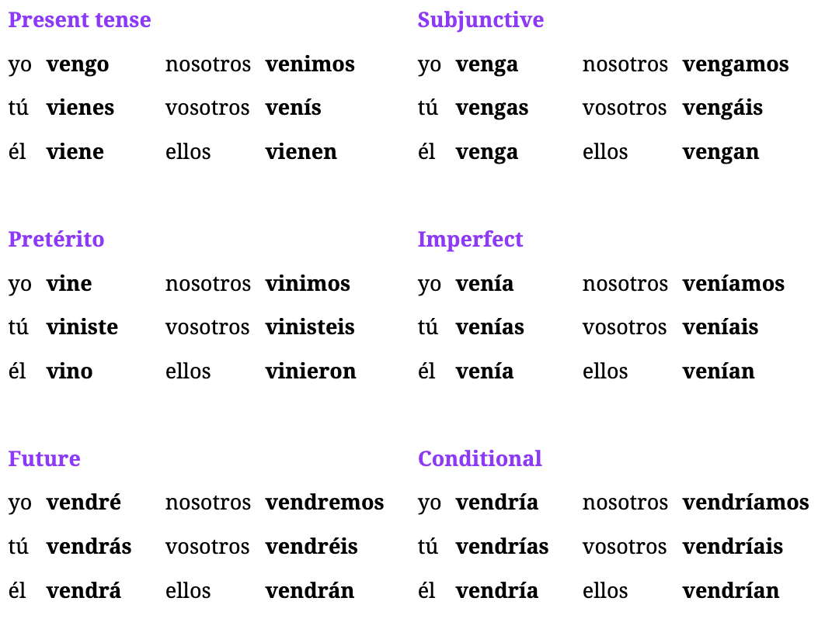

## Ep97: Venir

Understanding Venir - to come

* means “to come” but indicates going somewhere hypothetically closer to the speaker
* opposite of ir

Understanding Imperatives

* the main ones are subjunctive forms: Ven, Vengamos, Vengan and Venga (formal)

Examples Present Tense - **vengo, vienes, viene, venimos, vienen**

1. I’m coming and they’re coming, but she is not coming -> Yo vengo y ellos vienen, pero ella no viene.
2. I come here every morning -> Vengo aquí todas las mañanas.
3. He comes to our house every week -> El viene a nuestra casa todos las semanas.
4. This is the only time that we come here -> Esto es la única vez que venimos aquí.
5. These things come from Paraguay -> Esas cosas vienen de Paraguay.

Examples of Venir and Viendo

1. Do they want **to come** to the party? -> Quieren **venir** a la fiesta?
2. We have come to this place many times -> Hemos viendo a este lugar muchas veces.
3. You have to come with us -> Tienes que venir con nosotros
4. They have come in peace to say something -> Han venido en paz para decir algo.
5. My friend (m) hasn’t come to the party -> Mi amigo no ha venido a la fiesta.
6. I want to come here that year -> Quiero venir aquí ese año.

Examples of Preterite Tense - **vine, viniste, vino, vinimos, vinieron**

1. He came here ***because of*** love -> Vino aquí ***por*** amor.
2. We also came last year -> Nosotros también vinimos el año pasado.
3. Didn’t you come to this place before? -> No viniste a este lugar antes?
4. They almost came that month -> Casi vinieron ese mes.
5. I came with my family one time -> Vine con mi familia una vez.

Examples of Subjunctive Tense - **venga, vengas, venga, vengamos, vengan**

1. She wants me to come anew this week -> Ella quiere que yo venga de nuevo esta semana.
2. I’m not sure(m) you are coming with us -> No estoy seguro de que vengas con nosotros.
3. She’ll really be happy when we come with our family -> Realmente estará feliz cuando vengamos con la familia.
4. Maybe you(formal) will come to our house when they come -> Quizás usted venga a nuestra casa cuando ellos vengan.

Examples of Imperatives

1. Darling, **come here** now -> Cariño, **ven aquí** ahora!
2. !Let’s come to this place ***again*** this year -> ¡Vengamos a este lugar ***de nuevo*** este año!
3. !(Formal) Please, come with us to the party -> Por favor, venga con nosotros a la fiesta!
4. !Don’t come if you don’t want to be here -> ¡No vengas si no quieres estar aquí!
5. !(Plural) Come here or you won’t be able to do it either -> Vengan aquí o tampoco van a poder hacerlo!

## Ep96: Ver

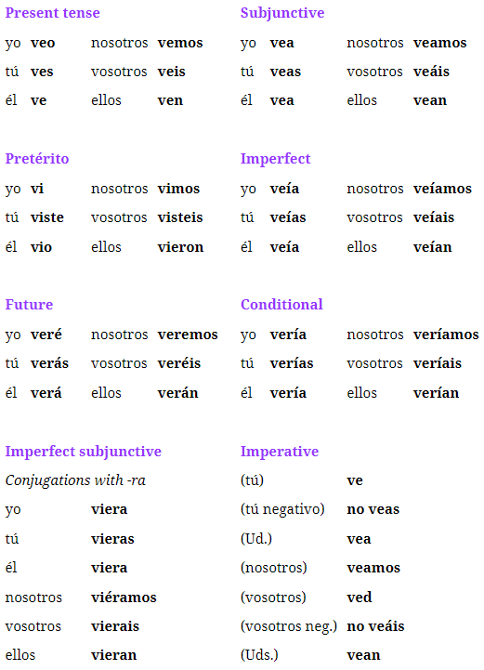

Words

Understanding Viendo and Visto

* the gerund is used often because its used as an ADVERB (not after estar) but to start an extra phrase in a sentence
* Ex: I’m sure she is not well, **seeing** that she went home -> Estoy seguro de que ella no está bien, **viendo** que se fue a casa.
* Ex: I can’t do it, **seeing** that I don’t have those things -> No puedo hacerlo, **viendo** que no tengo esas cosas.
* Ex: We haven’t **seen** him. -> No lo hemos **visto**.

Understanding Common Contractions

1. I wanted to see it before seeing you. -> Quería verlo antes de verte.
2. **Let’s see**. I’m not sure(f). -> **A ver**. No estoy segura.
3. I want to **see it** today. -> Quiero **verlo** hoy.
4. **Let’s see** if we can have peace. -> **A ver** si podemos tener paz.
5. I put it where we can **see it**. -> Lo puse donde podemos **verlo**.
6. **Let’s see** if they can see it. -> **A ver** si pueden verlo.
7. I know you aren’t going to be there, but still I want **to see you**. -> Sé que no vas a estar ahí, pero igual quiero **verte**.

Understanding Future/Imperatives Tense

* it is not common to use the future tense of VER as we use IR to put into the future
* its not common to use imperative TO SEE but instead, To Look which is Mira
* Ex: She’s **going to see** me -> Ella me **va a ver**

Understanding Preterite Tense - vi, viste, vio, vimos, vieron

* the most common way to put Ver in the past is this way
* Ex: He didn’t see anything. -> No vio nada.
* Ex: I didn’t see the same thing that they saw. -> No vi lo mismo que ellos vieron.
* Ex: I almost saw it before you, but you saw it first. -> Casi lo vi antes que tú, pero tú lo viste antes.
* Ex: He saw that it wasn’t love. -> Vio que no era amor.
* Ex: (formal) Put on the clothes that we saw! -> ¡Póngase la ropa que vimos!

Examples **Subjunctive** - vea, veas, vea, veamos, vean

1. I want them to see it. -> Quiero que lo vean.
2. Maybe you (formal) will see it. -> Quizás usted lo vea.
3. They are here so that we see them. -> Están aquí para que los veamos.
4. He does it so much that he wants me to see him. -> Lo hace tanto que quiere que yo lo vea.
5. I’m not sure(f) that you see it. -> No estoy segura de que lo veas.
6. They want him to see it tomorrow. -> Quieren que él lo vea mañana.

Examples **Present** Tense Ver - **veo, ves, ve, vemos, ven**

1. I don’t see what he sees. -> No veo lo que él ve.
2. He doesn’t see what I’ve seen. -> No ve lo que he visto.
3. The police have seen the man. -> La policía ha visto al hombre.
4. I see that this is too big. -> Veo que esto es demasiado grande.
5. Supposedly we are going to see it that day. -> Se supone que lo vamos a ver ese día.
6. Yes, we see what you see. -> Sí, vemos lo que ves.
7. You all don’t see that? -> ¿Ustedes no ven eso?

Week 17: Lectures 91-95

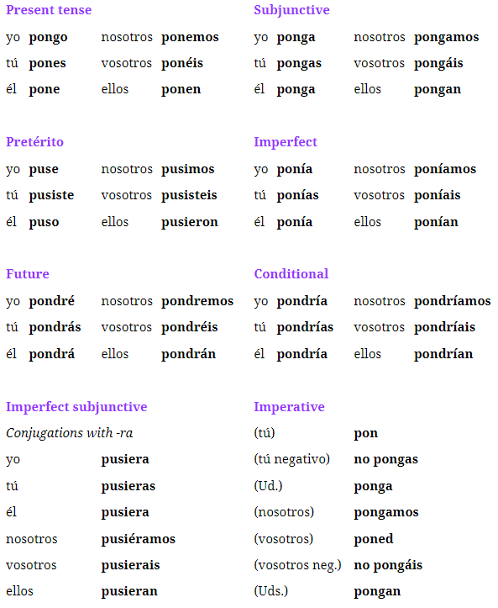

**Rules**

1. Putting something somewhere is regular verb
2. use haber + puesto for past tense?
3. putting something on -> me pongo + <CLOTHING>
4. getting happy/emotion -> pe pongo + <EMOTION>

## Ep94: Clase, paz, amor, and suponer

Words (Nouns)

* la clase: class singular)
* el equipo: team (singular); eh-kee-poh
* gusto: pleasure
* a gusto: comfortable
* suerte: luck (in spanish, you HAVE LUCK, to be lucky)
* paz: peace (commonly used with tener)
* miedo: fear (used with tener) mee-yea-doh
* amor: love (often used as a term of endearment)
* cariño: affection or darling
* se supone que: supposedly (present tense adverb)
* se suponía que: supposedly (past tense adverb)
* supuesto: supposed
* por supuesto: of course (often gets “que” when used at beginning)

Examples

1. The team *didn’t manage* to do that on time. -> El equipo *no pudo* hacer eso a tiempo.
2. The class worked as a team to do it. -> La clase trabajó como un equipo para hacerlo.
3. Do you even know that the class is better than the team? -> ¿Siquiera sabes si la clase es mejor que el equipo?
4. Maybe they’ll call the police. -> Quizá llamen a la policía.
5. It’s a pleasure for me to do that. -> Es un gusto para mí hacer eso.
6. **I’m not lucky** and I’m never **comfortable**. -> **No tengo suerte** y nunca estoy **a gusto**.
7. When he is here, we never have **peace**. -> Cuando él está aquí, nunca tenemos **paz**.
8. That’s why **I’m afraid**. -> Por eso **tengo miedo**.
9. She is not at peace, she is afraid of everything. -> No está en paz, tiene miedo de todo.
10. I’m not going to put those on, because I’m scared of them. -> No voy a ponerme esos, porque les tengo miedo.
11. Yes, my love, we are almost home now. -> Sí, mi amor, ya casi estamos en casa.
12. My mom made me something with **much affection**; put it on the table! -> Mi mamá me hizo algo **con mucho cariño**; ¡ponlo en la mesa!
13. My dad is harsh with me sometimes; **still**, I know he’s fond of me. -> Mi papá es severo conmigo a veces; **igual** sé que me tiene cariño.

Understanding Miedo (mee-yea-doh)

* RULE: used in spanish to “have fear” so use tener
* RULE: if you want to describe what you are afraid of -> use “de + thing afraid of” && can also use “a + thing afraid of”
* RULE: if someone is afraid of an entire fact or statement, requires “que”
* RULE: to indicate that something scares you, it “gives you fear” so use DAR
  + She is afraid of the truth -> Ella tiene miedo **de la verdad.**
  + She is afraid of the truth -> Ella tiene miedo **a la verdad** (fear to the truth)
  + I’m afraid of your friend. -> **Le** tengo miedo **a tu amigo**. (indirect object)
  + She **is afraid that** the clothes she bought won’t fit. -> Tiene **miedo de que** la ropa que compró no le sirva.
  + The lady **scares me**. -> La señora **me da miedo**.
  + **I’m scared of** the lady. -> **Tengo miedo de** la señora.

Understanding Cariño

* RULE: to express you have affection for someone/something, use indirect object
  + **I’m fond** of that girl. -> **Le** **tengo cariño** a esa chica.
* RULE: also used as the word “darling”
  + No, darling, you can’t go to work with dad. -> No, cariño, no puedes ir al trabajo con papá.

Understanding Suponer (to suppose)

* has two meanings, “to suppose” and “to guess” but not to guess with games
* most common is “I suppose (supongo), he/she supposes (supone)” and “I supposed” (supuse)
* Ex: **I suppose** they didn’t do it. -> **Supongo** que no lo hicieron.
* Ex: **I guess** he won’t do it on time. -> **Supongo** que no lo hará a tiempo.
* Ex: Where does **he suppose** that we are? -> ¿Dónde **supone** que estamos?
* Ex: **He supposes** that I don’t even have one. -> **Él supone** que ni siquiera tengo uno.
* Ex: **I supposed** that you went with them. -> **Supuse** que fuiste con ellos.
* Ex: **I guess** she is sad. -> **Supongo** que está triste.

Understanding Suponer (general supposed)

* when not talking about or describing anyone supposing or guessing anything, we just make it reflexive to “se supone”
* Ex: He is supposed to be here tomorrow. -> Se supone que estará aquí mañana.
  + **Literal**: It supposes itself that he will be here tomorrow
* Ex: **Supposedly** there’s nobody here. -> **Se supone que** no hay nadie aquí.
* Ex: I was with her, and **supposedly** we were friends. -> Estaba con ella, y **se suponía que** éramos amigos. (**PAST TENSE**)
* Ex: **Of course** I want to go with you! -> ¡**Por supuesto que** quiero ir contigo!

Examples: Se suponía que

1. **Supposedly** she is not going to be here during the party. -> **Se supone que** ella no va a estar aquí durante la fiesta.
2. **Supposedly** they did know the story. -> **Se suponía que** ellos sí sabían la historia.
3. We gave it to her, of course! She told you that. -> Se lo dimos, ¡por supuesto! Ella te dijo eso.
4. Supposedly they were going to put the things in that place. -> Se suponía que iban a poner las cosas en ese lugar.
5. If I really want to go? ¡Of course! -> ¿Si realmente quiero ir? ¡Por supuesto!

## Ep93: Casi, igual, quizas and adverbs

Words - Adverbs

* igual: equally; or even-so, regardless
* igualmente: likewise
* exactamente: exactly
* realmente: really
* quizás: maybe (normally triggers subjunctive)
* casi: almost
* siquiera: even / at least (very specific contexts like pleading)
* ni siquiera: not even
* tampoco: not either (synonym) but not either/neither due to “ni”
* demasiado: extremely / too (used like muy but more extreme)
* tanto: so much

Understanding Igual

* technically means “equally” but tends to be used idiomatically as “**even so**” or “**regardless**”
* tends to be used at the beginning of a phrase
* when used as “still”, its not about the length of time
* Ex: **Still**, I wanted to leave afterwards: **Igual**, quería irme después.
* Ex: No, she isn’t my friend. **Still**, she can go with us! -> No, ella no es mi amiga. **Igual**, ella puede ir con nosotros!

Examples w/ realmente, exactamente, igual, quizás, casi

1. Exactly! Put the things there! -> ¡Exactamente! ¡Pon las cosas ahí!
2. Still, if you put that there it could be a problem. -> Igual, si pones eso ahí podría ser un problema.
3. I don’t really know exactly what she wants. -> Realmente no sé exactamente qué quiere.
4. I know you don’t want it. Still, you have to put it on. -> Sé que no lo quieres. Igual te lo tienes que poner.
5. Maybe her friend isn’t present. -> Quizá su amiga no esté.
6. Almost everybody was there. -> Casi todos estaban ahí.
7. Maybe they’ll put the things there. -> Quizás pongan las cosas ahí.
8. Maybe he’ll do it if I put it here. -> Quizá lo haga si lo pongo aquí.
9. I almost went to that place. -> Casi fui a ese lugar.
10. I have almost put it here, but maybe it is in another place. -> Casi lo he puesto aquí, pero quizá esté en otro lugar.

Understanding Siquiera

* means **even** or **at least** but in very specific contexts; for pleading
* but not to confuse with ‘hasta’
* Ex:Could you give me **even** a little bit of your time? -> ¿Podrías darme **siquiera** un poco de tu tiempo?
* Ex: Could I have *one of those*, **at least** the smallest one? -> ¿Podría tener *uno de esos*, **siquiera** el más pequeño?
* Ex: We ***even*** put the food in the fridge.-> ***Hasta*** pusimos la comida en la nevera.
* Ex: Put it here, **at least** for one hour. -> Ponlo aquí, **siquiera** por una hora.
* Ex: He didn’t have anything, **not even** a house. -> No tenía nada, **ni siquiera** una casa.
* Ex: She didn’t tell it to anyone, **not even** to her best friend(f). -> No se lo dijo a nadie, **ni siquiera** a su mejor amiga.

Understanding Tampoco

* synonym for “no” or “not”
* dont confuse with neither or either because that word it “ni”
* Ex: I’m not her friend (either) -> !Tampoco soy su amiga (either)!
* Ex: Those things aren’t mine. And this house **isn’t** mine. -> Esas cosas no son mías. Y esta casa **tampoco** es mía.
* Ex: You’re not with that family? **Me neither.** -> ¿No estás con esa familia? **Yo tampoco**. yo no (optional)
  + using tampoco to emphasize that we’re in the group of people that isn’t with the family, like using neither in English
* Ex: I don’t even want to go **either**. -> Ni siquiera quiero ir **tampoco**.
* Ex: We aren’t putting things there **either**. -> No ponemos cosas ahí **tampoco**.

Others

* I didn’t know that he did **so much** for you. -> No sabía que hacía **tanto** por ti.
* She did it so much that I wasn’t able to do it myself(f). -> Lo hizo tanto que no podía hacerlo yo misma.

## Ep92: Ponte Feliz

Imperatives

* Pon!: Put! (imperative)
* Ponga: -> Put (imperative formal)
* Ponlo: Put it! (imperative)
* Ponte: Get! (imperative); but used for telling someone how they should be or what they should wear.
* Póngase: Put on! (imperative formal);

Idioms/Words

* por una vez: for once
* uno de esos: one of those
* to sympathize with someone else's feelings we say “put yourself in their shoes” -> “put themself in their place”
  + Put yourself in my shoes -> Ponte en mi lugar

Understanding Preterite Tense

* **puse, pusiste, puso, pusimos, pusieron**
* He got sad when I said that. -> Se puso triste cuando dije eso.
* I put those on the table. -> Puse esos en la mesa.
* She got sad with the book(m), which was about the war. -> Se puso triste con el libro, el cual era sobre la guerra.
* I got happy when I found it out. -> Me puse feliz cuando lo supe.
* Many say that she got sad when she found that out. -> Muchos dicen que se puso triste cuando supo eso.
* I put(past) on a jacket, but it doesn’t look good on my body. -> Me puse una chaqueta, pero no se ve bien en mi cuerpo.
* Did you get sad afterwards? -> ¿Te pusiste triste después?
* Which ones are the ones(m) that you put on the floor? -> ¿Cuáles son los que pusiste en el piso?
* They got nervous before the exam(m). -> Se pusieron nerviosos antes del examen.

Understanding se puso/me puse vs estuvo/estuve

* Example: Afterwards **I got** sad
  + Después **estuve** triste. || Después **me puse** triste
  + Use “me puse” because it emphasizes getting more “into the state” rather than being in it

Understanding Subjunctive

* **ponga, pongas, ponga, pongamos, pongan**
* I want them to put on their best clothes -> Quiero que se pongan su mejor ropa.
* She wants us to put it in the trash can. -> Quiere que lo pongamos en el basurero.
* I‘m not sure(f) that my dear son will get sad. -> No estoy segura de que mi querido hijo se ponga triste.
* I want **them to get** happy with this. -> Quiero que **se pongan** felices con esto.
* It might be that she’ll put that in her backpack. -> Puede que ponga eso en su mochila.
* He gives me a lot of work so that I get anxious. -> Me da mucho trabajo para que me ponga nervioso.

Understanding Imperatives

* **Put** that here -> **Pon** eso aqui.
* (formal) Put that here. -> Ponga eso aquí.
* Put it where he put it yesterday. -> Ponlo donde él lo puso ayer.
* Ponerse as imperative to tell someone how to be OR what to wear
  + Get happy! -> ¡Ponte feliz!
  + (formal) Please put on your best clothes. -> Por favor póngase su mejor ropa.

Examples: Imperatives

1. **Put it** where I told you. -> **Ponlo** donde te dije.
2. Please, **put on** this shirt(f), which I chose for you (formal). -> Por favor, **póngase** esta camisa, la cual elegí para usted.
3. Who are going **to put themselves in my shoes** for once? -> ¿Quiénes **se** van **a poner en mi lugar** por una vez?
4. Don’t **put it** there or it will break! (formal) -> ¡No **lo ponga** ahí o se va a dañar!
5. Put that on and give me a hand with this! -> ¡Ponte eso y dame una mano con esto!

Examples: Common Contractions

1. ***You left*** without **getting** sad. -> ***Te******fuiste*** sin **ponerte** triste.
2. I did it in order **to put myself in his shoes**. -> Lo hice para **ponerme en su lugar**.
3. ***Instead of*** putting themselves in my shoes, they ignored me. -> ***En lugar de*** ponerse en mi lugar, no me hicieron caso.

## Ep91: Poner (to put)

Words

* puesto: put (past participle) mainly used with haber; he puesto(I have put)
* hielo: ice (yeh-low)
* la ropa: clothing; (F) and always singular ie why it doesn't mean clothes
* los juguetes: the toys
* la caja: box
* ansioso: anxious
* una multitud: a crowd
* muchos de ustedes: many of you
* enojados: angry
* un traje: a suit
* una chaqueta: a jacket

Phrases

* the most common way to refer to putting something on is: reflexive + poner

Understanding Poner

* pongo, pones, pone, ponemos, ponen
* **USES**: can mean multiple things like: installing, establishing, changing something

Understanding Present Tense

* She puts it where we put it -> Ella lo pone donde lo ponemos
* They are putting many things there -> Ponen muchas cosas ahi
* I always put ice in my drinks -> Siempre pongo hielo en mis bebidas.
* We never put the toys back in the box. -> Nunca ponemos los juguetes de vuelta en la caja.
* She puts the book(m), which is about history, on the table. -> Ella pone el libro, el cual es sobre historia, en la mesa.

Understanding Ponerse (reflexive)

* **Use 1:** putting something on
  + Before leaving, **he puts on** something stylish -> Antes de irse, **se pone** algo elegante.
  + **I’m putting** on my best clothes. -> **Me pongo** mi mejor ropa.
* **Use 2:** getting or feeling a certain way
  + ponerse is “HOW YOU’RE BECOMING” vs hacerse is “WHAT YOUR’RE BECOMING”; used in same situations as ESTAR
  + **I get happy** when she says that -> **Me pongo feliz** cuando ella dice eso
  + **I become** her friend. -> **Me hago** su amigo.
  + They are going **to get** sad. -> **Se** van a **poner** tristes.

Examples for Ponerse - Feeling a certain way && Putting something on

1. I get anxious when I’m in a crowd, but **you get happy**. -> Me pongo ansioso cuando estoy en una multitud, pero **tú te pones feliz**.
2. Many of you get angry when you don’t eat. -> Muchos de ustedes se ponen enojados cuando no comen.
3. I get anxious when I’m in a crowd, but you get happy. -> Me pongo ansioso cuando estoy en una multitud, pero tú te pones feliz.
4. We are putting on a suit for the party, but he is putting on a jacket. -> Nos ponemos un traje para la fiesta, pero él se pone una chaqueta.

Week 16: Lectures 86-90

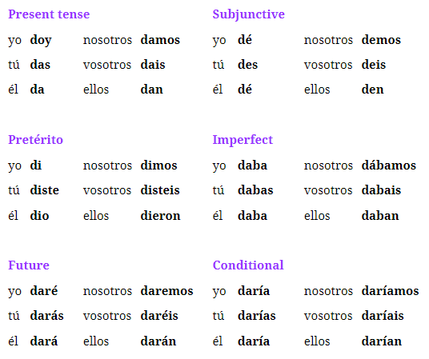

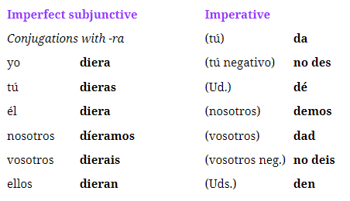

## Ep89: Cuerpo, manos, ojos y cabeza

Body Parts

* cuerpo: body
* cabeza: head
* mente: mind
* cara: face
* boca: mouth
* ojo: eye
* oreja: ear
* nariz: nose
* dientes: teeth
* pie: foot
* dedo del pie: toe
* pecho: breast
* pelo: hair
* dedo: finger
* mano: hand
* corazón: (M) heart
* sangre: blood
* extraños: beings
* de quien: whose (“of who” or “of whom”)

Idioms

* esta en manos del hombre: to say someone is handling something/have it in control (in hands of)
* dar una mano: give someone a hand/help someone out
* un ser quierdo: “a loved one” or “dear”

Understanding Body Parts

* use que instead of cual when asking about parts
* also you must use article in front of body part
* Ex: Which part of the body is unwell? -> ¿Qué parte del cuerpo está mal?
* Ex: Why are you scratching your head? -> ¿Por qué te rascas la cabeza? (*scratching yourself the head*)
* Ex: He hurt his head. -> Se he hurt la cabeza. -> Se lastimó la cabeza.
* Ex: She did all those things only with her mind. -> Ella hizo todas esas cosas solo con la mente.
* Ex: I want to see your face. -> Quiero ver tu cara.
* Ex: ***Whose*** mouth said those things? -> ¿La boca ***de quién*** dijo esas cosas?
* Ex: She washed her hands. -> Ella se washed las manos. -> Ella se lavó las manos.
* Ex: He really gave his heart to her. -> De verdad él le dio su corazón.
* Ex: We found some very strange **beings** in that place. -> Encontramos unos seres muy **extraños** en ese lugar.

Idiom Examples

1. The problem is in the dude’s hands. -> El problema está en manos del tipo.
2. The problem is in the boss’s(m) hands. -> El problema está en manos del jefe.
3. Can you give me a hand with this? -> ¿Me puedes dar una mano con esto?
4. Please, you have to give me a hand with this. -> Por favor, tienes que darme una mano con esto.
5. I want to be among my loved ones. -> Quiero estar entre mis seres queridos.
6. Dear Sara, how nice to have you here! -> Querida Sara, ¡qué bueno tenerte aquí!

## Ep88: Anque, cual, pues

Words

* muchos: many/alot (pronoun)
* la cual: which (when used as connector needs article)
* pues: for/then (synonym for entonces)
* mientras: as long as (will get subjunctive)
* aunque: although, even though, even if
* aunque: even if (this triggers the subjunctive due to uncertainty)

Understanding Pronoun: Mucho

* as adjective: We know many things -> Sabemos muchas cosas.
* can be used alone without a noun to represent “a lot”
* can also be used alone to say “many”
* acts very much like “todo” ie means everything/everybody
* Ex: I’m very well. I have **a lot**! -> Estoy muy bien. Tengo **mucho**!
* Ex: **Many** say that there’s nothing there. -> **Muchos** dicen que no hay nada ahí.
* Ex: I won’t give it to you because you have **a lot**. -> No te lo daré porque tienes **mucho**.
* Ex: Look at those people! There are **a lot** here! -> ¡Mira a esa gente! ¡Hay **mucha** aquí!

Understanding Quienes and Cuales

* use quienes when asking about multiple people
* Ex: Who are these things for? -> Para quienes son estas cosas?
* Ex: Who are they and why do you have to give it to them? -> ¿Quiénes son ellos y por qué se lo tienes que dar?
* Ex: What were their names? -> ¿Cuáles eran sus nombres?

Understanding Connecting Words

* **Quien**: without accent mark isn’t used as a question, but used as a relative pronoun like que; use when connecting two phrases with “who” rather than “that”
  + Ex: It was my brother **who** went to that place. -> Fue mi hermano **quien** fue a ese lugar.
  + Ex: It was the same man **who** the little boy was ***with***. -> Era el mismo hombre ***con*** **quien** estaba el niño. <- the preposition “con” must come before quien
* **Cual**: without accent mark; rule is that it needs the ARTICLE w/ cual when using to match the gender and number of things being described;
  + Ex: I went with her mother, **which** was a very nice person. -> Fui con su madre, **la cual** era una persona muy buena.
  + Ex: They were in many places, **which** were very safe. -> Estaban en muchos lugares, **los cuales** eran muy seguros.
* **Examples**
* This is the house from which we left. -> Esta es la casa de la cual nos fuimos.
* We gave him a phone(m) with which he called us. -> Le dimos un teléfono con el cual nos llamó.
* I have three kids, two of which I’m giving more things to. -> Tengo tres hijos, a dos de los cuales les estoy dando más cosas.
* They don’t have it anymore, **which** isn’t good. -> Ya no lo tienen, **lo cual** no es bueno.

Understanding Pues

* means “for” but extremely formal but more to mean how entonces is used
* Ex: Are you unwell? **Then** go home. -> ¿Estás mal? **Pues** ve a casa.
* Ex: I am very happy, **for** I now have a house. -> Estoy muy feliz, **pues** ya tengo una casa.

Understanding Mientras

* although means “while” but also can be used as a connector
* can also get a subjunctive after when used as “as long as”
* Ex: I’ll be here while you do that. -> Estaré aquí mientras haces eso.
* Subj Ex: **As long as** ***they’re*** here, I’m not going to leave. -> **Mientras** ***estén*** aquí, no me iré.

Understanding Aunque

* means “although”, “even though” or “even if”
* Ex: I’m leaving **even though** nobody else is leaving. -> Me voy **aunque** nadie más se va.
* Ex: I’ll be at the party **even if** she ***isn’t*** there. -> Estaré en la fiesta **aunque** ella no ***esté*** ahí.
* Ex: He’ll never be happy, **even if** he ***has*** it all. -> Nunca estará feliz, **aunque** lo ***tenga*** todo.

Understanding Connecting Same Sounding Words

* Using “and”: when connecting using and, replace y with “E”
* Ex: Yes, and I was going to do that. -> Sí, e iba a hacer eso.
* Using “or”: when connecting using or, replace o with “U”
* Ex: Is it time to leave or time to do something else? -> ¿Es hora de irse u hora de hacer algo más?
* Ex: I’m giving him a house or another thing. -> Le doy una casa u otra cosa.

## Ep87: Di, Dio, Dare

Words

* de vuelta: back; although means “again” but can also mean “in return” or “back”
  + ex: we gave them back

Understanding Imperatives and Dar

* most common forms of using dar to say things like “give me that” or “please give it to her”
* very common to use with **infinitive contractions**: darme, darle, darte
* this is the same form that means “he/she gives” but can tell from context because most imperatives use contractions like dale/dame
* Ex: Give me that -> Dame eso!
* Ex: Give her the job that she wants -> Dale el trabajo que quiere.
* Ex: I’m here in order to give you this -> Estoy aquí para darte eso.
* Ex: They were going to give me something. -> Iban a darme algo.
* Ex: Give him that thing and give me this! -> ¡Dale esa cosa y dame esto!

Understanding Past Tense (Preterite)

* when you talk about giving in the past, you almost always use preterite
* Ex: **I gave** her something yesterday. -> Le **di** algo ayer.
* Ex: **We gave** them ***back*** what they gave us. -> Les **dimos *de vuelta*** lo que nos dieron.
* Ex: You gave us that thing and we gave it to the young lady. -> Nos diste esa cosa y se la dimos a la señorita.

Understanding Future Tense

* Ex: I will give you something tomorrow. -> Te daré algo mañana.
* Ex: Yesterday she gave me that and I’ll give it to you tomorrow. -> Ayer ella me dio algo y yo te lo daré mañana.

Understanding Subjunctives

* Ex: I want him to give me that. -> Quiero que **él** me **dé** eso.
* Ex: Do you want me to give you something else? -> ¿Quieres que te dé algo más?
* Ex: I’m not sure(f) we’ll give it back to them. -> No estoy segura de que se lo demos de vuelta.

## Ep86: Dar

Words

* dando: giving (gerund)
* dado: given (participle)

**Idiom**

* me da lo mismo: its all the same to me
* les da lo mismo: its all the same to them

Understanding Dar

* takes both direct and indirect objects
* Ex: I’m going to give it to you -> Te lo voy a dar
* Ex: I have **given** him something -> Le he **dado** algo
* Ex: I am **giving** her something -> Le estoy **dando** algo.

Examples: Dar Conjugations

1. Sometimes I give her that -> A veces le doy eso.
2. Sometimes he gives me that -> A veces me da eso.
3. Today she’s going to **take a walk**. (give a turn) -> Hoy ella va a **dar una vuelta**.
4. When we give it to them, they give it to us. -> Cuando se lo damos, ellos nos lo dan.

Example w/ Idioms

1. They can do whatever they want, it’s all the same to me. -> Pueden hacer lo que quieran, me da lo mismo.

Week 15: Lectures 81-85

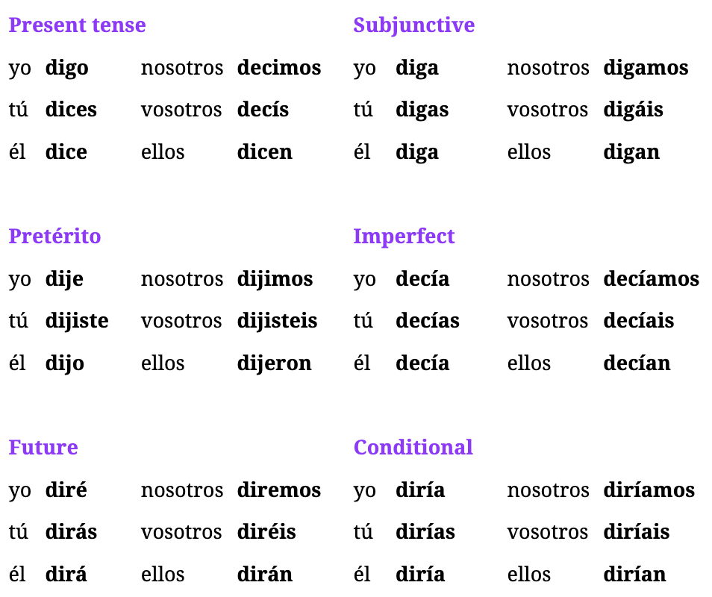

**Past Subjunctive:** dijera, dijeras, dijera, dijéramos, dijeran

Tips

## Ep84: Ayuda, camino, pregunta

Words

* help: ayuda
* opportunity: oportunidad (F)
* chance: oportunidad de
* way: camino (describing path/route)
* on the way: más de camino
* manner/way something is done: manera (dont confuse with forma)
* question: pregunta (normally used with hacer)
* case: caso (conditional word)
* obey/pay attention to someone: hacer + caso (IDIOM: have attention)
* turn/return: vuelta
* by then: para entonces

Idiom for Sobre

* means above, over or on-top-of
* alternate use: can be used to refer to talking “over” something or talking “about” something
* Ex:I said something about those things. -> Dije algo sobre esas cosas.
* Ex: It’s late, I don’t want to say anything about that. -> Es tarde, no quiero decir nada sobre eso.

Idioms for Again

* otra vez: another time
* de vuelta: again
* de nuevo: of new or anew

Understanding Camino

* **OPTION 1**: can be used idiomatically to describe the things that you might encounter “on” the way to somewhere
* or to mention that something is in your way
  + Ex: No, you’re in my way -> No, estas en mi camino.
* **OPTION 2**: can be used to describe doing something “on the way”
  + Ex: I did something else on the way -> Hice algo más de camino

Understanding Pregunta

* the literally meaning is “making a question” when you say “asked a question”
  + Ex: Afterwards, I asked her a question. -> Después, le hice una pregunta.

Understanding Caso

* uses the conditional form of verbs
* used as an idiom for “pay attention” or “obey”
  + Ex: You have to **obey** your parents. -> Les tienes que hacer **caso** a tus padres.
* IDIOM: obey/pay attention to someone
  + Hacerle caso a alguien == “make a case to someone”
  + Ex: He didn’t pay attention to me. -> No me hizo caso.
    - **RULE LITERAL**: He didn’t make me a case | But “making a case” to someone is how you pay attention

Understanding Vuelta

* **OPTION 1**: roughly means “turn” or “return”
* common way to say something about “taking a walk”
* in spanish, you don’t “take a walk” instead you “give a turn”
* Ex: In a moment **we’ll take a walk**. -> En un momento we’ll give una vuelta. -> En un momento **daremos una vuelta**. (use the term give NOT take)
* Ex: He’s not at home, **he’s taking a walk**. -> No está en casa, está giving una vuelta. -> No está en casa, **está dando una vuelta**.
* **OPTION 2**: another idiom used is “de vuelta” which literally of “of turn” which means “again”
* do not confuse with “otra vez” which means another time;
* Ex: Seriously, you’re going to do it **again**? -> ¿En serio lo vas a hacer **de vuelta**? “vas a hacerlo de nuevo”

Sentences

1. I want **the help** of a friend. -> Quiero **la ayuda** de un amigo.
2. Thanks for your(formal) help! -> ¡Gracias por su ayuda!
3. It’s late, but I want his help. -> Es tarde, pero quiero su ayuda.
4. You have to tell me if you want the help of my friend. -> Tienes que decirme si quieres la ayuda de mi amigo.
5. We say that he still has the opportunity. -> Decimos que todavía tiene la oportunidad.
6. Did he have a chance to do that? -> ¿Tuvo la oportunidad de hacer eso?
7. I don’t know **the way** to that place. -> No sé **el camino** a ese lugar.
8. What was her manner of saying that? -> ¿Cuál fue su manera de decir eso?
9. You can’t go along **that path** ***in that manner***. -> No puedes ir por **ese camino** ***de esa manera.***
10. I have to tell you that I don’t have the manner to do it yet. -> Tengo que decirte que aún no tengo la manera de hacerlo.
11. Afterwards, I asked her a question. -> Después, le hice una pregunta.
12. I want to do this anew/again. -> Quiero hacer esto de nuevo.
13. **By that time** she will have gone there. -> **Para entonces** habrá ido ahí.

Sentences w/ Caso and Pregunta

1. You have **to obey** your parents today. -> Les tienes que **hacer caso** a tus padres hoy.
2. In that case, I want to **ask you a question**. -> En ese caso, quiero **hacerte una pregunta**.
3. He says **I don’t pay him attention** while he talks. -> Dice que no **le hago caso** mientras habla.
4. He wants us to tell them to pay attention to him. -> Quiere que les digamos que le hagan caso.
5. In that case, we have to be there before that day. -> En ese caso, tenemos que estar ahí antes de ese día.

## Ep83: Hoy, manana, ayer

Words

* today: hoy
* yesterday: ayer
* tomorrow: mañana
* meanwhile: mientras
* then: entonces
* still: todavía or aún
* yet: todavía or aún
* beforehand: antes
* before: antes de + que/noun
* afterwards: después
* after: después de
* late: tarde (adverb) vs afternoon
* later: más tarde (use when you want to compare + que)
* later: luego

Understanding Antes

* it means “beforehand” but often we say “first”
* spanish has another word for “first” used for cases when something happens “first of all” before anything else
* Ex: We can go to your house today, but we have to go to my house **first**. -> Podemos ir a tu casa hoy, pero tenemos que ir a mi casa **antes**.
  + we dont mean “first” as in the first thing we do, we use it for order of operation
* **Meaning 2**: also used to indicate the concept of before but used in a specific way;
* to say “before” use **antes de + noun** for this usage
* Ex: We have to go to my house before that. -> Tenemos que ir a mi casa antes de eso.
* Ex: I’ll do it **before** he does it -> Lo haré **antes de que** el lo haga
  + The first half -> I’ll do it before + fact
  + the fact -> He does it
  + therefore, we have to separate with a que because antes needs a noun
  + since we use “que” everything becomes subjunctive like cuando and hasta que

Examples: Antes de que and Antes

1. We won’t do it **before** I have a house. -> No lo haremos **antes de que** yo tenga una casa.
2. I was there before she did it. -> Estuve ahí antes de que ella lo hiciera. **(past tense subj)**
3. I’m going to be there before they throw the party. -> Voy a estar ahí antes de que hagan la fiesta.

Understanding Después + que

* if you want to describe something that happens after an entire fact, “después de que”
* Ex: I’ll do it after he is here. -> Lo haré después de que él esté aquí.
* Ex: You have to tell me if he’ll be there afterwards. -> Tienes que decirme si estará ahí después.
* Ex: She did it after I did it. -> Lo hizo después de que yo lo hice.

Understanding Luego (late)

* you cannot use luego to say “later than” someone else like how “mas tarde que”
* luego is used by itself as a vague general concept
* Ex: Until Later -> Hasta luego
* Ex: He’ll be here later -> Estará aquí luego.

Examples of tarde, después, luego

1. We want to do it later. -> Queremos hacerlo luego.
2. The party starts later than the concert. -> La fiesta comienza más tarde que el concierto.
3. She wants you not to tell her that **after** tomorrow. -> Quiere que no le digas eso **después de** mañana.
4. She was **here** after everyone had left. -> Estuvo aquí **después de** que todos se habían ido.
5. Are you saying that we can go after they do that? -> ¿Dices que podemos ir después de que hagan eso?

## Ep82: Decir in the past

Words

* between the ages of 2 and 3: entre los dos y tres anos (between the 2&3 years)
* Imperative: Di

Understanding Preterite - Common Form

* most common term is “dijo” because saying something is normally a one-time event not ongoing
* Ex: She **said** something when we were at home -> Ella **dijo** algo cuando estábamos en casa.
* Ex: Your mother **said** that during the night but **I didn’t say** anything. -> Tu madre **dijo** eso durante la noche pero **yo no dije** nada.
* Ex: **We told** **the father** that her daughter ***had*** a baby. -> **Le dijimos** al padre que su hija **tuvo** un bebé. <- Note: maintains preterite tense

Understanding Other Forms

* less common to use imperfect tense but pretty common to use “decía” for I/he/she used to say
* Past Ex: As **I was saying**, she isn’t around -> Como **decía**, no está.
* Past Ex: **I used to say** those things between the ages of 2 and 3. -> Yo decía esas cosas entre los dos y tres años.
* Future Ex: ***Whatever it is***, he **will not tell** the truth. -> ***Sea lo que sea***, él **no dirá** la verdad.
* Subj Ex: He wants us to say that the party was his. -> Quiere que digamos que la fiesta era suya.
* Subj Ex: He’ll do it so that you tell it to him. -> Lo hará para que se lo digas.

Understanding Imperative Form (Di)

* it is very common to tell someone to say something or tell someone something
  + Say that it isn’t the truth. -> Di que no es la verdad.

Understanding Imperative + Contraction

* it is much more common to tell someone to tell someone something
* for example “tell her not to go there” or “tell me what you did that day”
* these cases you need to use the contraction with an indirect object at the end of the word
* Example: tell me -> di**me** | tell him/her -> di**le**
* Ex: **Tell me** what you did that day -> **Dime** qué hiciste ese día.
* Ex: Imperative to order someone to do something
  + **Tell her** **to go** home -> **Dile que** **vaya** a casa
  + Note: imperative + subjunctive

Understanding Imperative + when to use subjunctives

* Use Subjunctive: when you are **order someone to do something**
* Done Use: when you are telling someone to **say a fact**
* Subjunctive
  + Tell me **to do** something else this year. -> Dime que **haga** algo más este año.
* Non-Subjunctive
  + Tell me that those things are mine! -> ¡Dime que esas cosas son mías!

Understand Infinitive + Contractions

* its very common to put indirect objects at the end of infinitives
* You have to **tell me** what they did. -> Tienes que **decirme** lo que hicieron.
* The girl is going to **tell th**e dad. -> La niña va a **decirle** al papá.
* I can’t **tell you** that now, there are a lot of people. -> No puedo **decirte** eso ahora, hay mucha gente.

## Ep81: Decir

Words

* diciendo: saying/telling
* dicho: said/told

Understanding Decir

* in English: say is used with direct Objects to emphasize what it is we’re saying
* in English: tell is used with indirect Objects to emphasize who it is that we’re telling something to

Understanding Dicho (said)

* past participle for “said”
* different from others that end in “DO” like sido, estado, tiendo | this acts more like hecho due to the “cho”

Understanding Using Decir + que

* He always tells me to go with him. -> Siempre me dice que vaya con él.
* Are you telling me to be there? -> ¿Me dices que esté ahí?
* (Formal) You tell them to go towards that place. -> Usted les dice que vayan hacia ese lugar.
* Dad hadn’t told her to do that. -> Papá no le había dicho que hiciera eso.
* I’m telling you to do it now. -> Te estoy diciendo que lo hagas ahora.
* They are telling the little girl to be a doctor. -> Le dicen a la niña que sea doctora.
* It’s not my job. Do you mean to tell me to do yours? -> No es mi trabajo. ¿Quieres decirme que haga el tuyo?

Understanding Using Decir w/ both Indirect/Direct Objects

1. They tell me it. -> Me lo dicen.
2. You’re not telling it to us? -> ¿No nos lo dices?
3. He tells your mom. -> Le dice a tu mamá.
4. We tell three people. -> Les decimos a tres personas.
5. I don’t say it to the man. -> No se lo digo al hombre.
6. They haven’t told me it. -> No me lo han dicho.
7. The girls tell you it. -> Las chicas te lo dicen.
8. I say that to the girl. -> Le digo eso a la chica.
9. We’re telling that to the boys. -> Les estamos diciendo eso a los chicos.

Examples for Decir/Dicho/Diciendo

1. My mom is telling the truth -> Mi mamá está diciendo la verdad.
2. You have to tell me what he has told you. -> Me tienes que decir lo que él te ha dicho.
3. Can you tell me if the cat is on the table? -> ¿Me puedes decir si el gato está sobre la mesa?
4. I’ve told you this is the place where we met. -> Te he dicho que este es el lugar donde nos conocimos.
5. From now on we are telling them everything. -> Desde ya les decimos todo.
6. (Formal) You say this, but she says something else. -> Usted dice esto, pero ella dice algo más.
7. You say what they don’t say? -> ¿Tú dices lo que ellos no dicen?
8. Yes, I say that sometimes. -> Sí, digo eso a veces.
9. The boy tells the truth. -> El niño dice la verdad.
10. We tell our daughter what she has to know. -> Le decimos a nuestra hija lo que tiene que saber.
11. I’m telling you this and the family is telling me that. -> Te digo esto y la familia me dice eso.

Week 14: Lectures 76-80

**Past Subjunctive**: supiera -> supieras -> supiera -> supiéramos -> superian

Tips

* Remember: “P” for preterite/subjunctive
* Subjunctives forms are IRREGULAR
* Normally past tense “imperfect” form is used
* Haber and Saber are very close in conjugations
* **Tricky**: I want there to be -> uses the haber form vs ser/estar (Quiero que haya)

Class Tips

* just: acabo de
* Have you been to Chile? -> Has ido a Chile
* soon: pronto
* Investigación de mercado -> market research
* ví una película en español -> I saw a movie in spanish
* Fui al restaurante y la comida era muy cara -> I went to the restaurant and the food was very expensive.
* cheap: barata/barato (gender)
* Soy ahorrador: I am a saver
* ¡Que le vaya bien! -> Have a good one
* Estás en **la parte de atrás** de la construcción/del lugar -> You are at **the back** of the building/place
* Necesitas ir al frente -> You need to go to the front
* Do you need help (formal) -> Necesita ayuda?
* You need to help -> Necesitas ayudar!

## Ep79: Talking about Family

Words/Phrases

* father/mother (formal): padre/madre
* father/mother (normal): papa/mama
* children: ninos <- general children
* young boy/girl: niño/niña
* baby: bebe
* dude/guy: tipo (slang)
* people: gente (feminine)
* those people: esa gente (because its always singular)
* children: hijos <- sons and daughters
* son/daughter: hijo/hija
* husband/wife: esposo/esposa

**Idioms**

* Whatever it is: sea lo que sea (be what it be)
* Whatever they are: sean lo que sean
* I mean/That is: o sea (or be it)
* As far as I know: que yo sepa (that I know)
* Above all/especially: sobre todo
* From now on/As of now/from this moment on/in advance: desde ya

Idioms w/ Subjunctives Sentences

1. I can do ***what* I want** -> Puedo hacer **lo que *quiero***.
2. I can do ***whatever* I want** -> Puedo hacer **lo que *quiera***.
   * quiera after “lo que” makes it indefinite
3. You (all) know you can’t do **whatever** you want. -> Ustedes saben que no pueden hacer lo que **quieran**.
4. **Whatever it is**, it’s something good. -> **Sea lo que sea**, es algo bueno.
5. **Whatever they are**, I want them. -> **Sean lo que sean**, los quiero.
6. He’s my friend — **that is**, he’s like my brother. -> Es mi amigo, **o sea**, es como mi hermano.
7. **As far as I know**, there’s nobody else. -> **Que yo sepa**, no hay nadie más.
8. **As far as I know**, it is between them. -> **Que yo sepa**, es entre ellos.
9. She wanted my things, and **above all** my house. -> Quería mis cosas, y **sobre todo** mi casa.
10. I'm going to have those things **in advance**. -> Voy a tener esas cosas **desde ya**.
11. **From now on** I'm going to be with you. -> **Desde ya** voy a estar contigo.

Sentences

1. My dad doesn’t know where my mom went. -> Mi papá no sabe adónde fue mi mamá.
2. If I knew where my dad is, I could do that. -> Si supiera dónde está mi papá, podría hacer eso.
3. My brother would know that he is his son. -> Mi hermano sabría que él es su hijo.
4. If I knew where my brothers are, I would tell it to my daughter. -> Si supiera dónde están mis hermanos, se lo diría a mi hija.
5. My sister and her husband have two children. -> Mi hermana y su esposo tienen dos hijos.
6. I can’t go, I have to be at home with the children. -> No puedo ir, tengo que estar en casa con los niños.
7. That dude didn’t know who she was. -> Ese tipo no sabía quién era ella.
8. I don’t know why **those people** are here. -> No sé por qué **esa gente** está aquí.
9. Where are those people going? -> ¿Adónde va esa gente?

## Ep78: Desde, sin, sobre, hace. possessions

Words/Phrases

* without: sin
* beneath: bajo
* above/on top of: sobre
* during: durante
* since: desde (length of journey, not to confuse with ‘from’)
* hacia: toward
* hace: ago (preposition near noun)
* mine: mio (gender and can be plural)
* yours: tuyo (gender and can be plural)
* theirs: suyo (gender and can be plural)
* between/amongst: entre (estar)
* contra: against
* in opposition to: en contra de
* opposed to him: en su contra

Understanding Donde

* when asking where someone is going it's rephased to “To where someone is going”
  + Where are they going -> **Adonde** van?
  + Do they know where she is going -> Saben adónde va?
* If “where” is **functioning as a conjunction** its donde without an accent mark
  + I want **to go where** she went -> Quiero **ir a donde** ella fue. (ir uses “a”)
  + I want **to be where** she was -> Quiero **estar donde** ella estaba.
  + I know that this place is where we threw the party. -> Sé que este lugar es donde hicimos la fiesta.

Understanding Possessive Nouns (advanced)

* must add an article to talk about which of something you’re talking about
* Ex: My house is bigger **than yours**. —> My house is bigger **than THE yours**
  + Note: used to help identify object
* Ex: My house is bigger than **yours**. -> Mi casa es más grande **que la tuya**.
* Ex: My job was faster **than theirs**. -> Mi trabajo fue más rápido **que el suyo**.

Understanding Sin (without)

* opposite of “con”
* We went there without her -> Fuimos ahi sin ella.

Understanding bajo (beneath)

* There is something beneath her house -> Hay algo bajo su casa.

Understand Entre (between/among)

* use with **ESTAR** for normal conversations
  + We’re between the two houses -> Estamos entre las dos casas.
* use with **SER** for secrets between two people
  + I’m not sure, its something between them -> No estoy seguro, es algo entre ellos.

Understanding Durante (during)

* TIPS: “por” also means during BUT durante is for something happening during a length of time

Understanding contra (against)

* used when something is going against the direction of something else or against the interest of someone else
* Ex: I don’t have anything **against** him. -> No tengo nada **contra** él.
* Ex: They’re two **against** one. -> Son dos **contra** uno.
* Idiom: You know I am **against** injustice. -> Sabes que estoy **en contra de** la injusticia.
* Idiom: He wants to leave because he knows that I’m **opposed to him**. -> Quiere irse porque sabe que estoy **en su contra**.

Understanding desde (since)

* this is a nuanced word because it doesn’t quite mean “since”
* the word “since” can also mean “from” which means “de”
* “de” is used to emphasize “the place that you’ve come from”
* “desde/hasta” is used to emphasize the length of the journey itself
* —--Examples—---
* We did it **from** the morning **to** the night. -> Lo hicimos **desde** la mañana **hasta** la noche.
* We went **from** that place **to** his house. -> Fuimos **desde** ese lugar **hasta** su casa.

Understanding Possessive Pronouns

* mine: mía/mías (gender specific and if more than one, make plural to mías)
  + Those things are mine. -> Esas cosas son mías.
  + This restaurant(m) is mine. -> Este restaurante es mío.
* yours: tuya (gender specific)
* theirs: suya (gender specific)
* Ex: The friend(f) is **his**. -> La amiga es **suya**.
* Ex: This house is **yours**. -> Esta casa es **tuya**.
* Ex: You have to know that the problems aren’t **yours**. -> Tienes que saber que los problemas no son **tuyos**.

Understanding Hacia (towards)

* means towards; DO NOT CONFUSE WITH “hacía”
* pronounce as “haaa-seyah” not “ha-seee-yah”
* We are going toward that place. -> Estamos yendo hacia ese lugar.

Understanding Hace (ago)

* means ago
* because it is a preposition, it must go before a noun vs in english we tend to put it in the end of a sentence as an adverb
* Ex: He did it two years **ago**. -> Lo hizo **hace** dos años.

Sentences for Hacia and Hace

1. Three years **ago** we were going ***towards*** Berlin. -> **Hace** tres años íbamos ***hacia*** Berlín.
2. We wouldn’t know if he was going towards the place two hours ago. -> No sabríamos si iba hacia el lugar hace dos horas.
3. If you knew that I have been here since the morning, you wouldn’t do that. -> Si supieras que he estado aquí desde la mañana, no harías eso.

## Ep77: Supe, sabrá, haya and hubiera

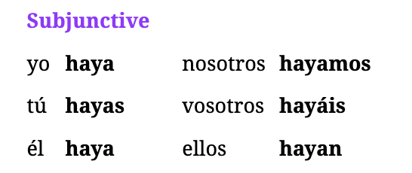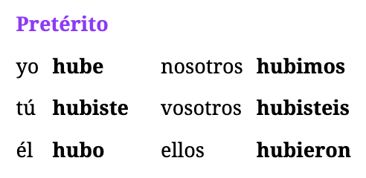

Words/Phrases

* How did he know -> ¿Cómo sabía?
* There was: Hubo (particular moment for preterite)
* Have been: He sido
* Have gone: He ido

Understanding Saber Preterite Tense usage -> (**I knew / found out**)

* normally used when you didn’t know something all along
* this creates the idea of “you just **found it out**” therefore use Preterite
* NOTE: if another verb is used, keep the imperfect
* That day **I knew** she was going to leave. -> Ese día **supe** que ***se iba*** a ir.
  + se iba -> iba is past-tense and “se iba” makes it reflexive
* This morning **he found out** what **I had**. -> Esta mañana **él supo** lo que **yo tenía**.

Understanding Saber and Haber close conjugations

* most first-person forms end with “o” or “oy” like hago/tengo or soy/estoy/voy
* “I have done something” or “I have been something”?-> He
* “I know”? -> Sé

Understanding Haber new conjugations

* using haber to talk about existence (Hay/Habia/Habra) we have to use it in any tense
* haber is used in two different ways
* **Ex before participle**: **They have** ***been*** friends; **I had** ***gone*** there ->
  + - * + **Han *sido*** amigos; **Había *ido*** ahí.
* **Ex for existence**: **There ar**e two people in the house -> **Hay** dos personas en la casa.
* **Preterite** Form: Hubo <- there was (particular moment)
  + That day **there was** a problem. -> Ese día **hubo** un problema.
* **Subjunctive** Form: Haya <- There is (Intention of existence)
  + I want **there to be** more people here. -> Quiero que **haya** más personas aquí.
* **Past Tense Subjunctive**: Hubiera <- There were
  + If **there were** someone here, I would know it. -> Si **hubiera** alguien aquí, lo sabría.

Understanding past subjunctives

* this is used **very common** because you talk in the hypothetical about what someone does/doesn’t know
* **Verbs**: supiera -> supieras -> supiera -> supiéramos -> superian

Saber Practicing Examples

1. At that moment **I found out** what ***she wanted***. -> En ese momento **supe** lo que ***ella quería***.
2. How did **he know** that ***we weren’t*** here? -> ¿Cómo **supo** que ***no estábamos*** aquí?
3. If **he knew** it, he wouldn’t do that. -> Si él lo **supiera**, no haría eso.
4. If **you knew** the truth, everything would be fine. -> Si **supieras** la verdad, todo estaría bien.
5. If **she knew** ***how to do*** that, she would be faster. -> Si **ella supiera** ***hacer*** eso, sería más rápida.
6. **I will know** it when he tells me it. -> Lo **sabré** cuando él me lo diga.
7. **You (formal) will know** **it** in 2 minutes. -> **Usted lo sabrá** en dos minutos.
8. **They wouldn’t know** the truth, but you would know it. -> **Ellos no sabrían** la verdad, pero tú la sabrías.
9. **We would know** the story if you told it to us. -> **Sabríamos** la historia si nos la contaras.

Hacer Practicing Examples

1. **There was** a person here this morning. -> **Hubo** una persona aquí esta mañana.
2. I want **there to be** enough food. -> Quiero que **haya** suficiente comida.
3. I am sure(f) that there wasn’t any problem. -> Estoy segura de que no hubo ningún problema.
4. I’m not sure(m) that **there is** enough money. -> No estoy seguro de que **haya** suficiente dinero.
5. She hopes **there are** games at the party. -> Espera que **haya** juegos en la fiesta.
6. I would leave if **there weren’t** anything here. -> Me iría si no **hubiera** nada aquí.
7. If **there were** a problem, you would have to do something. -> Si **hubiera** un problema, tendrías que hacer algo.

## Ep76: Saber: to know/find out

### Verb: Saber:

**Present:** sé, sabes, sabe, sabemos, saben

**Subjunctive:** sepa, sepas, sepa, sepamos, sepan

**Pretérito:** supe, supiste, supo, supimos, supieron

**Imperfect:** sabía, sabías, sabía, sabíamos, sabían

**Future:** sabré, sabrás, sabrá, sabremos, sabrán

**Conditional:** sabría, sabrías, sabría, sabríamos, sabrían

Words

* known: sabido (**participle**)

Understanding Saber

* saber is used only for factual knowledge and skills
* DO NOT USE for acquaintance with a person or place, the verb is conocer

Understanding: Leaving off “how to do something” with saber

* knowing how to do something is basically “knowing to do something” dropping the “HOW”
* Ex: I don’t know **how to do** this -> No sé **hacer** esto

Practicing different forms

1. They have **known** this for a while -> Han **sabido** esto por un tiempo.
2. I know it, and now, you have to know it. -> Lo sé, y ahora, tú lo tienes que saber.
3. I don’t know if they are on your side. -> No sé si están de tu lado.
4. **Even** the boy **knows** the truth; you don’t? -> **Hasta** el chico **sabe** la verdad, ¿tú no?
5. **We** already **know** that that is the best thing **about** the story. -> Ya **sabemos** que eso es lo mejor **de** la historia.
6. Do they really **know how to do** that? -> ¿De verdad **saben hacer** eso?
7. Not **everyone knew** the truth at that moment. -> No **todos sabían** la verdad en ese momento.
8. It is not certain that **you knew** what **I knew**. -> No es cierto que **tú sabías** lo que **yo sabía**.
9. I will do it when **she knows** that. -> Lo haré cuando **ella sepa** eso.
10. I want **you to know** that I love you. -> Quiero que **sepas** que te quiero.
11. The girl wants **me to know** this. -> La chica quiere que **yo sepa** esto.
12. He wants **us to know** everything and not just a part of the story. -> Quiere que **sepamos** todo y no sólo una parte de la historia.

Week 13: Lectures 71-75

(Phase II)

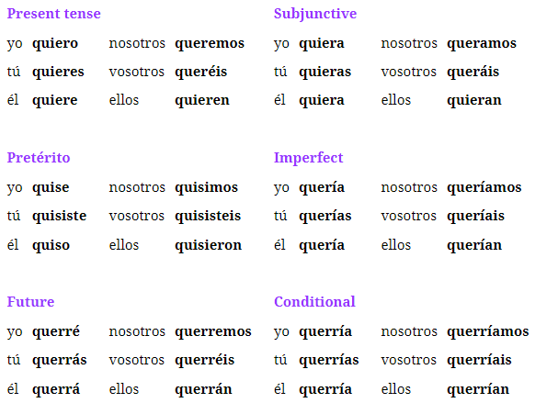

**Past Subjunctive**: quisiera -> quisieras -> quisiera -> quisiéramos -> quisieran

*Weekly Final/Group Notes*

Tips

* Pattern for Past Tense: tenia -> hacia -> queria
* Pattern for Preterite Tense: all rhyme with hacer -> hice (quise), hiciste (quisiste)
* Pattern for Subjunctive: Estar is the opposite with an “E” vs everything else uses “A”
* Not being sure about something triggers subjunctive -> template: “No estoy seguro..”
* Past Subjunctive: intentions in the past && hypotheticals

Idioms

* the best thing/part: lo mejor
* at least: al menos
* unless: a menos que
* by the way: por cierto

## Ep74: Spanish abstract nouns

Words

* nombre: name
* tipo: type
* historia: story
* forma: form (shape/format)
* parte: part (feminine)
* lado: side
* poco: little bit or small amount
* muy poco: a little bit big (using as an adverb like *muy grande*)
* persona: person (ALWAYS FEMININE)
* the best thing/part: lo mejor (**IDIOM**)

Understanding new nouns

* **RULE**: Use “Cual” vs que when using these nouns -> What’s your story? (Which is your story) is how this is used
* **RULE**: Use “Que” for asking “which part” or “which side”;
* **RULE**: when using lado + preposition of “de”
* Forma: used abstractly to talk about somethings shape/format
  + The house had a very good **shape** -> La casa tenía **una forma** muy buena.

Example Sentences

1. What’s the shape of the cake(m)? -> ¿Cuál es la forma del pastel?
2. Yes, it’s that kind of dessert. -> Sí, es ese tipo de postre.
3. He’s at this side of the house. -> Está en este lado de la casa.
4. This part of the story is very good. -> Esta parte de la historia es muy buena.
5. He’s **on** that side? -> ¿Está **de** ese lado?
6. What part do you want most? -> ¿Qué parte quieres más?
7. I hope they want to be on our side. -> Espero que quieran estar de nuestro lado.
8. I’m not sure(m) that he wants only a little bit. -> No estoy seguro de que quiera solo un poco.
9. The boy was a very nice person. -> El chico era una persona muy buena.
10. What was **the best part** of your day? -> ¿Qué fue **lo mejor** de tu día?
11. **The best thing** is to go when you can. -> **Lo mejor** es ir cuando puedas.
12. **He seriously** wants to do what he used to do. -> **En serio** quiere hacer lo que hacía.
13. She doesn’t want it **unless** they want it. -> Ella no lo quiere **a menos que** ellos lo quieran.
14. We don’t want it — or **at least**, I don’t want it. -> No lo queremos — o **al menos**, yo no lo quiero.

## Ep73: Spanish Adjectives: nuevo, menos, muerto

Words

* menos: less/fewer
* al menos: at least (**IDIOM**)
* a menos que: unless (**IDIOM**)
* nuevo: new (goes before noun)
* único: unique; only (adjective)
  + solo: I only want to do this -> Solo quiero hacer (ADVERB)
  + unico: This is the only house here -> Esta es la única casa aquí. (ADJECTIVE)
* muerta: dead (change w/ gender)
* vivo: alive/lively depending on ser/estar (change w/ gender)
  + SER: The party was very lively -> La fiesta fue muy viva
  + ESTAR: He is alive -> Está vivo.
* grande: big/great | great is used before noun | SER verb
* rápido: quick
* serio: serious
* en serio: seriously
* cierto: certain (when something is definitely the case)
* por cierto: by the way (**IDIOM**)

Understanding Grande (SER)

* if used before singular noun, you can change to “gran” like bueno
* if used before noun it means great
* if used after noun it means big
* Big Example: Her house is big -> Su casa es grande
* Great Example: What a great house -> Que gran casa!

Understanding Cierto (SER)

* used to describe something as “certain” when definitely the case
* very similar to the word “claro” (ESTAR)
* the difference just comes down to if you want to use ser or estar and pick which word to use
* Ex: Yes. **By the way**, she’s here now. -> Sí. **Por cierto**, ella está aquí ahora.

## Ep72: Spanish for loved/wanted

Words

Understanding Past Tense Imperfect

* talks about the general past of “wanting” or “loving”
* Ex: We loved our friends. -> Queríamos a nuestros amigos.
* Ex: It’s clear that you wanted it. -> Está claro que lo querías.

Understanding Past Tense Preterite

* in english we normally say “meant” when referring to one-time event
* Ex: We didn’t mean to do it. -> No quisimos hacerlo.
* Ex: I meant to help them(m). -> Los quise ayudar.

Understanding Subjunctive

* Ex: I’m not sure she loves him. -> No estoy seguro de que ella lo quiera.
* Ex: They hope you want to be at the party. -> Esperan que quieras estar en la fiesta.
* Ex: She wants me to want it. -> Ella quiere que yo lo quiera.
* Ex: She isn’t **sure that** we want to be here in the morning. -> Ella no está **segura de que** queramos estar aquí en la mañana.

Understanding Past Tense Subjunctive

* **Conditional Trigger**: acts as the conditional form for “I would want” because the conditional is almost never used
  + Ex: **I would want** to be there at that time. -> **Quisiera** estar ahí a esa hora.
  + Ex: **You would want** to go with them. -> **Quisieras** ir con ellos.
* **Verbs**: quisiera -> quisieras -> quisiera -> quisiéramos -> quisieran
* **IMPORTANT**: Two main reasons for this form
* **Intentions in the past**: I wanted them to love her -> Quería que ellos la quisieran.
* **Hypothetical Statements**: If I wanted to be there, I would be there. -> Si quisiera estar ahí, estaría ahí.
* Ex: They wanted him to want that once and for all. -> Querían que quisiera eso de una vez por todas.
* Ex:I wanted you to want to go this month. -> Quería que quisieras ir este mes.
* Ex:If I wanted to go there, I would do it. -> Si quisiera ir ahí, lo haría.
* Ex:If they wanted to be here, they would be here. -> Si quisieran estar aquí, estarían aquí.

## Ep71: Querer: want and love

Words

* wanted: querido (participle)

Understanding why “que” is used often with Querer

* normally we can say: I want a house -> Quiero una casa
* **RULE**: but if you want for something to be the case, you must use que + subjunctive
  + Ex: I want **it to be** here -> Quiero que **este** aquí.

Understanding querer + infinitive

* often followed by infinitive form when the person is intending something for themselves
* **RULE**: does not require a “que” when using infinitive to connect verbs
* Ex: She wants me to have a house -> Ella quiere que yo tenga una casa.
* **Ex**: She **wants to have** a house -> Ella **quiere tener** una casa

Understanding “to love” form:

* must use a person or a group as the direct object
* **RULE**: when a named direct object is a person, MUST put “a” before person
* Examples
  + The boy loves her -> El chico la quiere.
  + They(f) love us -> Ellas nos quieren.
  + The boy loves **the girl** -> El chico quiere **a la chica**.

Examples:

1. Do you want that? -> ¿Quieres eso?
2. I want the girls to be at home. -> Quiero que las chicas estén en casa.
3. They want me to be their friend(f). -> Quieren que yo sea su amiga.
4. She wants you to have this. -> Ella quiere que tengas esto.
5. I don’t want those things. -> No quiero esas cosas.
6. Do you want me not to be here? -> ¿Quieres que no esté aquí?
7. You(formal) want their things? -> ¿Usted quiere sus cosas?
8. She hasn’t wanted it. -> No lo ha querido.
9. He has wanted this. -> Él ha querido esto.
10. We want those things. -> Queremos esas cosas.
11. We want her to be his friend. -> Queremos que ella sea su amiga.
12. I have wanted the gentleman to be here for a while. -> He querido que el señor esté aquí por un tiempo.

Examples w/ Infinitive:

1. She wants to be my friend. -> Ella quiere ser mi amiga.
2. We want her to have this. -> Queremos que ella tenga esto.
3. I want to go home. -> Quiero ir a casa.
4. Do you want to be there? -> ¿Quieres estar ahí?
5. They have wanted to have those things. -> Han querido tener esas cosas.
6. I’m going to want him to leave. -> Voy a querer que él se vaya.
7. They want to be here. -> Quieren estar aquí.

Examples w/ Love

1. We love those guys. -> Queremos a esos chicos.
2. They love the miss. -> Quieren a la señorita.
3. I love the man. -> Quiero al hombre.
4. The boy loves the woman. -> El chico quiere a la mujer.
5. You don’t love the gentleman? -> ¿No quieres al señor?
6. You have to love the girl. -> Tienes que querer a la chica.
7. I have loved the boy for many years. -> He querido al chico por muchos años.

Week 12: Lectures 66-70

Weekly Final/Group Notes

**Understanding Hacerte and becoming friends**

* Question: ¿Te has hecho amigo de alguien recientemente?
* Literal Translation: Have you made a friend recently?
* Natural Translation: Have you become friends with someone recently?
* Alternative:
  + Have you made a new friend recently? -> Has hecho un nuevo amigo/a recientemente?
* Understanding Natural:
  + hacerse amigo de alguien literal is "to make oneself a friend of someone"
  + hacerse means "to become" or express the idea of becoming something or changing state
* General removing "te": if you remove the Te, this removes the idea of reflexive to perform the action on oneself
  + Ex: Can I ask you a question? -> Puedo hacerte una pregunta
  + Ex: I'm going to make you a sandwich. -> Voy a hacerte un sándwich
  + Ex: You have to become a doctor. -> Tienes que hacerte doctor.

## Ep69: Hora, Minuto, Semana, Mes

Words

* semana(f): week
* mes(m): month
* horas: hours
* minuto: minute
* manana: morning
* el pasado: the past
* en ese entonces: back then (referring to a specific era in the past)
* fiesta: party
* hacer una fiesta: throw a party
* momento: moment
* tiempo al tiempo: give it time/be patient

Idioms

Understanding tiempo vs memento

* tiempo refers to a more general time
* memento refers to a particular moment in which something changes ie suddenly time to leave a party

Examples

* This month he hasn’t been able to go. -> Este mes no ha podido ir.
* I was able to be here for 3 hours. -> Pude estar aquí por 3 horas.
* What time is it? It’s 1 in the afternoon. -> ¿Qué hora es? Es la una de la tarde.
* It’s three in the morning. -> Son las tres de la mañana.
* In the past we were able to do it. -> En el pasado lo podíamos hacer.
* In the past I was a student; back then I studied more. -> En el pasado yo era estudiante; en ese entonces estudiaba más.
* It’s time for us to leave. -> Es momento de irnos.
* It was time to make myself a friend -> Era tiempo de hacerme un amigo.
* That was the moment to leave the party. -> Ese fue el momento de irme de la fiesta.
* They can throw a party themselves. -> Ellos mismos pueden hacer una fiesta.
* Give it time, he’ll be able to do it this evening. -> Tiempo al tiempo, podrá hacerlo esta noche.

## Ep68: Feliz, Mismo, Seguro

Words/Idiom

* mismo: same; he/her themselves;
* ya mismo: right now, this instant
* al mismo tiempo: at the same time
* a la vez: at once
* a veces: at times/sometimes
* una vez: once
* una vez que: once (when conguncting sentences can stand on their own) but use subjunctives
* de vez en cuando: once in a while
* de una vez por todos: once and for all

Words (ESTAR) <- adjectives

* feliz: happy
* felices: happy (plural)
* solo/a: lonely
* seguro: sure
* de seguro: being sure about something
* seguro de: asking if someone is sure about a specific fact

Words (SER)

* seguro: safe

Understanding Mismo

* gender specific and means “same”
* could reference somethings self ie “what itself is” BUT it is not reflexive where it is used before the verb; the word itself is used to emphasize that were talking about that specific person and only that person
* IDIOM: ya mismo -> emphasize a very specific moment like “right now” or “this instant”
  + Ex: They were all in the same house -> Todos estaban en la misma casa
  + Ex: He himself has to be there -> El mismo tiene que estar ahí.
  + Ex: She herself has to go. -> Ella misma tiene que ir.
  + Ex: You have to be careful, because we did it ourselves. -> Tienes que tener cuidado, porque nosotros mismos lo hicimos.
  + Ex: Do it this instant! -> ¡Hazlo ya mismo!

Understand Happy and Lonely

* feliz means happy but has plural version for “felices”
* solo and sola means lonely
* Ex: We have all been happy here. -> Todos hemos estado felices aquí.
* Ex: She has been very lonely. -> Ella ha estado muy sola.

Understanding Seguro (ESTAR)

* the general word for sure is seguro
* to be sure about something you must use “de seguro”
* if you want to say that you’re sure about a sort of act “seguro de”
* Ex: I’m not sure(m). -> No estoy seguro.
* Ex: She’s sure about that. -> Ella está segura de eso.
* Ex: They(f) weren’t very sure about this. -> Ellas no estaban muy seguras de esto.
* Ex: You’re sure(f) that there’s nobody in the house? -> ¿Estás segura de que no hay nadie en la casa?

Understanding Seguro (SER)

* something that is secure or safe; normally for places NOT for people being in/out of harms way
* Ex: This place is very secure. -> Este lugar es muy seguro.
* Ex: There are always people, and for that reason the place is safe. -> Siempre hay gente y por esa razón el lugar es seguro.

Understanding Claro

* means clear
* Ex: It’s clear that we have to be there. -> Está claro que tenemos que estar ahí.

Idioms

* I did it once I was sure. -> Lo hice una vez que estuve seguro.
* We will do it once he is here. -> Lo haremos una vez que él esté aquí. (use subjunctive because its like using cuando/hasta que)
* It’s not a problem; we’ll do it once they are here. -> No es un problema, lo haremos una vez que estén aquí.
* She’ll go once you can go with her. -> Ella irá una vez que puedas ir con ella.
* We used to do it once in a while. -> Lo hacíamos de vez en cuando.
* I’m going to do it once and for all. -> Lo voy a hacer de una vez por todas.

## Ep67: How to say “Could”

Understanding Could

* often this is how you put “can” in the past but has multiple meanings
* RULE: keep the same conjugation for the context
* meanings
  + would be able
  + could | couldn’t
* Ex: That day I couldn’t do it, but now I can. -> Ese día no pude hacerlo, pero ahora sí puedo. (pude==preterite I)
* Ex: If she were here, I could do that. -> Si ella estuviera aquí, yo podría hacer eso. (podría==conditional I)

Examples: Imperfect Past Tense

* You were always able to do this -> Siempre podías hacer esto.
* She wasn’t able to have those things -> Ella no podía tener esas cosas.
* We weren’t able to do the things that way -> No podiamos hacer las cosas de esa forma.
* I was able to study for a long time when I was at home -> Podía estudiar por mucho tiempo cuando estaba en casa.

Examples: Preterite Tense

* I wasn’t able to do it -> No lo pude hacer
* Yes, I managed to do it that day -> Si, lo pude hacer ese dia.
* I studied all day, but I couldn’t pass the exam. -> Estudié todo el día, pero no pude pasar el examen.
* He couldn’t lift what I asked him. -> No pudo levantar lo que le pedí.
* Yes, I managed to complete the last level! -> ¡Sí, pude completar el último nivel!

Examples: Future and Conditional Tense

* You won’t be able to do that. -> Usted no podrá hacer eso.
* I would be able to go, but I won’t do it. -> Podría ir, pero no lo haré.
* I will be able to visit my family. -> Podré visitar a mi familia.
* We would be able to do it, if you let us. -> Podríamos hacerlo, si nos dejaras.

Examples: Subjunctive Tense <- use a

* I want us to be able to go. -> Quiero que podamos ir.
* I hope you (formal) can be with us. -> Espero que usted pueda estar con nosotros.
* She hopes that you can be here. -> Ella espera que puedas estar aquí.
* You’re right, she did it so that they can be here. -> Tienes razón, ella lo hizo para que puedan estar aquí.

Examples: Past Tense Subjunctive

* If I were able to be there, I would be there. -> Si pudiera estar ahí, estaría ahí.
* I did it so that she could go. -> Lo hice para que ella pudiera ir.
* If I were able to be there, I wouldn’t do it. -> Si yo pudiera estar ahí, no lo haría.
* She said it so that I could be careful. -> Lo dijo para que yo pudiera tener cuidado.

## Ep66: Poder

Words

* podido: been able (past participle)
* poder: to be able
* se puede: can be (is/isn’t able to be done OR is/isnt permitted)
* puede que: It might be that (how to say might)
* puede: might (changes based on conjugation and understands context around it)

**Verb Chart**

Preterite: pude, pudiste, pudo, pudimos, pudieron

Past: podia, podias, podia, podiamos, podian

**Present** (I can): puedo, puedes, puede, podemos, pueden

Subjunctive (I can): pueda, puedas, pueda, podamos, puedan

Future (I will be able): podré, podrás, podrá, podremos, podrán

Conditional (I could): podría, podrías, podría, podríamos, podrían

Past Subjunctive: pudiera, pudieras, pudiera, pudiéramos, pudieran

Understanding Poder

* means: can, may, or to be able
* you can use the infinitive of “poder” to represent being able to do something then use along with the phrase that follows it as a noun in the sentence.
  + Ex: I want to be able to do that -> Quiero poder hacer eso.
  + Ex: That was because of being able to do this -> Eso era por poder hacer esto.
  + Ex: I’m going to be able to do something -> Voy a poder hacer algo.
* the past participle is “podido” which means -> been able
  + Ex: We haven’t been able to do it -> No lo hemos podido hacer.

Understanding Poder to say might <- puede que

* two common ways to say “might”, which is using the normal poder conjugation OR using **puede que** which means “it can that” or something might be the case
* Ex: That can (might) be around here -> Eso puede estar por aqui
* Ex: They might be friends -> Ellas pueden ser amigas.
* Ex: It might be that he’s done -> Puede que este aqui.
* ex: It might be that they aren’t friends -> Puede que no sean amigas.

Understanding Poder Reflexive

* Has two general meanings
  + something is or isn’t able to be done
  + something is or isn't permitted
* Ex: Those things can’t be done in this place. -> Esas cosas no se pueden hacer en este lugar.
* Ex: Which of all these can be had here? -> ¿Cuál de todos estos se puede tener aquí?
* Ex: In this place those things can be done, but carefully. -> En este lugar se pueden hacer esas cosas, pero con cuidado.

Week 11: Lectures 61-65

Weekly Final Notes

1. Cual ie “which” asks questions about reasons/ways/ideas not “Que” which is used when things are completely unknown
2. past tense s
3. La última vez que estuve en un concierto fue hace(ago) muchos años
4. 05. She’s also going to the party(f) with us. -> Ella también va a la fiesta con nosotros.
   1. I am going to the party = yo voy a la fiesta

## Ep65: Practice Hacer

Past Subjunctive: hiciera, hicieras, hiciera, hiciéramos, hicieran

Understanding Past Subjunctive Form:

* If he did it, he wouldn’t be here -> Si lo hiciera, no estaría aqui.

## Ep64: Problema, Trabajo, Razón, Idea

Templates

* Esa es la razón por la que nos fuimos. (left)
* Tienes razón en eso. (are right about)
* No estoy de acuerdo. (i disagree)
* Hay que tener cuidado aquí.
* No sé cuál es la mejor forma de hacerlo.

Idioms

* **tienes razon: you are right**
* de acuerdo: of agreement (it normally is not used alone without preposition)
  + ah-quare-doh
* de esa forma: that way
* por el que/la que: for which
* en problemas: in trouble (they dont say in trouble, instead in problems)
* Ten cuidado: Be careful!
* no estoy de acuerdo: I don't agree

Words

* el problema: problem
* el trabajo: work/job
* aburrido: bored
* en el trabajo: at work
* la idea: idea (eee-day-ah)
* la razon: reason
* el cuidado: caution (qwee-dah-doh) (talking about being careful == having caution)
* con mucho cuidado: very carefully (there is no word for carefully)
* Cual: which && what (when question is about reason/ideas/ways)
* la forma: the way

Understanding Pronoun “Cual” -> Which (reasons,ways,ideas)

* **RULE**: literal meaning is “which” but normally used in asking questions about “reasons, ways, and ideas”
* **Rule**: Que is used when something is completely unknown vs Cual is used when its less unknown and you need to pick between options etc
* Ex: What is the reason for that? -> ¿Cuál es la razón por eso?
* Ex: What is the way to do this? -> ¿Cuál es la forma de hacer esto?

Understanding Razon/Cuidado/Acuerdo -> being right about == having reason in

* **RULE**: You are right translates into “you have reason” <- TENER
* **RULE**: being careful translates into “having caution” <- TENER
* **RULE**: in agreement translates into “being of agreement” <- ESTAR
* razon also means “being right about something”
* in spanish you dont describe someone as “being right about” instead “having reason in”
* agreements have two ways
  + general: its an agreement -> es un acuerdo
  + idiom: being of agreement -> estar de acuerdo
* Ex: You are right about that -> Tienes razon en eso
* Ex: We are all in agreement. -> Todos estamos de acuerdo.
* Ex: There is a need to be careful here -> Hay que tener cuidado aquí

Understanding the “for which’ structure

* That is the reason ?? we left
  + Step 1: looks like two sentences: “that is the reason” + “we left”
  + Step 2: join together with “**which**” -> el que / la que
  + Step 3: New sentence: “That is the reason *for which* we left”
* That is the reason for which we left -> Esa es la razón la que nos fuimos.
* This is the girl for which we did **that.** -> Esta es la chica para la que hicimos **eso**.
* This was the problem because of which we did that. -> Este fue el problema por el que hicimos eso.

Understanding Forma -> “the way”

* the concept of describing the way something is done the common use is “forma”
* Ex: We don’t know the best way of doing this. -> No sabemos la mejor forma de hacer esto.
* This is the way in which I did it. -> Esta es la forma en **la que** lo hice.

Examples: Problems and Work

* If you are bored with your job, you will be in trouble -> Si estas aburrido con tu trabajo, estarás en problemas.
  + you will be -> future tense NOT conditional
* What he did **caused us** a lot of problems -> Lo que él hizo **nos causó** muchos problemas.
* She used to do those things **at work** in order to do it well -> Ella hacia esas cosas **en el trabajo** para hacerlo bien.
* Do the work! -> Haz el trabajo!
* This is the best **job.** -> Este es el mejor **trabajo**

Examples: Razon, Cuidado

* She is right and that’s why we told it to her. -> Ella tiene razón y por eso se lo dijimos.
* I wasn’t right and I didn’t want to do you that favor. -> No tenía razón y no quería hacerte ese favor.
* He thinks I’m right so he always does it. -> Cree que tengo razón así que siempre lo hace.
* That day he was very careful. -> Ese día tuvo mucho cuidado.
* We did it very **carefully**. -> Lo hicimos con mucho cuidado.
* We didn’t reach an agreement, **so** we’ll do it **that way**. -> No llegamos a un acuerdo, **así que** lo haremos **de esa forma**. *(we arrived == llegamos)*
* Be careful upon doing him that favor. -> Ten cuidado al hacerle ese favor.
* We always do it that way. -> Siempre lo hacemos de esa forma.

Examples: Idea and Razon

* We left for that reason -> Nos fuimos por esa razón
* They told us that idea and for that reason they did it -> Nos contaron esa idea y por esa razón lo hicieron.
* The reason for which I did it **was** because I **had** that idea. -> La razón por la que lo hice **fue** porque **tuve** esa idea.

Examples: Cual

* What is the reason for which you did that? -> ¿Cuál es la razón por la que hiciste eso?
* I don’t know which is the best way to do it. -> No sé cuál es la mejor forma de hacerlo.
* We didn’t know which to choose and that’s why you left. -> No sabíamos cuál elegir y por eso te fuiste.
* Which one did you do? I did this one(m). -> ¿Cuál hiciste? Yo hice este.

## 

## Ep63: Redundant indirect objects

Tips

* “se” is for reflexive objects

Refreshers

* Direct Object Pronouns: direct receives the action
  + I see **it** -> Lo veo
* Indirect Object Pronouns: recipient of the action
  + I give **her** the book -> Le doy el libro.

Understanding Dual Indirect/Direct Object Sentences

* **RULE**: when a sentence has both indirect and direct object pronoun, indirect goes first
* Ex: They gave it(f)(2) to us(1)-> Ellos nos lo dieron.
* Examples
  + She is telling me it(f) -> Ella me la está contando.
  + I will give them something -> Yo Les dare algo.
  + Are you giving me them -> Me los are you giving (das).
  + I’m asking her a question -> Le estoy haciendo una pregunta.
  + He gave it(f) to you -> Te la dio.

Understanding replacing with “se” for him/her

* RULE: when you need to replace with him/her ideally you would use “le” but if “lo” is in the sentence directly after this needs to replace
* Ex: I told him it -> Him it I told -> Le lo I told -> Se lo I told => Se lo dije.
* Examples
  + Will you tell it(f) to her -> Se la contaras.
  + I told him it(m) -> Yo se lo dije.
  + She told it(f) to us -> Ella nos la conto.
  + I would give it(m) to you -> Te lo daria
  + They will give it(f) to me -> Ellos me la daran.

Understanding Redundant Indirect Objects

* RULE: if the recipient is named, it needs the indirect object pronoun; You will still need to use le/les even if you name it after the “a” as well.
* Ex: We gave it(2) to our friend(1) -> *Lo we gave a nuestro amigo* -> Se lo dimos a nuestro amigo.
* Examples
  + They(f) gave Sofia many things -> Ellas le dieron muchas cosas a Sofia.
  + We told something to our friends(m) -> Nosotros les dijimos algo a nuestros amigos
  + He asked his friend if he had something -> Le preguntó a su amigo si tenia algo.

## Ep61: Congugate Hacer

Words Imperative

* **Subjunctives**: haga, hagas, haga, hagamos, hagan
* Do it -> Hazlo <- Informal
* Don’t do it -> No hagas <- Informal (negatives==subjunctive + no contraction)
* Do it-> Hagalo (formal ie usted/el/la)
* Don't do it -> No lo haga (formal ie usted/el/la) == subjunctive

Understanding Imperatives

* Refresher: turning “YOU GO” into “ve” && “YOU LEAVE” into “vete” by making it reflexive BUT **remember negatives dont get contraction + use subjunctive**
* Informal Imperative way to say “do” == Haz
* Formal Imperative way to say “Do” == Haga <- ie the subjunctive
* Examples
  + Do it now -> Hazlo ahora
  + Do it now -> Hagalo ahora (formal)
  + Do me a favor -> Haganme un favor (formal)
  + Dont do it now -> No lo hagas ahora. (negative use subjunctive)
  + Dont do it now -> No lo haga ahora (formal)

Understanding Object Pronouns after Verbs w/ Contractions

* when sentence has two verbs like “tiene que hacer” and the object pronoun goes before the conjugated verb Ex: He has to do it -> Lo tiene que hacer
* but this is a problem when we want to use an object pronoun but no verb to put it before. Ex: I am here in order to do it
  + Step 1: Estoy aqui para…
  + Step 2: After preposition (para) **there should be a noun or infinitive**
  + Step 3: So we need to turn the phrase “to do it” or the idea of “doing it” into a noun
  + Step 4: Use the contraction -> hacerlo

Examples

* She’s here to do **him** a favor -> Ella está aquí para hacer**le** un favor
* Doing it here would be good -> Hacerlo aqui seria bueno.
* We put emphasis on doing it well -> Ponemos enfasis en hacerlo bien.
* Leaving would be good -> Irse seria bueno.
* I dont have it, because she has to have it -> No lo tengo, porque ella tiene que tenerlo.
* I have to leave -> Tengo que irme
* Do you have to leave now? -> Tienes que irte ahora?
* They didnt have to have it -> No tenian que tenerlo.
* We did it in order to leave -> Lo hicimos para irnos.

## Ep61: Hacer - “to do/to make”

Words

* done: hecho | doing: haciendo
* do: haz (imperative)
* to become/is done: hacerse

**Understanding Hacer**

* preterite: hice, hiciste, hizo, hicimos, hicieron
* past: hacia, hacías, hacía, hacíamos, hacían
* present: hago, haces, hace, hacemos, hacen
* future: haré, harás, hará, haremos, harán
* subjun: haga, hagas, haga, hagamos, hagan
* cond: haría, harías, haría, haríamos, harían

Understanding Hacerse

* reflexive of hacer -> “to become” or “is done”
* can pair with “tener” to put emphasis on obligation BUT ‘se’ leads the sentence
* Ex: That's not done around here -> Eso no se hace por aquí.
* Ex: That has to be done -> Eso se tiene que hacer

Week 10: Lectures 56-60

Weekly Final Notes

1. past tense subjunctives are for hypothetical things or past intentions
2. “hasta que” creates subjunctive mood and for future tense scenarios
3. “anything that” or “all that” -> todo lo que

**Group Final Notes**

Questions

* What do you think is the best movie? -> Cuál crees que es la mejor película
* I think the best movie is -> Creo que la mejor película es
* If you could have another job, what would it be? -> Si pudieras tener otro trabajo, ¿cuál sería?
* If I could have another job, it would be a simple job like helping people who have physical challenges that cannot help themselves. -> Si pudiera tener otro trabajo, sería un trabajo simple como ayudar a las personas que tienen desafíos físicos que no pueden ayudarse a sí mismos.
  + simple -> simp-ley
  + desafíos -> des-ah-fee-ohs

Sentences

* Both of them have to be here -> Los dos tienen que estar aquí.
* Thank you for **telling me** that I had to do it -> Gracias por **decirme** que lo tenia que hacer
* They will leave the party when they finish dancing -> Se irán de la fiesta al terminar de billar
* Tomorrow I will go to the park if it doesn't rain, but when I was a child, I used to go every Sunday. -> Mañana iré al parque si no llueve, pero cuando era niño, iba todos los domingos.
  + iré: Future tense of "ir" (I will go)
  + iba: Past imperfect tense of "ir" (I used to go)

**1 on 1 Final Notes**

* I am the middle child -> Yo soy el medio
* I practiced -> Practique (preterite)
* I used to practice -> Practicaba (imperfect)
* I played -> jugué
* Auto pilot -> Piloto automático
* even though -> aunque
* therefore -> por lo tanto
* this past weekend -> El fin de semana pasado
* no hablaba -> i didn't speak (past tense hablar)
* hablaba -> spoke
* I ate -> comi
* I did not smoke -> No fume (past) | I smoke -> Fumo | You smoked->Fumaste

Conversation

My job was easy today even though I had a lot of work. Nobody bothered me today therefore I was focused. -> Mi trabajo estaba facil hoy aunque tenia mucho trabajo. Nadie me molesto hoy, por lo tanto, estaba enfocado.

* por lo tanto -> therefore
* aunque tenía -> even though I had

The past weekend I played video games and practiced my spanish again -> El fin de semana pasado jugué videojuegos y practiqué español otra vez.

Que cosas tienes que tener para ser feliz -> What things do you have to have to be happy

* Las cosa que tengo para ser feliz son:
  + mi salud (my health)
  + ir al gimnasio (go to the gym)
  + ser amable y ayudar para los demás (being nice and helpful to others)
  + tiempo libre para hacer lo que quiero (free time do to what i want)
  + solo eso (thats it)

Cuales han sido tus mejores vacaciones -> Which have been your best vacations?

* Mis mejores vacaciones han sido en cuba / Mis mejores vacaciones fueron en Cuba
* porque fue muy tranquilo, las personas era muy amables aunque no hablaba español.
* La amiga de mi mejor amigo esta estudiando en Cuba medicina
* Soy muy simple
* Todos los dias comi pollo con arroz
* No fume pero vi como hacer un cigarro Cubano -> I didn't smoke but I saw how to make a Cuban cigar

## Ep60: Practice

Idioms

* Todo lo que -> all that or everything that
* "Lo tengo todo" -> "I have it all"
* "Todo lo que tengo" -> "Everything that I have"
* “Todo lo que quieres” -> everything you want
* "Si o si" -> "No matter what" or “Either way”
* "Por ahí" -> "Around there"
* "Así que" -> "So that / Thus that"
* "¿Cómo que?" -> "How's that?"

Sentences

1. All that I can do is wait -> Todo lo que puedo hacer es esperar
2. I dont have it all -> No lo tengo todo
3. This is everything that I have -> Esto es todo lo que tengo
4. She has it all -> Lo tiene todo
5. It isnt everything that you have to do -> No es todo lo que tienes que hacer
6. We’ll be at home either way -> Estaremos en casa si o si
7. Yes, they’re around -> Si, estan por ahi
8. Now everyone is present, so lets go -> Ya estan todos, asi que vamos
9. I dont have it so please go home -> No lo tengo, asi que por favor ve a casa
10. They aren’t present? How that they aren’t present -> No estan? Como que no estan
11. What do you mean we dont have it -> Como que no lo tenemos?
12. We have to go no matter what. -> Tenemos que ir sí o sí.
13. She isn’t around, so we can leave. -> No está por ahí, así que nos podemos ir.
14. I told you I don’t have it all. -> Te dije que no lo tengo todo.
15. They are about to do something either way -> Están por hacer algo sí o sí.
16. We were friends for years but recently he had a problem with me. -> Fuimos amigos durante años pero recientemente tuvo un problema conmigo.

**Additional Help:**

* My mother would have to go if she were her daughter. -> Mi madre tendría que ir si fuera su hija.
  + **RULE**: Conditional + subjunctive past
  + would have -> conditional form of tener == “tendria”
  + if she were -> subjunctive past of ser == “fuera”

## 

## Ep59: Porque and Hasta

New Words

* Even: hasta <- adverb (right before noun to emphasis surprise)
* Until: hasta <- preposition
* Also: también

Topics: Revisiting “por” <- preposition

* means “by” or “because of” and tend to talk about the source of something or the idea of being near something
* cannot use “por” here: I’m here because he’s here
  + cant use “por” because prepositions are normally followed by a noun
  + we are following it with a full sentence “He’s here”
  + therefore we need a conjunction -> porque

Topics: Deeper into Adverbs

* adverbs add information about a noun?? <- not sure
* normally adverbs can be thrown in anywhere:
  + He has it -> El lo tiene
  + He has it here -> Aqui el lo tiene OR El lo tiene aqui
* adding in a “no” means it goes AFTER subject and BEFORE the verb && lo_tiene MUST stay together -> El no lo tiene

Topics: Adverbs and Placing Emphasis (Hasta)

* if we want to place emphasis on the subject the adverb needs to be placed specifically
* Ex: Even she is here vs She is even here
  + first puts emphasis on the subject of she vs the emphasis being on the fact she is here
* Even she is here -> Hasta ella esta aqui
* She is even here -> Ella hasta esta aqui
* Examples
  + Even he is nice: Hasta el es bueno
  + Actually, you have it also -> En verdad, tu lo tienes también
  + I have had that too -> Yo he tenido eso también
  + Even this afternoon is good -> Hasta esta tarde es buena.
  + She even has it -> Ella hasta lo tiene
    - because “even” is used as an adverb it needs to come before noun of “it”

Topics: Understanding “ni” ie the opposite of “o”

* remember “o” means “or” and “either”
* ni -> “neither” and “nor” (NOTE: for conjunctions only)
* the adverb for neither is “tampoco”
* you will use this with double negatives
* It wasn’t either a boy or a girl -> No era ni un chico ni una chica

Topics: Understanding “hasta” <- preposition (right before a noun) or conjunction

* means “until” but used to emphasize events leading to a moment of time
* can be used as a conjunction with “hasta que” if a statement or description comes after
* when using “hasta que” it behaves like cuando and creates a subjunctive mood && if the future is referred, this creates subjunctive mood as well

Examples:

* I had it until 3’oclock -> Lo tuve hasta las tres
* He was here until that day -> Estuvo aquí hasta ese dia
* I was here until she left -> Estuvo aquí hasta que se fue.
* We’ll think about it until your party. -> La pensaremos hasta tu fiesta.
* We’ll think about it until your party happens. -> La pensaremos hasta que ocurra tu fiesta.
* I’m going to be unwell until she’s here -> Voy a estar mal hasta que ella esté aquí.
* I will have it until she leaves -> Lo tendré hasta que ella se vaya.

## Ep58: Fuera and other past tense subjunctives

New Words (Past Subjunctives)

* Ser: I was, You were -> fuera, fueras (**ADD AN A**)
* Ir: I went, You went -> not iba, ibas | fuera, fueras
* Lesson Common
  + Estar: I was -> estuviera
  + Tener: I was -> tuviera

Verbs Support

* The conditional forms of Ir are iría, iría, irías, irían, and iríamos.
* The conditional forms of Tener are tendría, tendría, tendrías, tendrían, and tendríamos.
* Ser’s past tense subjunctives: fuera, fuera, fueras, fueran, and fueramos.
* Ir’s past tense subjunctives: fuera, fuera, fueras, fueran, and fueramos.
* Estar’s past tense subjunctives: estuviera, estuviera, estuvieras, estuvieran, and estuviéramos.
* Tener’s past tense subjunctives: tuviera, tuviera, tuvieras, tuvieran, and tuviéramos.

Ser: Past Subjunctive Verb Table

* fuera | fueras | fuera | fuéramos | fueran

Topics: Past tense of SER and Hypotheticals -> Fuera + conditional

* **RULE**: must use past tense subjunctive of SER -> fuera + conditional verb
* used to indicate that something is not true or hypotheticals
* for example: when saying “if I were taller” you are not talking about past tense and indicates of a present tense
* Ex: If it were you(formal), it would be at home -> Si fuera usted, estaría en casa
  + it would be: estaria <- conditional he/she/it

Topics: Past tense desires -> past-desire que + past subjunctive

* past tense desires create past tense subjunctive mood
* Ex: She wanted me to be her friend -> Ella quería que yo fuera su amigo.
* Ex: I hoped that it was the gentleman -> Esperaba que fuera el señor.

Topics: Past tense “Ir” for Hypotheticals and Intentions

* normally to say “I went” you would use iba, however, past subjunctive is “fuera”
* Ex: If I went to the party, I would eat all the food -> Si fuera a la fiesta, comería toda la comida
* Ex: They wanted me to go home -> Querían que yo fuera a casa
  + me to go: is basically -> “I go”

Topics: Less common for Estar and Tener

* If I were at home, I wouldn’t be here -> Si yo estuviera en casa, no estaría aquí.
* I wanted her to have this -> Quería que ella tuviera esto.
* She wanted me to be at home. -> Ella quería que yo estuviera en casa.
* If I had money, I would be there. -> Si tuviera dinero, estaría ahí.
* If she was here, this wouldn’t be a problem. -> Si ella estuviera aquí, esto no sería un problema.

## Ep57: Ser, preterite tense

New Idioms

* What was that: que fue eso

Topics: Past Tense of Ser w/ Fue

* used when the past tense was a specific event like was a mistake, was a winner etc

Examples

* I was the one that helped you that day -> Yo fui el que te ayudó ese día.
* Juan was a good man that year -> Juan fue un buen hombre ese año.
* That day you were nice -> Ese dia tu fuiste buena.
* When we were kids all was well -> Cuando eramos niños todo estaba bien.
* We have gone there before, when she was your friend -> Ya hemos ido ahí antes, cuando ella era tu amiga
* Please, go to the store and buy milk -> Por favor, ve a la tienda y compra leche

## Ep56: Spanish Personal ‘a’

New Idioms

* It has some of everything
* It’s not too much/it could hurt/not extra
* for nothing/intended for nothing
* instead of
* in place of
* RULE: add ‘a’ before verb when talking about a person/group

Topics: Prepositions Deeper Dive -> “a”

* these dont carry much meaning by themselves and get all of their meaning from the phrases around them
* Direct Object Template: We had **your things** here -> Teniamos tus cosas aqui.
  + direct object: tus cosas
* Direct Object Pronoun Template: We had **them** here -> Las teniamos aqui
  + direct object pronoun: them
* **RULE**: when a direct object is a person/group of people, the ‘a’ preposition goes in front
  + The boy loves the girl -> El chico quiere a la chica.
  + Now he doesn’t have anybody in the world -> Ahora no tiene a nadie en el mundo
* Non-direct objects **do not** follow this rule
  + The boy has done it with the girl -> El chico lo ha hecho con la chica.
    - prepositional object: the girl (because of con)

Topics: IDIOMS -> “de” and “para”

* Idiom: “It has some of everything” -> Tiene de todo (had=tenía)
* Idiom: “its not too much” or “it couldn’t hurt” or “not extra” -> no esta de mas
* Idiom: “for nothing” or “intended for nothing” -> para nada
* Idiom: “instead of” -> en vez de (MORE COMMON)
* Idiom: “in place of” -> en lugar de
* Examples
  + You have two extra things -> Tienes dos cosas de mas
  + It couldn't hurt to do that -> No esta de mas hacer eso
  + My friends house has a bit of everything -> La casa de mi amiga tiene de todo
  + I have this in place of that -> Tengo esto en lugar de eso
  + We have done this instead of that -> Hemos hecho esto en vez de eso

Week 9: Lectures 51-55

Weekly Final Notes

1. All commands require the subjunctive form
2. If reflexive -> subjunctive + conjunction | If negative -> dont use conjunction
3. ten and ve means “Have” and “Go”
4. asi que -> so
5. Had: tenido | Having: teniendo
6. otra vez: again
7. there will be a need: Habra
8. upon: al + verb/noun

## Ep55: Spanish Imperatives Practice

New Words

* la semana pasada: last week
* mudar/mudarme: move
* tu habitación: your room

Examples w/ Notes

1. I have had the best family -> He tenido la mejor familia.
   1. haber is used to put something in the past, this is NOT POSSESSION
2. You will have to tell me what you know -> Me tendrás que decir lo que sabes.
   1. before you respond, if you’re directing to yourself, say “ME” first
3. They had to have only one house -> Tienen que tener solo una casa.
   1. not haber because the possession is a house
4. Let’s go! I dont want them to have to take us -> Vamos! No quiero que tengan que llevarnos.
   1. No quiero (I don't want) is the conjugated verb.
   2. tengan que llevarnos uses the subjunctive form because it expresses a desire or wish for something to happen – and “que” because its a desire
5. I want us to have to do it -> Quiero que lo tengamos que hacer
   1. I want + it we have to do
6. I’ll have to move upon finishing school -> Tendre que mudarme al terminar la esquela
7. It’s done, we dont have them anymore -> Ya esta, ya no los tenemos
8. She had to do it, since she **has** it -> Ella lo tenia que hacer, ya que ella lo **tiene**.
   1. has is a “present tense” verb NOT HAD
9. You didn’t have to be there -> No tenias que estar ahí.
   1. did is a “past tense” verb
10. Let’s leave since he has to study -> Vamonos ya que el tiene que estudiar
11. Have the thing that **I had** -> Ten lo que yo tuve <- preterite
12. I hope they have what they have to have -> Espero que tengan lo que tienen que tener
13. Leave now or they will have to clean -> Veta ahora o tendran que limpiar
14. There will be a need to work that day -> Habra que trabajar ese dia
    1. There will be a need == ALL ONE WORD
15. (All of you) Go now! We have to help them -> Vayan ahora! Los tenemos que ayudar.
16. She didn’t have time at 1, so she hasn’t done it -> No tuvo tiempo a la una, asi que no lo ha hecho.
17. She doesn’t want me to have both -> No quiere que tenga los dos.

## Ep54: Spanish Imperatives

New Words

* again: otra vez
* Solo habia: There was only
* Habia: There was
* unos/unas: some + verb ex: Some girls -> Unas chicas
* los/las dos: both Ex: Both boys are here -> Los dos chicos están aquí,
* otro: other/another Ex: they have another thing -> Tienen otra cosa. (gender spec)
* mucho: much/many/a lot; gender specific
* un or una: changes depending on gender
* un before noun: There was only one boy -> Solo habia un chico.
* uno without noun: There was only one -> Solo habia uno

New Templates

* ¡Ten esto! -> Have this | Take this
* ¡Ve a la casa! -> Go to the house
* ¡Vete ahora! -> Leave Now!
* ¡No te vayas! -> Do not go
* ¡Vayan al lugar! -> Go to the place!
* ¡Vamos a la casa! -> Let’s go home
* ¡Vámonos de aquí! -> Lets go from here
* No tengamos estas cosas. -> Let’s not have these things

Topics: Understanding Imperatives

* Gentle obligations like “tener que” or “haber que” -> must or have to
* Expressing “GO” to one person: “Ve” -> Ve al lugar ahora
* Expressing “GO” to formal person: “Vaya” -> Vaya al lugar, por favor.
* Expressing “GO” to group of ppl: “Vayan” -> Vayan al lugar ahora.
* Expressing “HAVE” to one person: “Ten” -> Ten esto!
* Expressing “HAVE” to formal person: Tenga esto <- uses subjunctive
* Expressing “HAVE” to group of ppl: Tengan esto
* Examples:
  + Go now -> Ve ahora
  + (All of you) go to his house -> Vayan a su casa.

Topics: Reflexive Imperatives w/ Contractions after verb (subjunct+te/se/nos)

* RULE: must use the **contraction** to put the object pronoun AFTER VERB
* Ex: Leave now! -> Vete ahora
* Ex: Let's leave the house -> Vámonos de la casa.
* Ex: (All of you) leave this place -> Vayanse de este lugar.

Topics: Negative Imperatives -> DON'T USE CONTRACTIONS

* RULE: only use the subjunctive forms + for reflexive verbs DONT USE CONTRACTION
* Ex: Don’t go -> No vayas
* Ex w/ Reflexive: Don’t leave -> No te vayas (DON'T SAY: “~~No vete~~”)

Examples w/ Notes

1. Don’t leave -> No te vayas
   1. Details: Reflexive and negative
   2. Rule: use subjunctive without contraction && since reflexive need te/se/nos
2. Let’s not go to the place -> No vayamos al lugar.
   1. Details: negative
   2. Rule: needs a subjunctive since its a demand + negative
   3. No Imperative: We don't go to the place -> No vamos al lugar
3. Let’s not leave the house -> No nos vayamos de la casa.
   1. Details: reflexive and negative
   2. Rule: if reflexive use contraction but since negative put in front
   3. Non negative: Let’s leave the house -> Vámonos de la casa.
4. (All of you) didn’t go to his house -> No vayan a su casa.
5. (All of you) don’t leave this place -> No se vayan de este lugar.

## Ep53: Express Obligation

New Templates

* Tenemos que ser amigos -> They have to be friends
* Hay que hacer algo -> There is a need to do something
* Lo he tenido que hacer -> I have had to do it
* Tienes que tener esto -> You have to have this.

Topics: Understanding “to have” English uses -> 3 different uses

* Put verb in past: I have done this <- Haber
* Possession: I have the things <- Tener
* Obligation: I have to do this <- Tener

Topics: Using Que with “to have” -> Express Obligation

* Use tener + que: to express obligation
* Use haber + que: “there is a need to”
* Ex: I have to do this -> Tengo que haber esto
* Ex: They had to do it -> Lo tenían que hacer
* Ex: There is a need to be there -> Hay que estar ahi.
* Ex: There was a need to do those things -> Había que hacer esas cosas

## Ep51 & 52: Tener

New Words

* tener: have
* tenido: had
* teniendo: having

New Templates

* No tenías las cosas. -> You didn’t have the things
* Ese día tuve un accidente. -> That day you had an accident
* Nunca tendrás todo. -> You will never have everything
* Estaré aquí hasta que tengan eso. -> I will be here until they have that
* Lo tenemos. -> We have it
* No la tengo. -> I don't have it
* Lo van a tener. -> They are going to have it
* No los tiene. -> He does not have them

Topics: Haber vs Tener

* Haber is used to put things in the past using participles
  + I have done -> He hecho | They have been: Han sido
* Tener is used for possession and often with direct object pronouns
  + You are going to have it -> La vas a tener
  + We haven’t **had** them -> No las hemos **tenido**.

**Topics: Congugations**

* Present: Tengo, Tienes, Tiene, Tenemos, Tienen
* Past Tense: Tenía, Tenías, Tenía, Teníamos, Tenían
* Subjunctive: Tenga, Tengas, Tenga, Tengamos, Tengan
* Future: Tendré, Tendrás, Tendrá, Tendremos, Tendrán
* Conditional: Tendría, Tendrías, Tendría, Tendríamos, Tendrían
* Preterite: Tuve, Tuviste, Tuvo, Tuvimos, Tuvieron

Sentences

1. There will be the same things that there already were -> Habrá las mismas cosas que ya había
2. Are you leaving already -> Ya te vas?
3. The good(thing) is that the lady has had a good life. -> Lo bueno es que la señora ha tenido una buena vida.

Week 8: Lectures 46-50

Weekly Final Notes

1. Remember, fui is for specific moment in past and iba is for general past tense
2. If you “leave from location” use “DE” -> We left the house (Nos fuimos de la casa)
3. Words: gente(always singular and female); arrive:llegar; nos vemos: we’ll see each other
4. Convo: junk food: comida chatarra; gain weight: ganar peso; last year: año pasado

## Ep50: Idioms

New Idioms

* todo bien: all well <- used casually like “everything good?”
* ya esta: now it is <- used better than it was before, now done, or now ready
* ya que: since (when since means because)
* desde: since (when talking about time)
* al hacer eso : upon doing that (talking about time when put “a” infront of infinitive hacer)

Examples

1. All done, I’ve done it -> Ya está, lo he hecho.
2. It’s ready now, they left -> Ya está, se fueron.
3. We haven’t done it, since he has done it -> No lo hemos hecho, ya que el lo ha hecho.
4. We haven't done it since that day -> No lo hemos hecho desde ese día.
5. We are leaving since she is leaving -> Nos vamos ya que ella se va.
6. All done, he will leave -> Ya esta, él se irá.
7. She will go upon doing that -> Ella ira al hacer eso.
8. I’m going to do that upon being here -> Voy a hacer eso al estar aqui.
9. They are going to go upon being friends(m). -> Van a ir al ser amigos.
10. They are going to be friends upon going there. -> Van a ser amigos al ir ahí.

## Ep49: Spanish Adverbs

New Words

* solo: only/just
* tan: so/as (used before a descriptive word) like muy | or comparative
* asi que: so (so she hasn’t done it)
* siempre: always
* nunca: never (often uses double negatives)
* a tiempo: on time

Topics: Understanding New Adverbs <- can go before or after verb structure

* when using adverbs like solo dont break up verb structures where verb+gerund is broken ie “have gone” vs “have only gone”
* when using mucho, it normally goes after the verb (vas mucho/you go alot)
* RULE: if you say “xyz than him/her” it is literal to “xyz que el/ella” so when you compare you must use **SUBJECT PRONOUNS** like her/him/we instead of him/her/us
* nunca often uses double negatives and can also say “ever” in a negative way;
  + nunca w/ ever double negative:
  + She isn’t ever at home -> Ella no está en casa nunca.
* Examples: solo, tan, cuando, cuanto
  + I’m only going to do this: Solo voy a hacer esto. <- option 1
  + I’m going to do only do this: Voy a hacer solo esto <- option 2
  + They have only gone that day -> Solo han ido ese dia. (keep verb-struct)
  + This was so good that… -> Esto era tan bueno que…
  + They have done it so badly -> Lo han hecho tan mal
  + I was so unwell that I left -> Estaba tan mal que me fui.
  + How much are you going to do that -> Cuánto vas a hacer eso?
  + When are you going to do that -> Cuando vas a hacer eso.
  + How much has he done it this afternoon? -> ¿Cuánto lo ha hecho esta tarde?
  + When will the gentleman be here? -> ¿Cuándo estará aquí el señor?
    - The subject noun (senor) often goes at the end!
* Examples: siempre, nunca, ahí, mejor
  + The man isn’t ever here -> El hombre no esta aqui nunca.
  + Good morning, are you always here -> Buenos Dias, Estas siempre aquí.
  + I dont go there alot -> No voy much ahi
  + Actually there is never anyone here -> En verdad, nunca hay nadie aquí.
  + I have done it better **than him** -> Lo he hecho mejor **que el**. RULE

Topic Basic Exchanges

1. Cuanto lo has hecho? <- How much have you done it?

Lo he hecho mas que el <- I’ve done it more than him.

Lo he hecho mucho. <- I’ve done it a lot.

1. Vas mucho a ese lugar <- Do you go a lot to that place

Si, voy todos los fines de semana <- Yes, I go every weekend

1. Donde has estado? <- Where have you been?

He estado en mi casa

## Ep48: Hey and Greeting

New Words

* Hay: there is/there are
* Habia: there were (past tense) <- only can use this form
* Habra: there will be (future tense)
* Buenas noches: good evening
* Buenas tardes: good afternoon

Topics: Understanding Hay

* this is a conjugation of Haber but unique to only
* putting in **past tense** requires “Habia” which means “they were” which from previous lessons means “had”
* putting in **future tense** requires “Habra” which means “there will be”
* can also pair **future tense ir** with “Va a haber” which means “there is going to be”
* There is someone in my house -> Hey alguien en mi casa
* There is something else at that place -> Hay algo mas en ese lugar.
* There are more things here -> Hay mas cosas aqui.
* There were more things here -> Había más cosas aquí.
* There will be more things here -> Habrá mas cosas aquí.
* There is going to be something here -> Va a haber algo aqui.

Sentences: Practicing Hay

1. There is a man at the place -> Hay un hombre en el lugar.
2. There will be a woman here -> Habrá una mejor aquí.
3. The truth is that there was something here -> La verdad es que había algo aquí
4. There isn’t anything -> No hay nada
5. There is going to be something -> Va a haber algo.
6. Yes, in case there was somebody here -> Si, por si había alguien aquí.
7. There was nothing here -> No habia nada aqui. **

Sentences: Practicing Greetings

1. You’re really Sofia? Hi -> De verdad eres Sofia? Hola!
2. Good night! Your friends already went home? -> Buenas noches! Tus amigos ya fueron a casa
3. Good afternoon! Will your friend go with you tonight? -> ¡Buenas tardes! ¿Tu amigo irá contigo esta noche?
4. Thanks for your time -> Gracias **por** su tiempo.

## 

## Ep47: Senor, verdad and vida

New Words

* noche: evening/night (f)
* tarde: afternoon (f)
* ano: year (m)
* mes/meses: month/months
* vida: life
* verdad: the truth
* en verdad: actually (idiom)
* de verdad: really
* hombre/mujer: man/woman | senor/senora/senorita: Mr/Mrs/Miss
* por: about (about to do something or near doing it)
* por si: in case of/because of if (must use right before conjunction of si)

Topics: Sentences w/ New Words

1. You went to the house that night -> Fuiste a la casa esa noche.
2. They were going to be there for a year -> Iban a estar ahi para una ano.
   1. fui is for specific moment (preterite) vs iba is ongoing (imperfect)
3. It’s the afternoon, but I want you to leave by this afternoon -> Es la tarde, pero quiero que te vayas para esta tarde.
4. That’s life -> Asi es la vida
5. The truth is that I wasn’t going to go -> La verdad es que no iba a ir
6. Did they really leave -> De verdad se fueron
7. The truth is that it isn’t a good life -> La verdad es que no es una buena vida
8. Actually we were going to be here -> En verdad, ibamos a estar aqui.
9. I really dont want them to go -> De verdad no quiero que vayan.
10. The lady went to the place with the gentleman -> La señora fue al lugar con el señor
11. I will go but not if the women are present -> Yo iré, pero no si las mujeres están
12. Miss (f), were you going to be the mans friend -> Senorita, usted iba a ser la amiga del hombre
13. I didn’t go to the house with the woman -> No fui a la casa con la mujer <- moment
14. The man is about to go to the place -> El hombre está por ir al lugar
15. The women are about to do that -> Las mujeres estan por hacer eso.
16. We were about to go to his house -> Estábamos por ir a su casa.
17. Estoy aqui por si ella va a estar aqui -> I am here because of if she is going to be here
18. I left in case she was going to be here -> Me fui por si ella iba a estar aquí.

## Ep46: Reflexive Pronouns and Irse

Topics: The Three Types of Object Pronouns

1. Direct objects: Lo, La
2. Indirect objects: Le
3. Reflexive Pronouns: Se

Topics: Understanding Reflexive Pronouns

* So certain verbs can be modified to become new verbs if adding a reflexive pronoun in front of it. So “I am going” can be turned into “I am leaving” by saying: Voy a -> Me voy
* **Me**: myself | **Te**: yourself
* **Se**: himself,herself,themselves | **Nos**: ourselves
* Ex: I hurt myself -> Yo me lastime
* Ex: They asked themselves something -> Ellos se asked algo.

Topics: Converting Ir to Irse -> To Leave

* I go myself -> Voy becomes “me voy”
* He goes himself -> Va becomes “se va”
* They go themselves -> Van becomes “se va”
* You go yourself -> Vas becomes “te vas”
* **Examples with “Ir” -> To go**
  + She leaves -> Ella se va
  + Are you already leaving? -> ¿Ya te vas?
  + We’re leaving from the place -> Nos vamos del lugar.
  + Now I’m leaving -> Ahora me voy.
* **Examples with To go (past tense) went**
  + They left -> Se fueron
  + They have left -> Se han ido. <- note: since have is verb, must use **participle**/gerund
  + They are going to leave -> Se van a ir.
  + I want them to leave -> Quiero que se vayan.
  + They were going to leave -> Se iban a ir.

Week 7: Lectures 41-45

Weekly Final Notes

1. Make any action future tense using ‘voy a’ -> Voy a <verb+ing>
2. Make any action past tense using ‘iba a’ -> Yo iba a <verb+ing>
3. Ir past tense is like “estaba” -> iba
4. Bien/Mal can mean right/wrong: It’s not right. No está bien. I was going to do it, but it was wrong. Lo iba a hacer, pero estuvo mal.

## Ep44: Ir Congugations

New Words: Fue (Preterite Past Tense: Specific moment) -> Went to

* Fui: I went
* Fuiste: You went
* Fue: he/she went
* Fuimos: we went
* Fueron: they went

New Words: Vaya (Subjunctive Tense) -> X to go

* Vaya: Me,He,She to go
* Vayas: You to go
* Vayamos: Us to go
* Vayan: Them to go

New Words: Ire (Future Tense) -> X to go

* Ire: I will go
* Ira: He/she/it will go

**Sentences**: Ir Subjunctive w/ Vaya

1. They want her to go to the place -> Quieren que vaya al lugar
2. I hope that we go to the house -> Espero que vayamos a la casa
3. He wants me to go to this place -> Quiere que yo vaya a este lugar.

**Sentences**: Fue (past) and Ira (Future)

1. Will he go to that place -> Ira a ese lugar
2. I’ll go to your house that day -> Ire a tu casa ese dia.
3. We are not going now, we already went there that day -> No vamos ahora, ya fuimos ese dia.
4. Why aren’t you going now if you already went that time? -> ¿Por qué no vas ahora si ya fuiste esa vez?
5. You weren’t going to go to my house. -> No ibas a ir a mi casa.

## Ep43: Put Verbs into Future

New Words: Iba (Imperfect Past Tense) -> Was going to

* Iba: I/he/she was going
* Ibas: You were going
* Ibamos: We were going
* Iban: They were going
* Asi: this/that way or like this/that
* Como: as or like
* **Ido**: gone

Topic: Understanding Ir && Turning any verb into the future -> “Going to do”

* the phrase “I am going to do…” can be used to take a verb and convert to future tense
* Tip: I am going <verb> -> Voy a <verb>
* Ex: You are going to do something -> Vas a hacer algo.
* Ex: I am going to go to that place -> Voy a ir a ese lugar
* Understanding Ir Part II
  + Other Meaning: it can also be used as auxiliary verb to put another verb in future
  + This is also like: lo hemos hecho (We have done it);

Topic: Understanding Iba -> Was going to

* This is the Future Past
* Reference something that was going to be the case: *I was going to be at the place*
* Requires Imperfect Past Tense of the word Ir -> Iba
* Ex: He was going to be here -> Iba a estar aqui
* Ex: We were going to be friends -> Ibamos a ser amigos.

Topic: New Adverbs -> describes how things are being done or the way its being done

* Word: “asi” which means “THIS/THAT WAY”, “LIKE THIS/THAT”
  + I have done it this way -> Lo he hecho así
  + They were doing it like that -> Lo estan haciendo asi
  + I dont want to do this like that -> No quiero hacer esto asi
* Word: “como” which means “as”, “like”
  + LIKE RULE: like vs as -> if the word “like” can be replaced with “as” USE LIKE
  + I have gone to the place, as you know -> Yo he ido al lugar como tu sabes
    - Note: These can be two sentences “You know” and “I have done to the place”
  + He has done it as I have done it -> El lo ha hecho como yo lo he hecho
    - Note: you can also just say “El lo ha hecho asi” | “El lo ha hecho como yo”
  + Those houses are like these -> Esas casas son como estas.
  + I have **gone** to the house, like she -> He **ido** a la casa, como ella
  + They are doing it as he is doing it -> Lo están haciendo como el lo esta haciendo

## Ep42: Ir

New Words - Ir (To Go)

* ido: gone (participle)
* yendo: going (gerund)
* voy: I go
* vas: You go
* va: he/she go
* vamos: we go | van: they go

Topic: Using Yendo

* its less common to phrase things like “We are going” or “He is going”
* RULE: translate these sentences as the simple present tense, not using the gerund, unless it’s really clear from context that we’re emphasizing the moment.
* use yendo if you’re emphasizing what’s happening in a specific moment like “currently en route” -> Estabamos yendo a ese lugar.
* NEVER use: “I’m going (yendo) to a party tomorrow” must use voy a

Sentences - ‘yendo and ido’

1. I want to go to the place -> Quiero ir a lugar
2. We’re going to the place -> Estamos yendo al lugar
3. We have gone to that house -> Hemos ido a esa casa.
4. He has gone, but she hasn’t gone -> El ha ido, pero ella no ha ido.
5. They were going to the house -> Estaban yendo a la casa.

Sentence - Ir Conjugations (Final)

1. That’s why I’m going to his house -> Por eso voy a su casa.
2. The boys go to the place all the time -> Los chicos van al lugar todo el tiempo.
3. She isn’t going with me -> Ella no va conmigo
4. YOU are going to where we had gone -> Usted esta yendo a donde nosostros habiamos ido.
5. I had made this for you -> Yo había hecho esto para ti.
6. They are going to that place because they hadn’t been there before -> Van a ese lugar porque ellos no habían estado allí antes.
7. By next week he will have talked with her -> Para la próxima semana él habrá hablando con ella.
8. You all have to go to the house with him -> Ustedes tienen que ir a la casa con el.

## 

## Ep41: Complex Tenses

past of the future and the future of the past.

New Words - Haber (past imperfect tense) -> **Había**: to had

* Habias: you had
* Habian: they had
* Habiamos: we had
* Habia: I/he/she had

New Words: Haber (future tense) -> Habrá: will have

* Habré: I will have
* Habras: You will have
* Habra: He/she will have
* Habremos: We will have
* Habran: They will have

Topic: Putting being/doing in a specific moment in the past/future

* Initial: currently we can say things like “she is being good” or “she was being good” which is present and past -> ella era buena | ella estaba siendo buena.
* However, what if we want to say “she **will be** good” or “she **will be being** good” to talk about future actions -> ella sera buena | ella estara siendo buena.
* Ex: I was being a bad friend -> Yo estaba siendo un mal amigo.
* Ex: They are doing what I asked them -> Estan haciendo lo que les I asked.
* Ex: You were being jealous -> Estabas siendo celoso
* Ex: I will be doing my homework -> Estaré haciendo mi tarea.
* Ex: We were making cakes for the party -> Estabamos haciendo cakes para la fiesta.
* Ex: You (formal) will be doing that -> Usted estara haciendo eso.

Topic: Specific Moment w/ Haber

* Rule: Haber + participle of a verb -> He sido | Hemos hecho
* Rule: Estar + gerund of verb -> Estoy siendo | Estan haciendo
* What happens when: Haber (past tense) + participle? ->
  + They haven’t done it. <- pointing back from RIGHT NOW
  + They hadn’t done it. <- point back from some moment in the past ie “*As of that day, they had not done it*” <- **PluPerfect or Past of the Past**

Topics: Practicing Había

* Purpose: conveys past tense of “to do: haber” to set the scene or background for another past action or event
* Purpose: acts as an “auxilary verb: had” for past perfect tense which is an action that occurred before another past action which allows to set the timeframe for the completion of another action ie I had done it -> done is the completed action
* Tricky because “I have done X” vs “I had done X” mean different things
* NOTE: if someone HAS done something == he or ha
* NOTE: if someone HAD done something == había

1. I had done it -> Yo lo había hecho.
2. She had been here -> Ella había estado aquí
3. I have done it well -> Yo lo he hecho bein
4. I had been her friend (m) for a while -> Yo había sido su amiga por un tiempo.
5. He hadn’t been at that place -> El no había estado en ese lugar.
6. The boy hadn’t done it? -> El chico no lo había hecho?
7. We had been here -> Habíamos estado aquí.

Topics: The past of the future w/ Habra -> will have

* Purpose: describes future, but saying at that point, something will be true in the past
* Used for 3rd person singular
* RULE: Will be followed by a participle (sido, estado, hecho)
* RULE: direct objects (lo) MUST come before Habra -> lo habra hecho (will have done it), lo estaba haciendo (I was doing it), lo estamos siendo (we are being)

1. By that day, she will have done it -> Para ese dia, ella lo habrá hecho.
2. He will have been here -> El había estado aqui.
3. She will have been my friend for a while -> Ella habrá sido mi amiga por un tiempo.
4. That day you (formal) will have done it. -> Ese día usted lo habrá hecho.

Randoms:

He wasn’t here, but now everyone is here. -> Él no estaba aquí, pero todos ya están aquí.

It isn’t very good anymore. -> Ya no es muy bueno.

They(f) were friends, but they’re not anymore -> Eran amigas, pero ya no lo son.

Week 6: Lectures 36-40

Tips:

1. adjective: comes right before noun -> “more” things
2. adverb: muy, now

Sentence Templates (EP40)

* Nosotros le gave esto.
* Yo no les did a favor.
* Ellos nos told their story.
* No era nadie.
* He hecho todas esas cosas.
* Todos están aquí.

Templates

1. He hecho muchas cosas -> I have done many things
2. Es para mí. -> Is for me.
3. ¿Estaban con él? -> Were they with him?
4. Ya no están con nosotros. -> They are no longer with us.
5. Lo he hecho contigo. -> I have done it with you.

## Ep40: Conmigo and Pre-prepositional pronouns

New Words

* conmigo: with me

Topic: Adding Pre-proposition pronouns

* if you have a preposition like de, con, etc followed by a pronoun like him, her things change with words “me and you” to “mi and ti”
* Ex: Were you with me that day? -> Estabas conmigo ese dia?
* Ex: Will he be with her? -> Estará con ella?
* Ex: I have done it with you one time. -> Lo he hecho contigo una vez.
* Ex: That was because of me -> Ese era por mi.

## Ep39: Ya vs ahora

New Words

* ya: now | ya no: not anymore
* muy: very | mas: more, else
* algo mas: something else | alguien mas: someone else
* nadie mas: nobody else | nada mas: nothing else
* ahora: now

Topic: Affirming language w/ “Si” -> indeed

* use “si” to affirm a specific sentence or phrase; since ‘d’ is dropped for negative words, we can add it back with ‘si’
* She is doing us a favor -> Ella si nos esta haciendo un favor (she yes us is doing a favor)
* You are the one(f) that was here that day -> Tu si eres la que estuvo aqui ese dia. (you yes are)
* We (m) aren’t present, but they (m) are present -> Nosotros no estamos, pero ellos sí están.

Topic: Mas vs muy && indefinite pronouns

1. She is doing it more -> Ella lo está haciendo más.
2. We HAVE done more -> Nosotros si hemos hecho mas.
3. Someone else is at that house -> Alguien más está en esa casa.

Topic: Understanding “ahora” and “ya”

* ahora means now in the **present moment** | Are they here right now -> Estan aqui ahora?
* ya is related to asking have something arrive yet; can use now but indicates that **something recently changed**; when using negative form, can also mean not being there anymore Ex #2,3
  + Rule: if you see anymore, expect “Ya no” with no directly after;
  + Rule: If there is a named subject, ya will go after the subject BUT BEFORE the verb
    - The girls aren’t here anymore -> Las chicas ya no estan aqui.
  + Ex: Now they are here -> Ya están aquí.
  + Ex: They’re not here anymore -> Ya no están aqui <- negative can turn into anymroe
  + Ex: She’s not at home anymore -> Ella ya no está en casa
  + Ex: I don't pay attention to you anymore -> Ya no te presto atención (not anymore you i pay attention)
* Examples:

1. But now you’re here -> Pero ya estas aqui. (recent change that now someone is here)
2. We’re not doing it anymore -> Ya no lo estamos haciendo
3. All of us are here now -> Todos estamos aqui ahora
4. He’s not my friend anymore -> Él ya no es mi amigo.
5. They (f) were friends, but they’re not anymore -> Eran amigas, pero ya no lo son.
6. We’re not doing it right now -> No lo estamos haciendo ahora.

## 

## Ep38: Algo, nada, todo, les

New Words

* un favor: a favor (masculine)
* hacer: to do
* hecho: made/done (participle form)
* haciendo: doing (gerund)
* dicho: told | ningún: any |

Topic: Understanding **To Do** “hacer”

* two meanings: “to do” && “to make”
* to make: when doing something unselfishly like giving something up -> making sacrifices

Topic: Understanding “hecho” -> done

* this is the past participle form to put “to do” in the past → done
* very similar to: sido and estado for “been”
* Ex: I have done it -> Lo he hecho (it I have done) <- not indirect
* Ex: They have done her a favor -> Le han hecho un favor
  + Her they have done a favor <- indirect object pronoun
* Have you done it? -> Lo has hecho?
* He has done them a favor -> Les ha hecho un favor (Them he has done a favor)
* You (formal) have done us a favor -> Usted nos ha hecho un favor (You us have done a favor)

Sentences: Hacer && Haciendo

1. She wants to make it -> Ella lo quiere hacer
2. They want to do her a favor -> Ellos le quieren hacer un favor
3. I’m doing you a favor -> Te estoy haciendo un favor
4. We are doing it -> Lo estamos haciendo

Quiz

1. This time I havent done anything -> Esta vez no he hecho nada
2. Having been here doesn’t do us any favor -> Haber estado aqui no nos hace ningún favor.
3. Somebody told them that they didn’t have time -> Alguien les told que no they had tiempo.
4. Everyone wants to do what we have told you -> Todos quieren hacer lo que te hemos dicho.
5. They have made something for me -> Me han hecho algo
6. He loves us and that’s why he has made that for us -> Nos he loves y por eso nos ha hecho eso.
7. Please, I have already done what you’re doing -> Por favor, yo ya he hecho lo que tu estas haciendo.

## Ep37: Algo, nada, todo, les

Direct Object Pronouns: him, her, you, me, us

* Purpose: when someone does something DIRECTLY to something or someone else
* They found him -> Ellas **lo** found -> “him” is direct object pronoun
  + lo can be changed with nos, la, te, los

Indirect Object Pronouns

* Purpose: when pronoun is recipient of something
* use “le” if him can be changed to “for/to him”
* I gave **him** a book -> Le di un libro
  + the direct object is actually “book” since we are performing the action on the book
  + the indirect object is “him” because they are the recipient of the action

New Words

* nos: us
* le: him (indirect)
* una mentira: a lie
* dijiste: said
* nadie: nobody | nada: nothing
* something: algo | somebody: alguien
* todos: everybody | todo: everything/all

Topics: Indirect object Pronouns

* him normally converts to “lo”
* if “him” can be changed to “for him” or “to him” etc use “le” for indirect object
* Ex: I gave him a book -> Le gave un libro

Topics: Indefinite Pronouns

* nothing, nobody | something, somebody | everything, everybody
* double negatives happen when negative pronoun happens after verb
  + its nobody -> *es nadie (incorrect)* —> no es nadie.
  + its nothing -> no es nada (its not nothing)

Sentences: indirect objects

1. She told her a story -> Ella le contó una historia.
2. You asked him a question -> Tú le hiciste una pregunta. (we are taking a question and giving it to him)
3. We did her a favor -> Nosotros le hicimos un favor (she is recipient of favor)
4. We gave them a book -> Nosotros les dimos un libro.
5. I want to give them a thing -> Les quiero dar una cosa.
6. You told him a lie -> Tu le dijiste una mentira.

Sentences: indefinite pronouns

1. We’re with someone here -> Estamos con alguien aquí.
2. Everybody is here -> Todos estan aqui.
3. Something is in your house -> Algo esta en tu casa.
4. He told me something -> Me dijo algo.
5. She saw you and I saw her -> Ella te vio y yo la vi.
6. I want everything, but I have nothing -> Quiero todo pero no tengo nada.
7. We have had to give them that thing -> Les hemos had to give esa cosa.
8. He has told us that one time -> Nos ha told eso una vez.
9. Look at this place, you haven’t been here -> Mira este lugar, no has estado aquí.
10. **She will give you what I have given her** -> Ella te will give (dara) lo que yo le he given (dado).

## Ep36: Haber

New Words

* **hacer**: to do
* he: I have
* has: you have
* ha: he/she has
* hemos: we have
* han: they have
* una vez: once or ‘a time’ | la vez: the time
* un tiempo: a while

Topics: The Two Forms of “to have”

* Tener: used for possession
* Haber: having done something or **putting a verb in the past**

Topics: Understanding Time

* Tiempo: the passage of time, something long lasting; amount of time that you can use more/less of
* la vez: used for events or instances of something happening; this/that time -> esta/esa vez

Sentences: vez vs tiempo

1. That time that he was at my house -> Esa vez que estuvo en mi casa
2. How much time do you want to spend here -> Cuánto tiempo quieres pasar aquí.
3. I want to be here for a long time -> Quiero estar aquí por mucho tiempo.
4. I have been at that place one time -> He estado en ese lugar una vez.
5. We have been at that place for a while -> Hemos estado en ese lugar por un tiempo.

Sentences: sido vs estado

1. You have been at the house -> Has estado en la casa.
2. It has been a good day -> Ha sido un buen dia.
3. Nobody needs to have been at that place -> Nadie necesita haber estado en ese lugar.

Week 5: Lectures 31-35

Overall

* How to think:
  + is it a specific moment for cause and effect -> use the preterite (estuve)
  + am I desiring or hoping for someone else && hasn’t happened yet -> use subjunctive (sea,este)
  + is it something in the future -> use future (sere,estare)
* past tense: era, estaba, and estuve
* future tense: seré/a/ia, estare/a/ia
* subjunctives: seas/este
* preterite past: specific moments, durations and events
* this and that: general forms end with “o”

IMPORTANT

1. Para + Infinitive == Person expressing a purpose for oneself
   1. Carlos studies medicine to be a doctor -> Carlos estudia medicina para ser medico
2. Para que + Subjunctive == express purpose for someone else
   1. Carlos studies medicine so that his father can be proud of him -> Carlos estudia medicina para que su padre esté orgulloso de el
3. Subjunctives
   1. unreal, doubts opposite of fact, intentions, wishes, desires
   2. para que, cuando (about future for you or someone else)
   3. que (for emotions) and para que (so that/in order that)

## Ep31: Preterite Past - conditionals (estuvo/estuve)

New Words

* estuve: I was
* estuvo: he/she was
* estuvimos: we were
* estuvieron: they were

Topics

* purpose of preterite past: allows us to say complex things to describe specific situations more that happened in the past for cause and effect;
* the word “was” has two meanings already:
  + imperfect: estaba -> I was here (yo estaba aquí)
  + preterite: estuvo -> The child was hurt (el niño estuvo hurt)
* Use preterite past for event driven things ie the boy got hurt
  + **specific moment**: after that, he was okay
  + **duration**: I was at the place for 2 hours
  + **event**: You [formal] were great at the show.

Sentences

1. His friend was here once -> Su amigo estuvo aquí una vez.
2. The girl, the one that I know, was not here -> La chica, la que conozco, no *estaba* aquí. [not cause and effect]
3. I was with your friends for a few hours -> Estuve con tus amigas por unas horas.
4. That’s why I was at your house this afternoon -> Por eso estuve en tu casa esta tarde.
5. I was here in order to be with his friends -> Estuve aqui para estar con sus amigos. [not subjunctive because this actually happened so there is no doubt]
6. The good (thing) is that you were a good girl -> Lo buena es que eras una buena chica.
7. She got sad when you said that -> Ella estuvo trieste cuando tu said (dijiste) eso.
8. I was here when we(f) were here -> Yo estaba aqui cuando nosotros estabamos aqui.
9. Were you (formal) here just now? -> Estuvo usted aqui hace un moment?
10. We weren’t there with those guys -> No estabamos ahi con esos chicos.

## Ep32: Ser Future Tense

New Words

* sere: i will be
* sera: he/she/it will be
* seria: I, he/she would be | serias (you) | seriamos (we) | serian (they)
* sido: been
* siendo: being -> action that happened in present ie eating/insults

Topics: Understanding ‘siendo’ -> being

* means ‘being’ for temporary judgements/insults and actions that happen in the present
* **RULE**: if ‘to be’ 2x in a row == ESTAR + gerund of SER
  + Ex: I am (1) being (2) a good friend -> Estoy siendo un buen amigo.
  + Ex: I hope that they’re (1) being (2) good boys -> Espero que estén siendo unos chicos.

Topics: Understanding ‘being -> ser vs siendo

* ser: deals with “to be” as a characteristic for DOCTOR
* siendo: focuses on a temporary characteristic going on right ow
* Examples:
  + The boys are not being good -> Los chicos no están siendo buenos.
  + He was here yesterday because of being your friend -> El estuvo aquí ayer por ser tu amigo.
  + What are we being mean for? -> Para que estamos siendo malos.

Sentences (mid class)

1. Will he be my friend -> Será mi amigo?
2. I would be your friend -> Yo sería tu amigo.
3. It would be good -> Seria bueno.
4. Would she be the girl or would he be the boy? -> Ella seria la chica o el seria el chico?
5. You have been my friend for a long time -> Tu has sido mi amigo por mucho tiempo.
6. The good (thing) is that he has been our friend -> Lo bueno es que él ha sido nuestro amigo.

## Ep33: Estar Future Tense

New Words

* estaré : i will be
* estará : he/she will be
* estaria: I, he/she would be | estarías (you) | estaríamos (we) | esterian (they)
* estado: been

Sentences: I will be

1. She will be at the place -> Ella estará en el lugar.
2. I will be home when you are here -> Estaré en casa cuando tu estes aqui.
3. I will be your friend -> Sere tu amigo.

Sentences: I, he/she would be && been

1. But they would be at your house and we wouldn’t -> Pero estarían en tu casa y nosotros no lo estaríamos.
2. We have been at their house -> Hemos estado en su casa.
3. The boy, the one that was here, has been well -> El chico, el que estaba aquí, has estado bien.

## Ep34: this, that and thing genders

Overall Tips

* this and that general terms end with “o”

Words:

* la cosa: thing (f)
* las cosas: the things (hard s)
* eso vs esa vs ese: that (general, female, male)
* esto vs esta vs este: this (general, female, male)

Topics

* understanding eso: that; that typically is used for general ideas but can be masculine (ese) or feminine (esa) based on what you’re talking about.
* understanding esto: this; also follows the gender rules for masculine (este) or feminine (esta).
* how to use the neuter vs masculine/feminine:
  + Gender: This one is my house -> Esta es mi casa (drop the word ‘one’)
  + Neuter: After reading about an upcoming party you say “Hey, this sounds like fun” -> Oye, esto suena divertido. | That would be nice -> !¡Eso sería bueno!

Sentences

* the things are at her house -> las cosas están en su casa.
* its a thing that she wants -> es una cosa que ella quiere.

Final Questions

1. That one (f) was here because of him -> Esa estuvo aquí por el. (could be estaba)
2. It would be good to be at that place -> Seria bueno estar en ese lugar.
3. He wouldn't be here, but that’s ok. -> No estaría aquí, pero está bien.

## Ep35: ser and estar practice

Topics: Understanding del and al

* from the == de el -> del
* to the == a el -> al
* Ex: We went from the place to the house -> Nosotros went del lugar a la casa
* Ex: We are at the guys house -> Estamos en la casa del chico.
* Ex: I want to go to the place -> Quiero ir al lugar.
* Ex: They have gone from the place to the house -> Ellos have gone del lugar a la casa
* Ex: I said that to the guy -> Le dije eso al chico.

Grammar Support

### English Lesson

1. **Subjunctives:**

* things that haven’t happened yet that are desires and wishes
* these are not wishes on yourself,
* use when future tense + when NOT past tense
* uses “so that” and “in order that” for para que
* She asks that they be students. -> Les pide que sean estudiantes.
* [formal] I want you to be my teacher. -> Quiero que usted sea mi maestro.

### Infinitive Forms

* 1. expresses purpose for yourself like ‘i study to be(ser) a doctor’

1. Para: Infinitive vs Que Subjunctive
   1. Infinitive: Expressing a purpose for oneself
      1. Carlos studies medicine to be a doctor -> Carlos estudia medicina para ser medico
   2. Que Subjunctive: expresses a purpose for someone else
      1. Carlos studies medicine so that his father can be proud of him -> Carlos estudia medicina para que su padre esté orgulloso de el.
2. Indefinite Pronouns:

* “Somebody” is alguien, “something” is algo.
* “Nobody” is nadie, “nothing” is nada.
* “Everybody” is todos, “everything” is todo.
* “All” is either todo, todos, toda, or todas (e.g. todas las cosas, todo el tiempo).
* The negative indefinite pronouns, nada and nadie, often involve double negatives (e.g. “it’s nobody” is no es nadie).

1. Direct Object Pronouns, Indirect Object Pronouns

* Spanish distinguishes direct object pronouns (like lo and la) from indirect object pronouns (such as le).
* Our direct object pronouns are lo (“him”), la (“her”), los (“them”), las (“them” feminine), te (“you”), me (“me”), and nos (“us”).
* Our indirect object pronouns are le (“to him/her”, “for him/her”), les (“to them”, “for them”), te (“to you”), me (“to me”), and nos (“to us”).
* Indirect object pronouns tend to involve an action directed toward someone, as in “I told him a story” (yo le told a story) or “they gave us a book” (ellos nos gave a book).

1. Indicative Mood:
   1. facts/present, intensions, wishes and desires for yourself, para (in order to)
   2. Ella es inteligente | Quiero ser feliz ( i wanna be happy)
   3. Estudio para ser doctor. (i study to be a doctor)

Tenses

| Preterite | specific moment in past | estuvo |
| --- | --- | --- |
| Imperfect | ongoing in the past | era/estaba |
| Present | happening right now | es/esta |
| Subjunctive | desires and doubts | sea/este |
| Future | anticipated future | seré/estaré |
| Conditional | future hypothetical or conditions | sería/estaría |

1. Preterite: describe actions that were completed in a specific moment in the past. actions that happened once, had a specific beginning or end, or were completed in the past without any ongoing relevance to the present.
   1. I was: estuve, estuviste, estuvo, estuvimos, estuvieron
   2. I went: fui, fuiste, fue, fuimos, fueron
   3. Anoche estuve en casa de mi amigo. -> Last night I was at my friend's house.
   4. El año pasado fui a México. -> Last year I went to Mexico.
2. Imperfect: used to describe ongoing or habitual actions in the past;
   1. I was: estaba, estabas, estaba, estábamos, estaban
   2. I was: era, eras, era, eramos, eran
   3. Cuando era niño, siempre estaba jugando en el parque. -> When I was a child, I was always playing in the park.
3. Present: actions that are happening right now, habitual actions, general truths, or actions that will happen in the near future
   1. soy, eres, es, somos, son || estoy, estas, esta, estamos, estan
   2. Tú eres mi mejor amigo. -> You are my best friend.
   3. Esta casa está cerca del centro. -> This house is close to the downtown.
4. Subjunctive Present: used to express desires, doubts, wishes, recommendations, or hypothetical situations that may or may not happen.
   1. este, estes, este, estemos, esten || sea, seas, seas, seamos, sean
   2. Mi madre quiere que yo esté feliz. -> My mother wants me to be happy.
   3. Espero que hoy sea un buen día. -> I hope today is a good day.
5. Future: actions that will happen in the future. It's used to express events or states that are anticipated to occur after the present
   1. I will be: seré, serás, será, seremos, seren
   2. I will be: estaré, estarás, estará, estaremos, estarán
   3. La próxima semana estaré en Madrid. -> Next week I will be in Madrid.
   4. Mañana seré médico. -> Tomorrow I will be a doctor.
6. Conditional: used to express actions that would happen under certain conditions or to convey hypothetical situations in the future; also polite requests or desires.
   1. would be: estaria, estarías, estaría, estaríamos, estarían
   2. would be: sería, serías, sería, seríamos, serían
   3. Si estuviera en casa, estaría leyendo un libro. -> If I were at home, I would be reading a book.

Grammer

**Para**: in order to | Para que: so that/in order that

**Por**: because of | por eso: that is why

**Que**: used to introduce two separate subjects or combining “not” || they have told him something <que> not to do today; they have told him <que> not to be here that day

| Indefinite Pronouns | unspecified or unidentified people or things | nothing, nobody | something, somebody | everything, everybody |
| --- | --- | --- |
| Indirect Object Pronouns | when pronoun is recipient of something; | if “him” can change to “for him” or “to him” use “le” *Ex: Le gave un libro* |
| Participles | used to create verb tenses for past and present; modifies a verb AFTER  past: He hecho  gerund: estoy haciendo | past: hecho (done)  present: haciendo (doing) |
| Imperfect vs Perfect | Imperfect: focus on ongoing or repeated past actions w/o completion  Perfect: focus on completion or result of past actions |  |
| Past Perfect | describes action that occurred before another past action to set timeframe for the completion of another action | I **had** done it   * done: completion of this action |
| Adverbs | describes how things are being done or the way they are being done | aqui describe where something is done; mas describes how much something is done; bien |

Tips

1. Indirect object pronoun and verb MUST go together: You **told** him a lie -> Le **dijiste**
2. If sentence ends with “to be” add an it at the end
   1. You have been nice, but the boy **hasn’t been** -> Tú has sido bueno, pero el chico no **lo ha sido**.
3. Group: ¿Estás por terminar algún proyecto? -> Are you about to finish some project?

Additional Focus

## Ser vs Estar Past Tense

1. What were you for those people? -> ¿Qué eras tú para esas personas?
2. It has to be sent to the girl by this afternoon. -> Tiene que ser enviado a la chica para esta tarde.
   1. (to be sent deals with an obligation which is a sense of identity, tarde is feminine)
3. I hope they go along this path. -> Espero que ellas sigan este camino.
   1. (use 'este' because path is camino which is masculine)
4. The house that is my mom’s isn’t around here. -> La casa que es de mi mamá no está por aquí.
5. You are from Lima, too? -> ¿Tú también eres de Lima?
6. I know them because of being here. -> Los conozco por estar aquí.
7. Why? So that she doesn’t meet her? -> ¿Por qué? ¿Para que ella no la conozca?
8. What is the place for? -> ¿Para qué es el lugar?
9. The problem was that she wasn’t present. (trait, location) -> El problema era que ella no estaba.
10. Being a bank teller is hard, that’s why I quit. -> Ser cajera bancaria es difícil, por eso renuncié.
11. that: eso/ese | this: esta/este <- changes based on the word that comes after

## Focus Area: Group Class

1. Subjunctives: these are not real YET, not facts and these are doubts
   1. I hope this happens (not real yet)
   2. I always do x when y happens (this is a fact) <- not subjunctive
   3. She wants me to go (subjunctive)
   4. She will eat the chicken WHEN you prepare it <- subjunctive
2. Subjunctive Rules
   1. Want/Wish for yourself IS NOT A SUBJUNCTIVE
      1. I want to be a nurse (NO)
3. Subjunctive == Future + When
   1. I will be there when you arrive -> Estare alli cuando llegues.
4. Not Subjunctive == Past + When
   1. You were there when we were studying -> Estabas there cuando estabamos studying.
5. Para: Infinitive vs Que Subjunctive
   1. Infinitive: Expressing a purpose for oneself
      1. Carlos studies medicine to be a doctor -> Carlos estudia medicina para ser medico
   2. Que Subjunctive: expresses a purpose for someone else
      1. Carlos studies medicine so that his father can be proud of him -> Carlos estudia medicina para que su padre esté orgulloso de el.
6. My Q/A for Professor
   1. We did it to be at the place -> Nosotras lo did para estar en el lugar
      1. Question: why isn’t this using the subjuntive?
      2. Answer: because this is technically a purpose for oneself (infintive)
   2. I did it for them to be at home -> Yo lo did para que esten en case.
      1. Question: why is que used for the word “for”
      2. Answer: because you are introducing two different subjects (I and them)

| Subjunctive | 1. unreal, doubts, intentions, opposite of fact, wishes 2. para que (so that/ in order that) 3. cuando (talk about future for you or others) 4. que (for emotions) | 1. Quiero que tu seas feliz. 2. I prepared la comida para que estén be happy (so that they would be) 3. Cuando arrive, estare en casa. (When you arrive, I will be at home) 4. Es importante que estes tranquilo. (that you are calm) |
| --- | --- | --- |
| Indicative | 1. facts/present 2. intensions, wishes and desires for yourself 3. para (in order to) | 1. Ella es inteligente 2. Quiero ser feliz ( i wanna be happy) 3. Estudio para ser doctor. (i study to be a doctor) |